Fill in the blanks. Use the simple past tense.

buy drink eat give have sing take

1 | 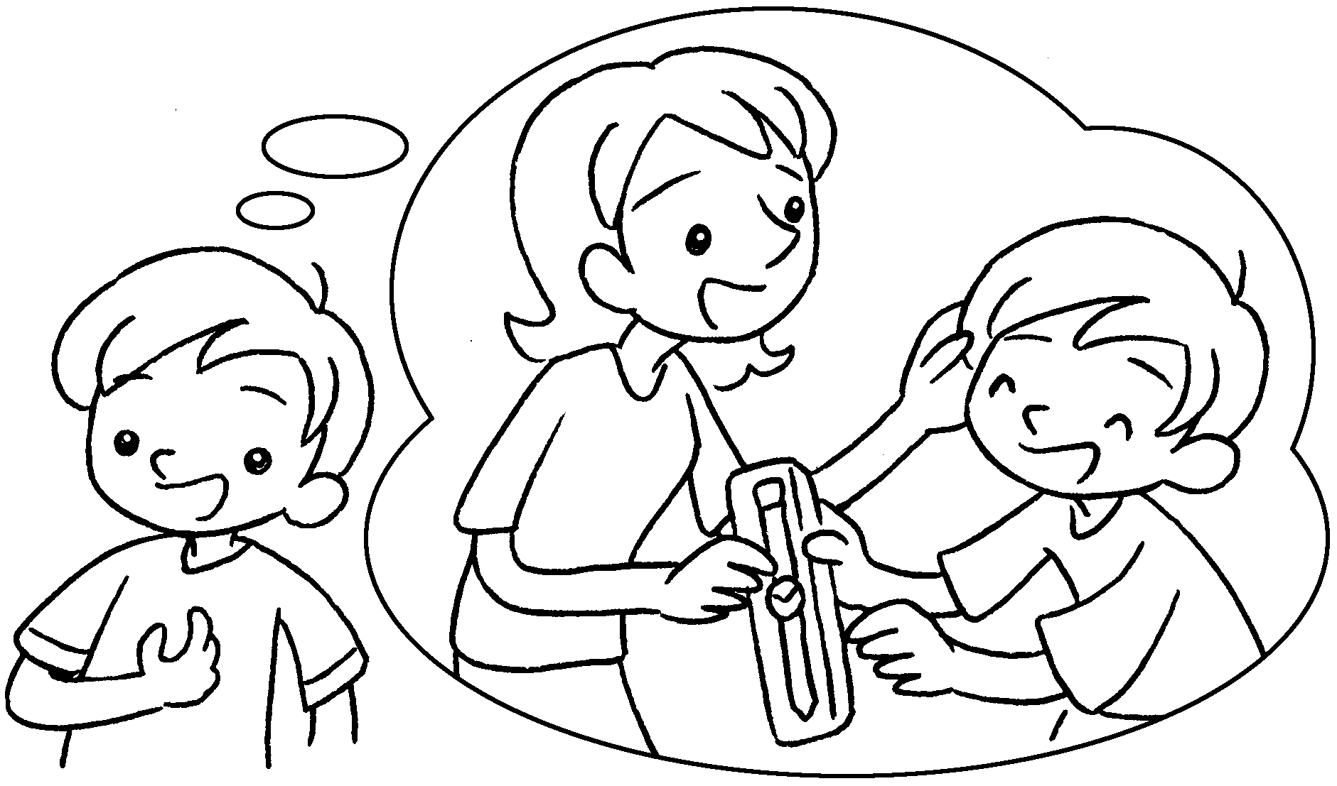 | Mum me a new watch yesterday.
2 | 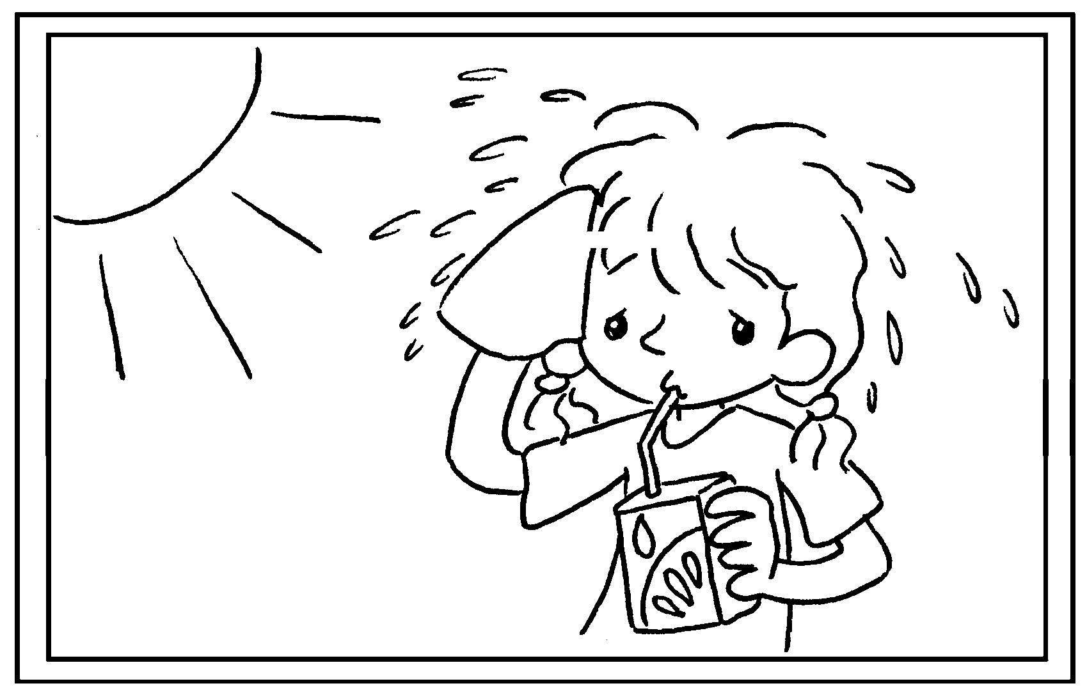 | Fion was thirsty so she  some juice.
3 | 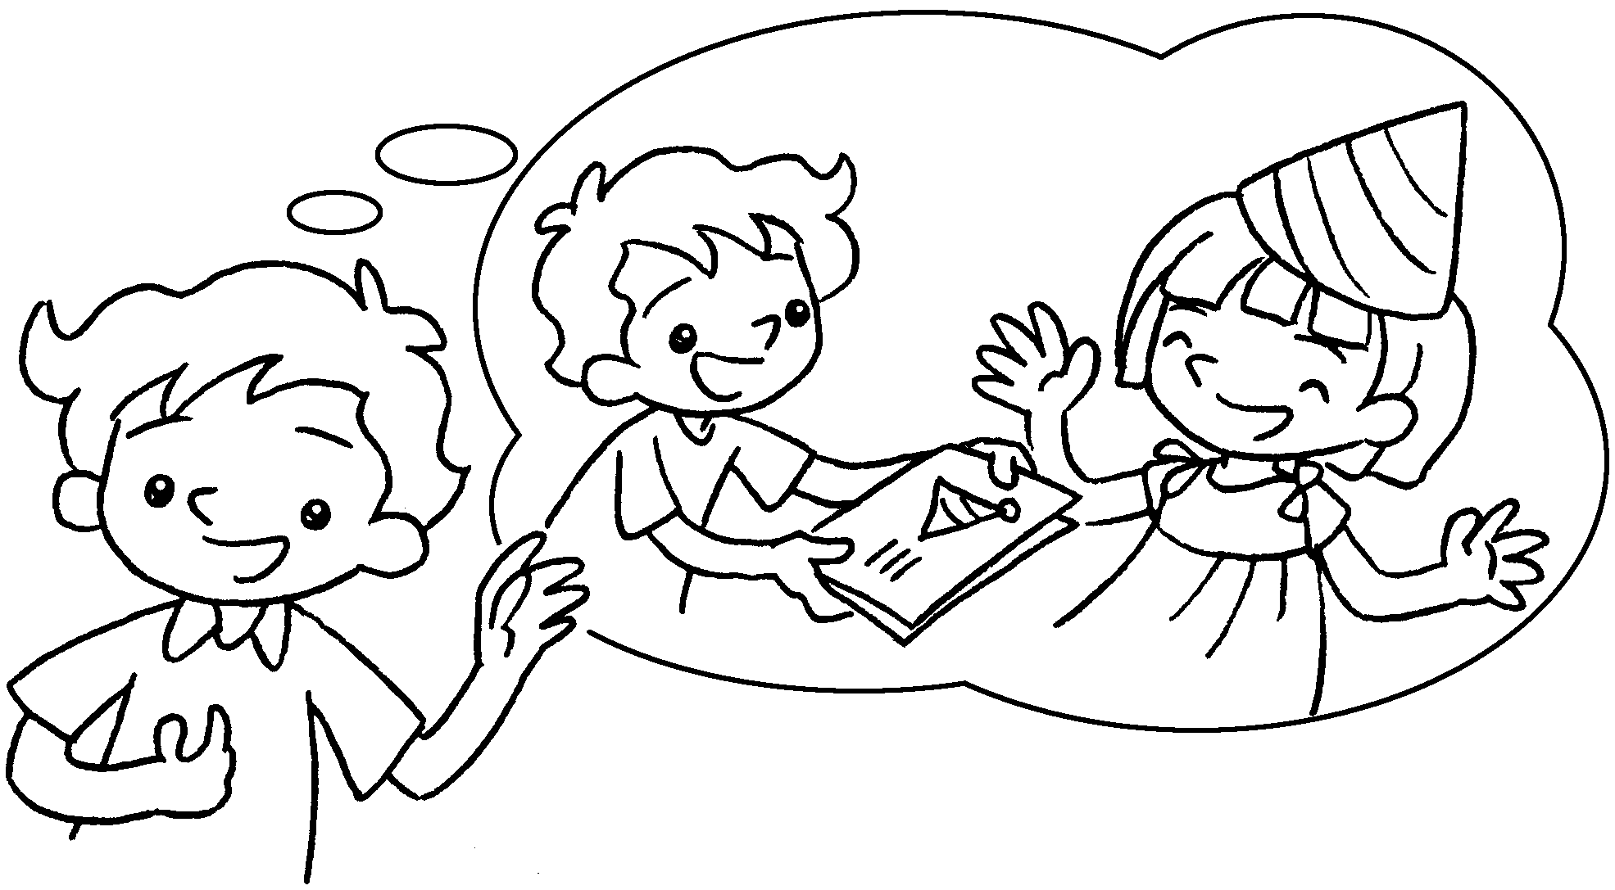 | It was Katie’s birthday last Monday  so I her a card.
4 | 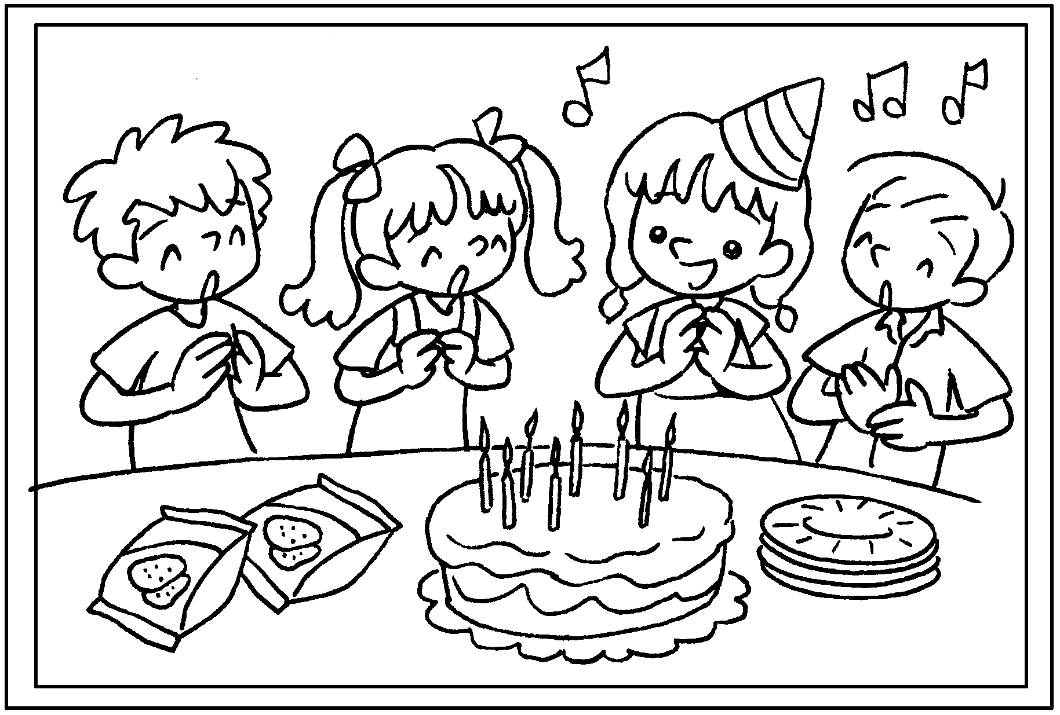 | We the birthday song and a birthday cake.
5 | 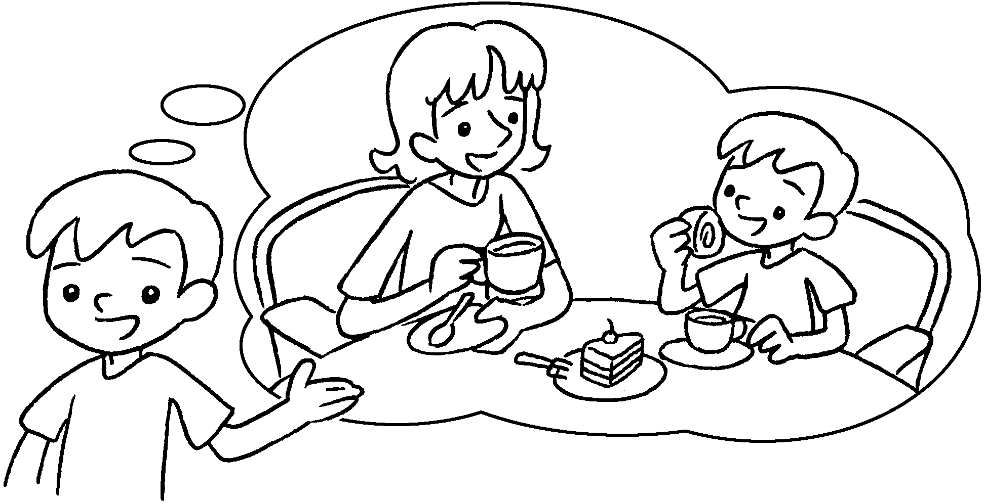 | My mother me  to a cafe and we afternoon tea.



Book 3B Chapter 5 Graded Worksheets
Worksheet 2⬇⬇⬇
- bought / gave
- drank
- gave / bought
- sang ate
- took had

