Choose and write.
his
him

her
her

1  A  B | 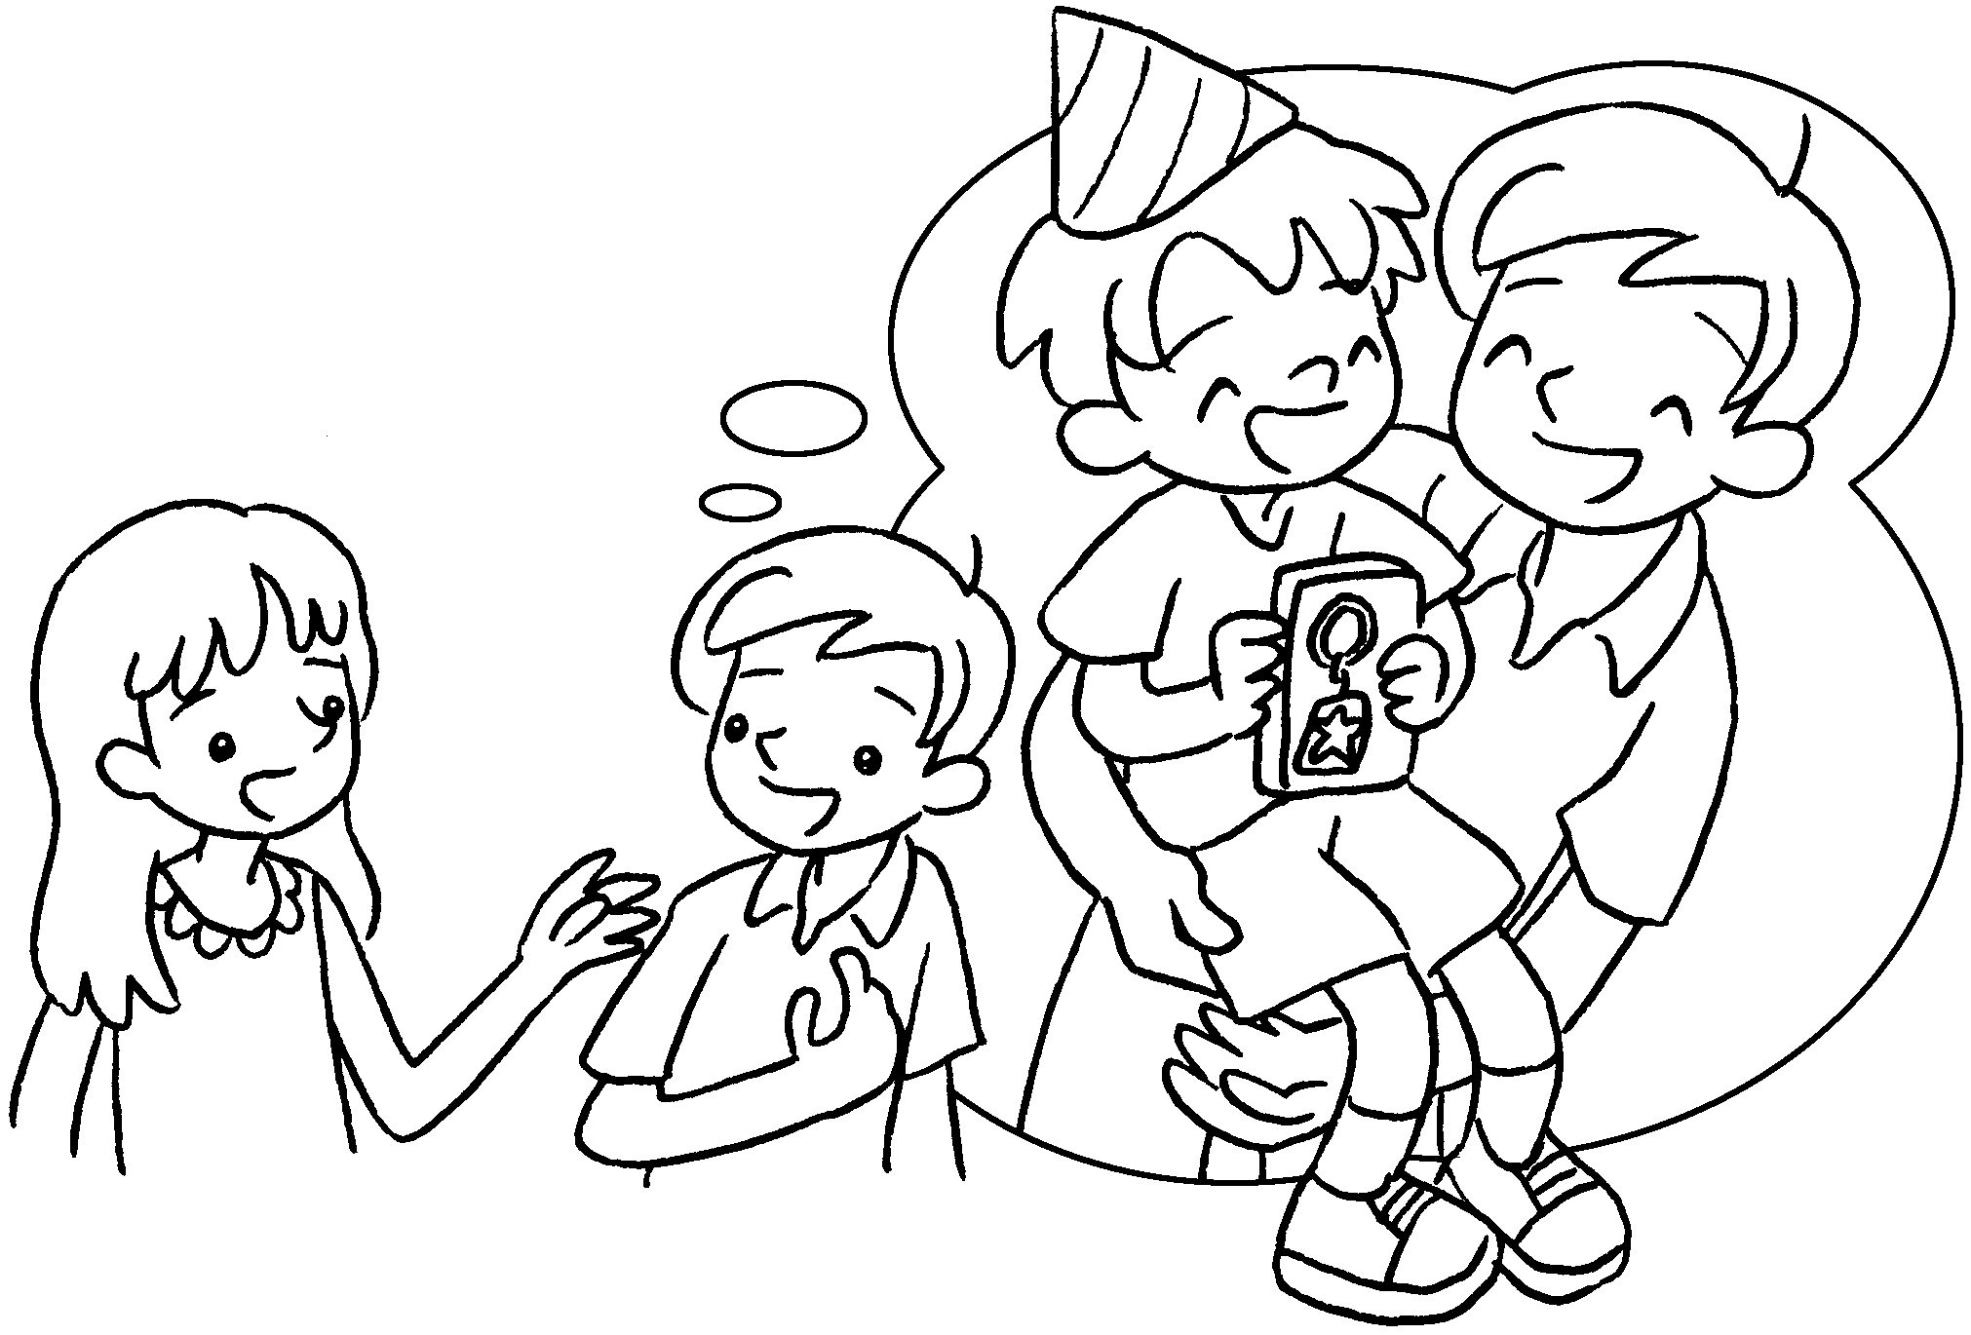 |  | A : What did you give your brother on birthday?  B : I gave a key ring.
2  A  B | 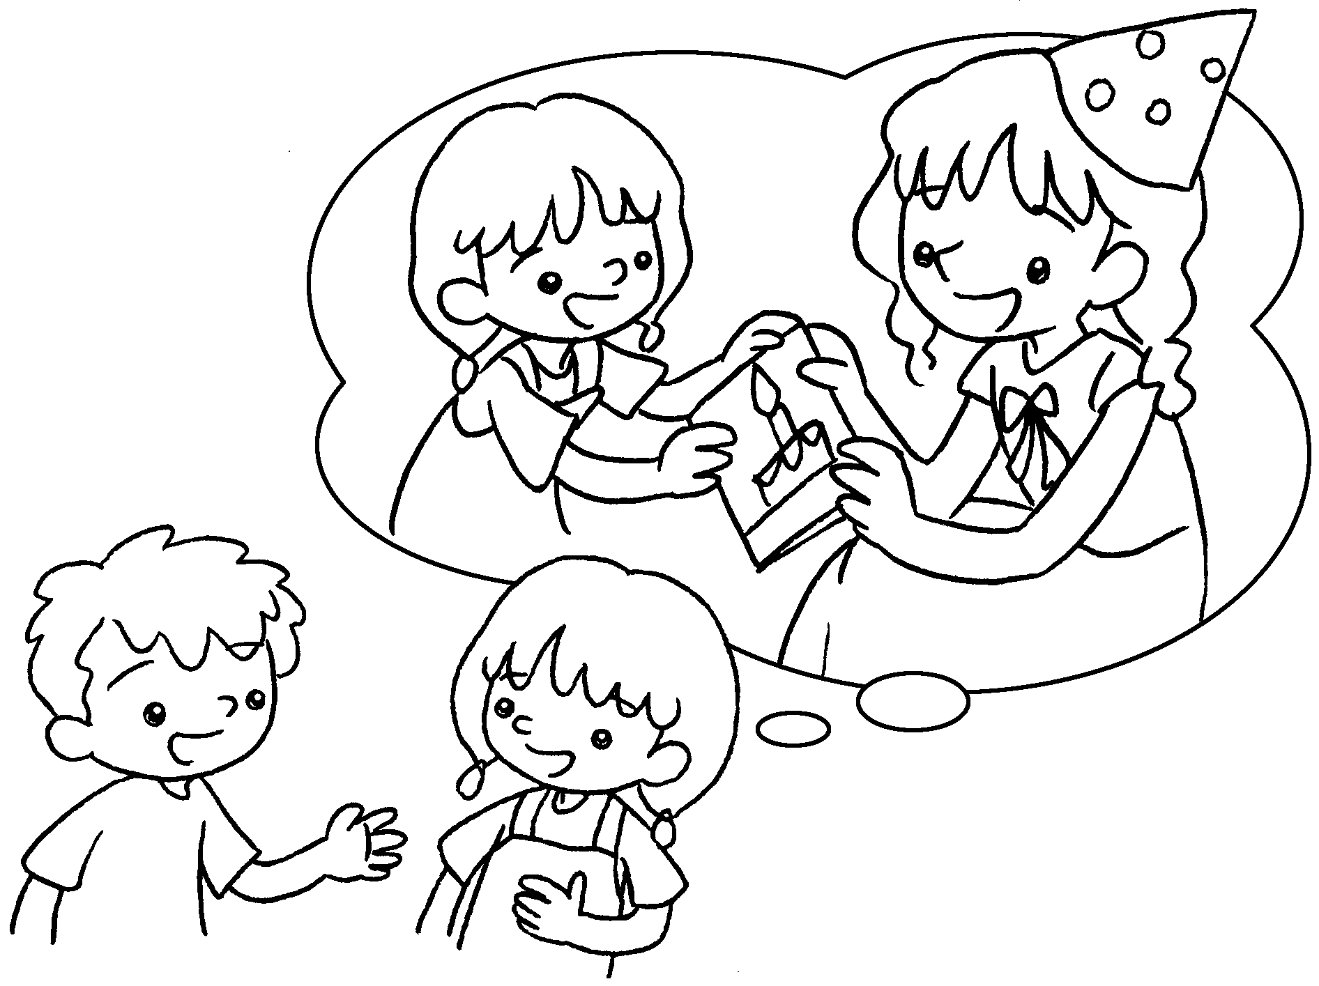 |  | A : What did you give your sister on birthday?  B : I gave a card.
3  B  A | 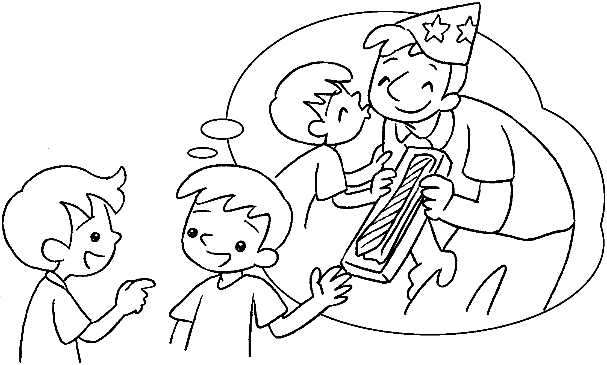 |  | A : What did you give your dad on birthday?  B : I gave a tie.

4  A  B | 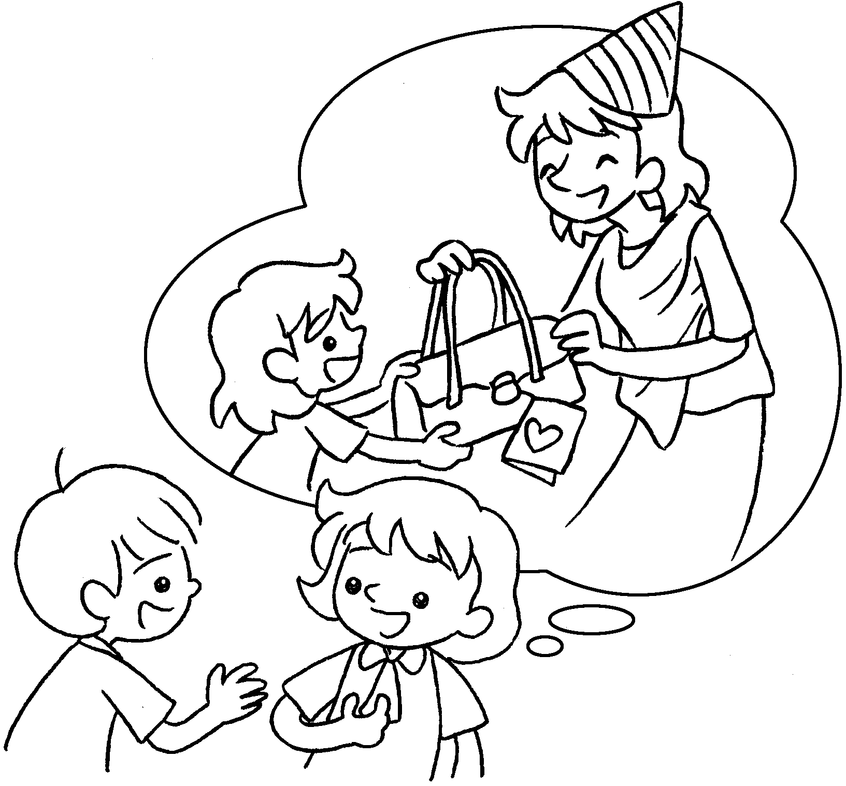 |  | A : What did you give your mum on birthday?  B : I gave a handbag.


Book 3B Chapter 5 Graded Worksheets
Worksheet 3⬇
- his
him
- her
her
- his
him
- her
her

