Finish the questions and answers.
his
him

her
her

1  A  B | 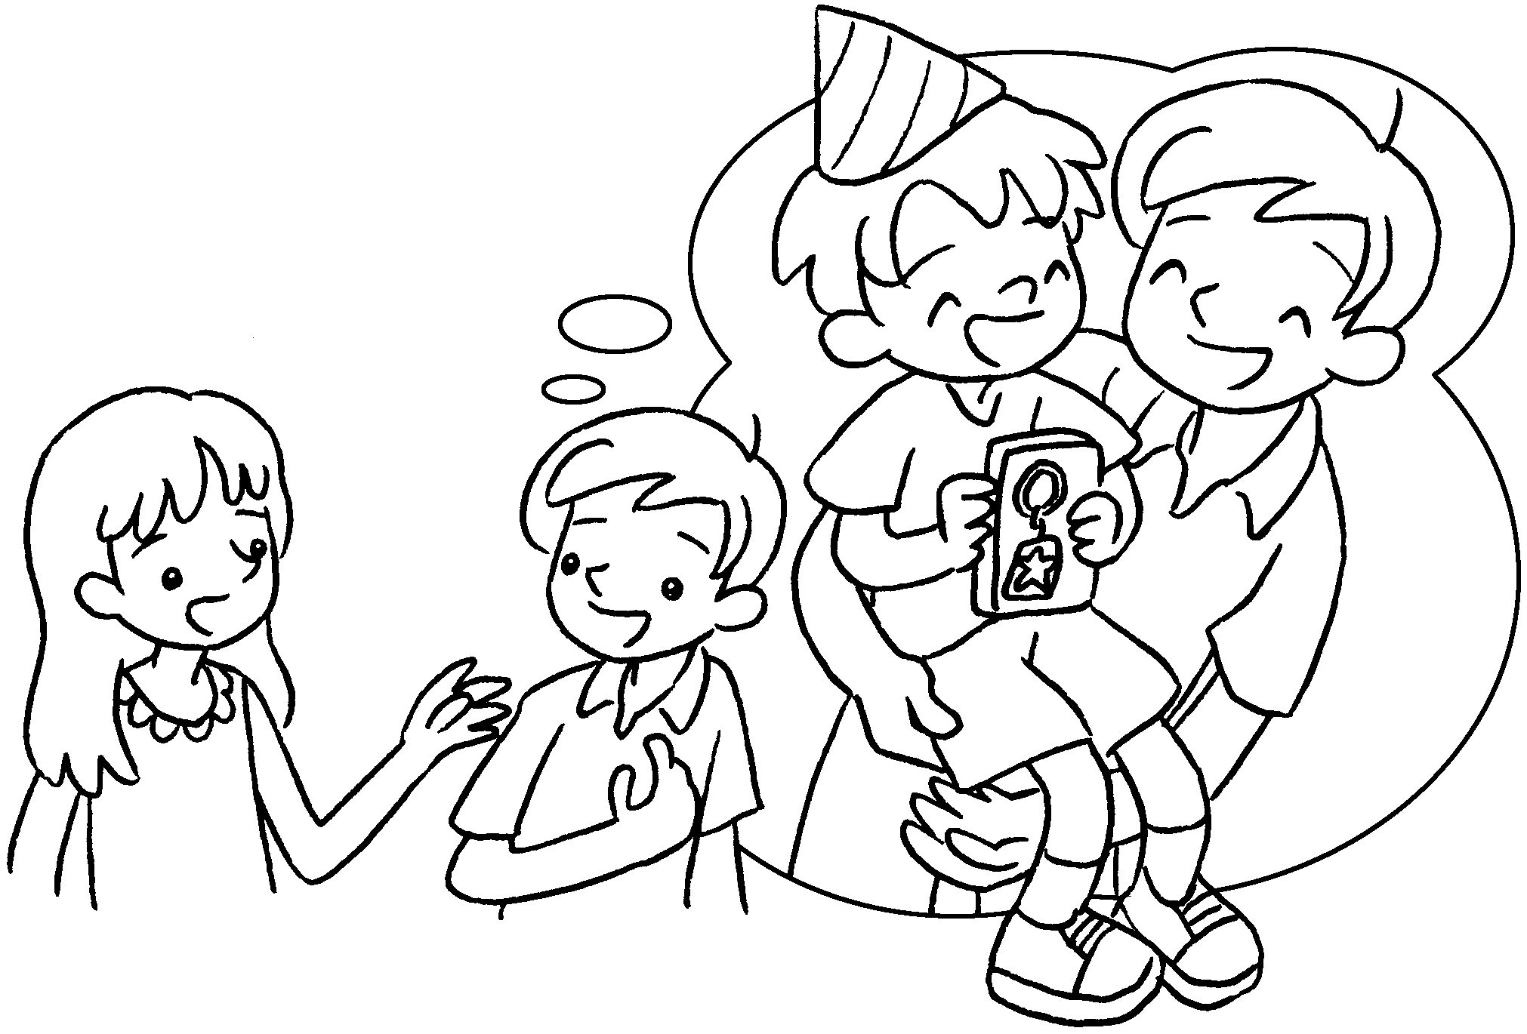 |  | A : What did you give your brother on birthday?  B : I gave a key ring.
2  A  B | 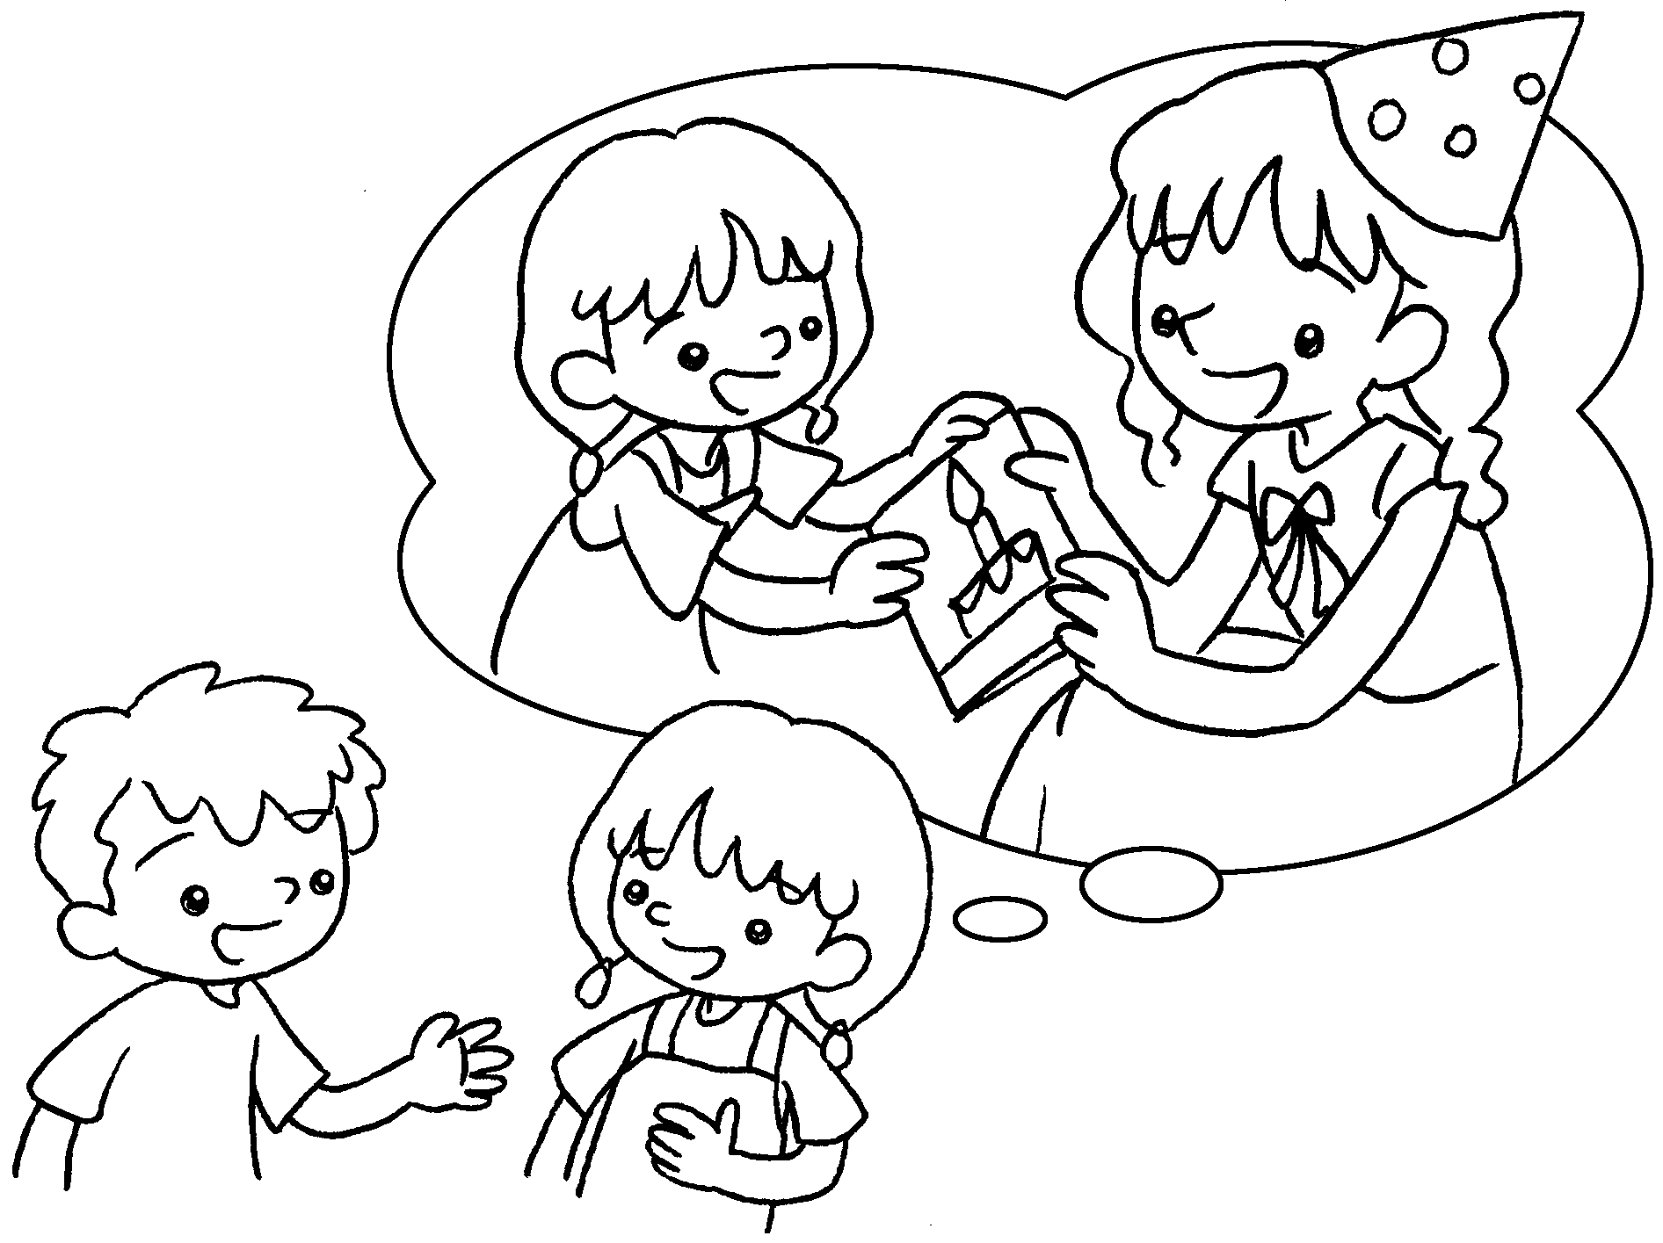 |  | A : What did you give your sister on birthday?  B : I gave a .
3  B  A | 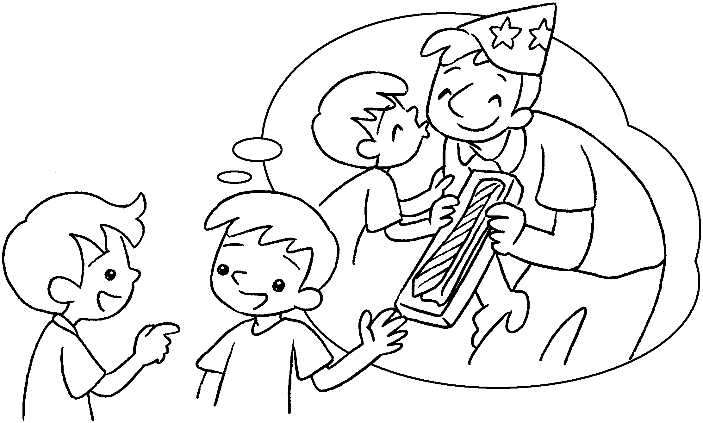 |  | A : What you give your dad on birthday?  B : I a .

4  A  B | 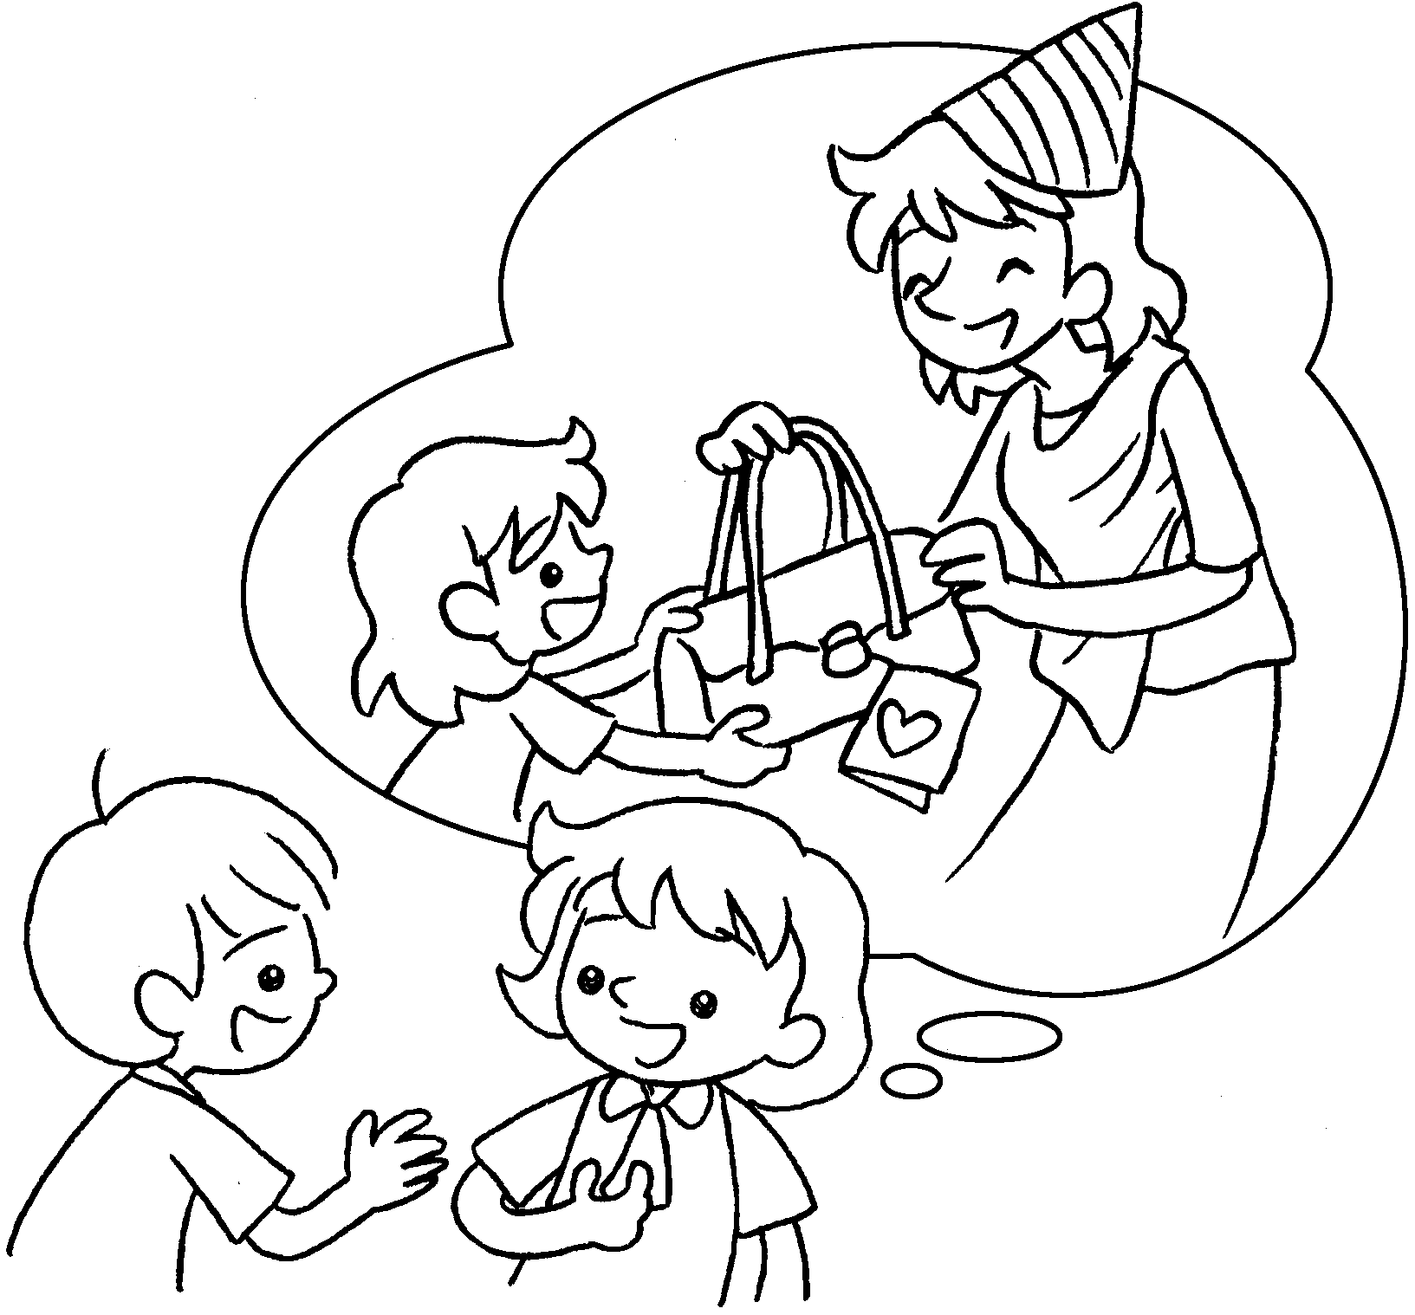 |  | A : What you give your mum on birthday?  B : I .


Book 3B Chapter 5 Graded Worksheets
Worksheet 3⬇⬇
- his
him
- her
her card
3 did his
gave him tie
4 did her
gave her a handbag

