Finish the questions and answers.

1  A  B | 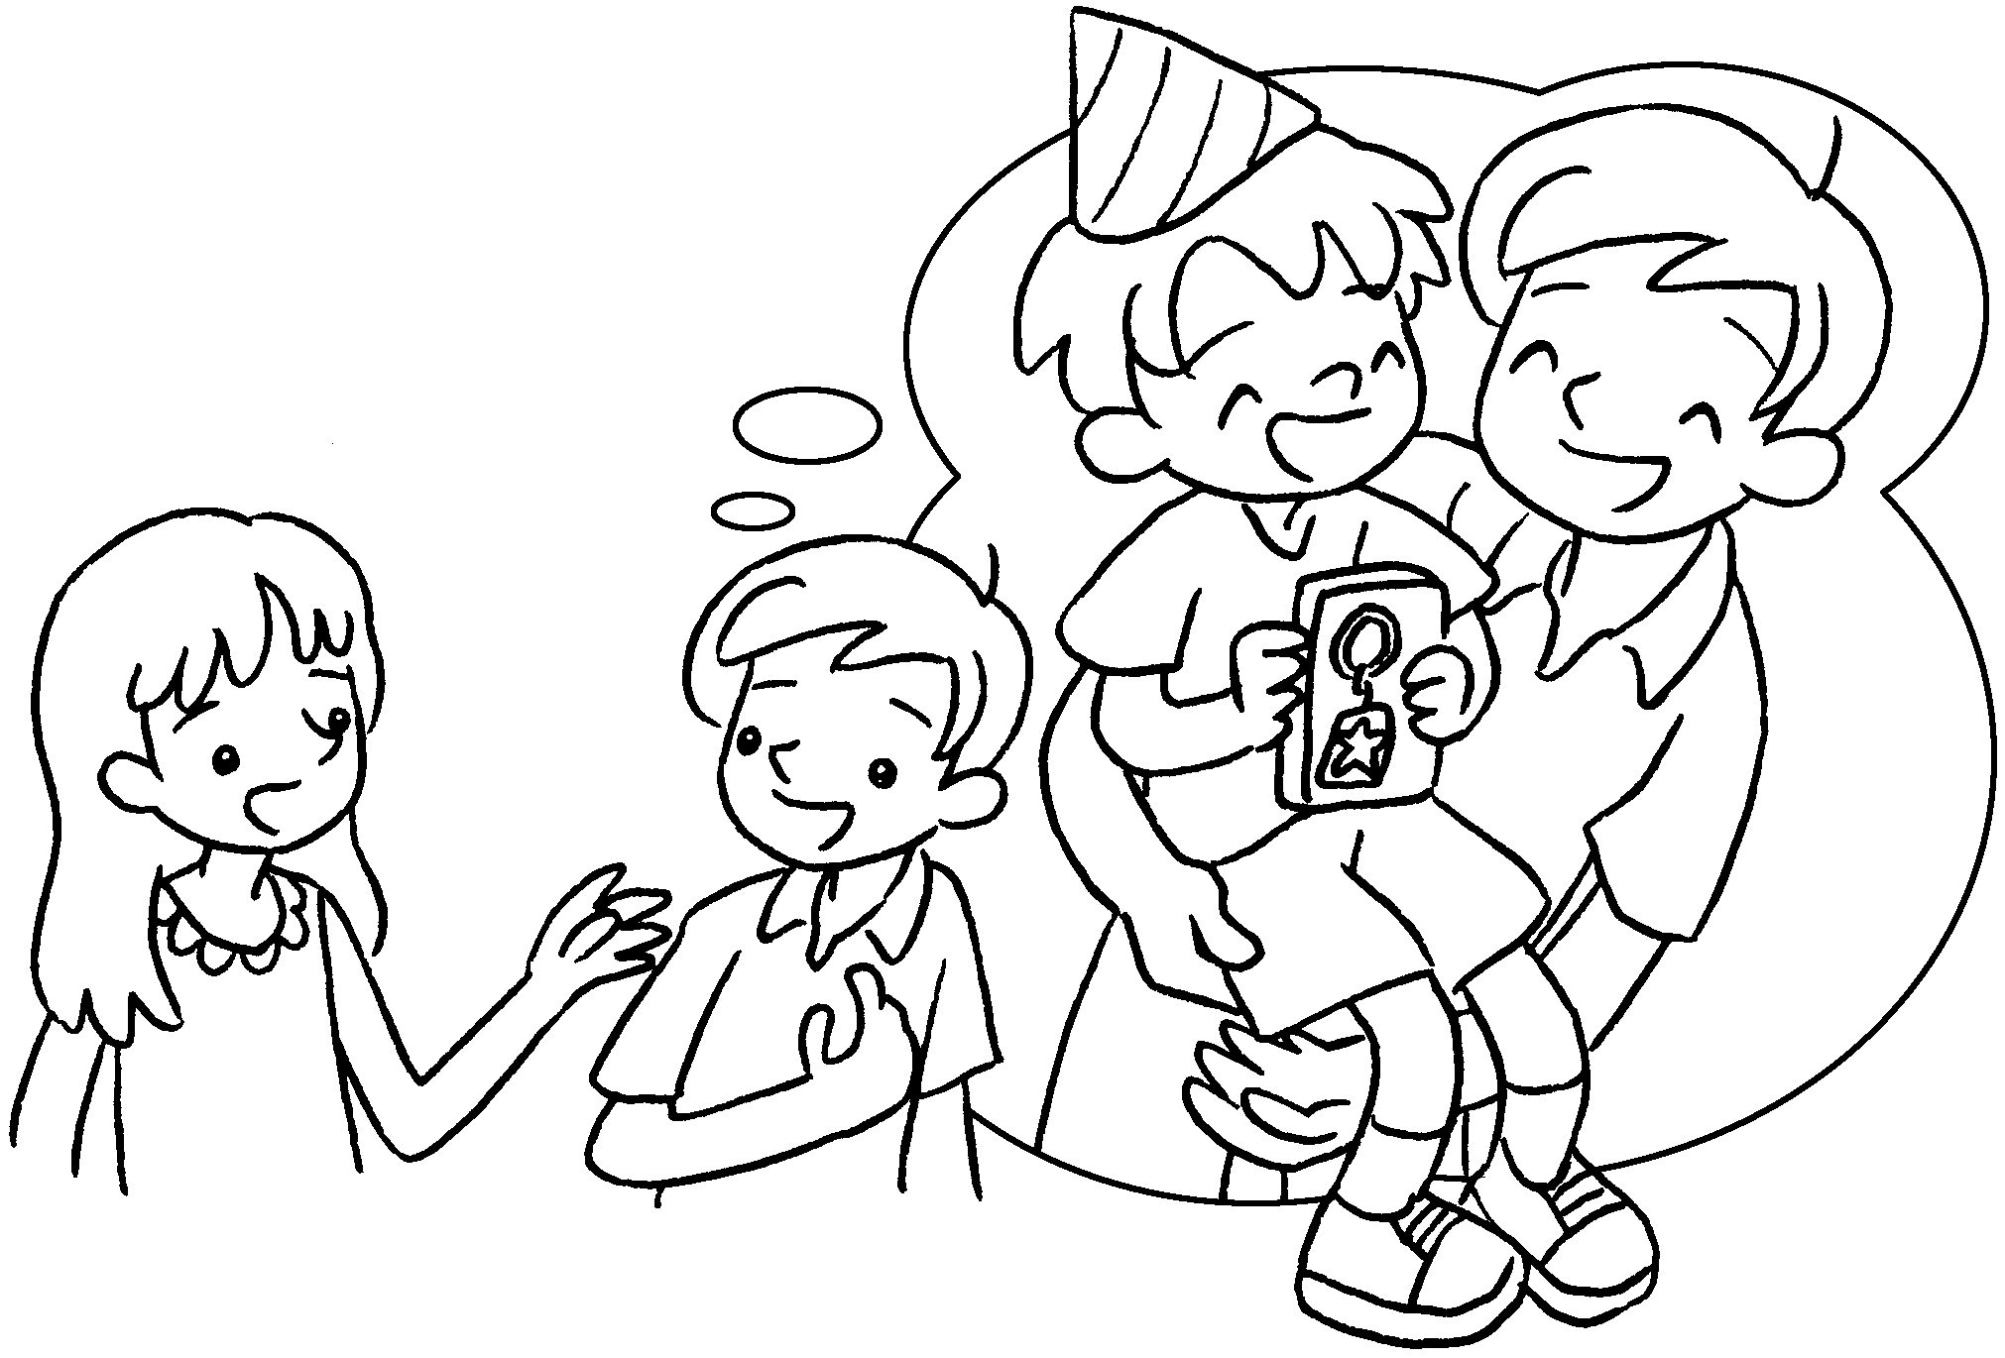 |  |  | A : What did you give your brother on birthday?  B : I gave a key ring.
2  A  B | 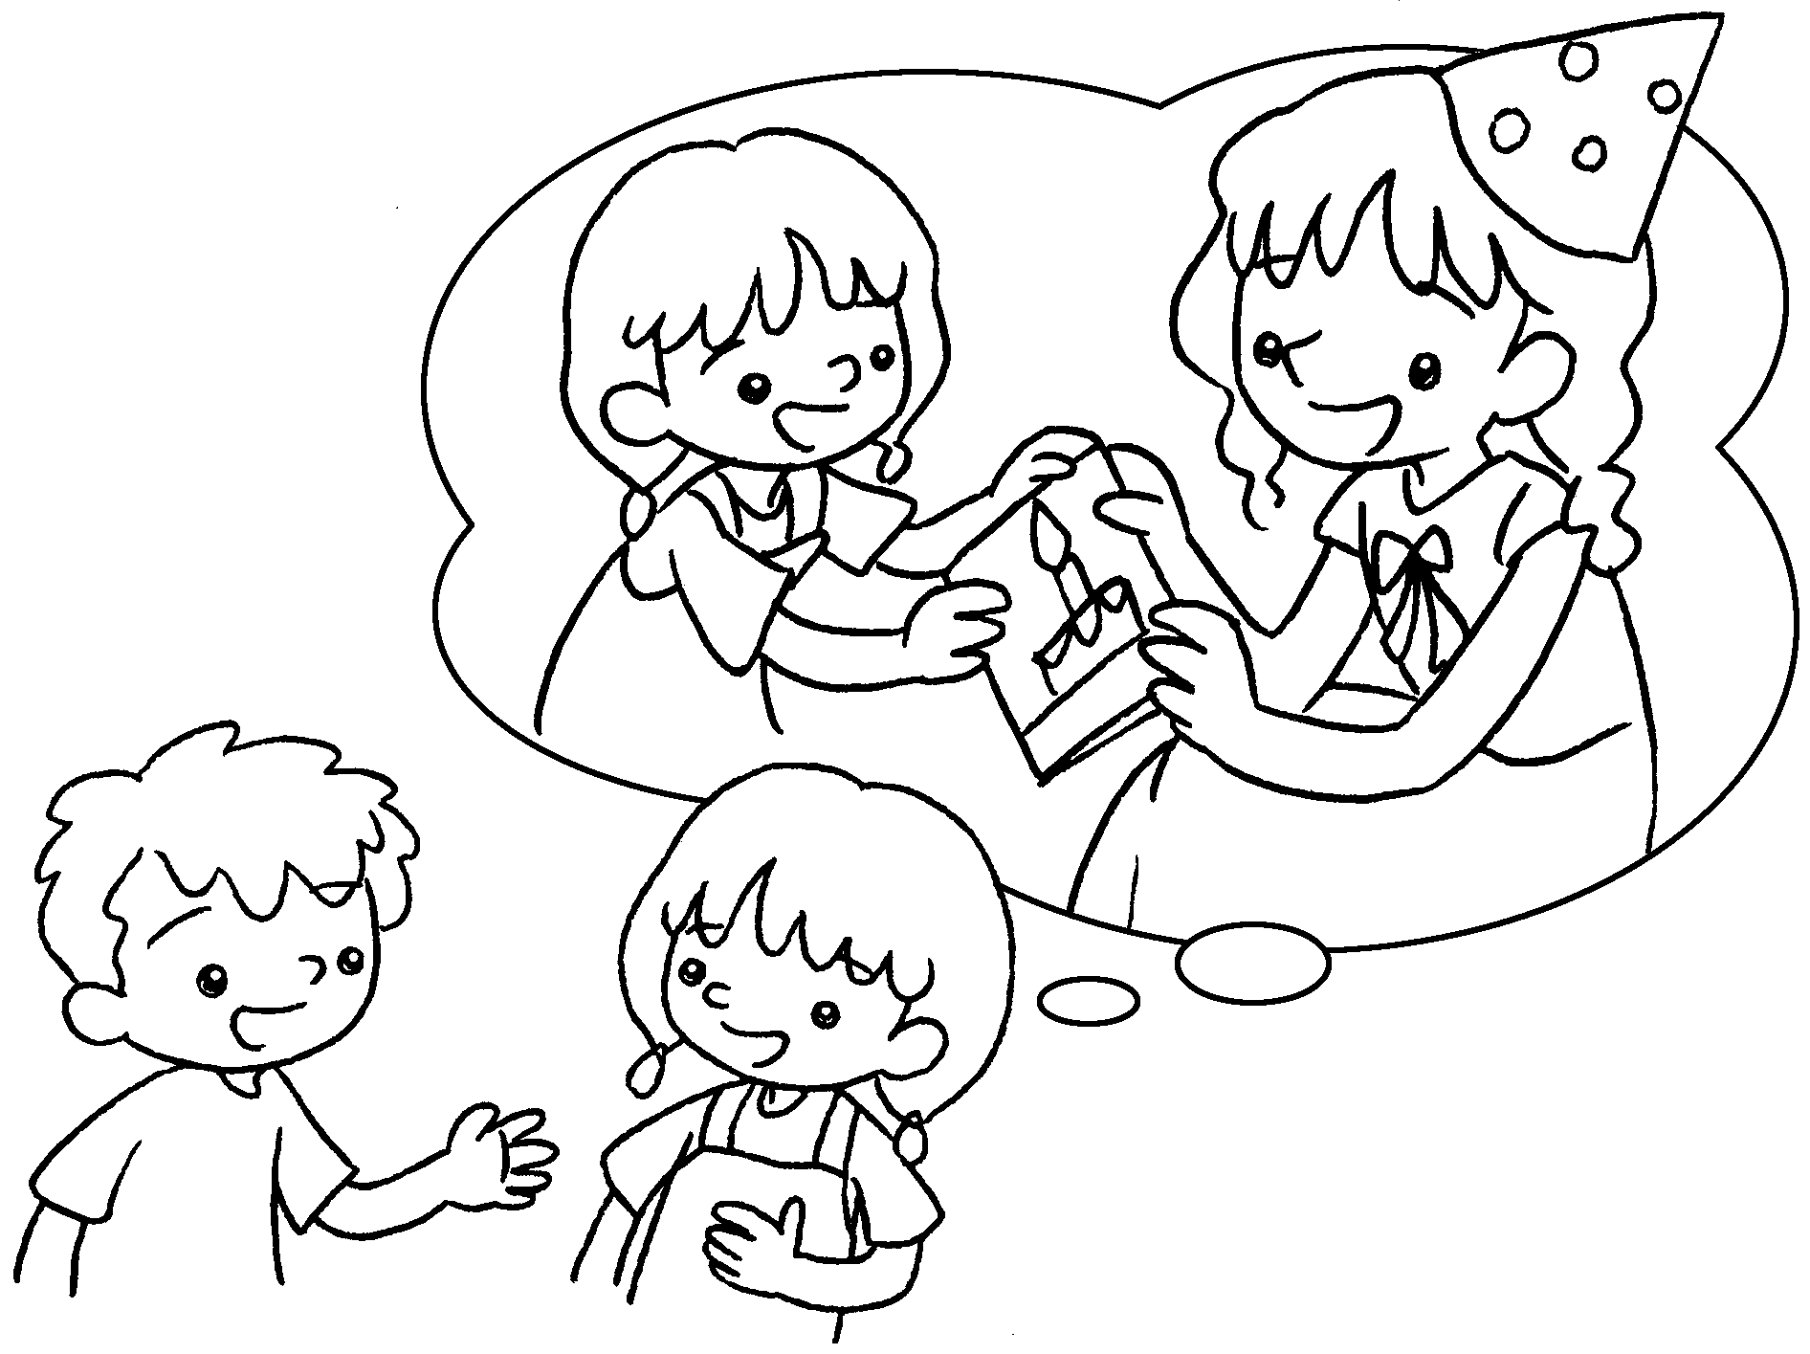 |  | A : What did you give your sister on  birthday?  B : I gave .
3  B  A | 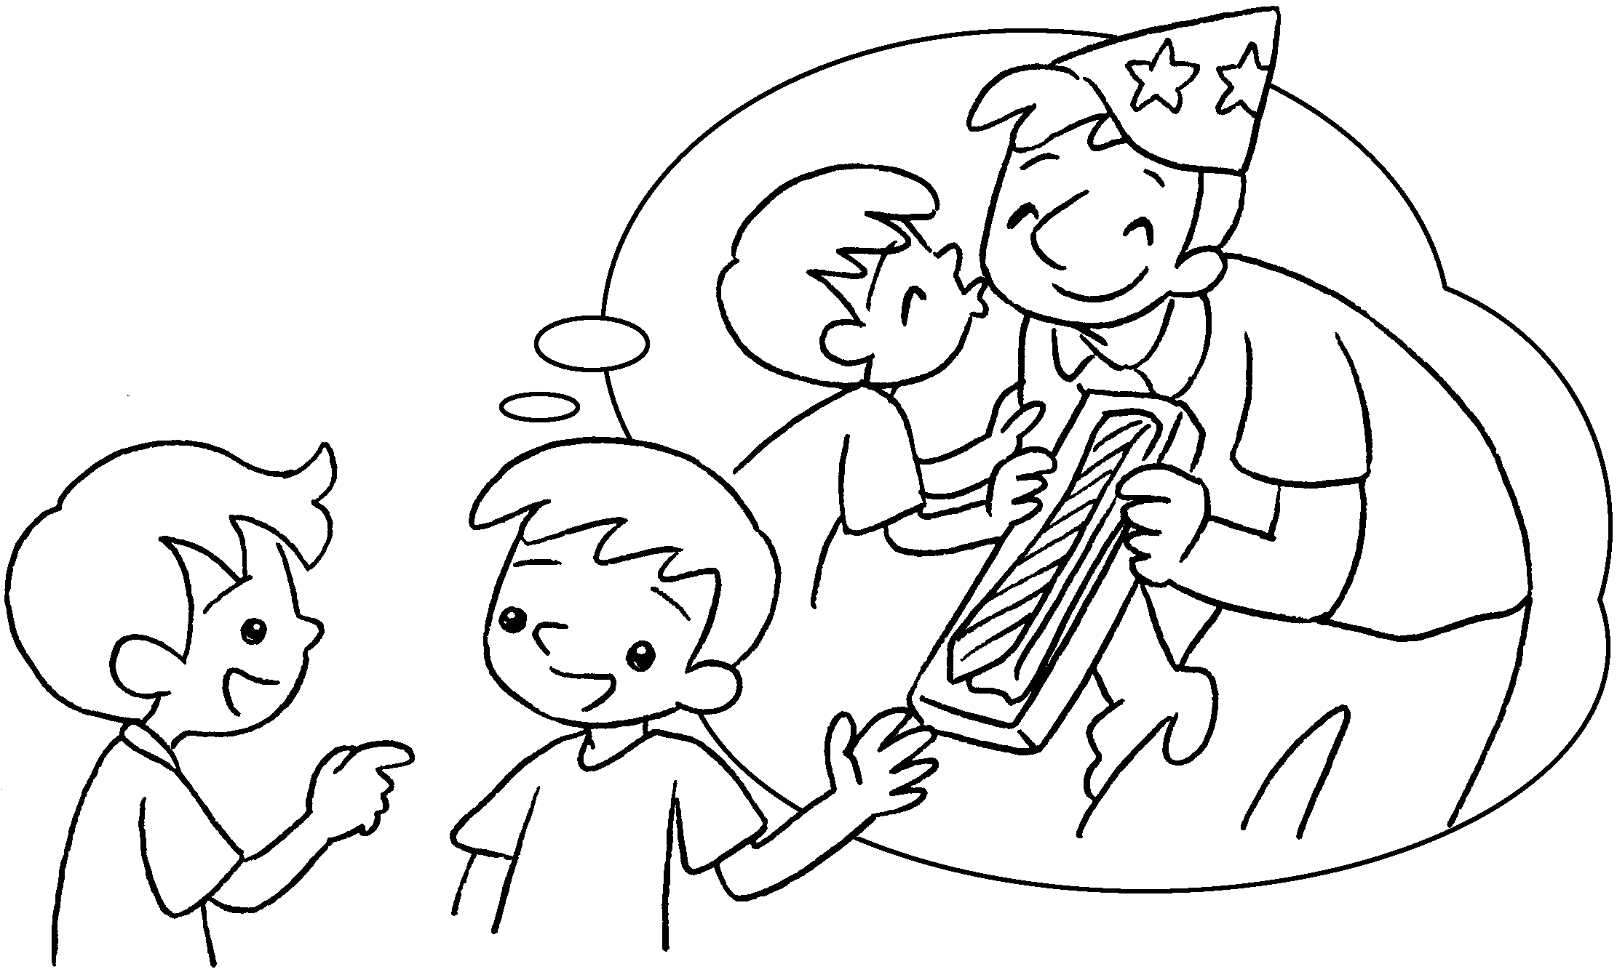 |  | A : What your  dad birthday?  B : I .

4  A  B | 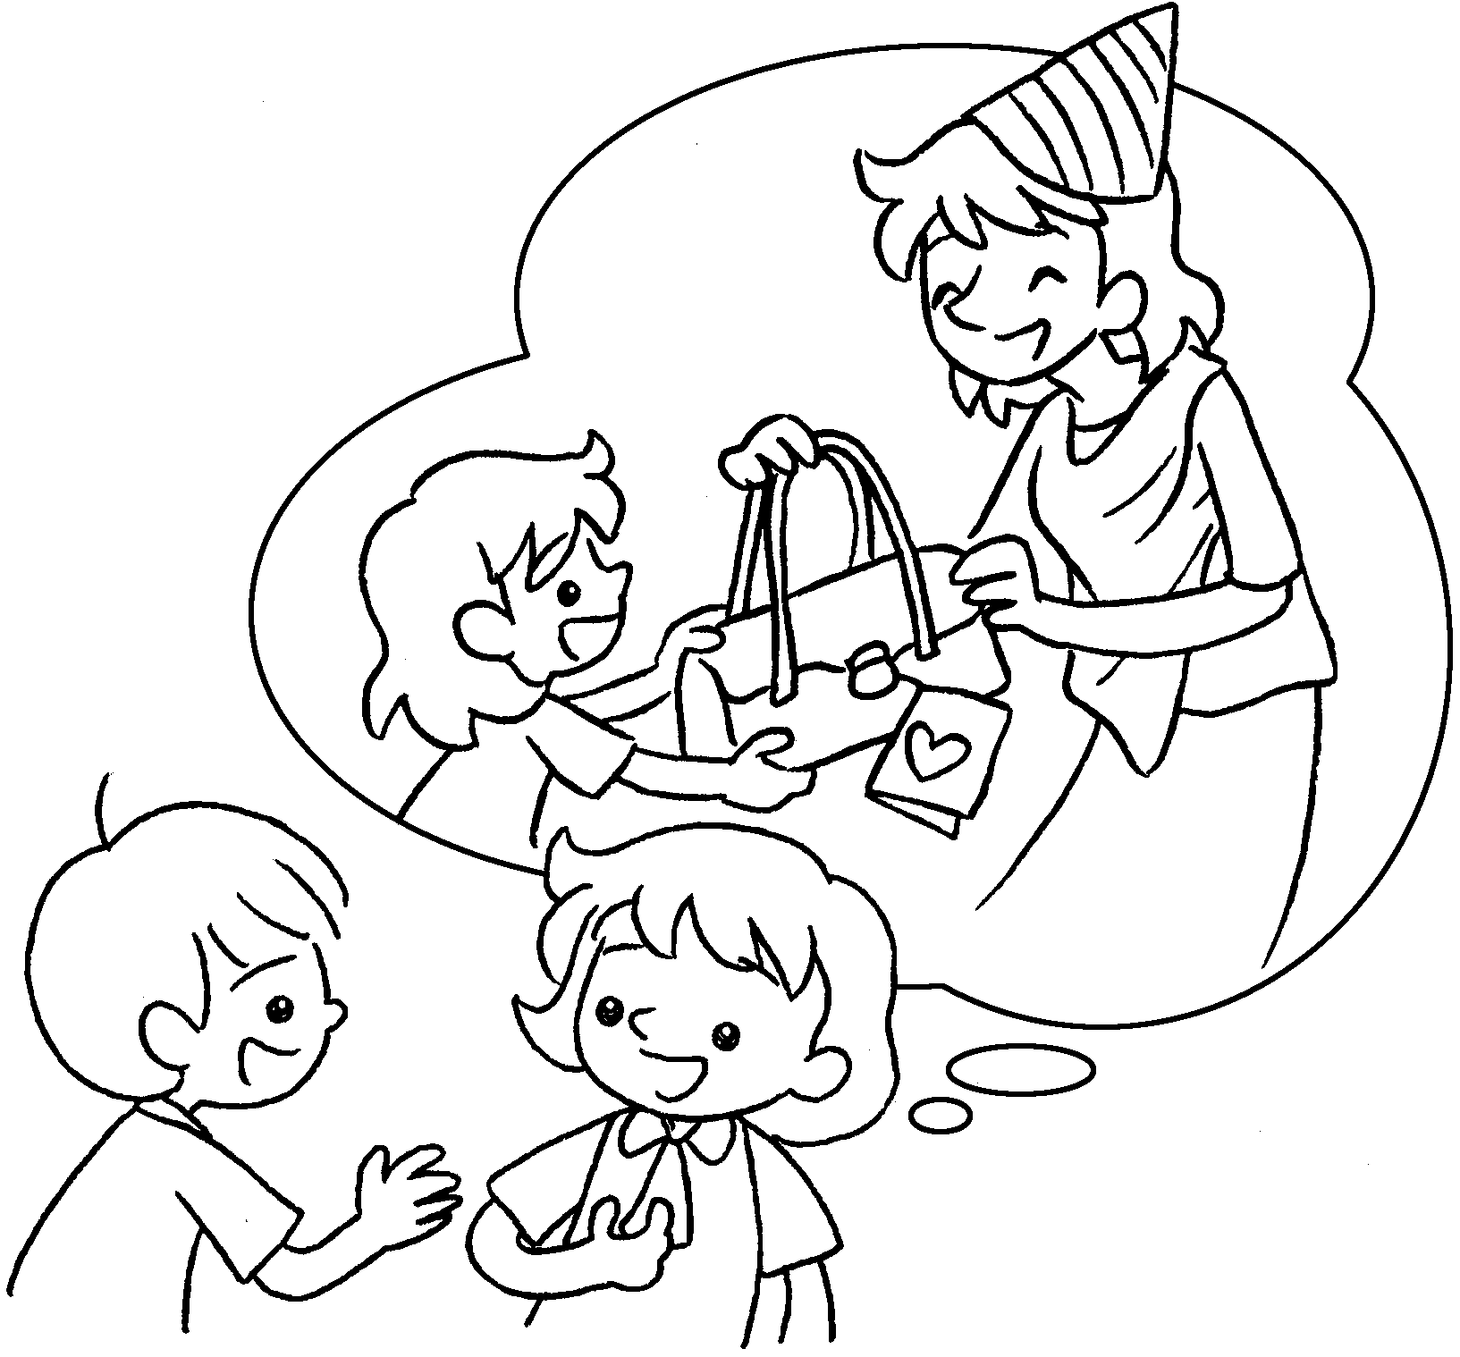 |  | A : your  mum birthday?  B :


Book 3B Chapter 5 Graded Worksheets
Worksheet 3⬇⬇⬇
- his
him
- her
her a card
3 did you give on his
gave him a tie
4 What did you give on her
I gave her a handbag.

