- Special gifts
Book 3B Chapter 5
Simplified reading passage
What gifts did you get on your last birthday? What gifts did Simon and Jenny get? Read the story and find out.


Simon and his twin sister Jenny wanted to give each other a special birthday gift but they did not have much money.

Simon had an old gold watch but the chain was broken. ‘I can buy him a new watch chain,’ Jenny thought.

Jenny had lovely long hair. ‘I can buy her some hair combs,’ Simon thought.

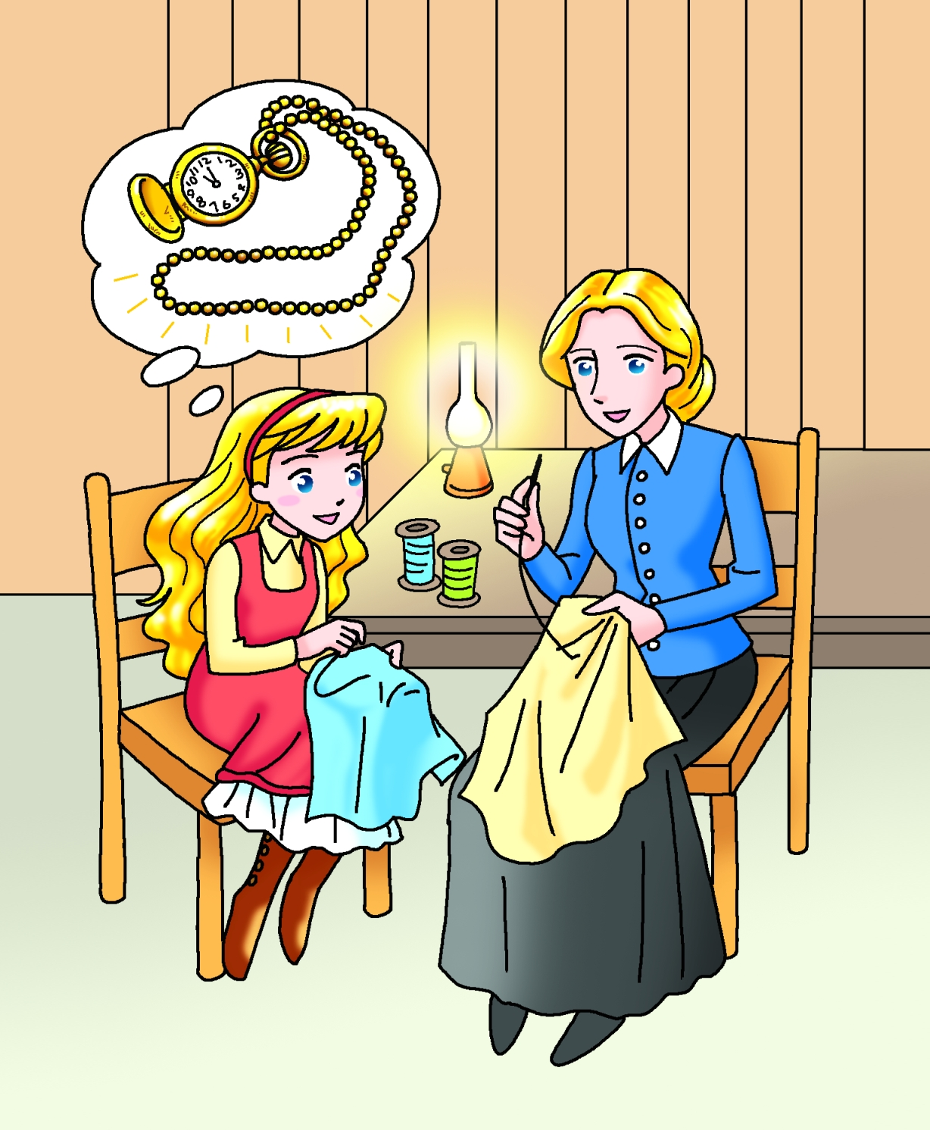

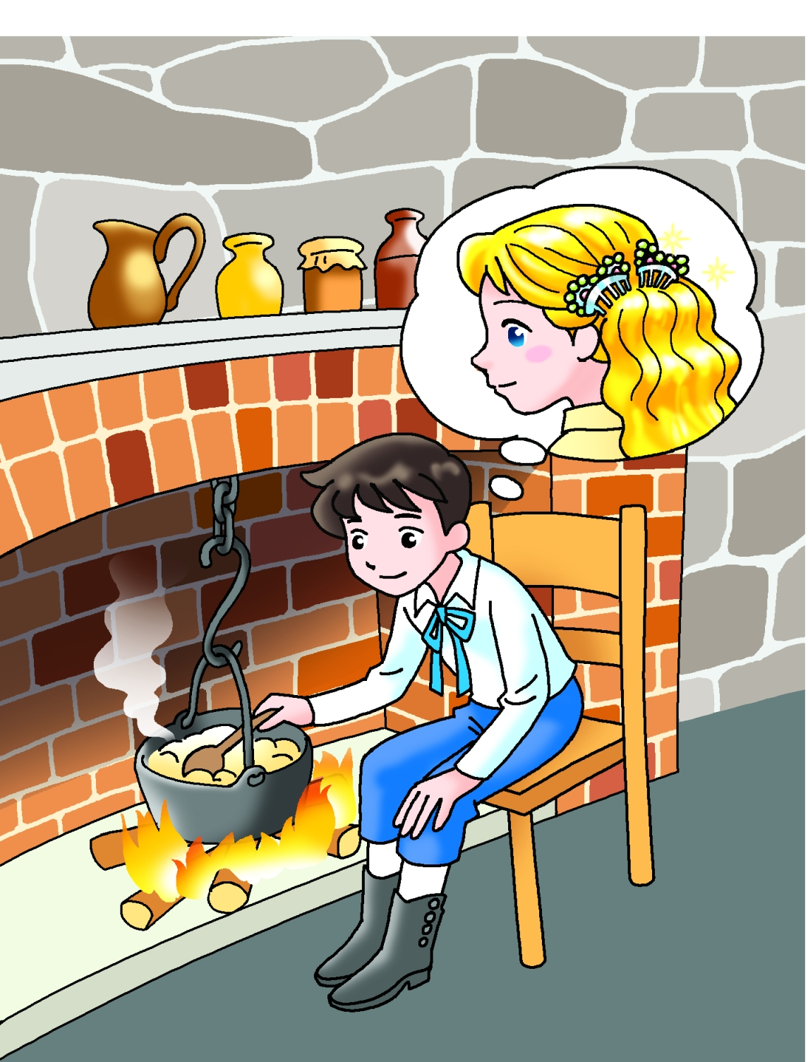

Book 3B Chapter 5
Simplified reading passage

The next morning Jenny rode her old bicycle to a wig shop and sold her hair. Then she bought Simon a watch chain.

When Simon saw Jenny’s new short hair, he said, ‘Oh no! I sold my watch and bought you these hair combs,’ said Simon.

‘Never mind. Let’s go out and have some fun,’ said their mother. She took them to the forest. They had a lovely time.

