Notices
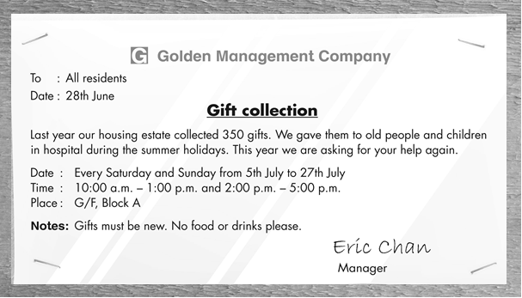

Write the answer and blacken  the circles.

1 Who is the notice for?

2 Golden Management Company wants to ___ .
 A. collect food for old people and children in hospital
 B. collect gifts for old people and children in hospital
 C. collect gifts for the people living in the housing estate
 D. help the residents buy gifts

3 What CAN’T you find in the notice?
 A. the name of the management company
 B. the name of the hospital
 C. the time for collecting gifts
 D. the name of the manager

4 Candy is a resident in the housing estate. She wants to help. What can she do?
 A. She can take some cookies to G/F, Block A on 5th July.
 B. She can take some new toys to G/F, Block A on 28th July.
 C. She can take some new toys to the hospital on 5th July.
 D. She can take some new toys to G/F, Block A on 5th July.

Answers:
1 (All) the residents / people living in the housing estate. 2 B 3 B 4 D

