Choose and write.

barbecue | kite | picnic | sandcastle

1 | 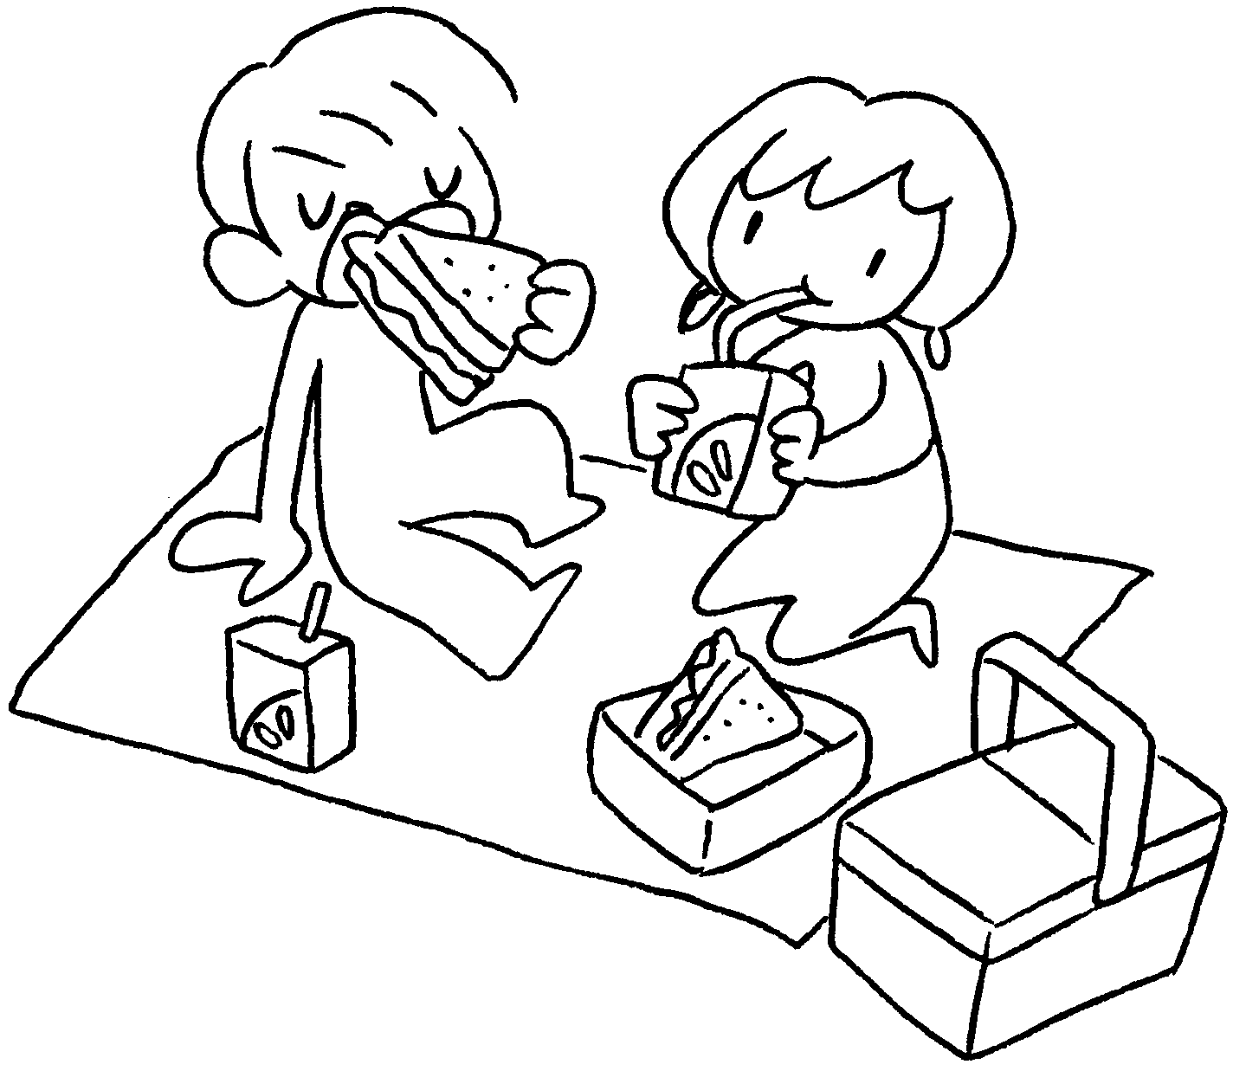 | 2 | 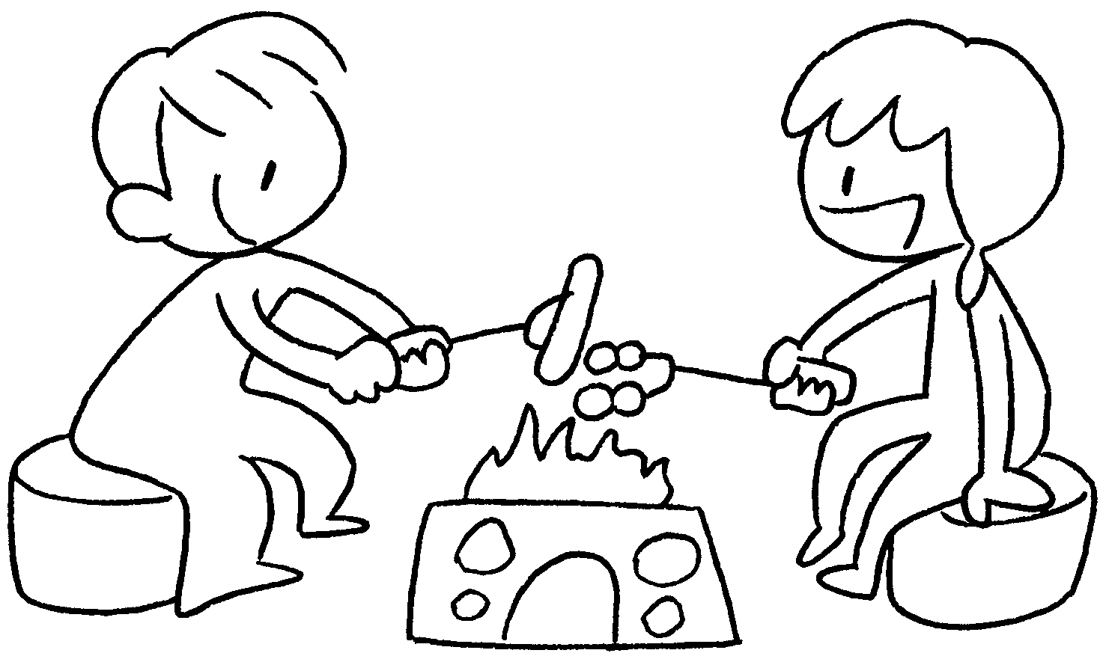 | 1 | have a
 |  |  |  | 2 | have a
3 | 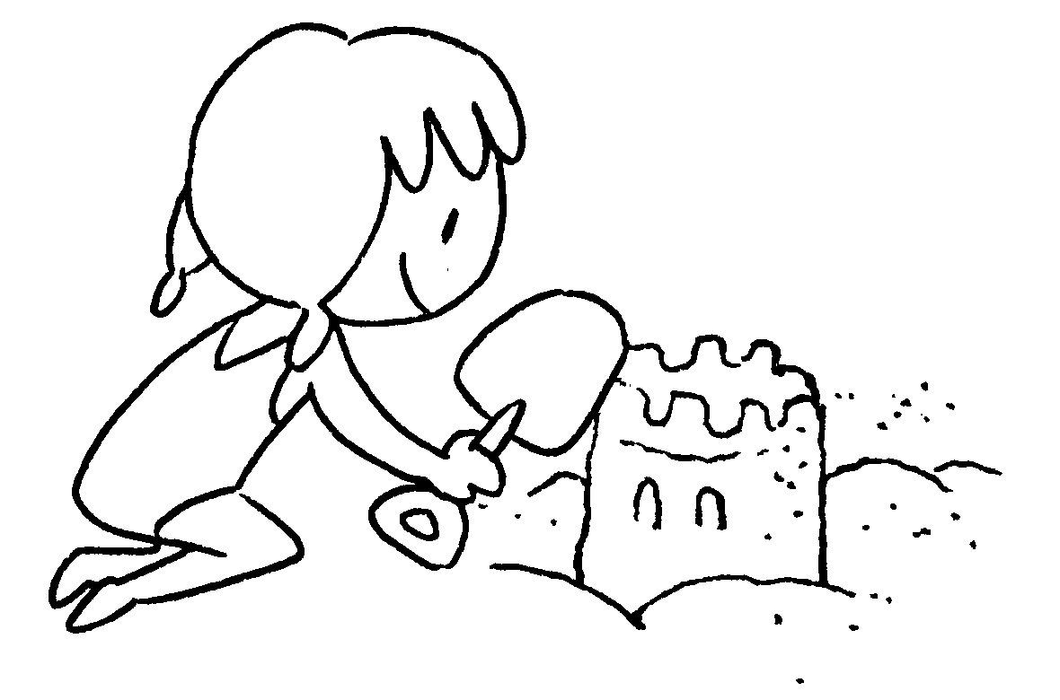 | 4 | 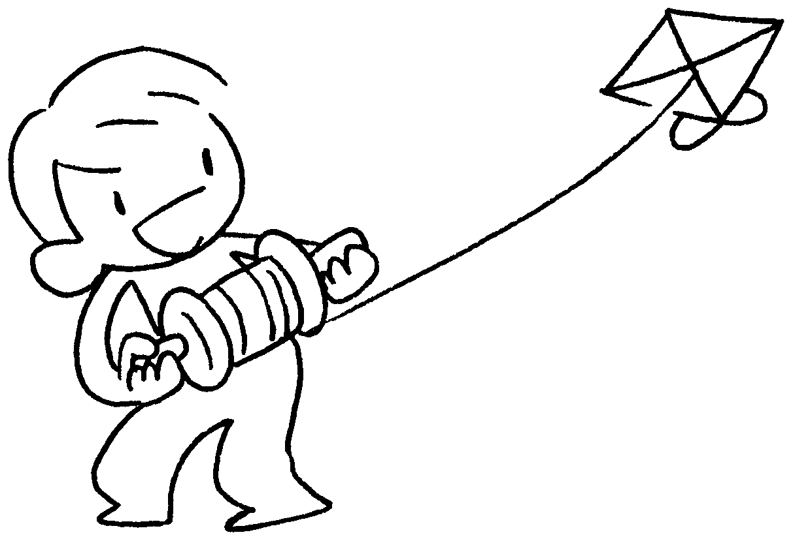 | 3 | build a
 |  |  |  | 4 | fly a

hiking | magazines | models
photos | puzzles | shopping

5 | 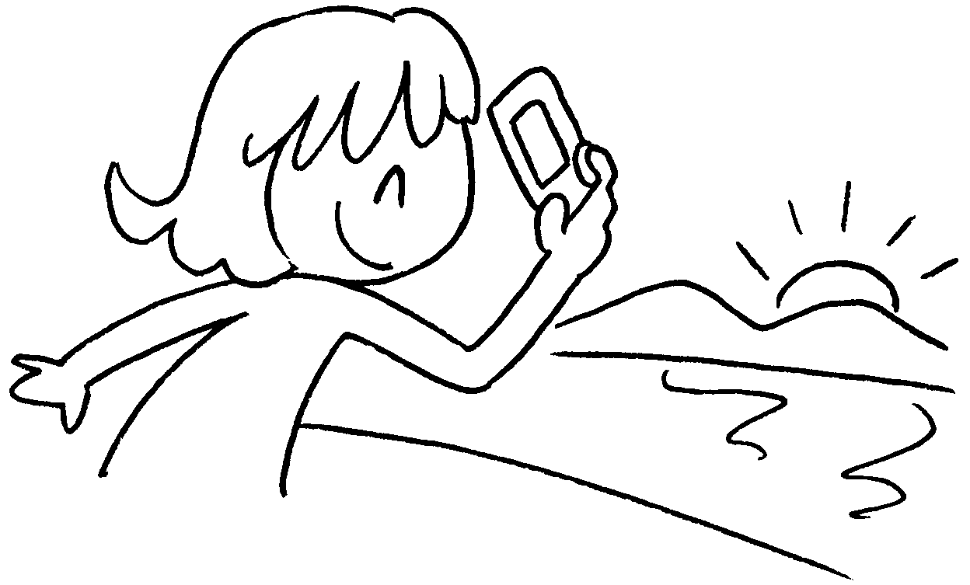 | 6 | 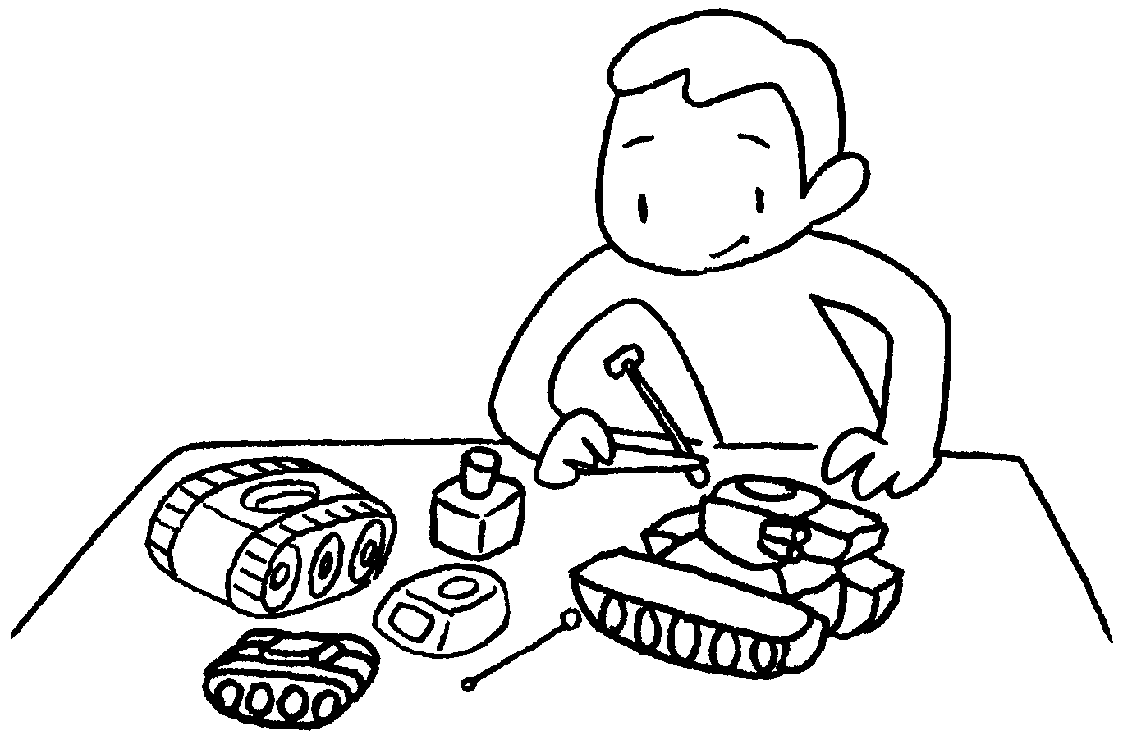 | 5 | take
 |  |  |  | 6 | make
7 | 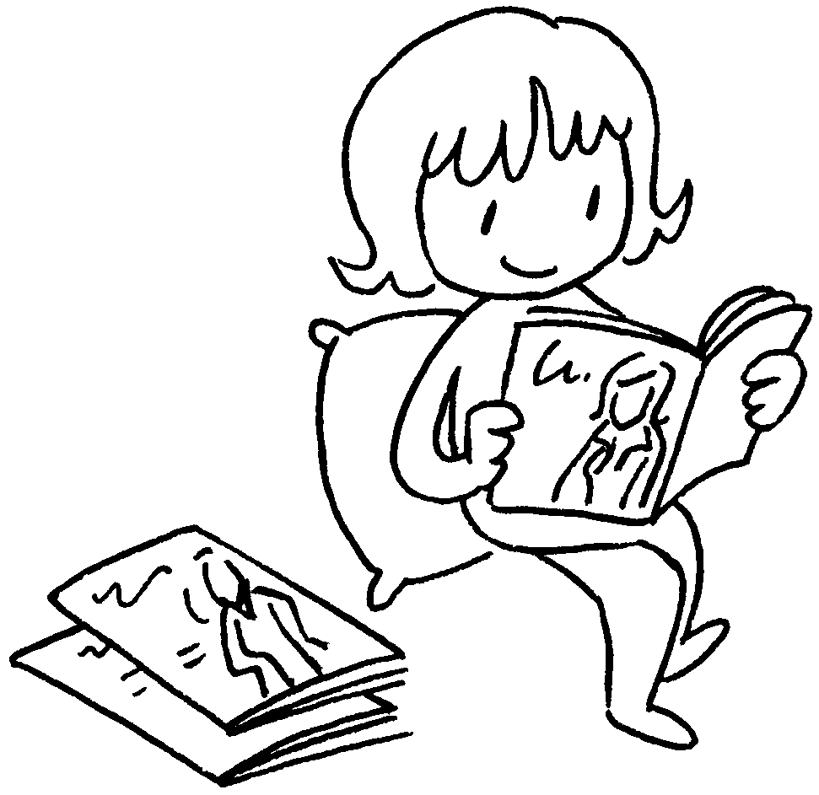 | 8 | 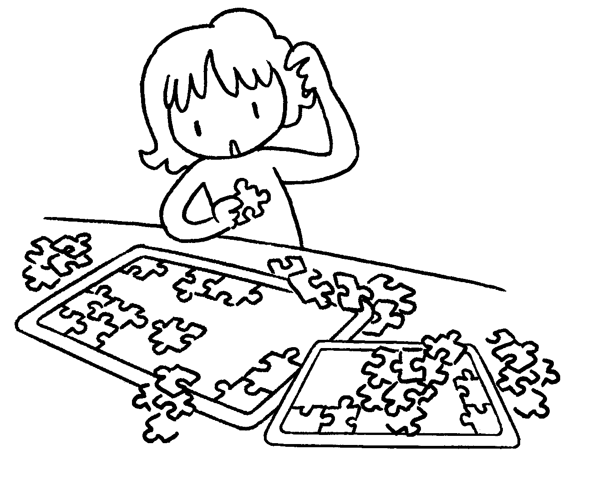 | 7 | read
 |  |  |  | 8 | do
9 | 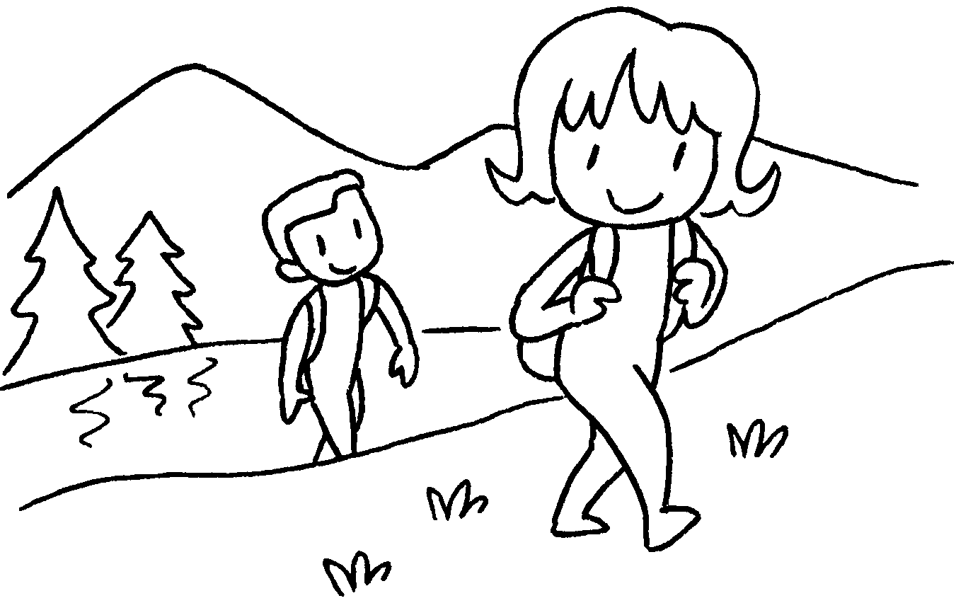 | 10 | 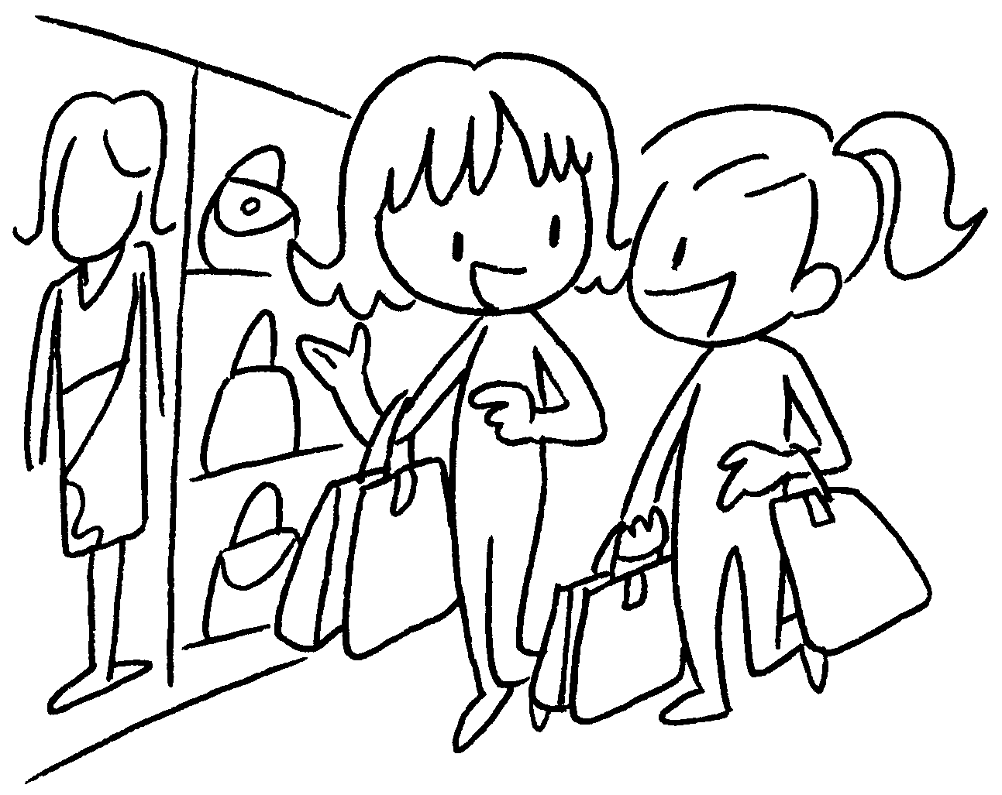 | 9 | go
 |  |  |  | 10 | go


Book 3B Chapter 6 Graded Worksheets
Worksheet 1⬇
- picnic
- barbecue
- sandcastle
- kite
- photos
- models
- magazines
- puzzles
- hiking
- shopping

