Fill in the missing letters.

1 | 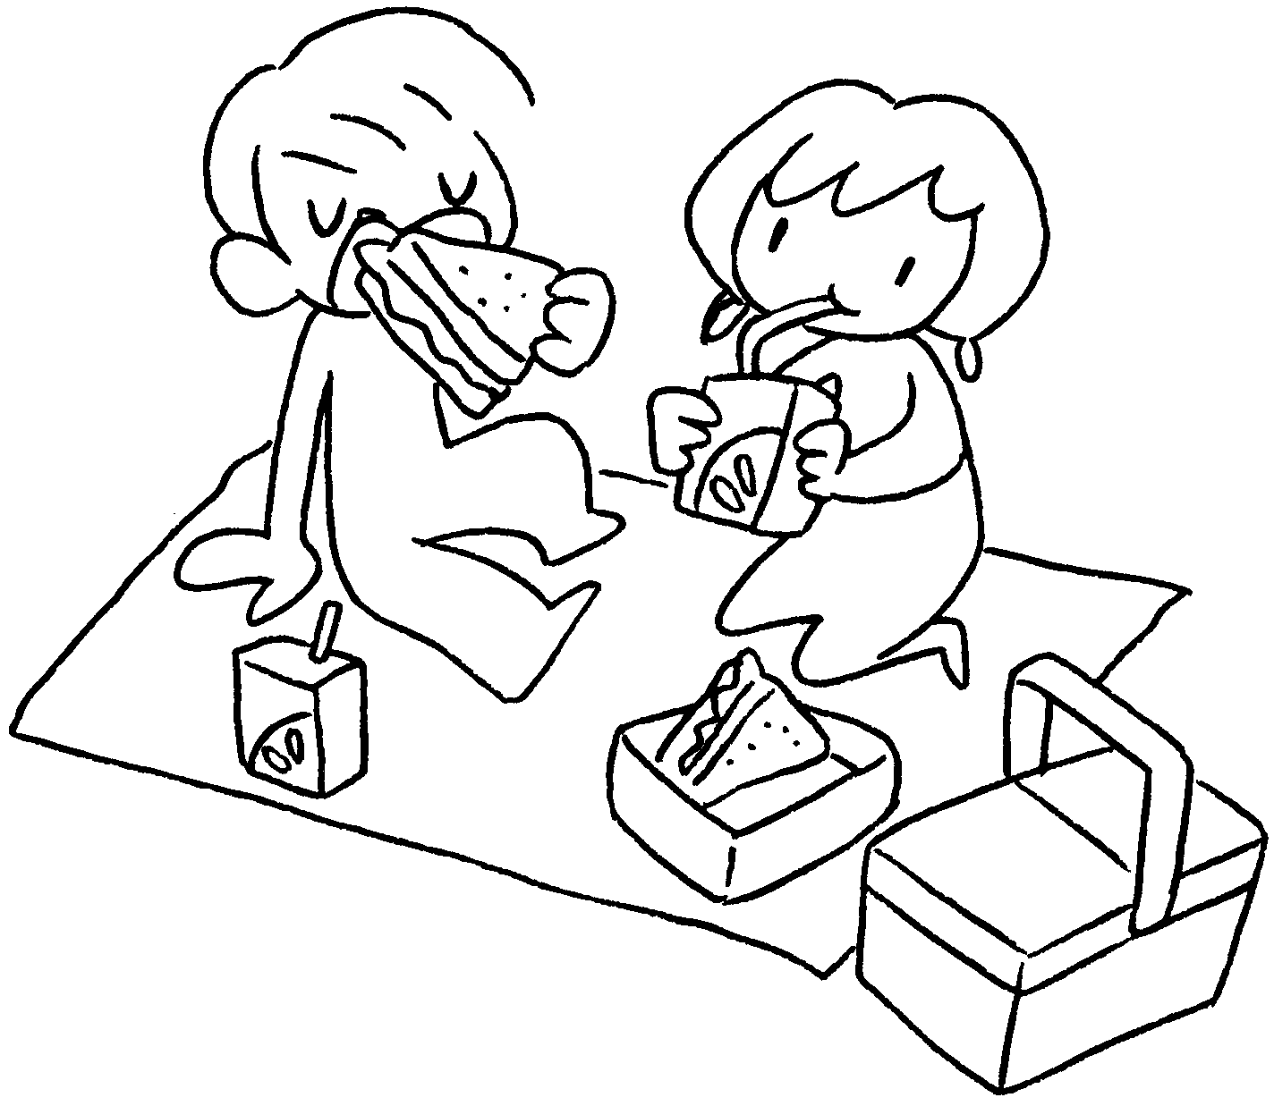 | 2 | 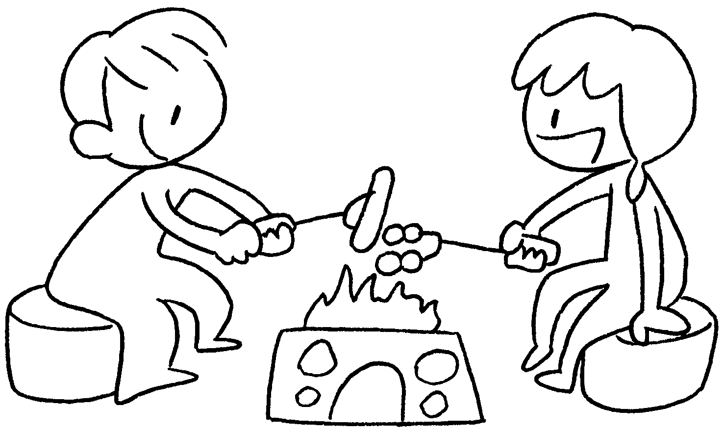 | 1 | have a p __ __ __ __ __
 |  |  |  | 2 | have a b __ __ __ __ __ __ __

3 | 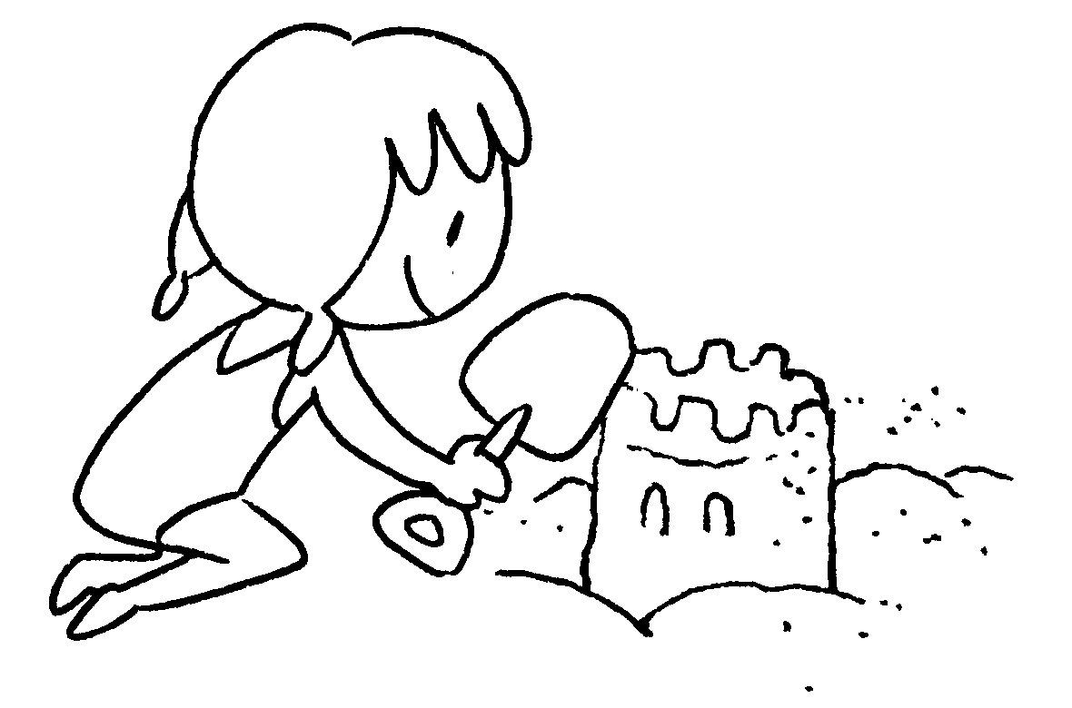 | 4 | 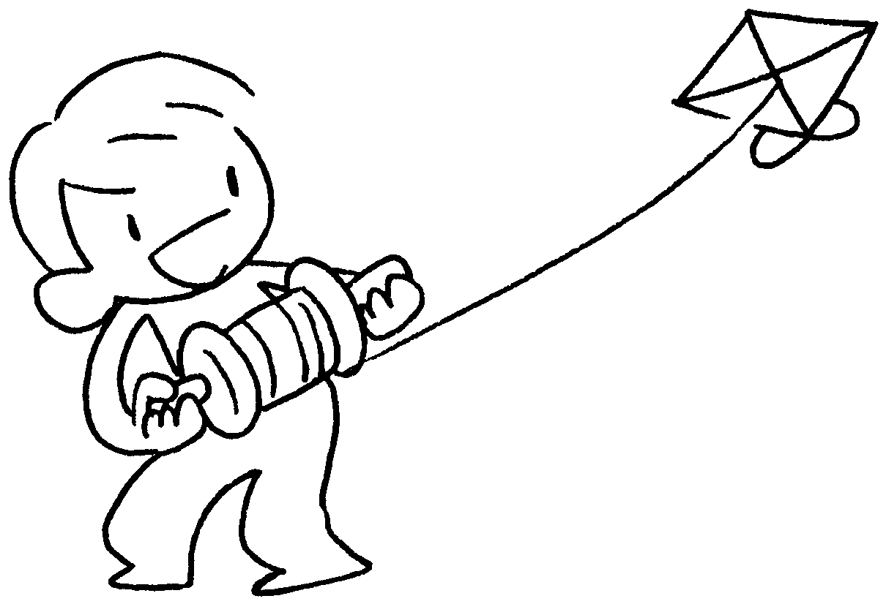 | 3 | build a s __ __ __ __ __ __ __ __ __
 |  |  |  | 4 | fly a k __ __ __

5 | 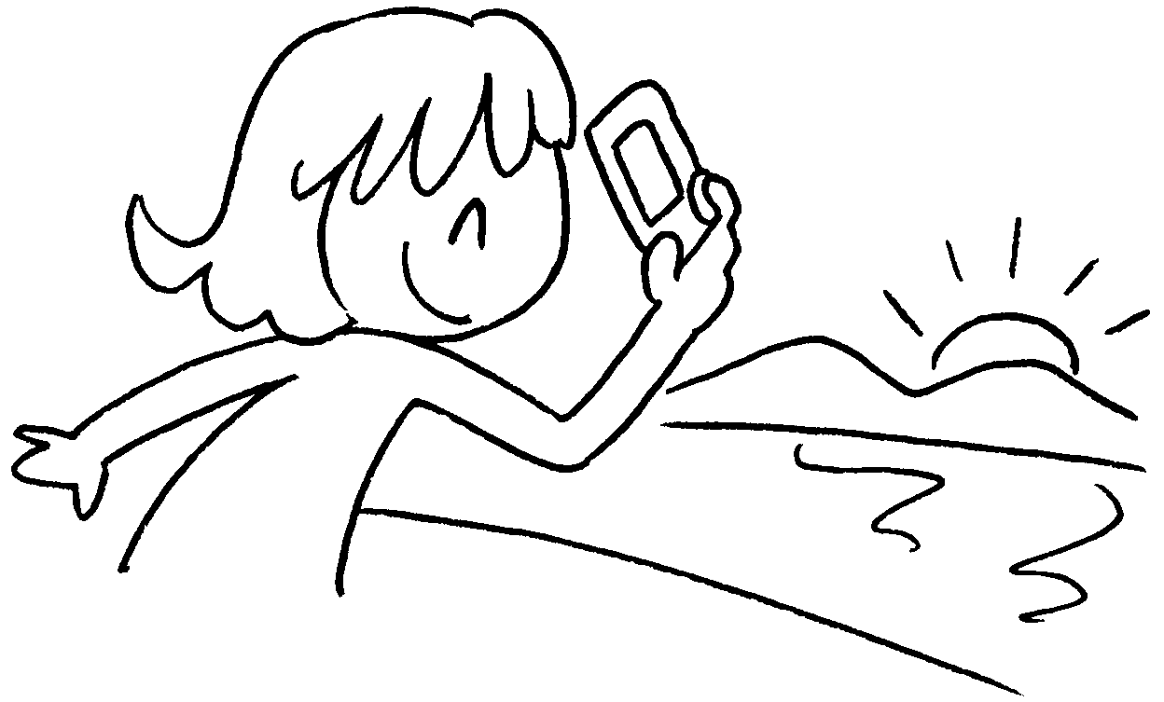 | 6 | 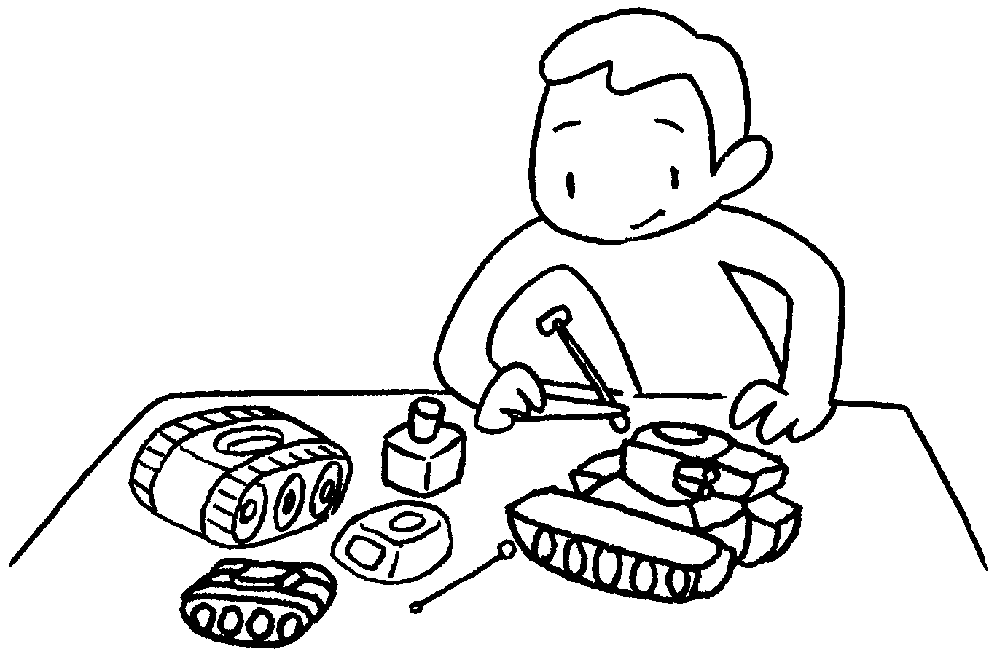 | 5 | take p __ __ __ __ s
 |  |  |  | 6 | make m __ __ __ __ __

7 | 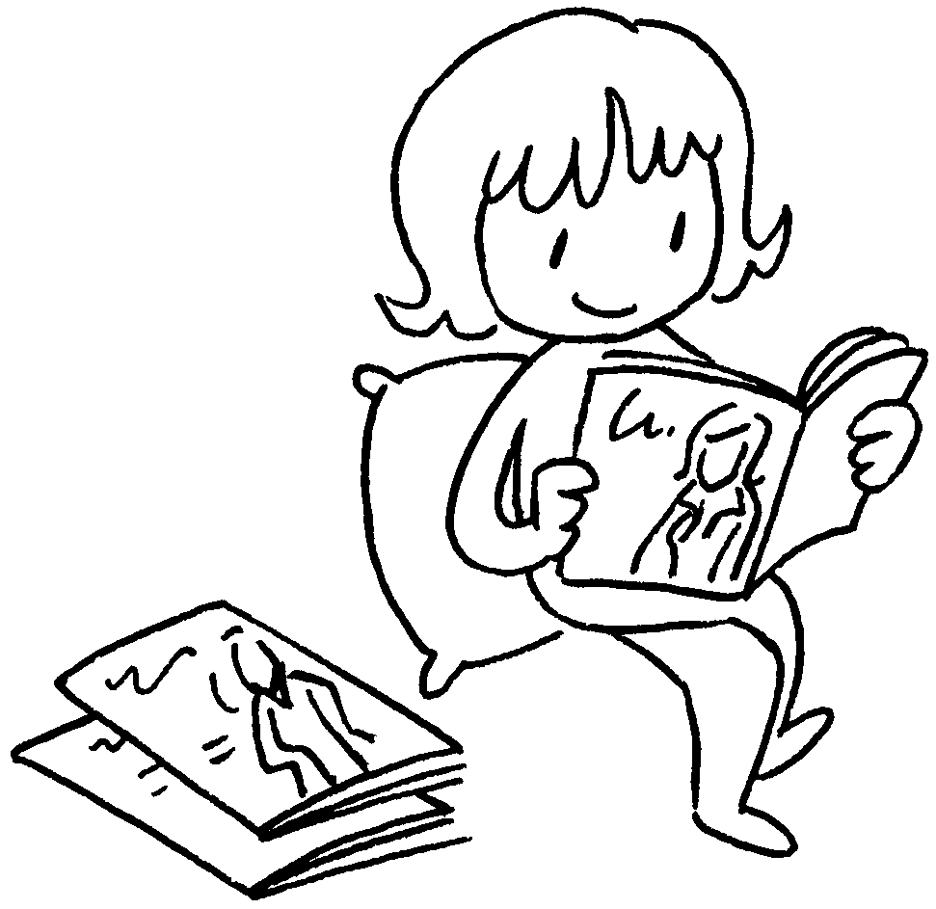 | 8 | 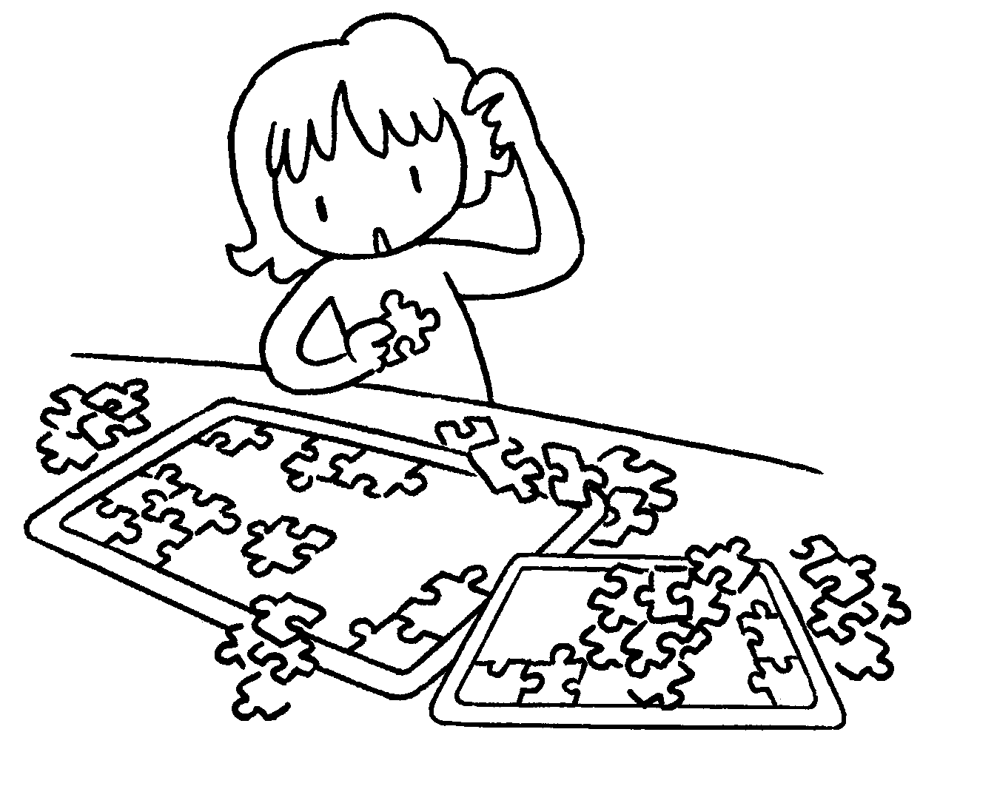 | 7 | read m __ __ __ __ __ __ __ __
 |  |  |  | 8 | do p __ __ __ __ __ __

9 | 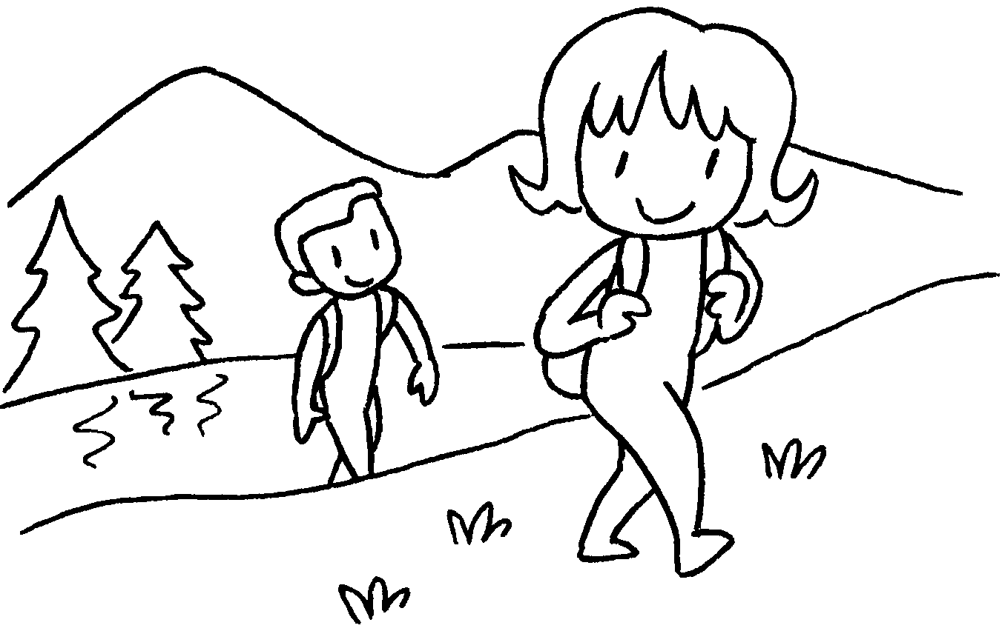 | 10 | 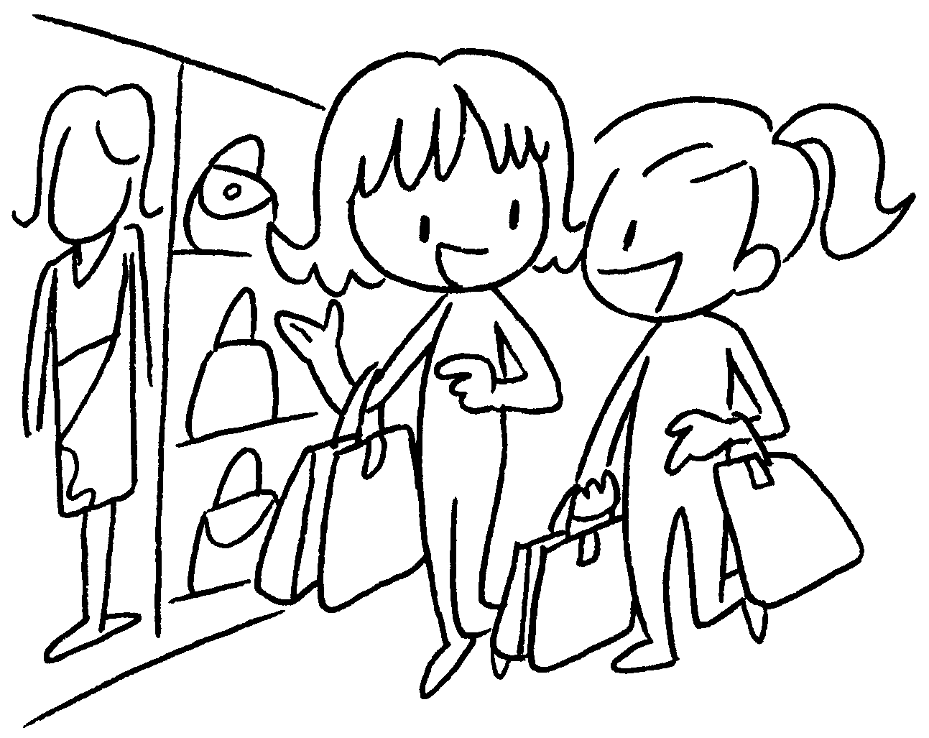 | 9 | go h __ __ __ __ __
 |  |  |  | 10 | go s __ __ __ __ __ __ __


Book 3B Chapter 6 Graded Worksheets
Worksheet 1⬇⬇
- p i c n i c
- b a r b e c u e
- s a n d c a s t l e
- k i t e
- p h o t o s
- m o d e l s
- m a g a z i n e s
- p u z z l e s
- h i k i n g
- s h o p p i n g

