Look and write.

build do fly go have make read take

1 |  | 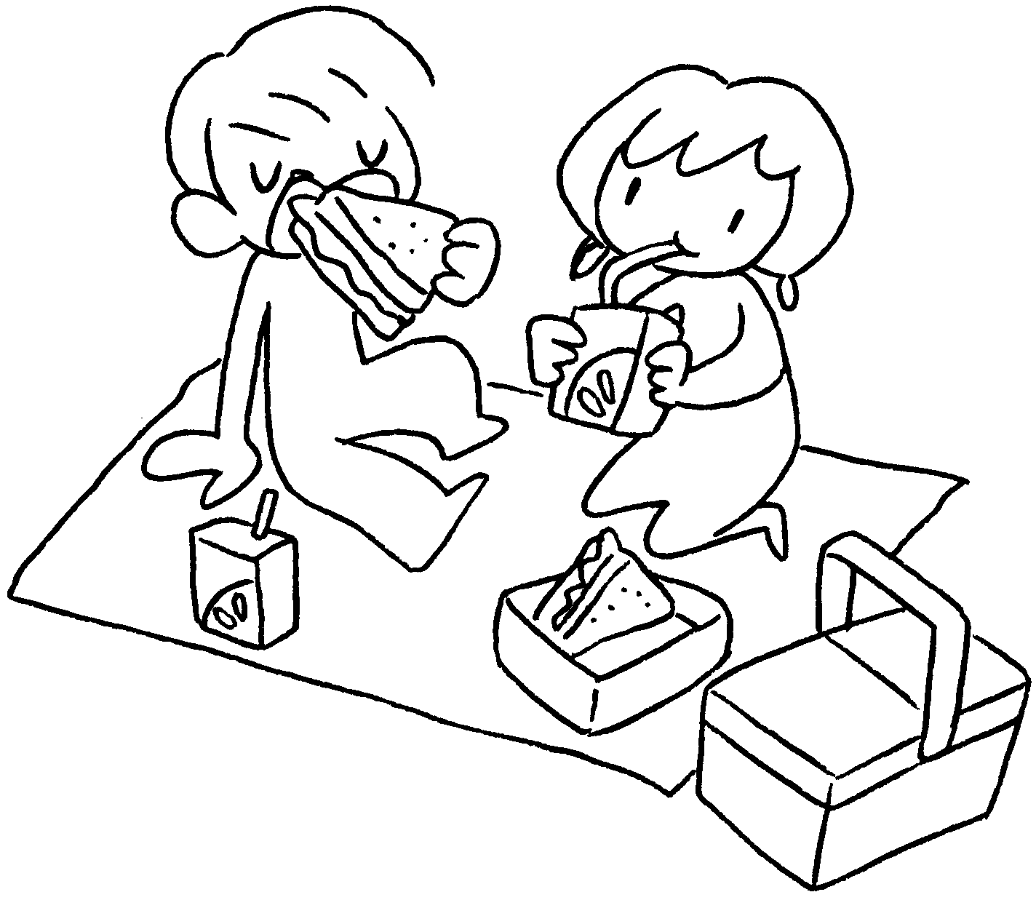 |  | 2 |  | 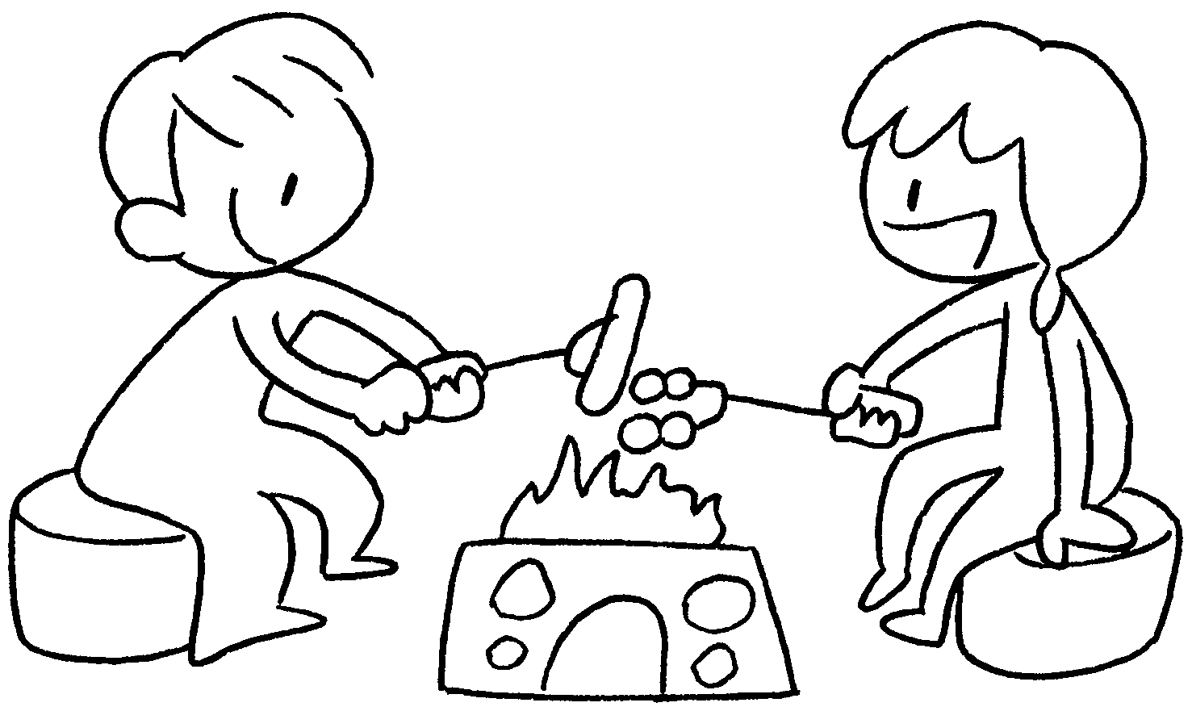 |  | 1 | have a p
 |  |  |  |  |  |  |  | 2 | a b
3 |  | 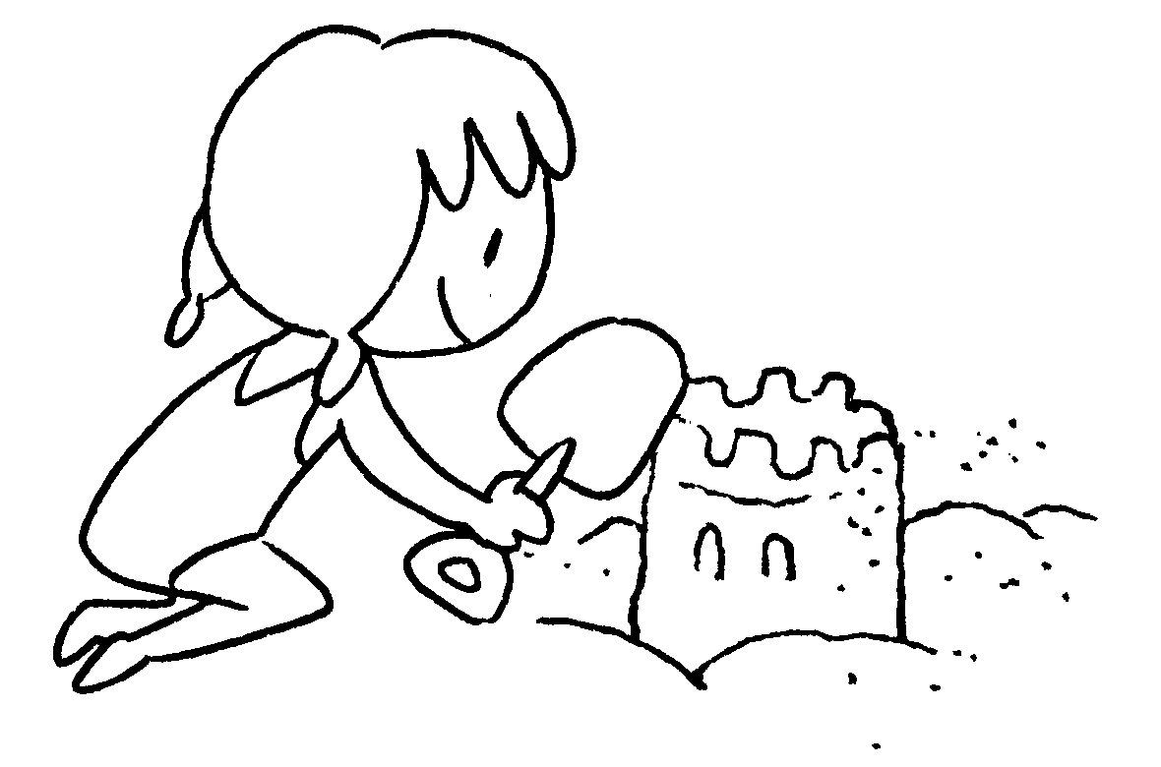 |  | 4 |  | 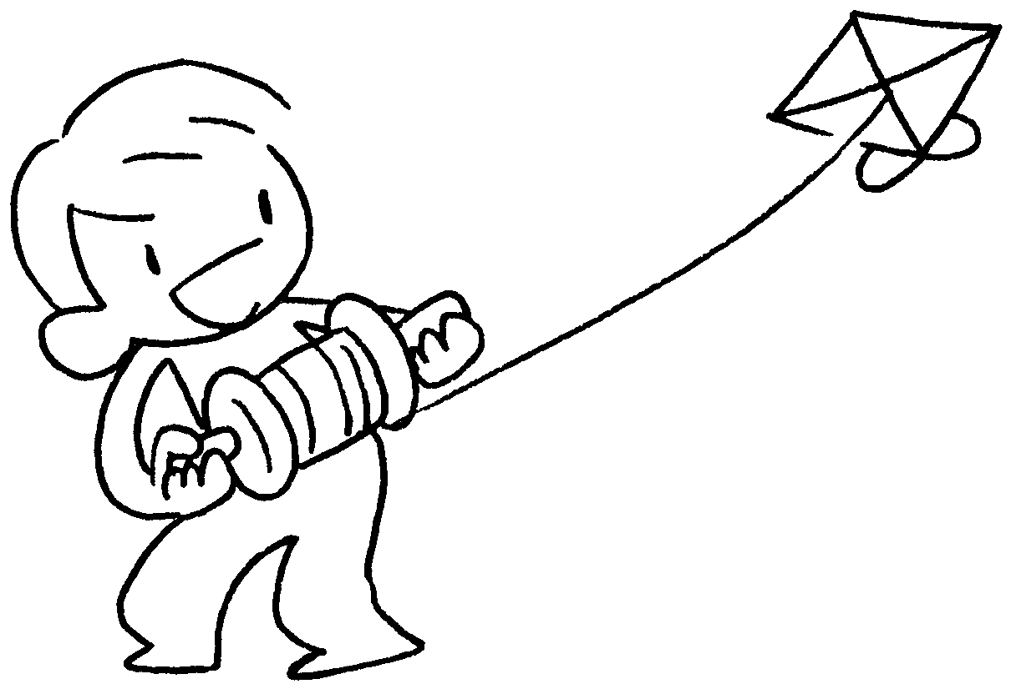 |  | 3 | a s
 |  |  |  |  |  |  |  | 4 | a
5 | 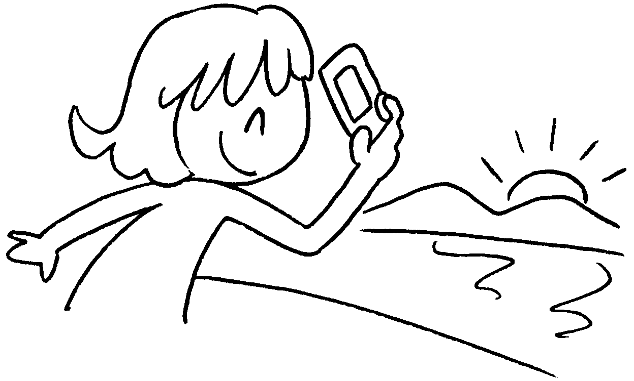 |  | 6 |  | 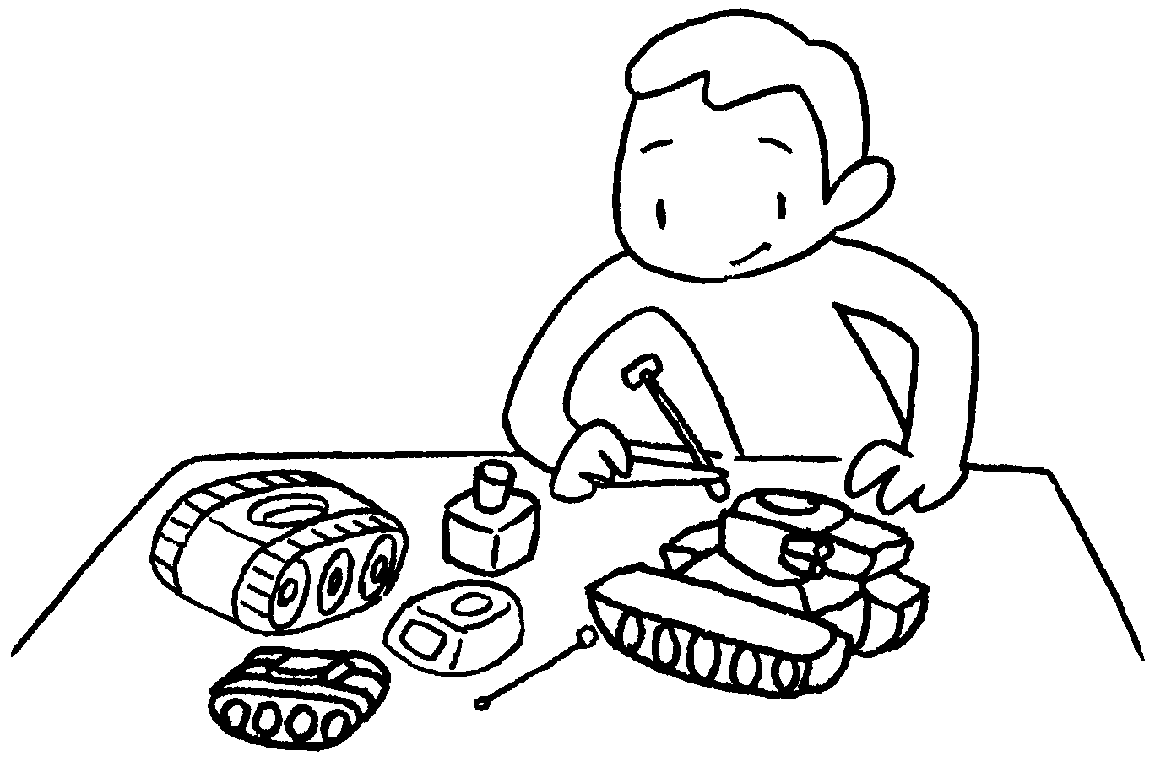 |  | 5
 |  |  |  |  |  |  | 6
7 | 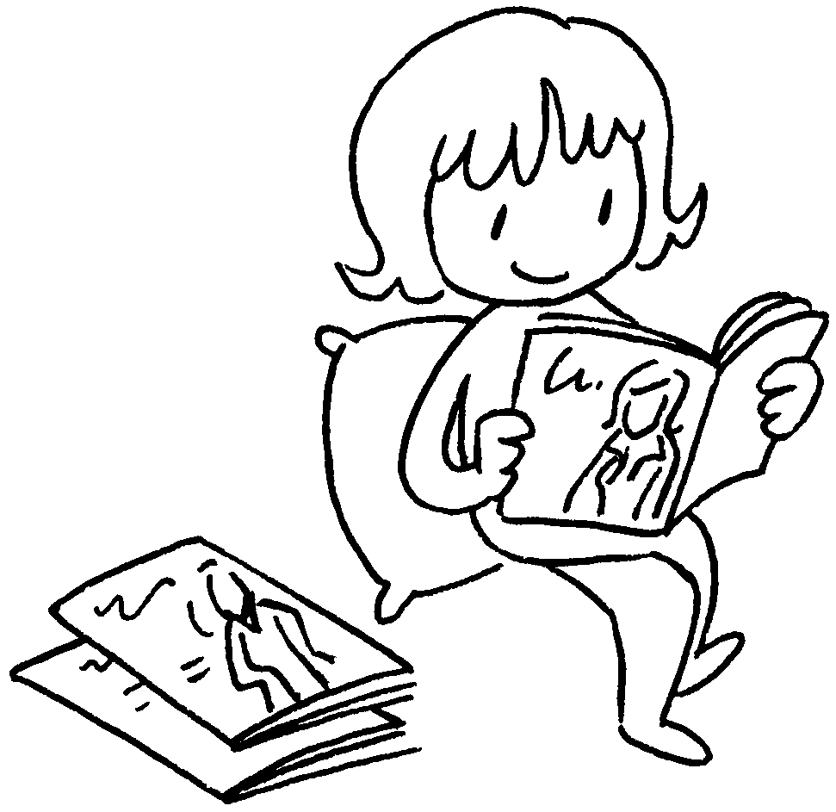 |  | 8 |  | 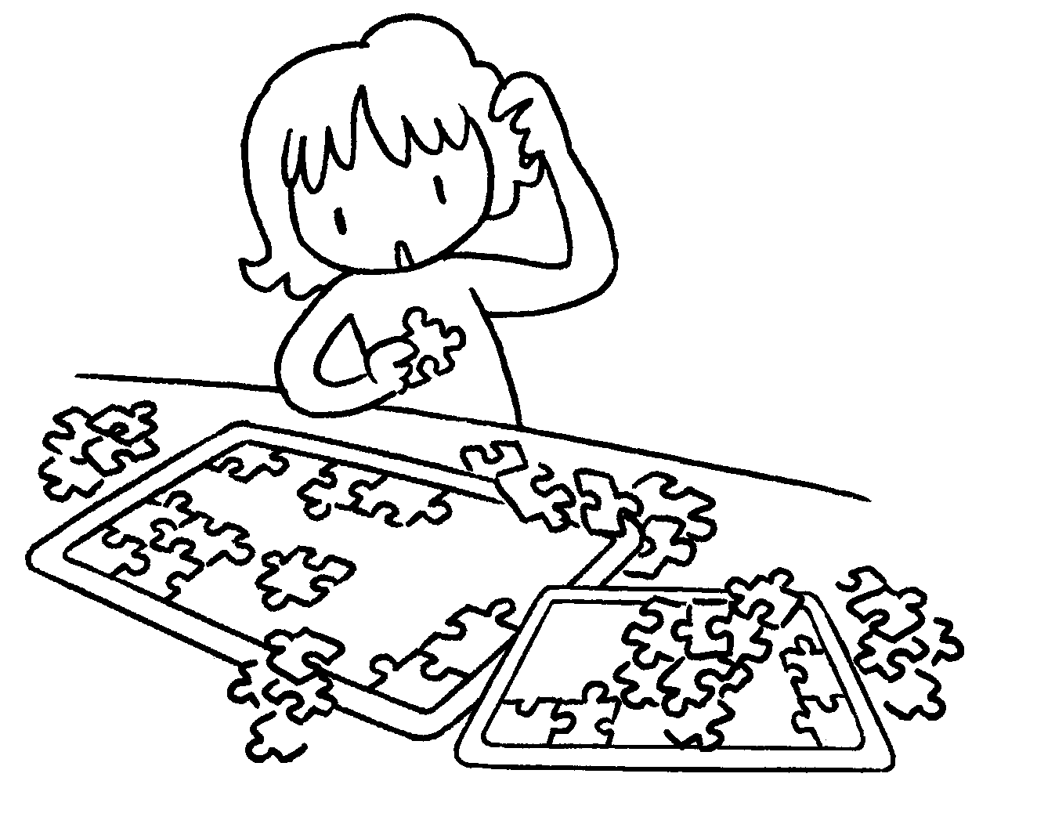 |  | 7
 |  |  |  |  |  |  | 8
9 | 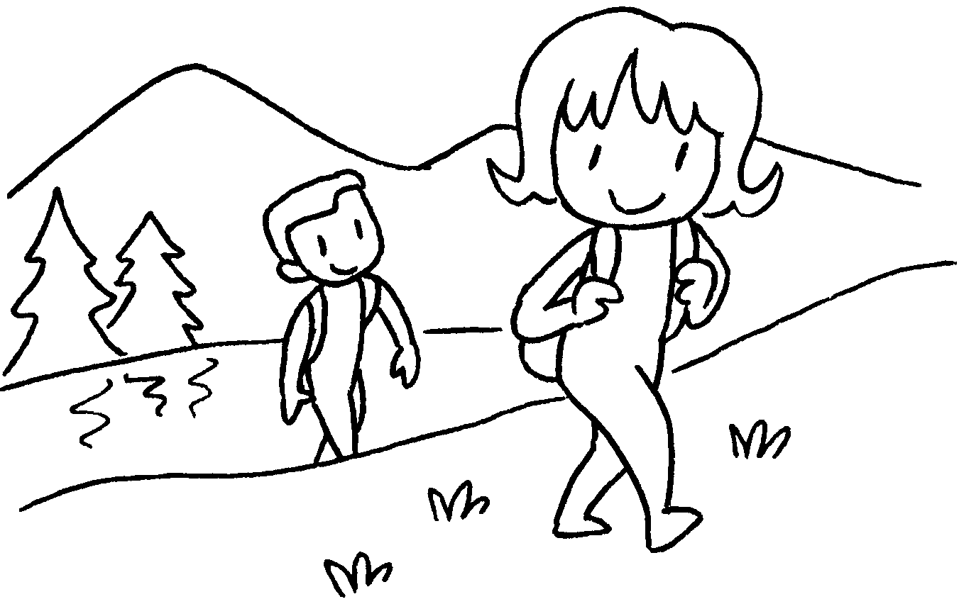 |  | 10 |  | 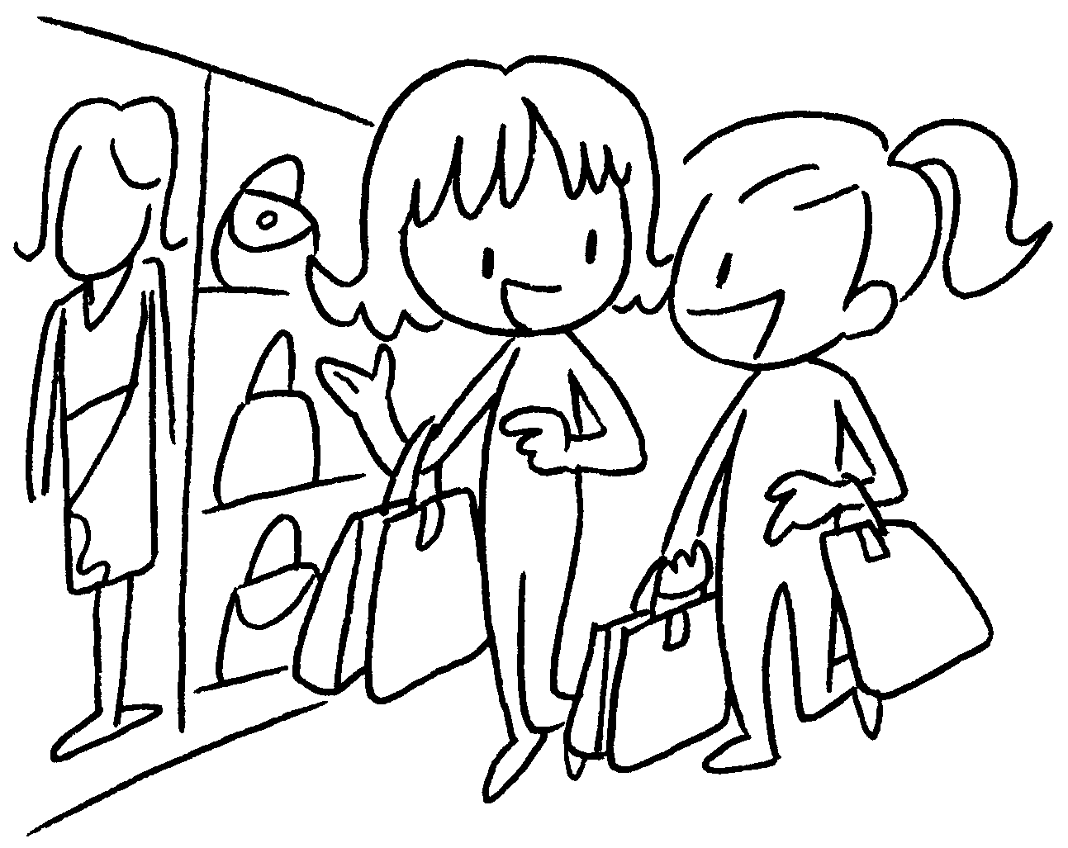 |  | 9
 |  |  |  |  |  |  | 10


Book 3B Chapter 6 Graded Worksheets
Worksheet 1⬇⬇⬇
- picnic
- have barbecue
- build sandcastle
- fly kite
- take photos
- make models
- read magazines
- do puzzles
- go hiking
- go shopping

