Finish the questions and answers.
Did
Yes
No
did
didn’t
1 | 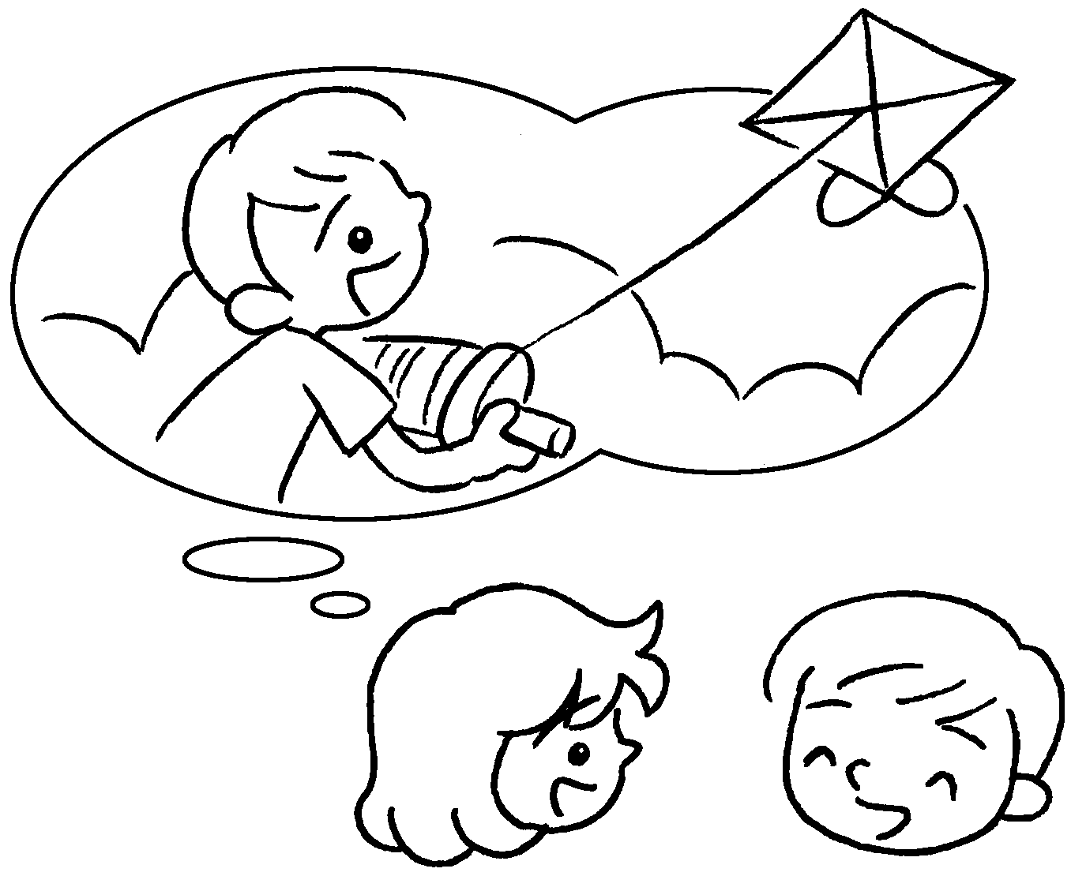  ✓  B |  | A : Did you fly a kite?  B : , I .
2 | 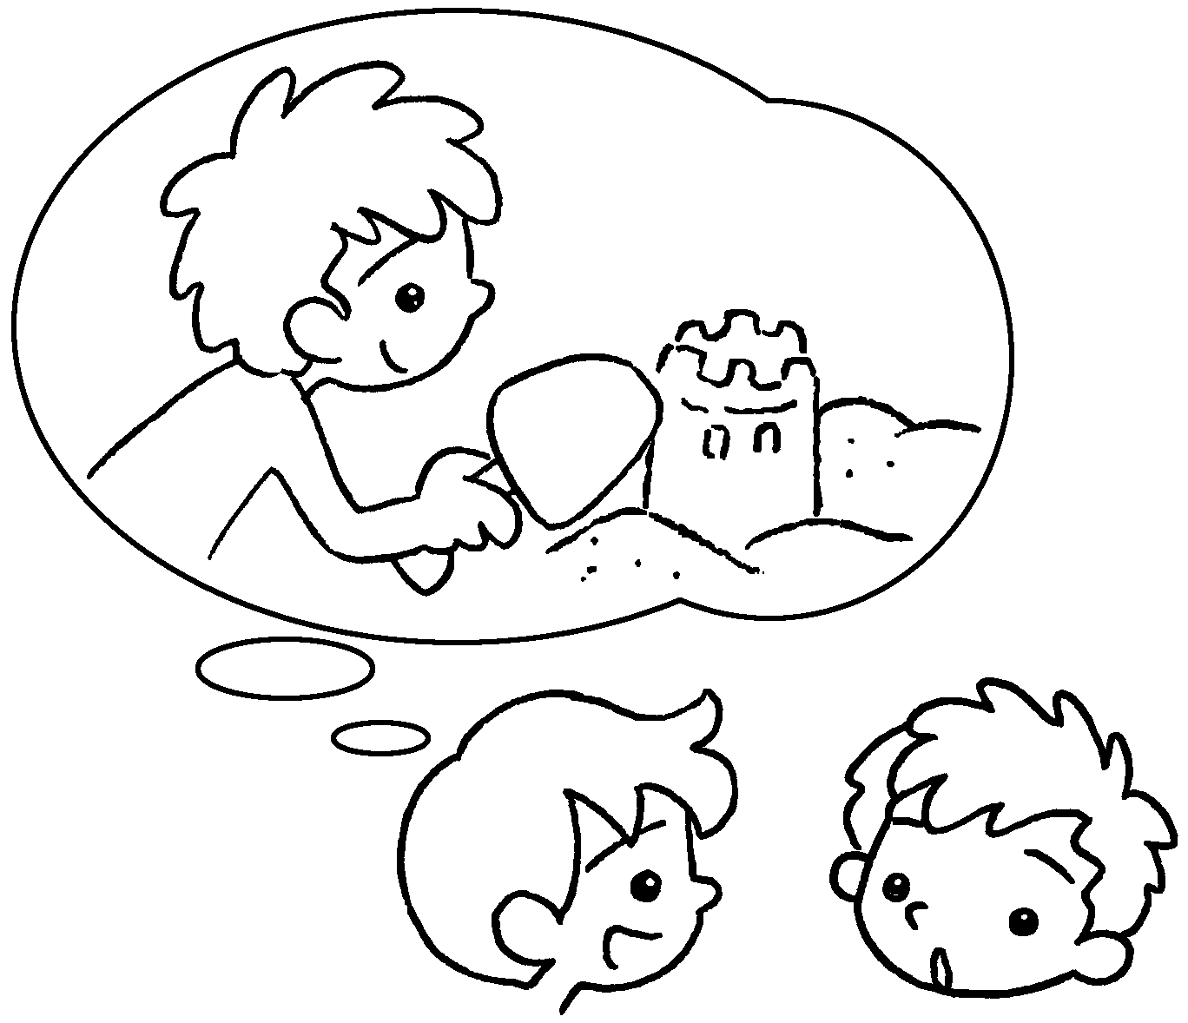  ✗ |  | A : Did you build a sandcastle?  B : , I .
3 | 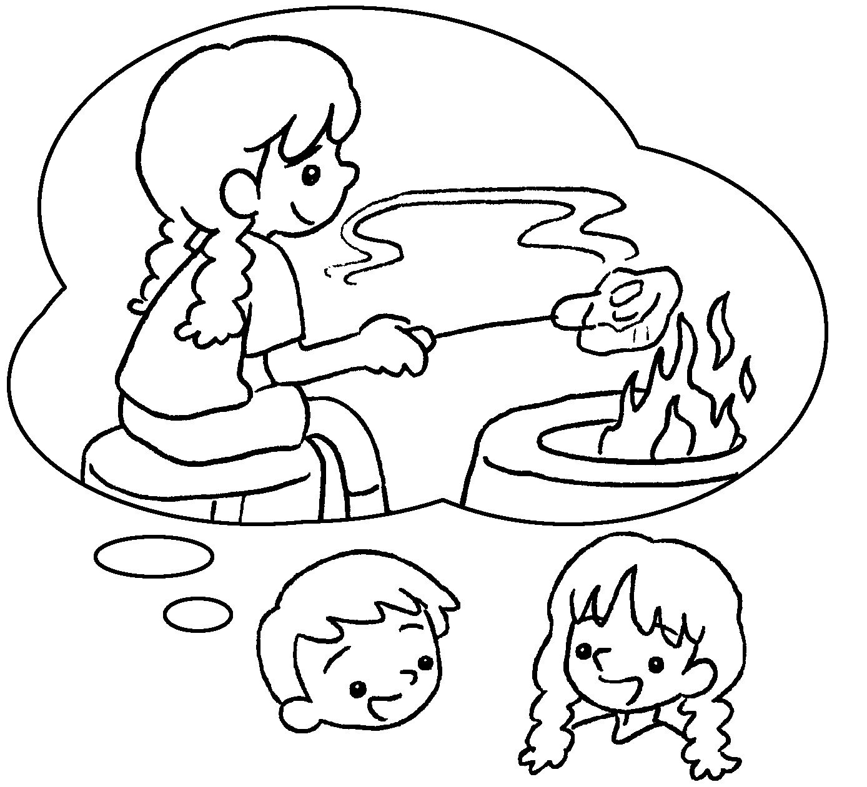  ✓  A |  | A : you  ( have ) a barbecue?  B : Yes, I did.
4 | 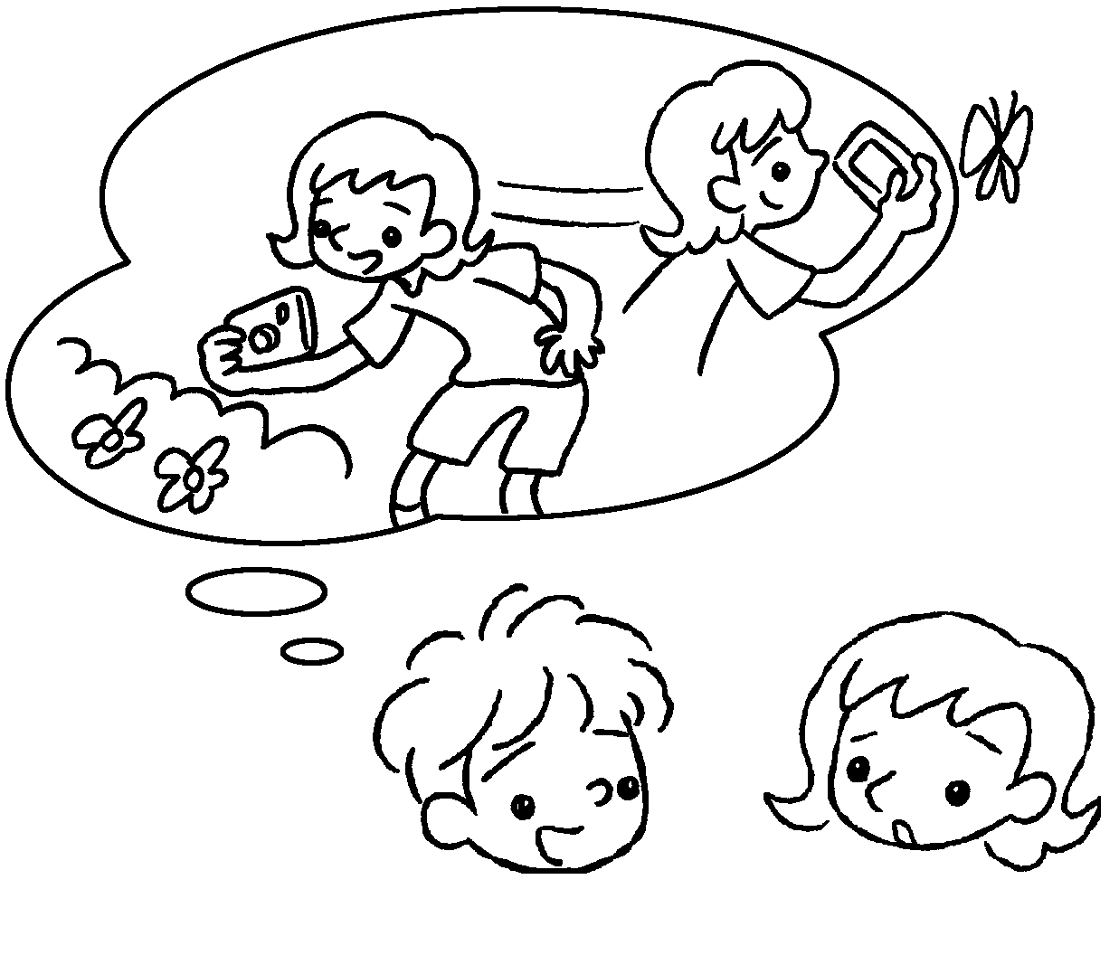  ✗  A  A  A  B  B  B |  | A : you  ( take ) photos?  B : , I .


Book 3B Chapter 6 Graded Worksheets
Worksheet 2⬇
1 Yes did
2 No didn’t
3 Did have
4 Did take
No didn’t

