Finish the questions and answers. Use the simple past tense.

1 | 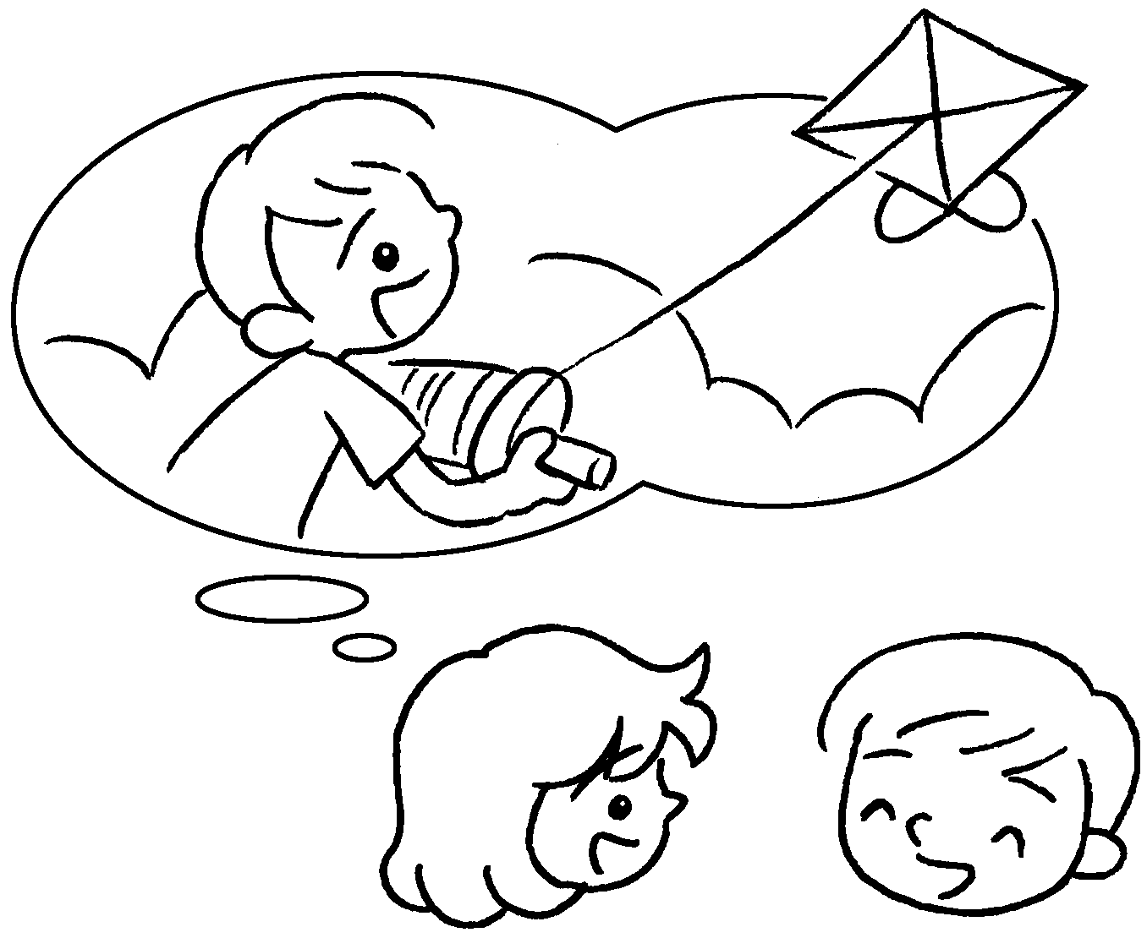  ✓  B |  | A : Did you a kite?  B : , I did.
2 | 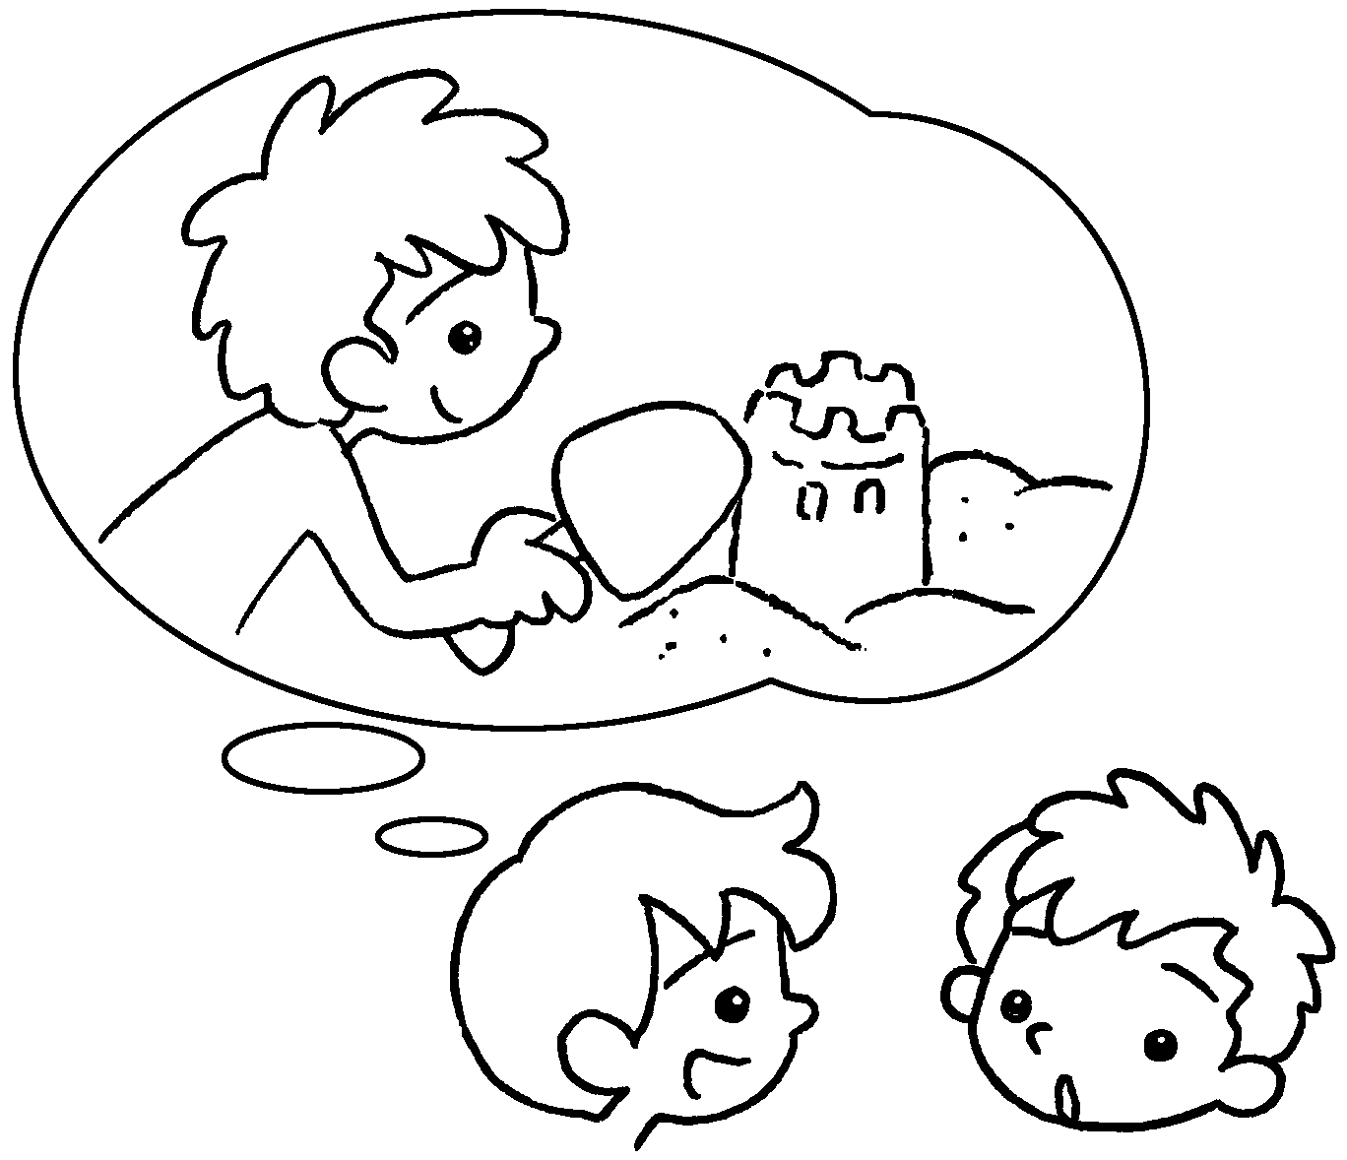  ✗ |  | A : Did you a ?  B : No, I .
3 | 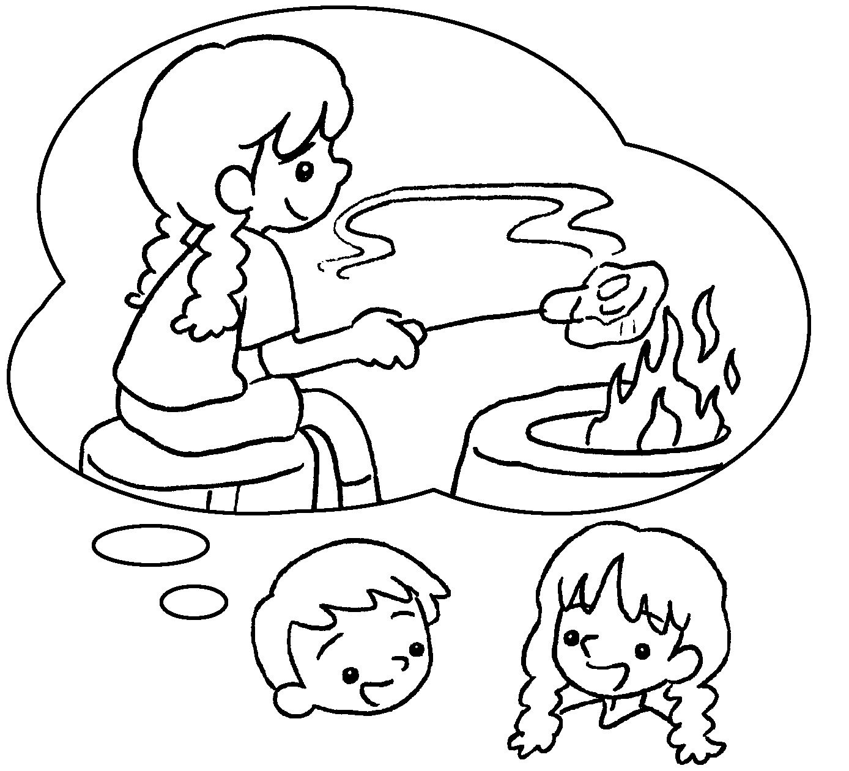  ✓  A |  | A : you  a ?  B :
4 | 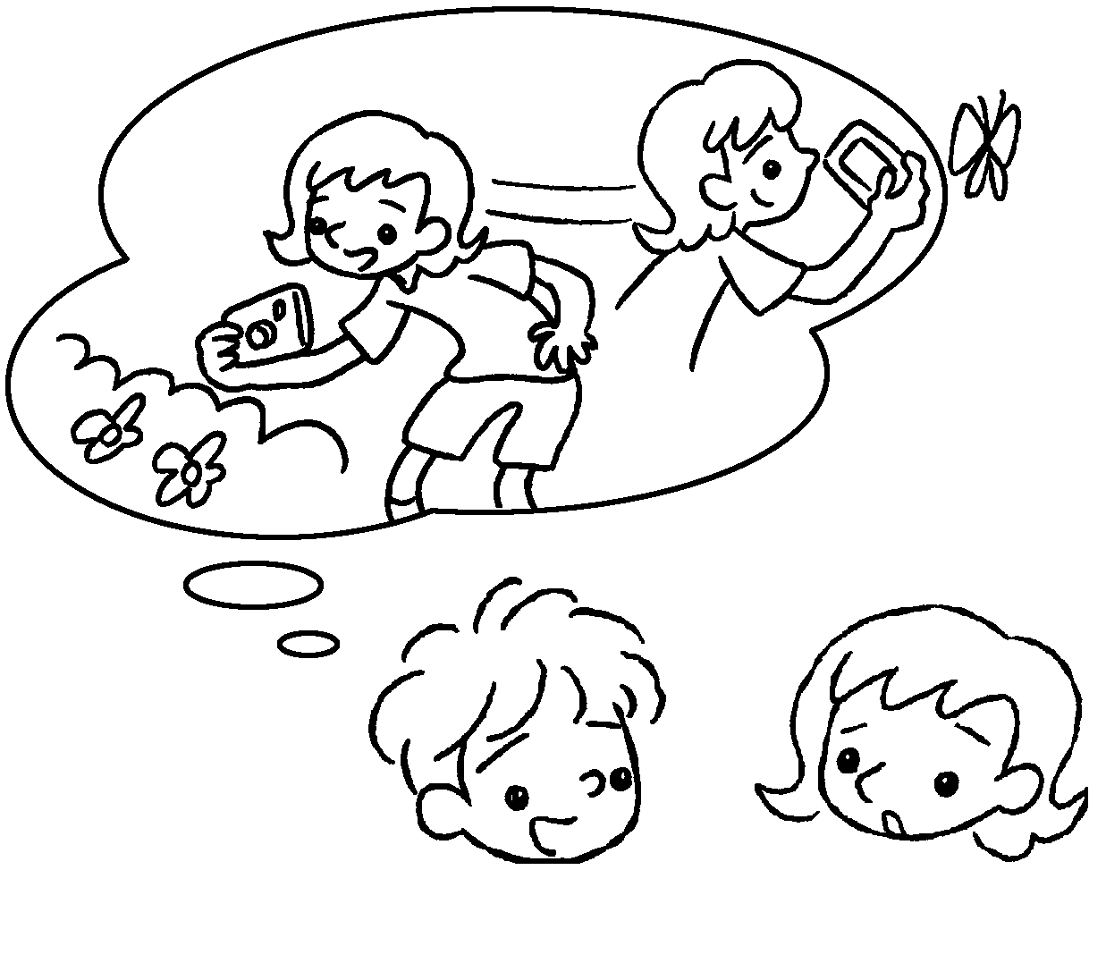  ✗  A  A  A  B  B  B |  | A :  photos?  B :


Book 3B Chapter 6 Graded Worksheets
Worksheet 2⬇⬇⬇
- fly
Yes
2 build sandcastle
didn’t
3 Did have barbecue
Yes, I did.
- Did you take
No, I didn’t.

