Choose and write.
Where
What
did
go
do
1 | 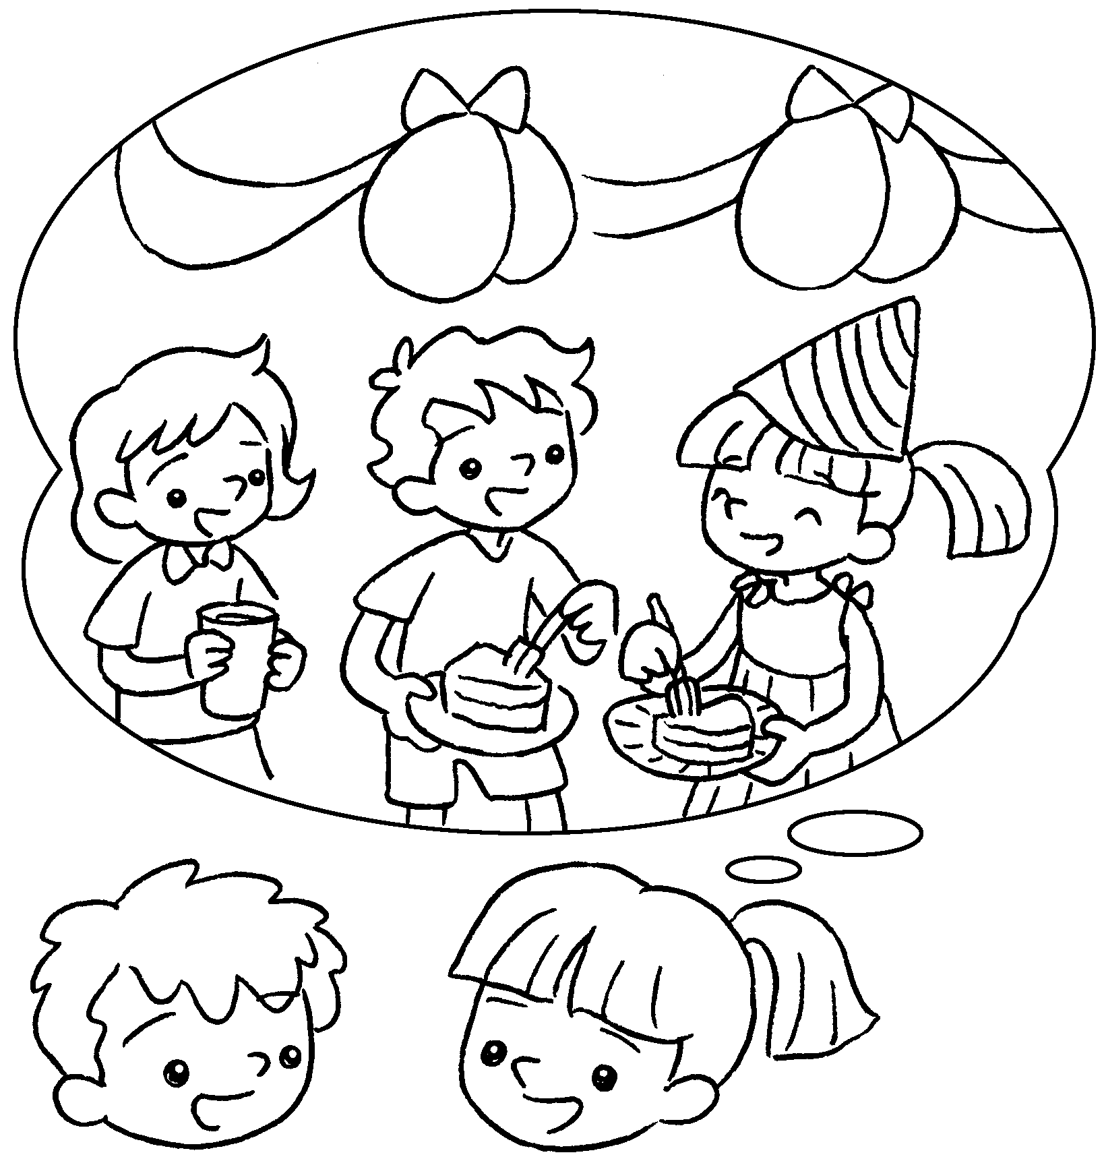  B |  | A : did you do on  your birthday?  B : I had a birthday party.
2  A  B | 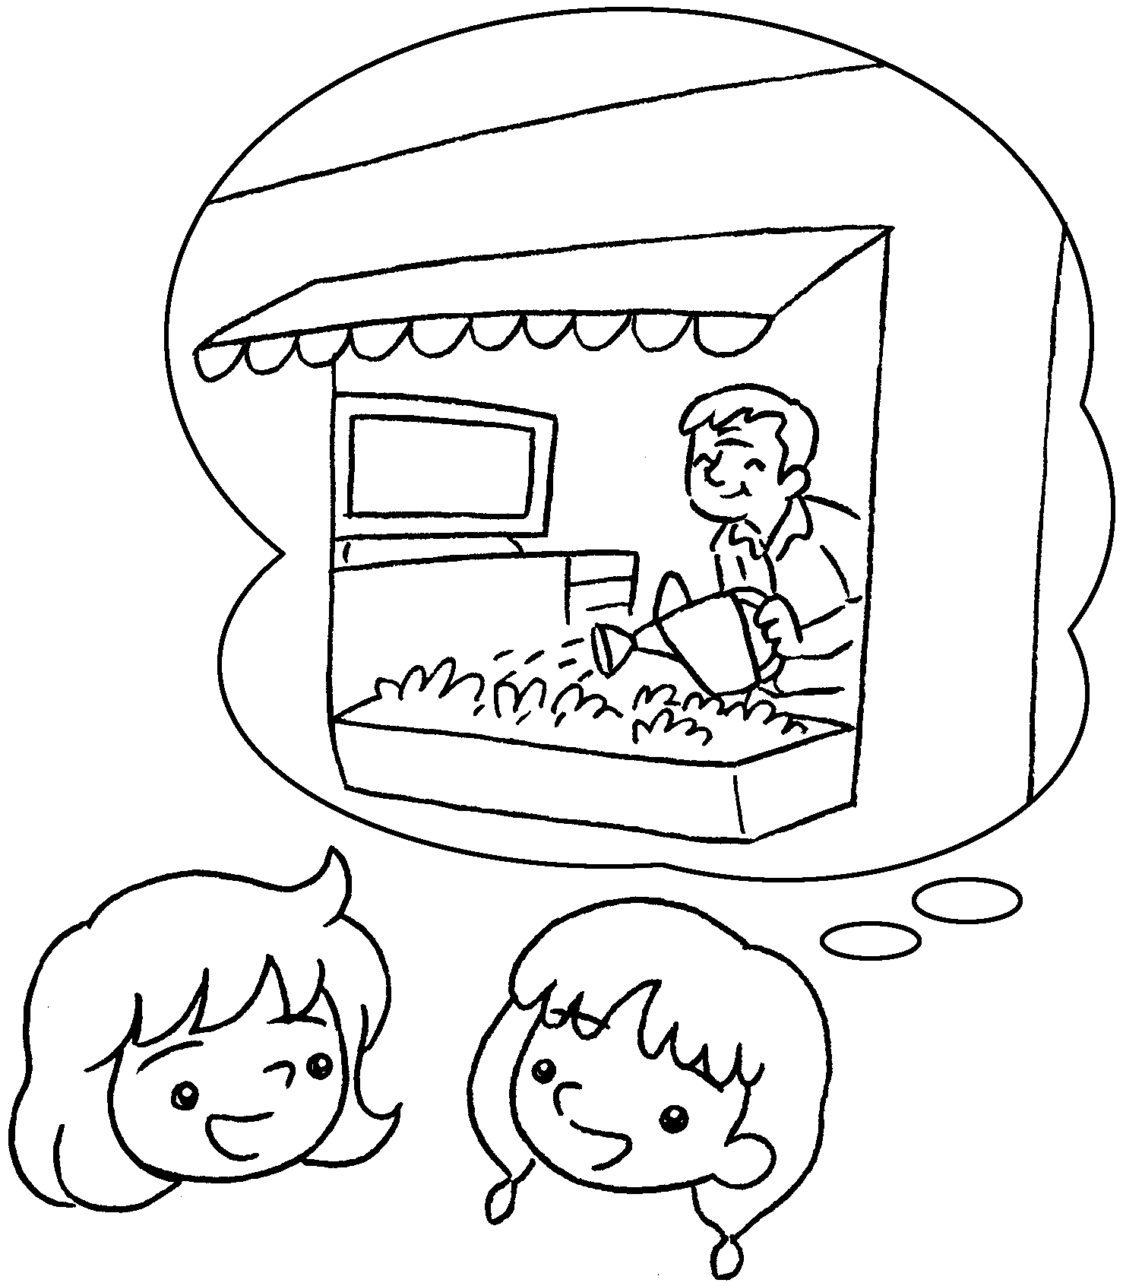 |  | A : did you go at the  weekend?  B : I went to Grandpa’s home.
3  A  B | 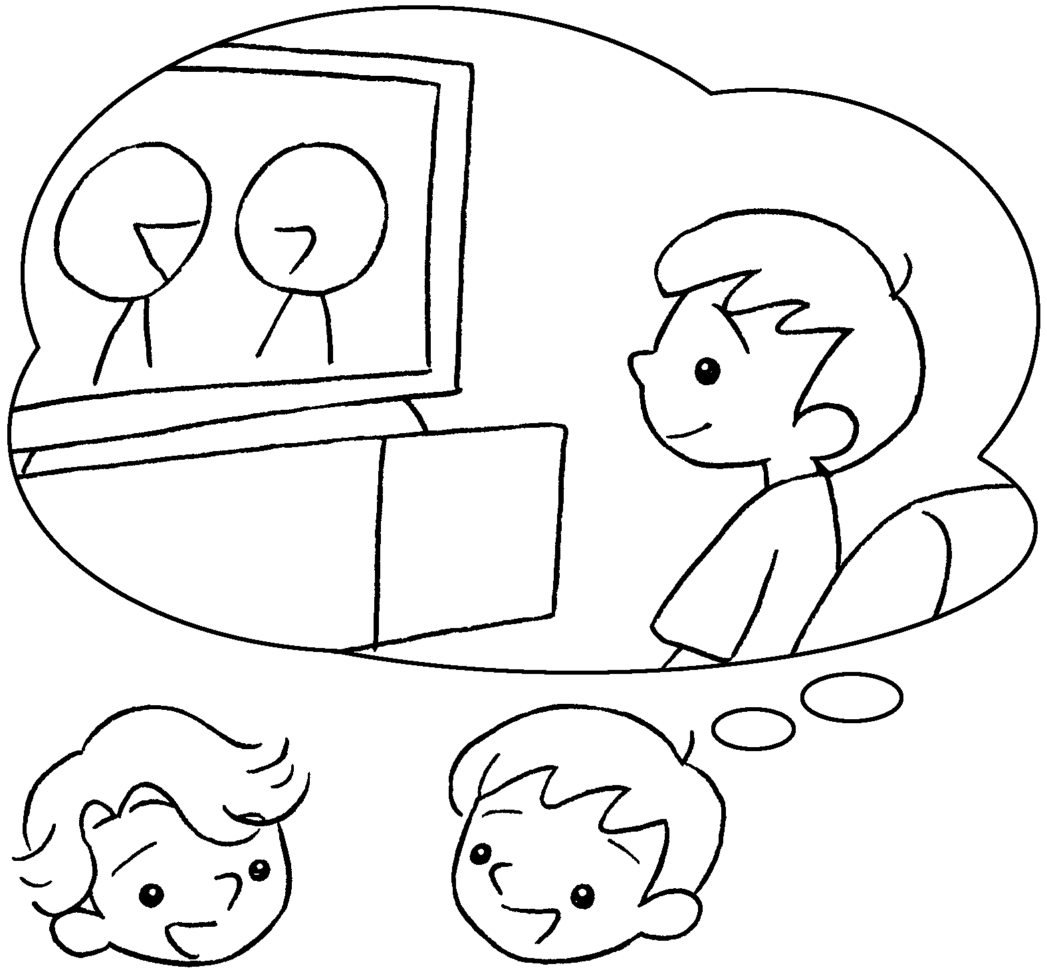 |  | A : you  last night?  B : I watched TV.
4  A  B | 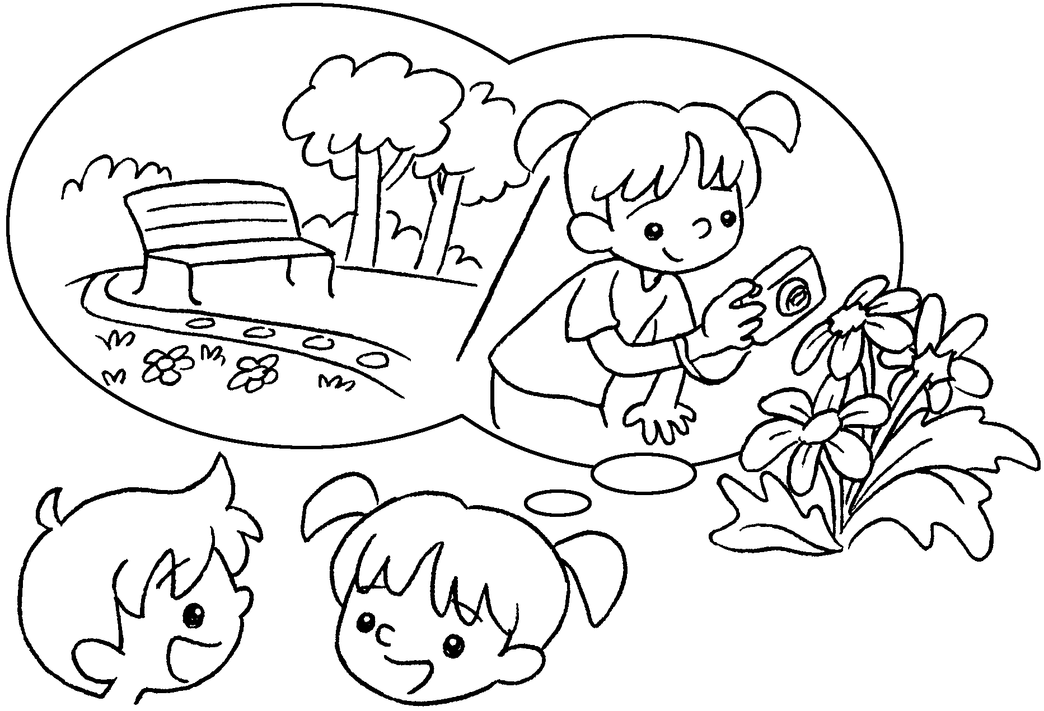  A |  | A : you  yesterday?  B : I went to the park.  A : you  there?  B : I took some photos.


Book 3B Chapter 6 Graded Worksheets
Worksheet 3⬇
- What
- Where
- What did do
- Where did go
What did do

