Finish the questions and answers. Use the simple past tense.
Where
What

1 | 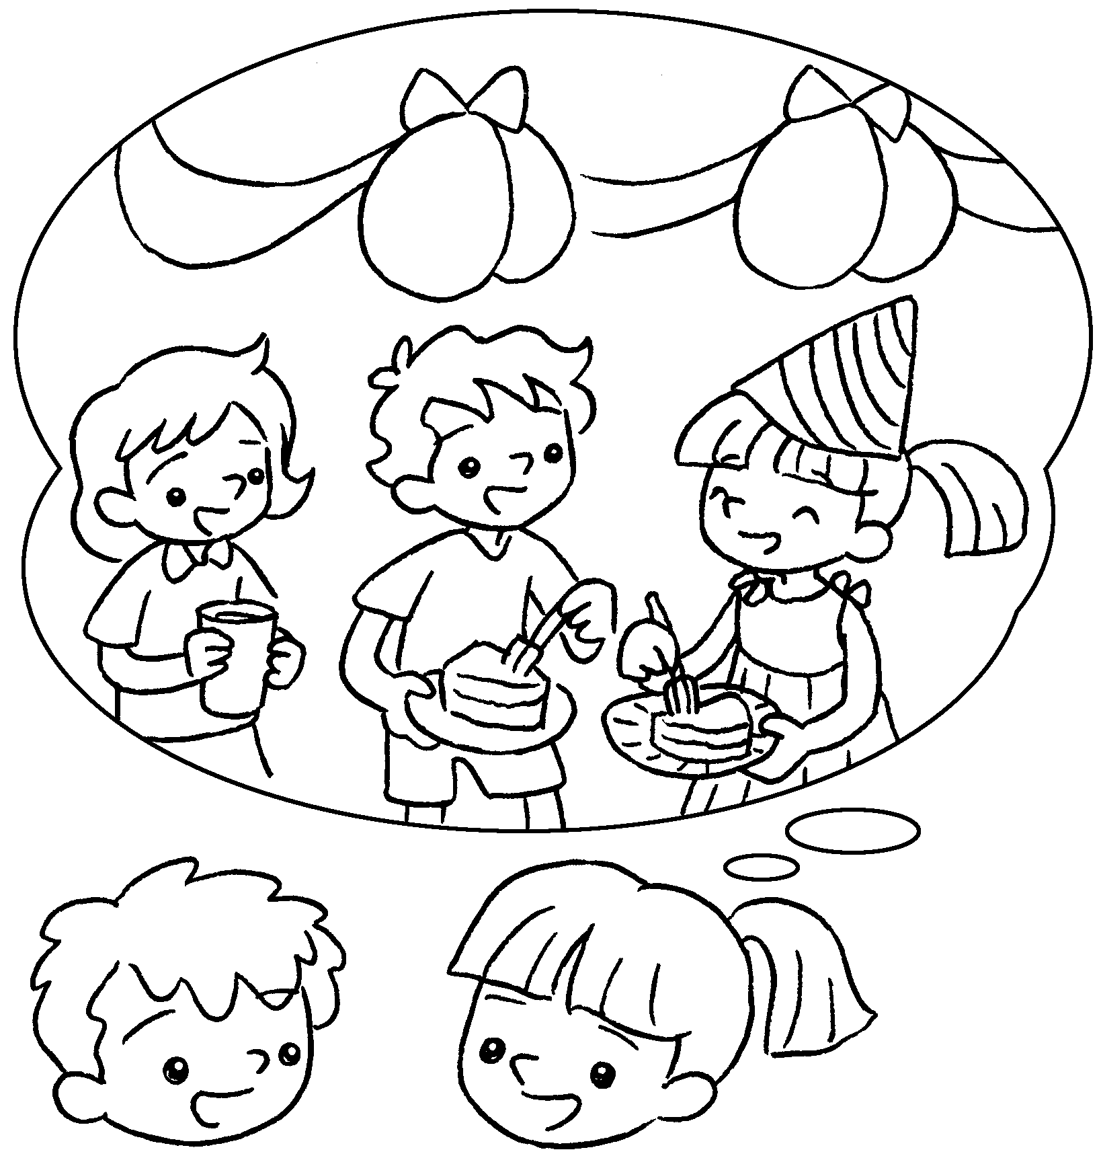  B |  | A : did you do on  your birthday?  B : I a birthday party.
2  A  B | 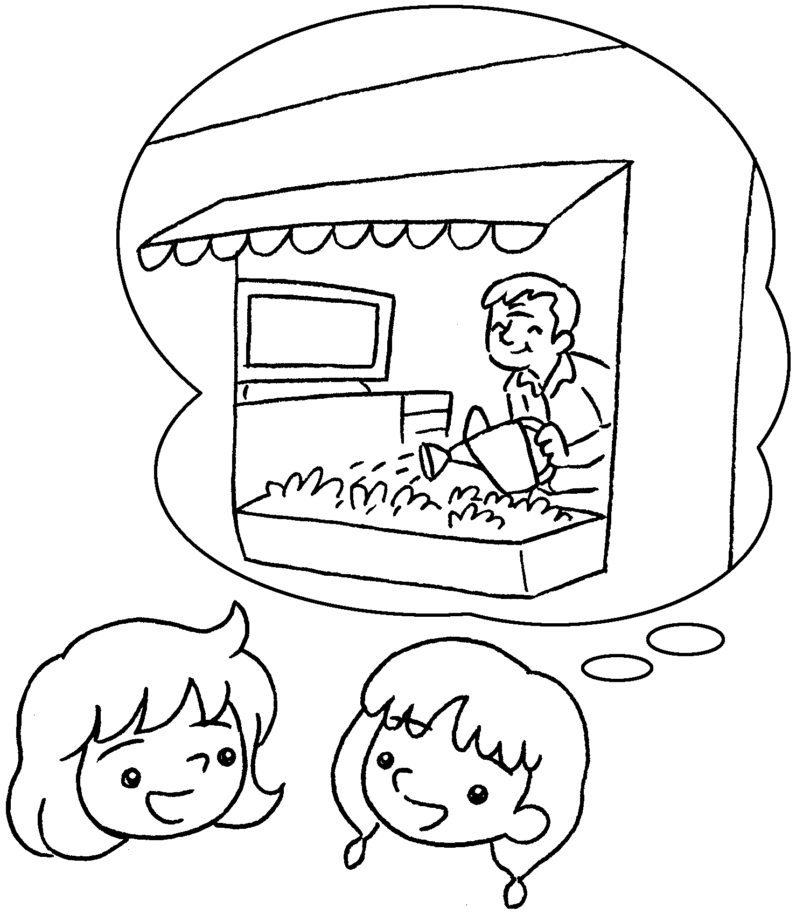 |  | A : did you go at the  weekend?  B : I to Grandpa’s home.
3  A  B | 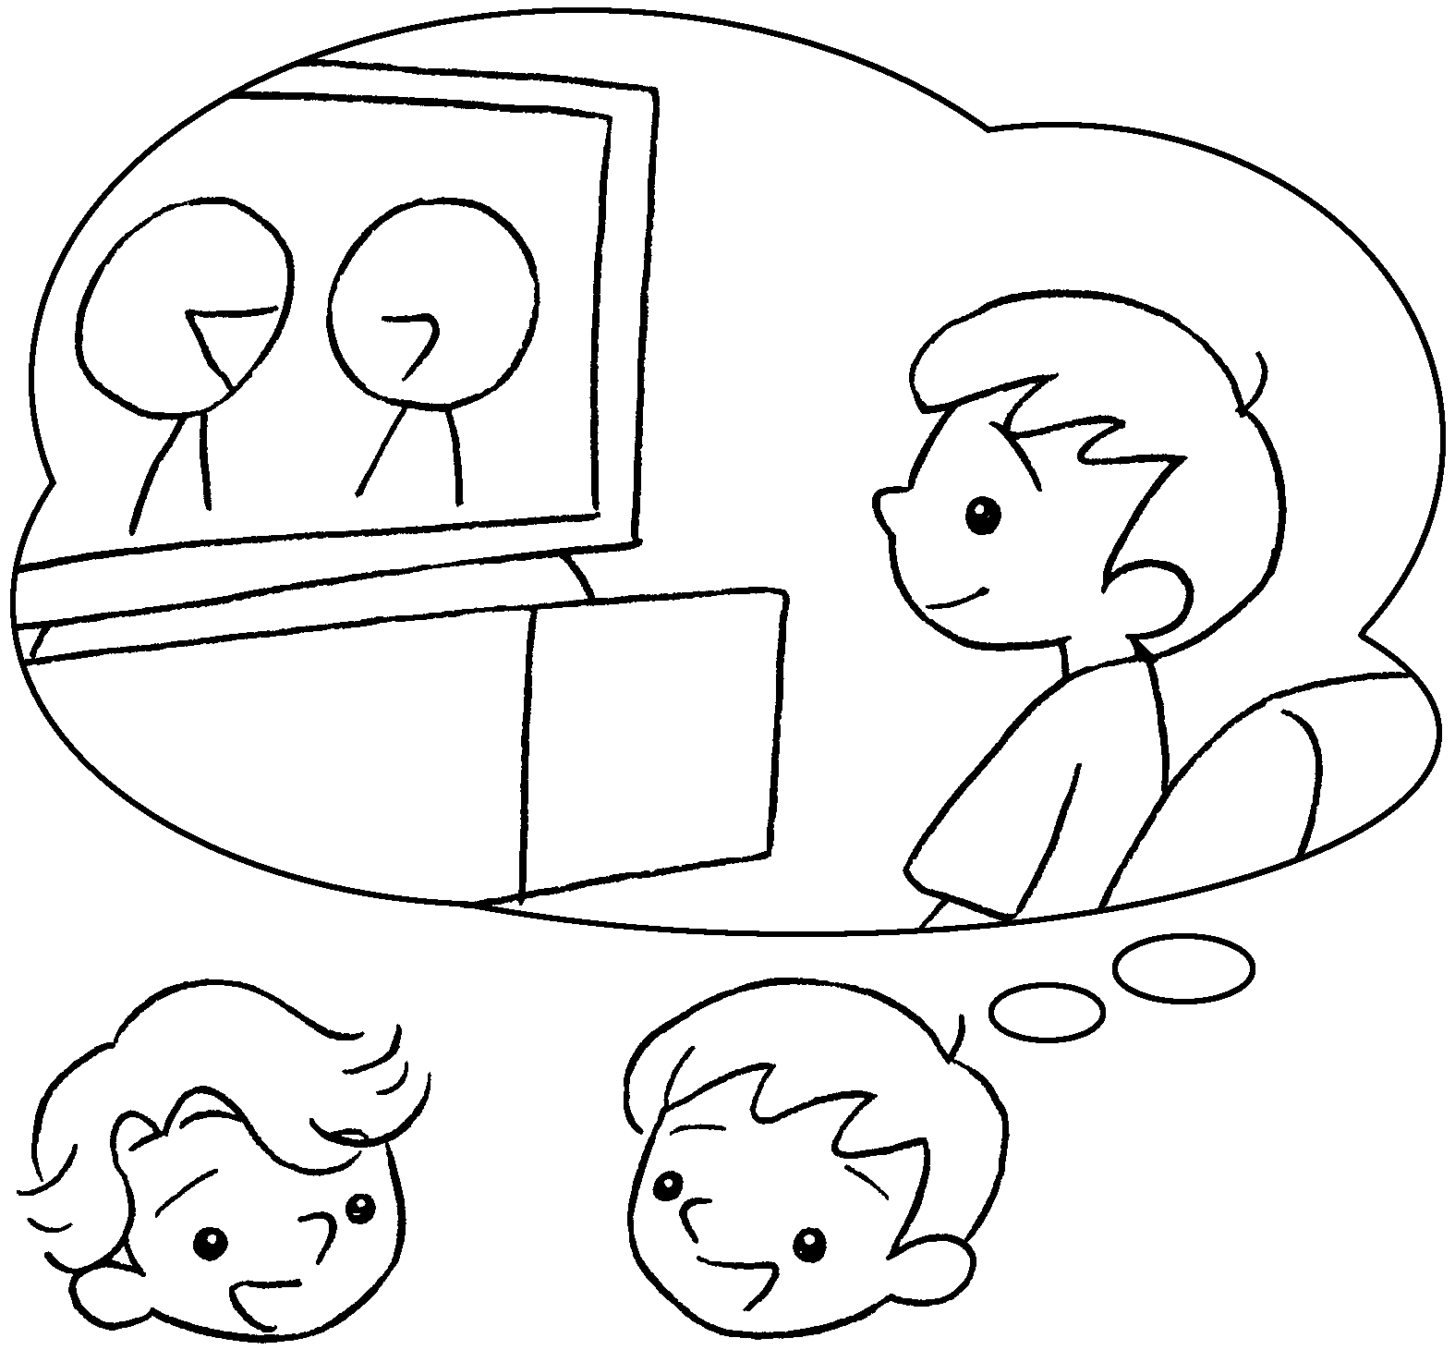 |  | A : you  last night?  B : I TV.
4  A  B | 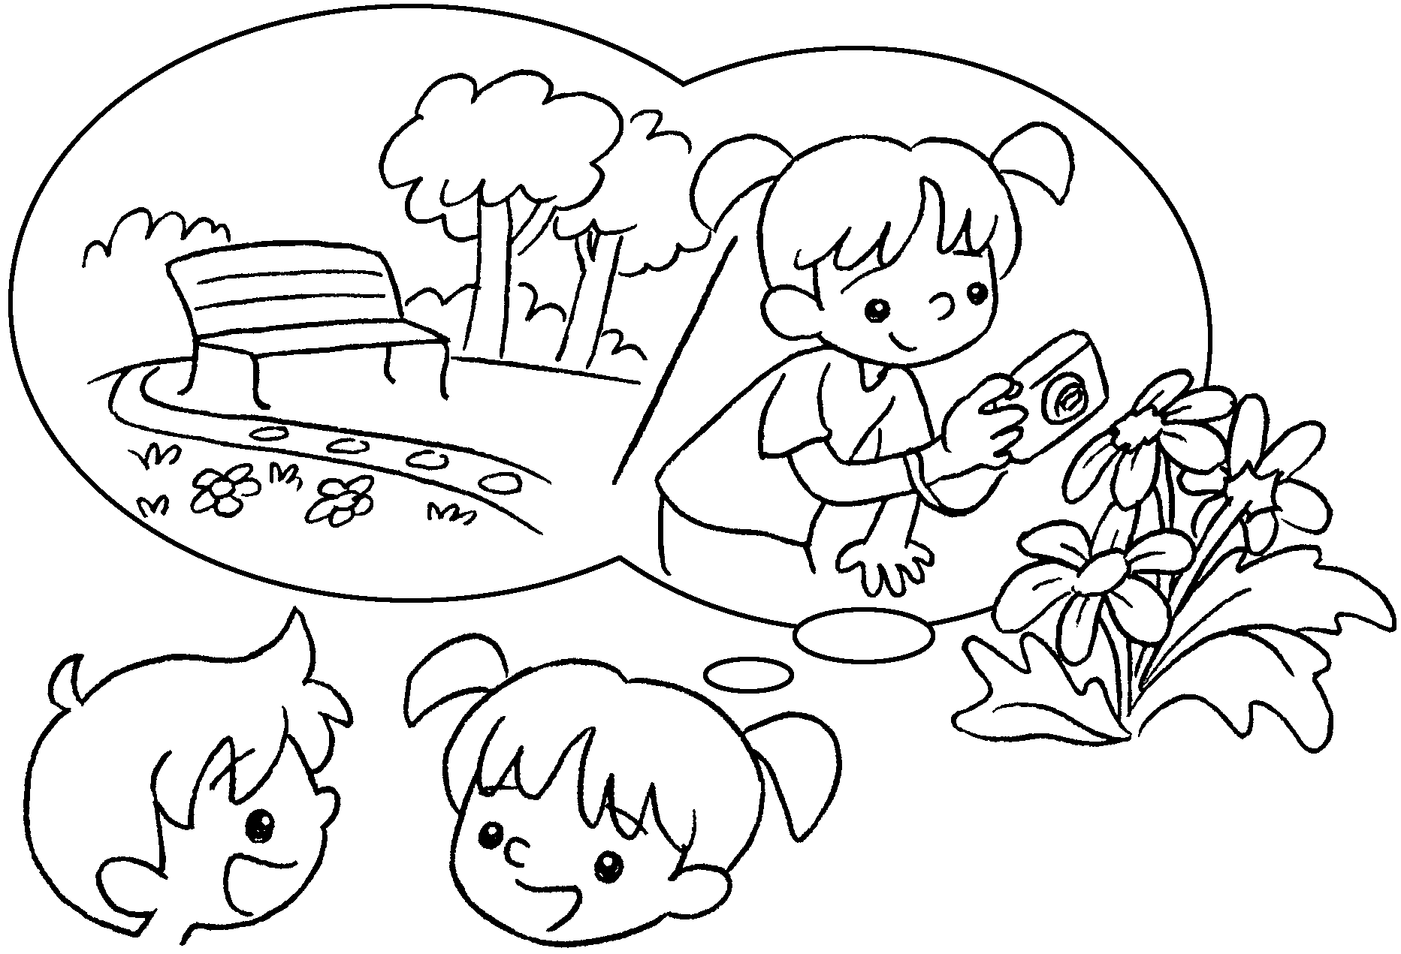  A |  | A : you  yesterday?  B : I to the park.  A : you  there?  B : I some photos.


Book 3B Chapter 6 Graded Worksheets
Worksheet 3⬇⬇
- What
had
- Where
went
3 What did do
watched
4 Where did go
went
What did do
took

