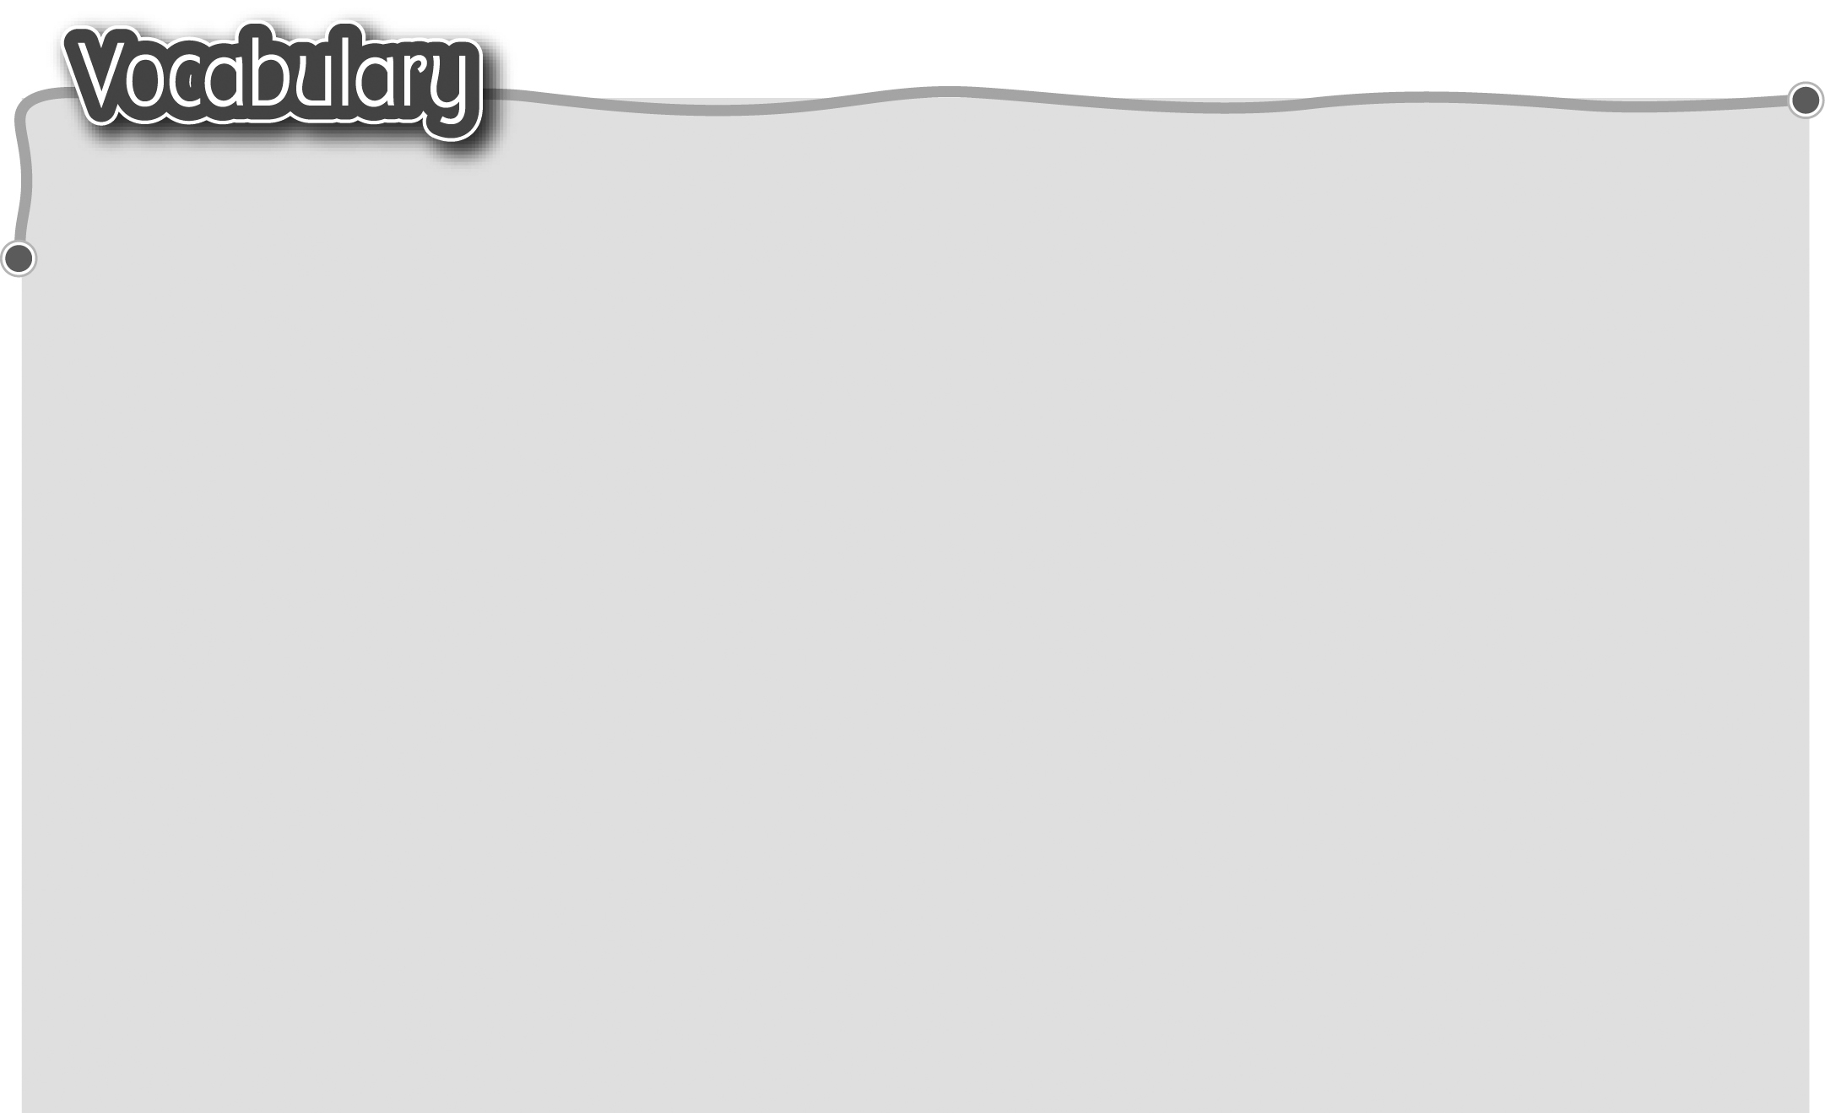
1 leisure activity 閒餘活動 6 take photos 拍照
2 build a sandcastle 7 go hiking 遠足
堆沙城堡 8 go shopping 購物
3 have a picnic 野餐 9 read magazines 閱讀雜誌
4 have a barbecue 燒烤 10 do puzzles 砌拼圖
5 fly a kite 放風箏 11 make models 砌模型
The words marked with * have different meanings in other
contexts. You can look up those meanings in a dictionary.
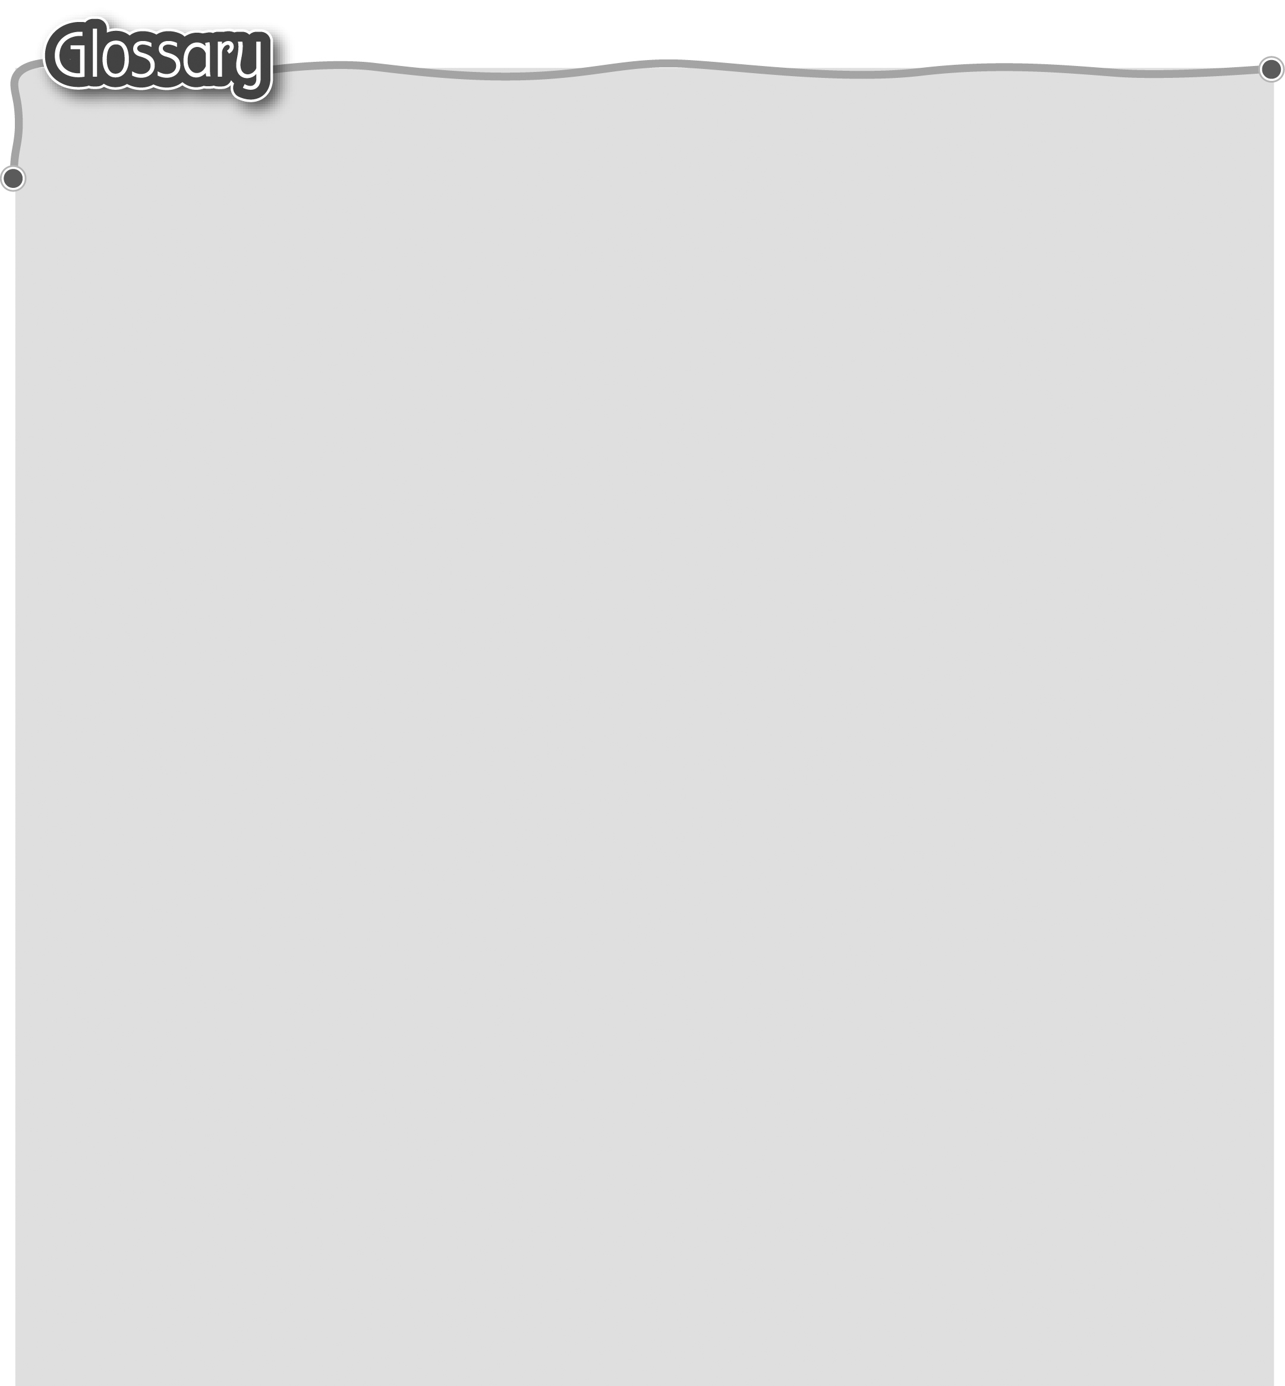
1 boring (p.46) 沉悶 13 understand (p.46) 明白
2 anything* (p.46) 任何事 14 flew* (fly) (p.47) 乘……飛行
3 travel guide (p.46) 旅遊指南 15 time machine (p.47) 時光機
4 before (p.46) 在……之前 16 choose (p.47) 選擇
5 was (be) called (p.46) 叫作 17 press* (p.47) 按下（動詞）
6 meant (mean) (p.46) 意思是 18 button* (p.47) 按鈕（名詞）
7 bay* (p.46) 海灣 19 smile (p.47) 微笑（動詞）
8 wood factories (factory) 20 holiday (p.49) 假期
(p.46) 木廠 21 outdoor (p.50) 戶外
9 enjoy (p.46) 享受 22 indoor (p.50) 戶內
10 fishing (fish) (p.46) 釣魚 23 during … (p.50) 在……期間
11 home to (p.46) 24 in the end (p.52) 最後
……座落的地方 25 suddenly (p.53) 突然
12 (be) born (p.46) 出生

