- Fun activities
Book 3B Chapter 6
Simplified reading passage
What did Mike and Tinky do last weekend? Read the story and find out.

‘Hi, Mike, did you have a good weekend?’ asked Tinky.
‘No, I didn’t,’ said Mike. ‘How about you? Where did you go?’
‘I went to Yam O. Look!’ said Tinky.
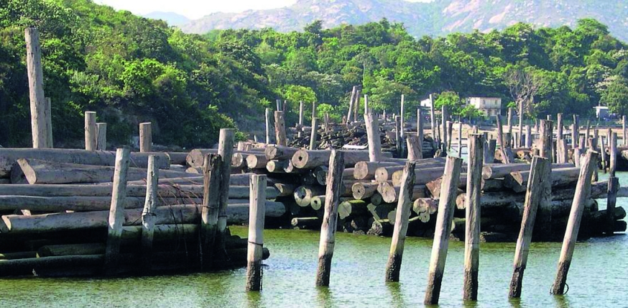
About Sunny Bay

Before 2005, Sunny Bay was called Yam O. The old name meant ‘dark bay’ but it was a beautiful place. There were wood factories. Now it is home to Disneyland and it is called Sunny Bay!

‘Did you go to Disneyland?’ asked Mike.
‘No,’ said Tinky. ‘I went to Yam O ― in 1985.’
1985 = nineteen eighty-five
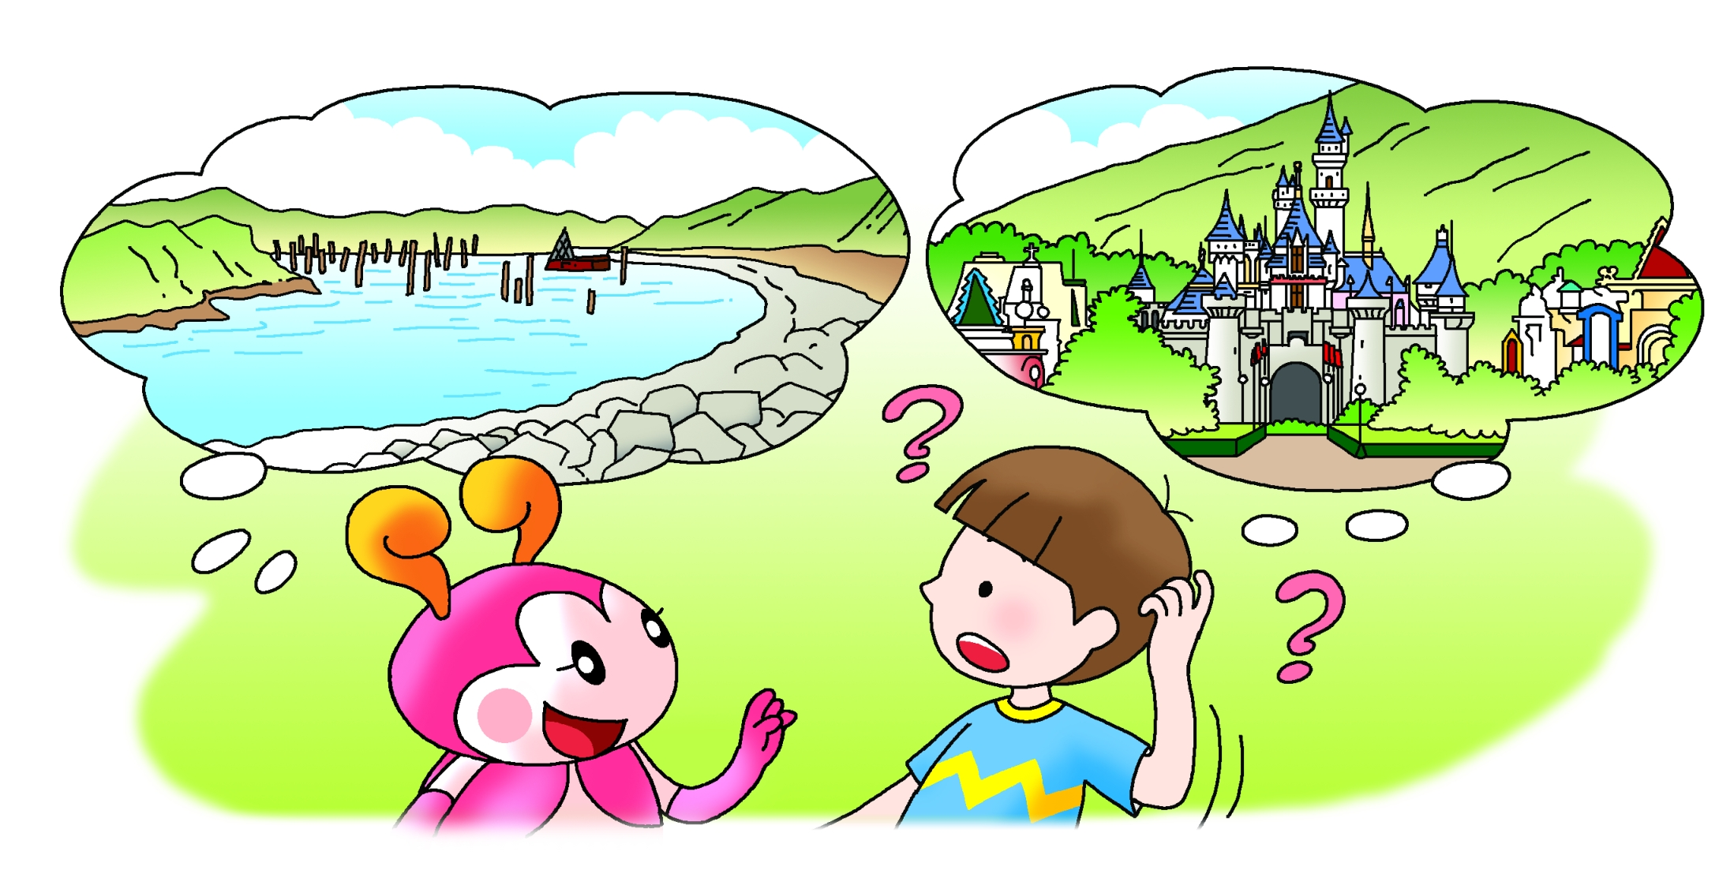
‘What?’ asked Mike. ‘You weren’t born then.’

‘I flew there in my time machine,’ said Tinky.
Book 3B Chapter 6
Simplified reading passage
‘What did you do there?’ asked Mike.
‘I swam in the sea,’ Tinky said. ‘I took some photos and had a picnic. It was fantastic!’
‘Wow!’ said Mike. ‘Can I use your time machine?’
‘Sure,’ said Tinky.
‘Choose the year and place here,’ Tinky said. ‘Then press the red button.’
Mike smiled. ‘Here goes,’ he said …


