RP no: Century Gothic 15pt
(所有圈號用15pt)
Choose and write.
 | basketball  football |  |  | Chinese checkers  the piano |  |  | computer games  the violin
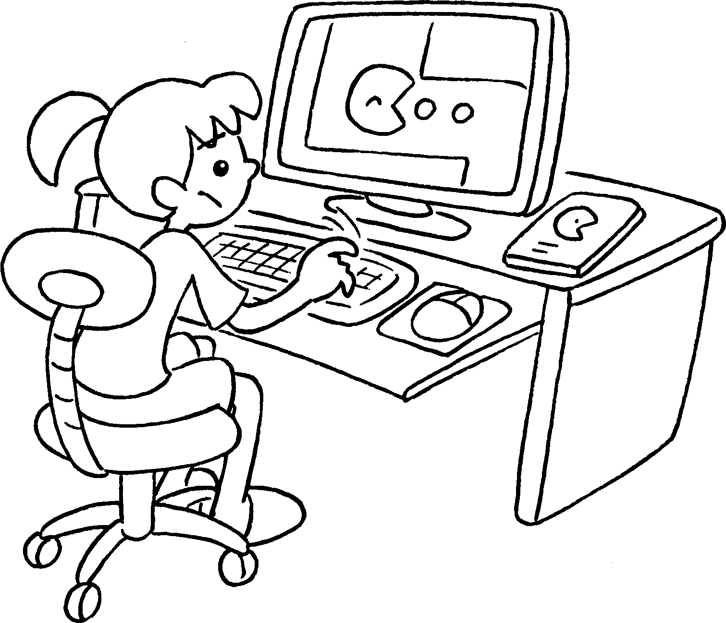  1 |  | 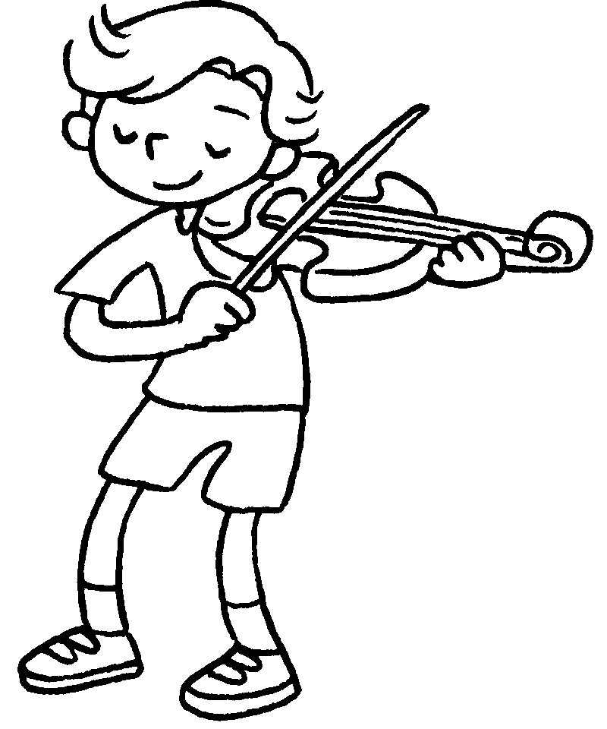  2  3 |  |  | 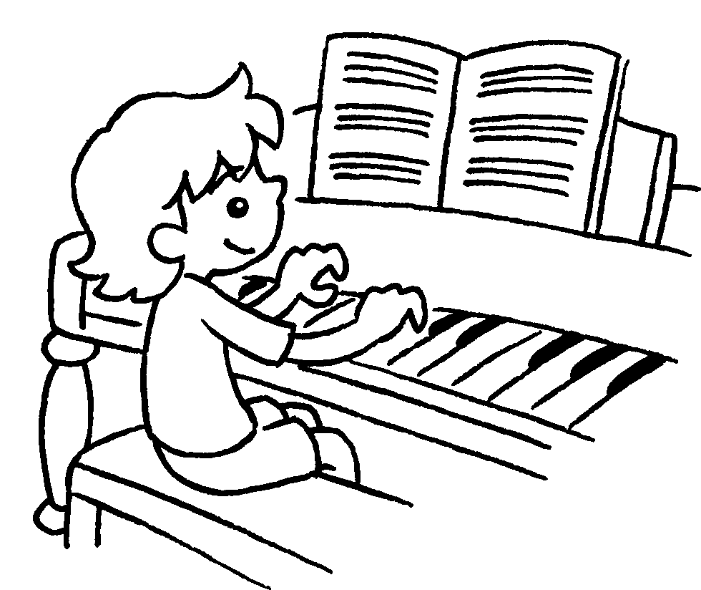 | 1 play ____________________  2 play ____________________  3 play ____________________  4 play ____________________  5 play ____________________  6 play ____________________
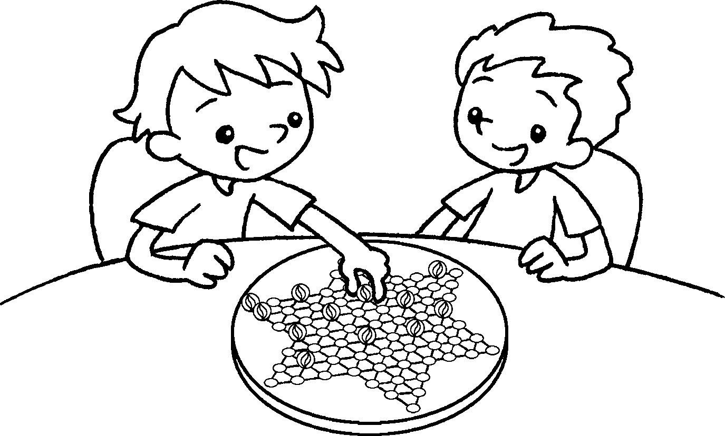  4  5 |  | 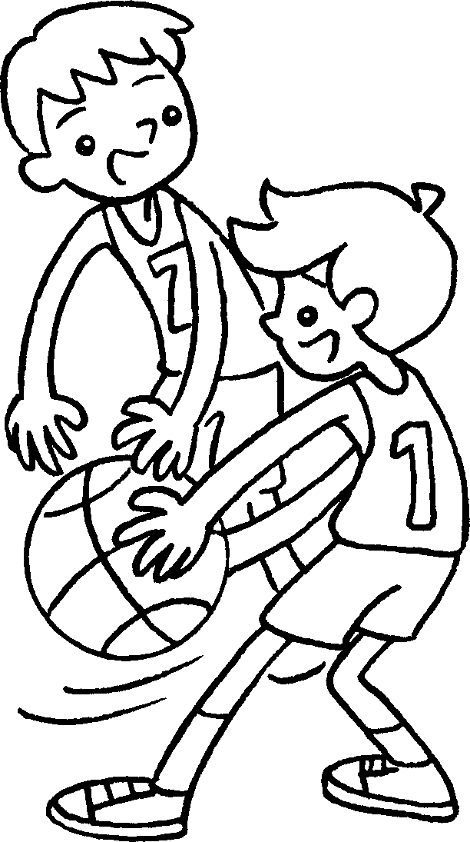  6 |  |  | 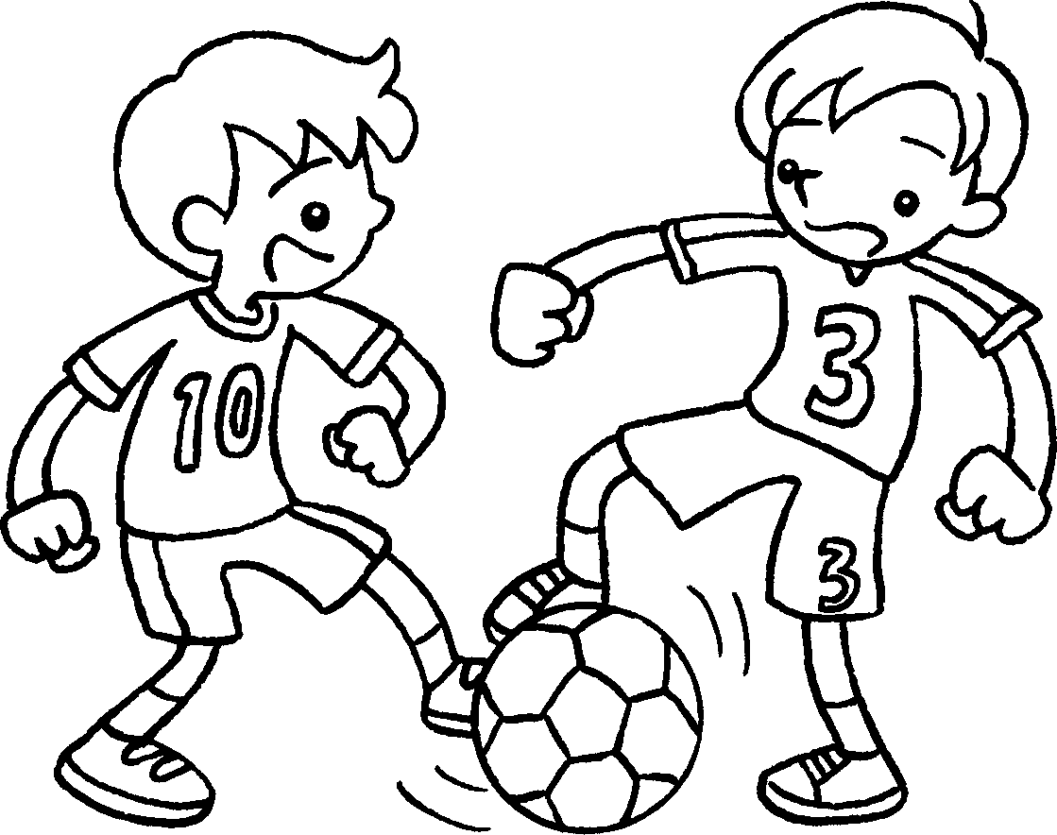
 | cycling |  |  | ice-skating |  | swimming
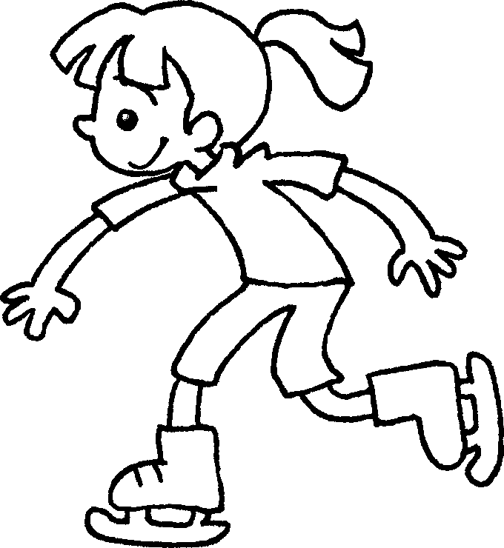  7  8 |  | 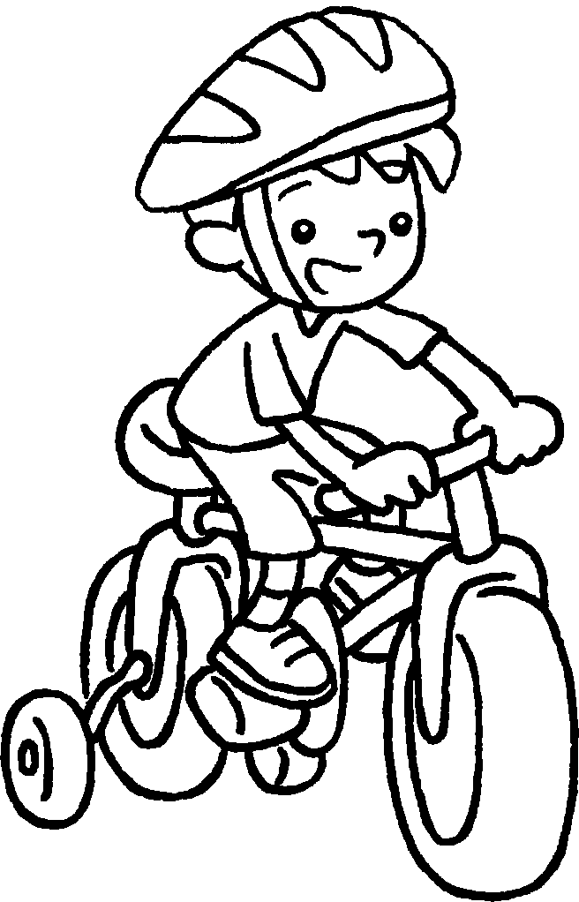  9 |  |  |  | 7 go ____________________________  8 go ______________________  9 go _______________________
 | cards  10  11  12 |  |  | stamps |  | stickers
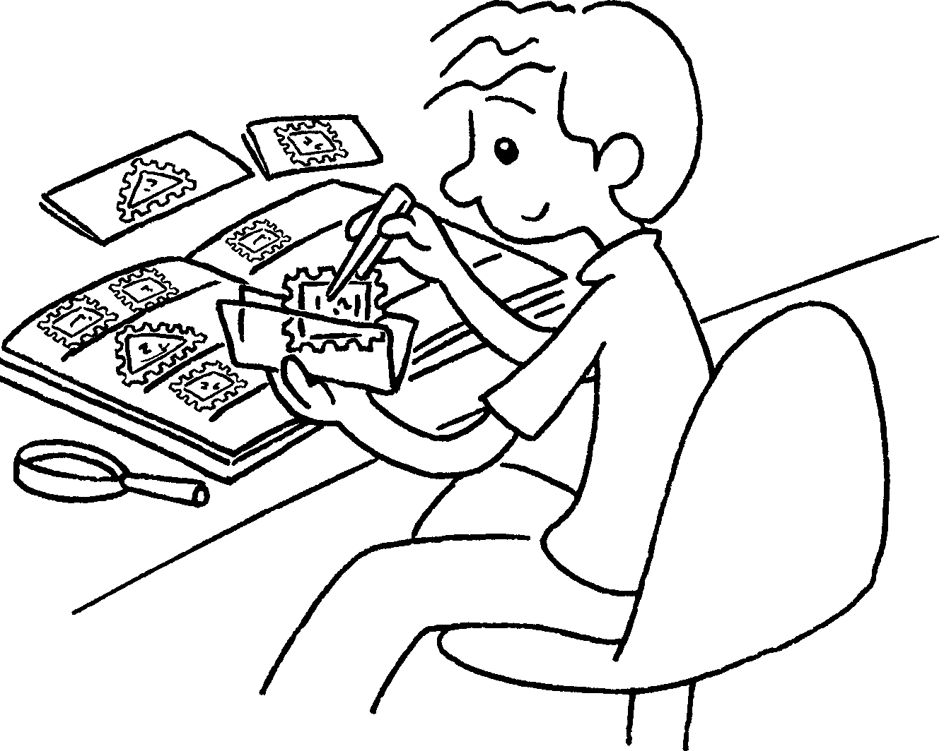 |  | 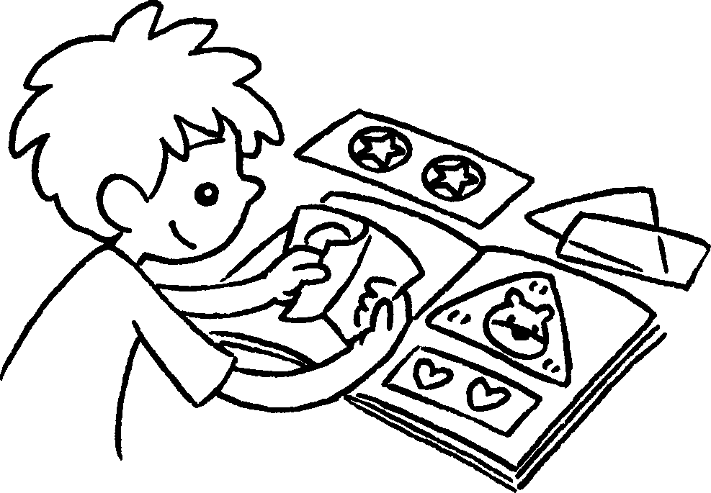 |  |  | 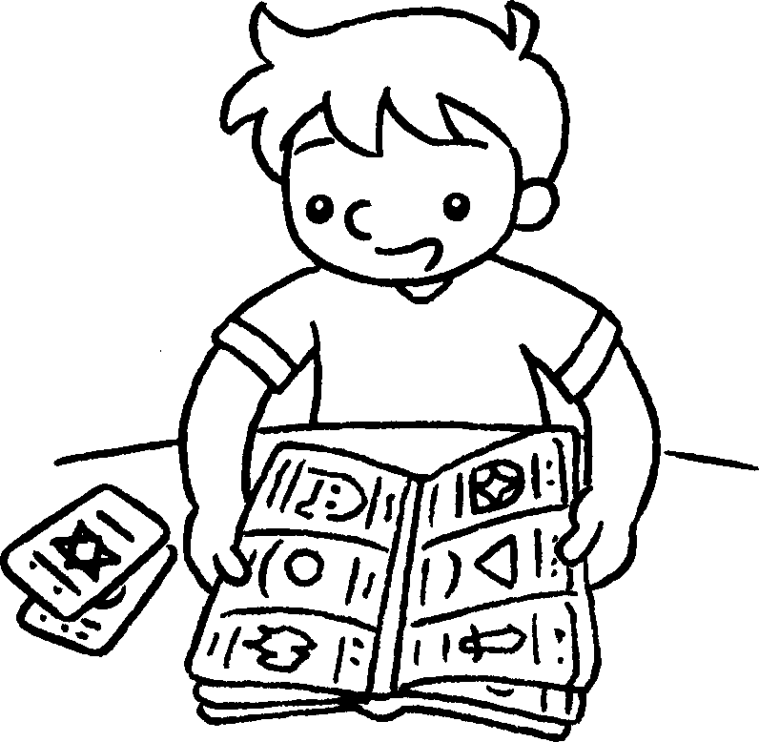 | 10 collect __________________  11 collect __________________  12 collect __________________
 | comics  133  14  15 |  |  | magazines |  | the newspaper
 |  |  | 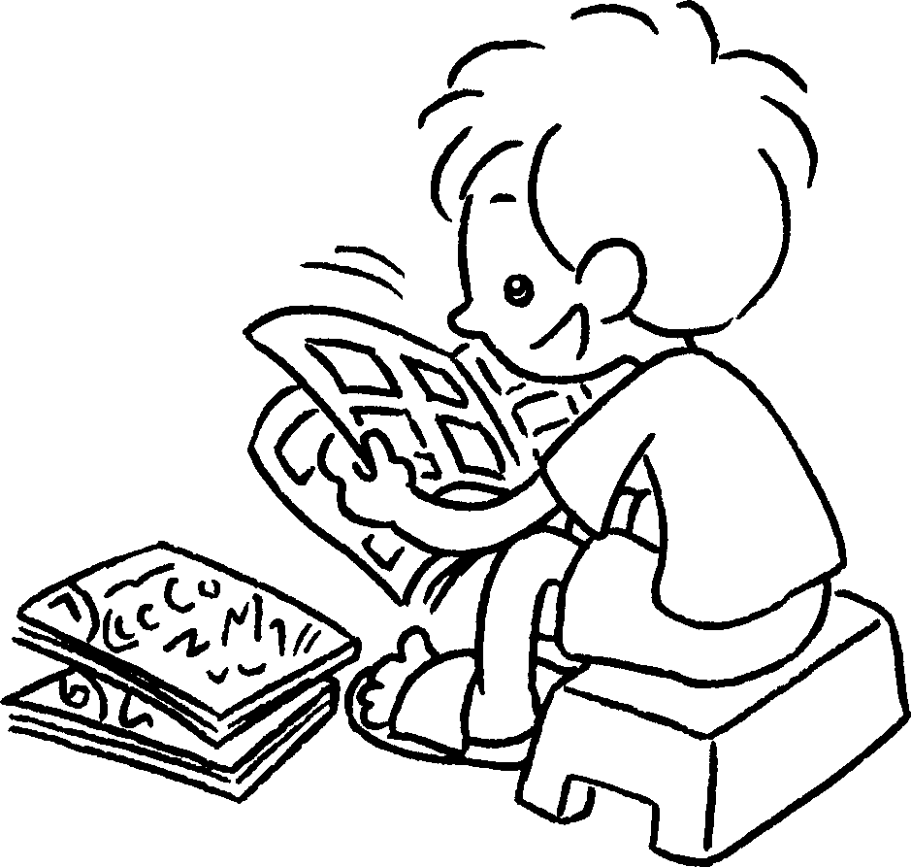 |  | 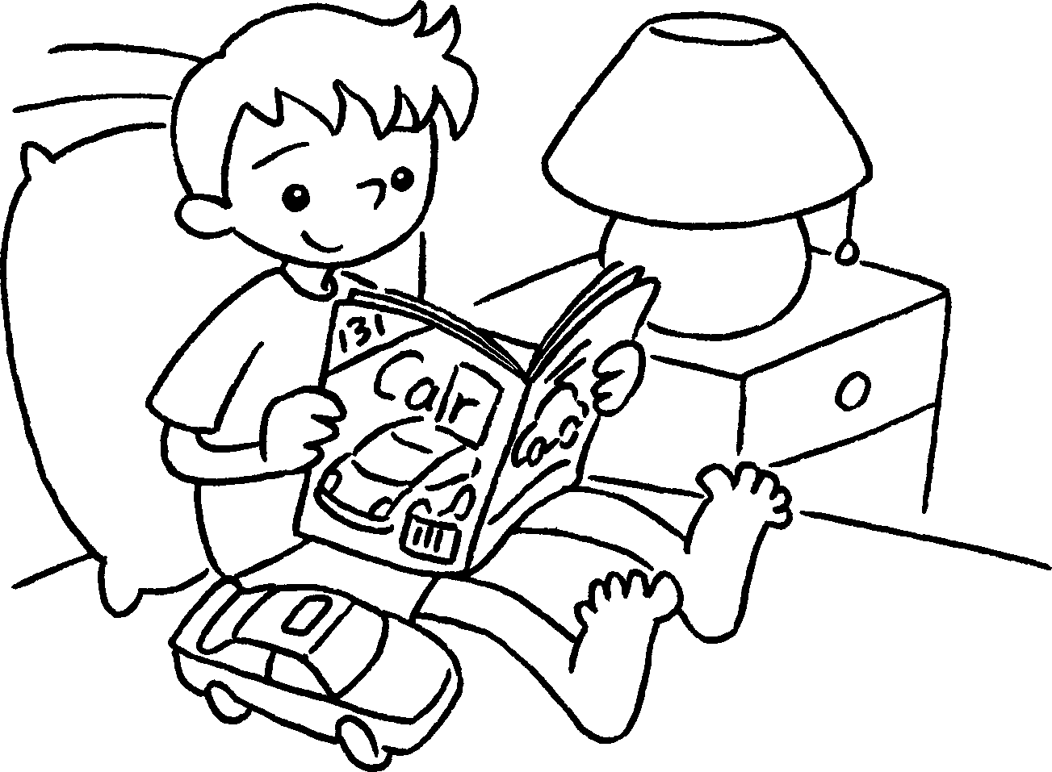 | 13 read __________________________  - read __________________________  15 read __________________________


Book 4A Chapter 1 Graded Worksheets
Worksheet 1⬇

1 computer games
2 the violin
3 the piano
4 Chinese checkers
5 basketball
6 football
7 ice-skating
8 cycling
9 swimming
10 stamps
11 stickers
12 cards
13 the newspaper
14 comics
15 magazines

