RP no: Century Gothic 15pt
(所有圈號用15pt)
What are the children’s hobbies? Write.
 | 3
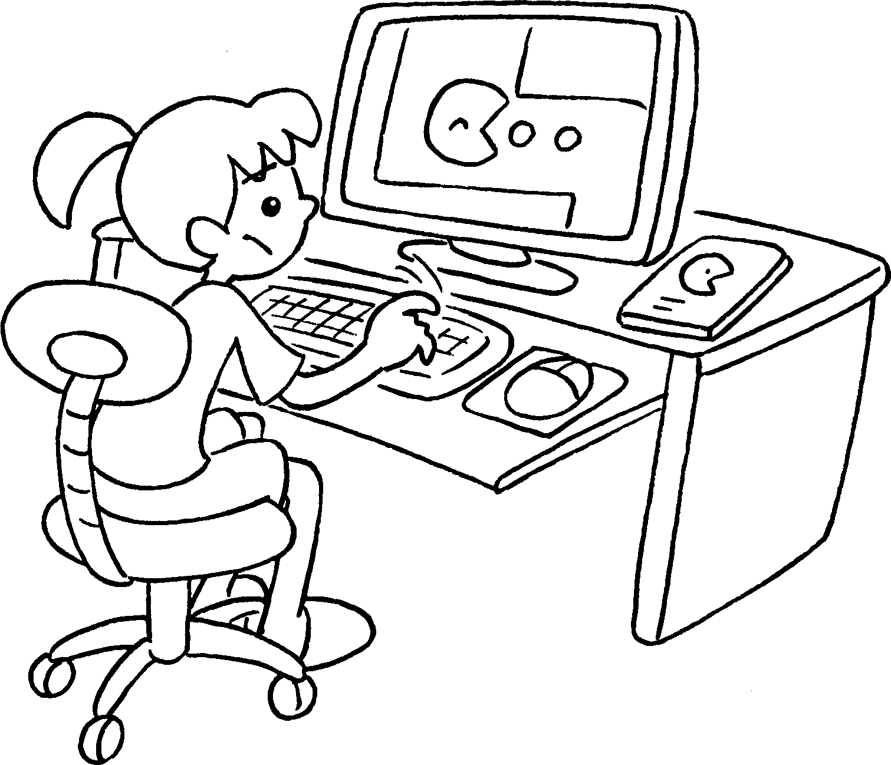  1  2 |  | 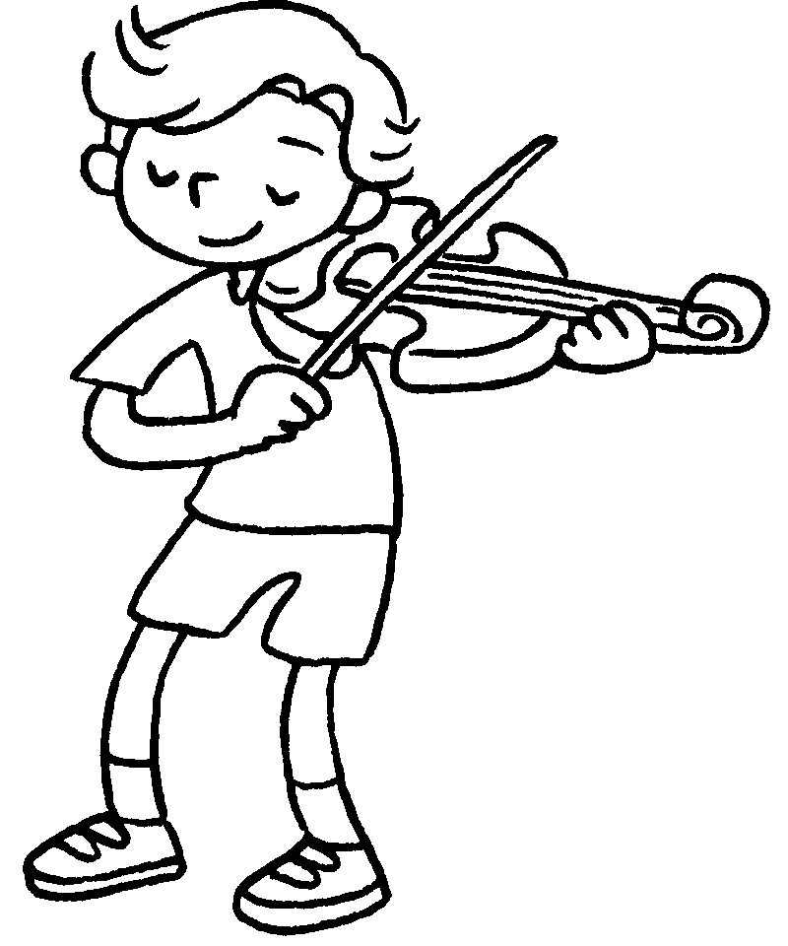 |  |  | 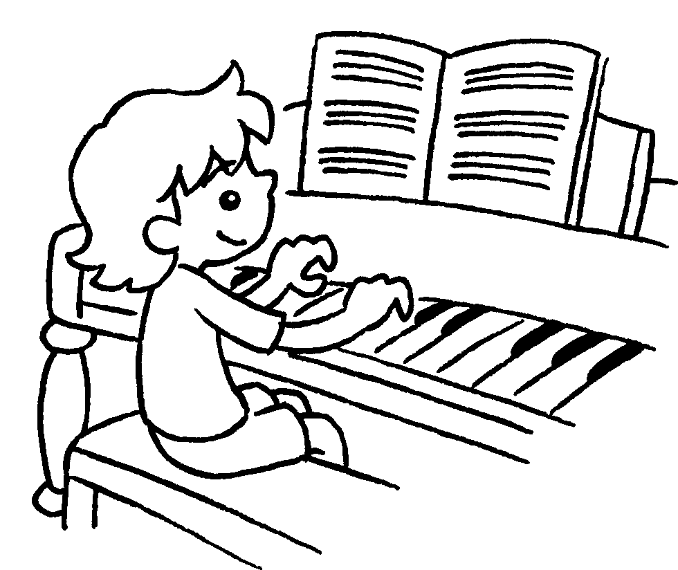 | 1 play c g  2 play the v  3 play the p  4 play C c  5 play b  6 play f
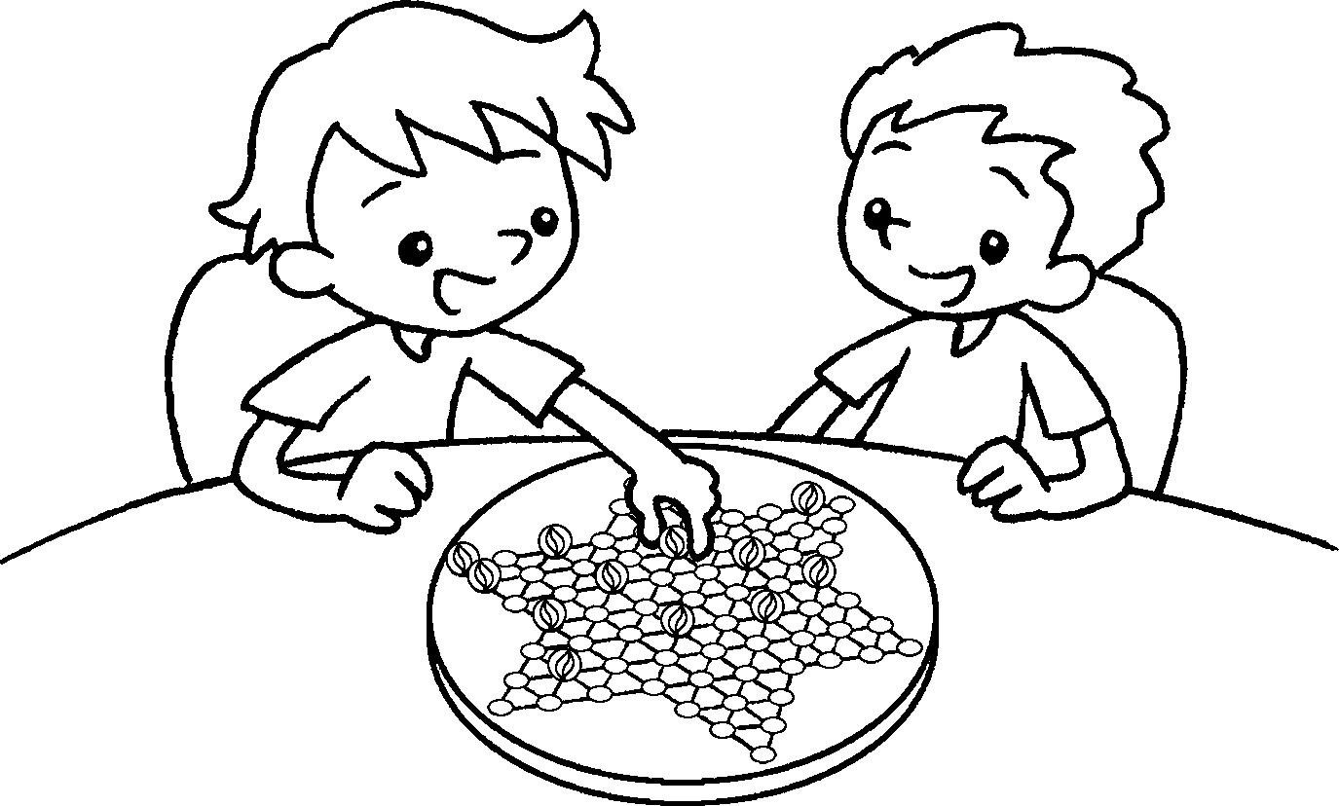  4  5 |  | 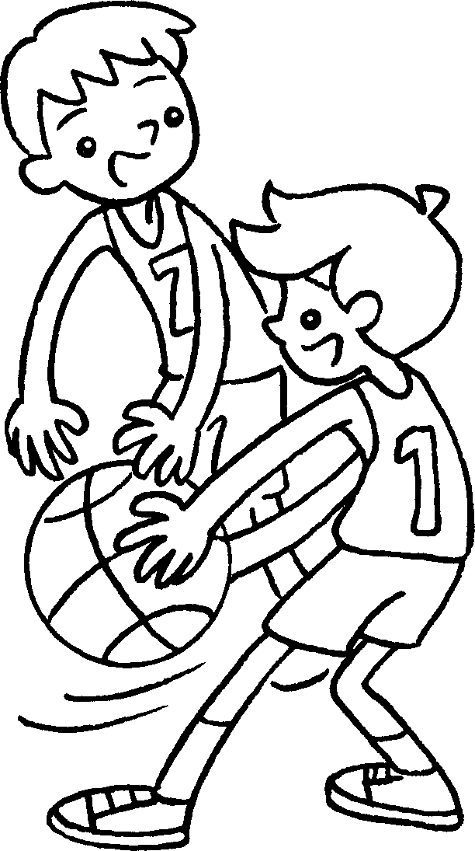  6 |  |  | 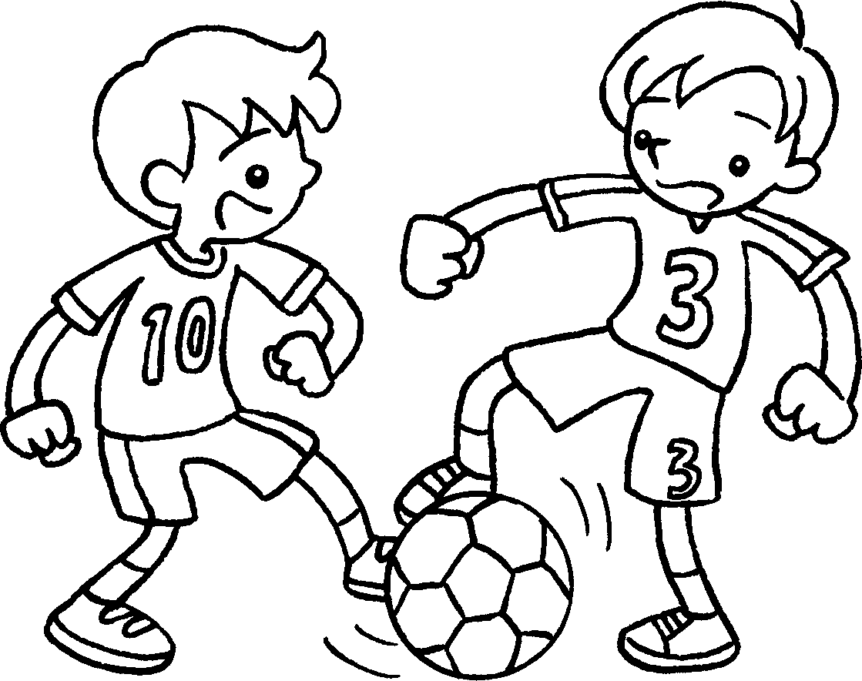
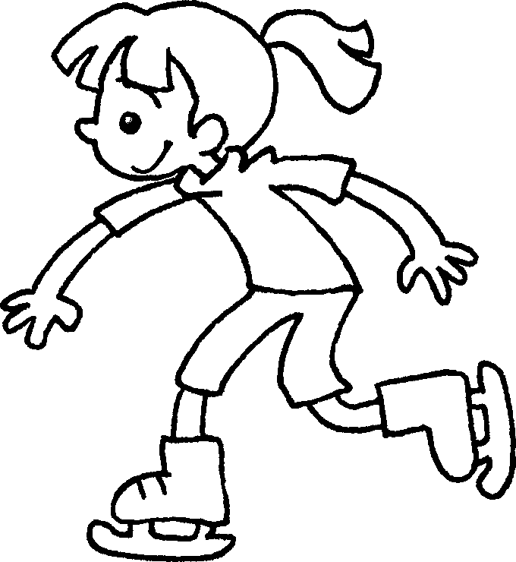  7  8 |  | 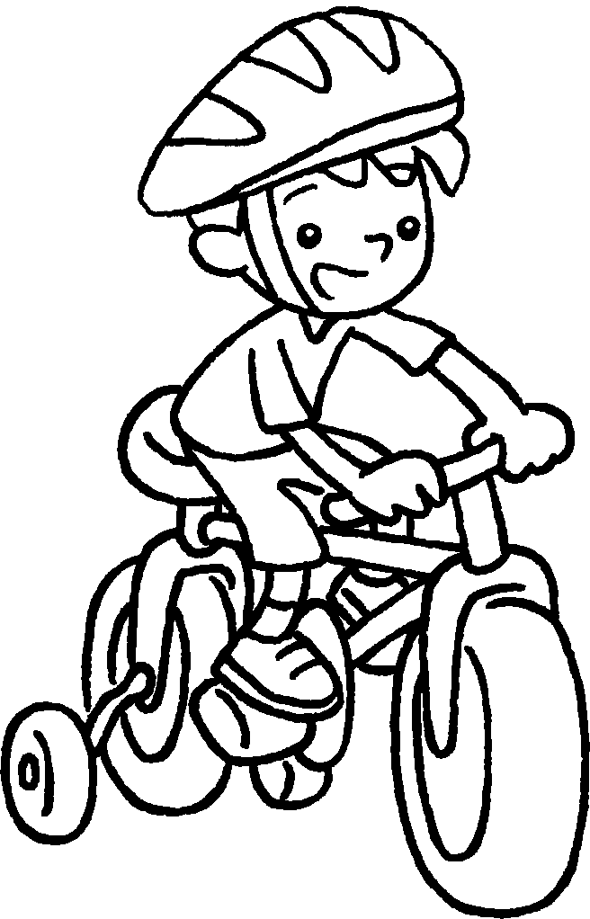  9 |  |  | 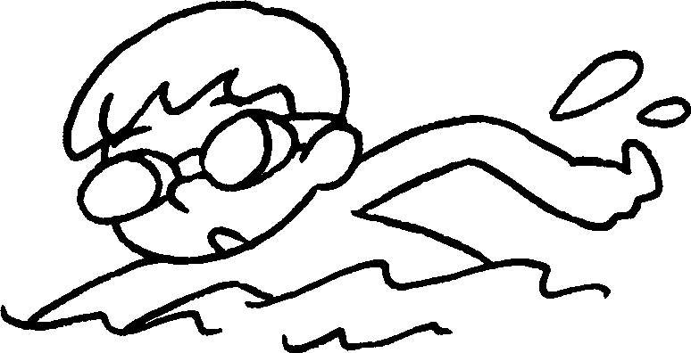 | 7 go i  8 go c  9 go s
10
11
12
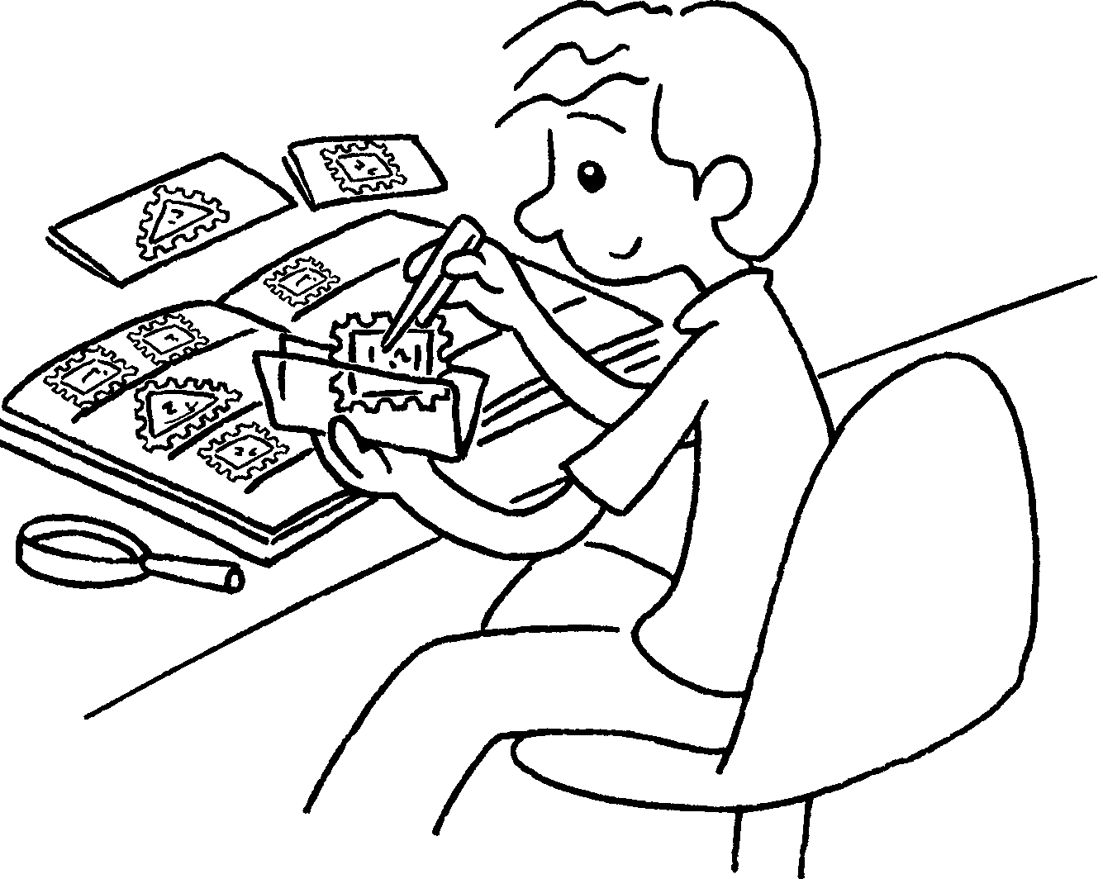 |  | 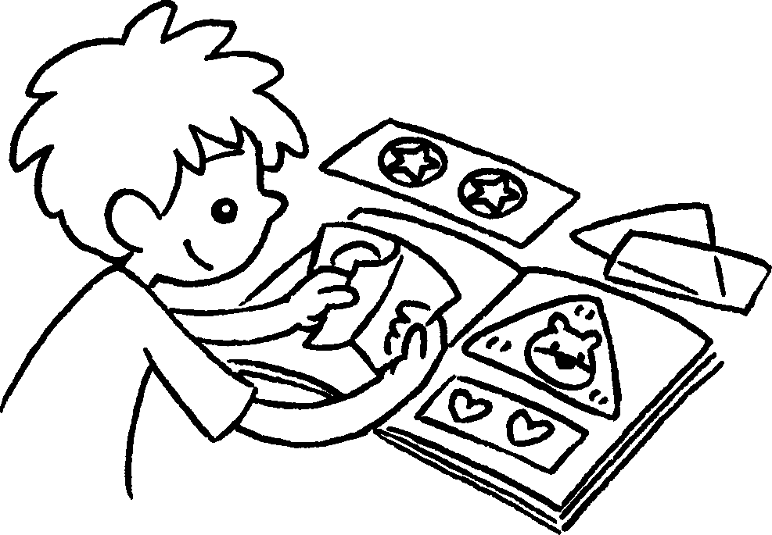 |  |  | 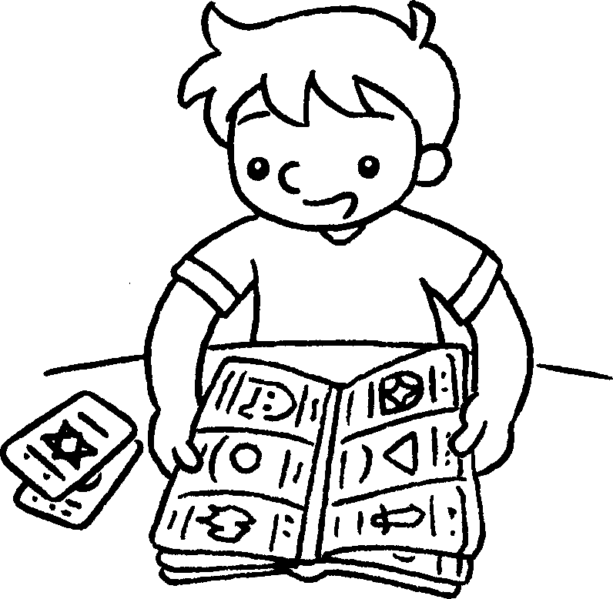 | 10 collect s  11 collect s  12 collect c
  133  14  15 |  |  | 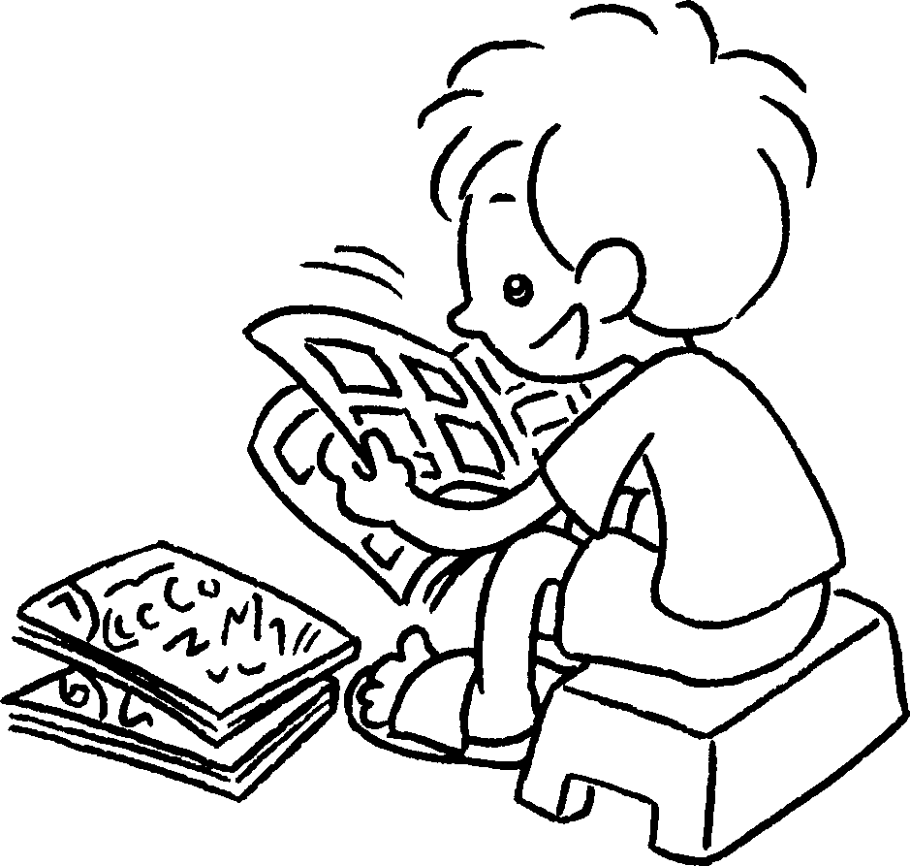 |  | 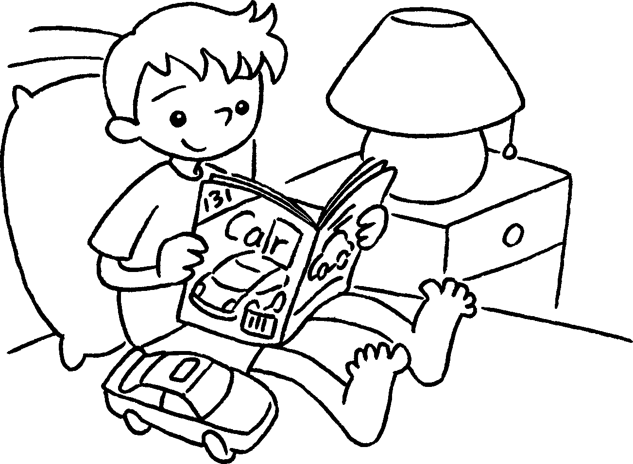 | 13 read the n  14 read c  15 read m
RP no: Century Gothic 15pt
(所有圈號用15pt)


Book 4A Chapter 1 Graded Worksheets
Worksheet 1⬇⬇

1 computer games
2 violin
3 piano
4 Chinese checkers
5 basketball
6 football
7 ice-skating
8 cycling
9 swimming
10 stamps
11 stickers
12 cards
13 newspaper
14 comics
15 magazines

