RP no: Century Gothic 15pt
(所有圈號用15pt)
RP no: Century Gothic 15pt
(所有圈號用15pt)
What are their hobbies? Write.
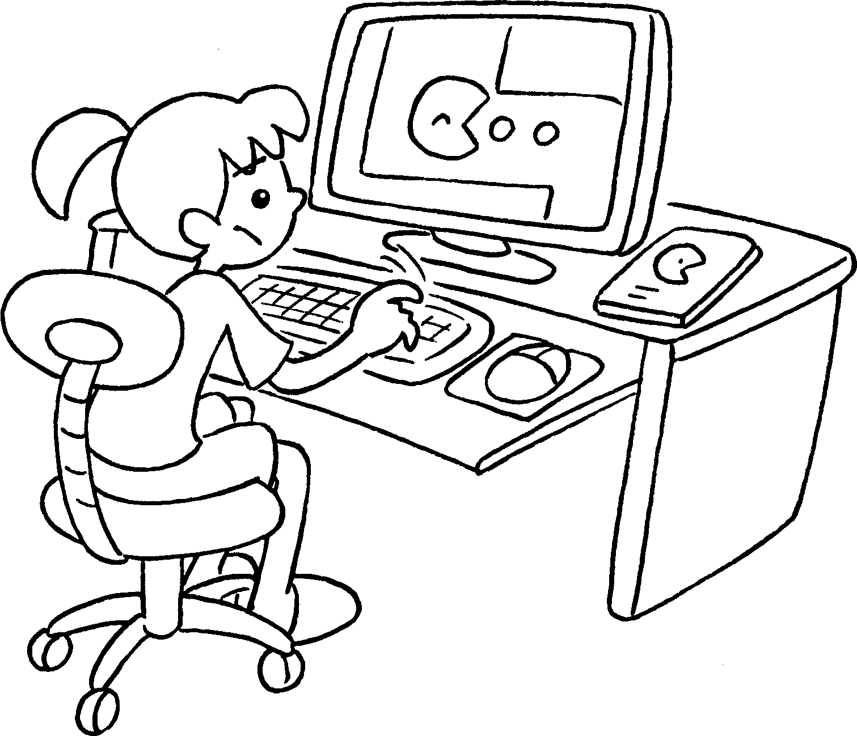  1  2 |  |   3 |  |  | 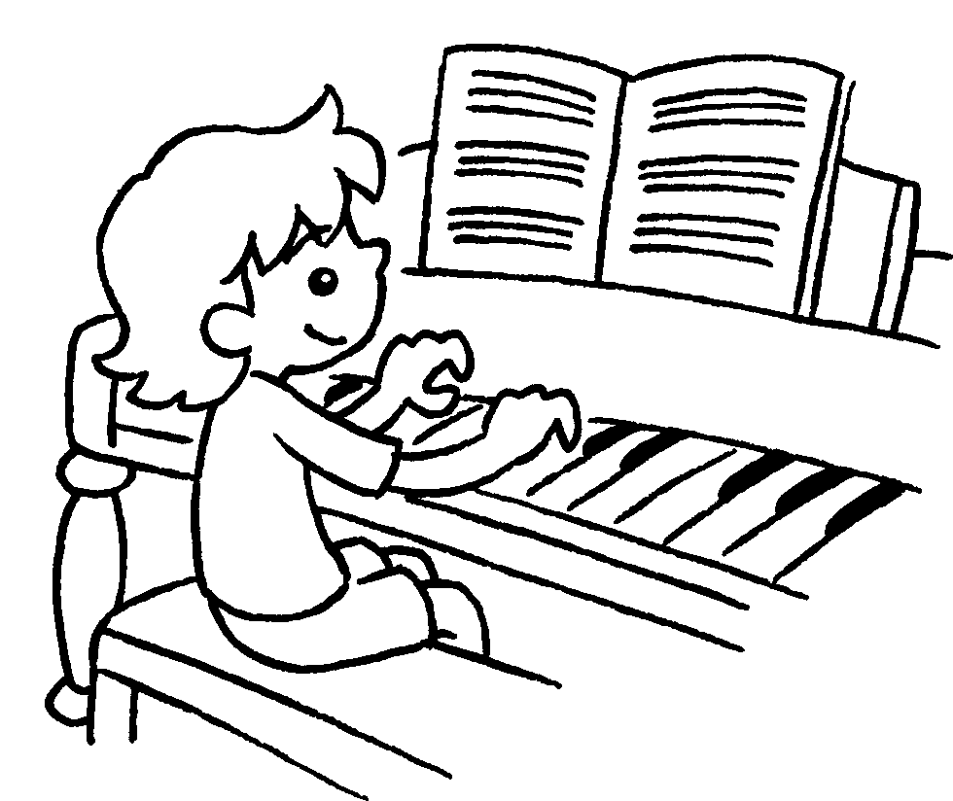 | 1 play computer  __________________  2 play the ________________  3 play ____________________  4 play ____________________  5 play ____________________  6 play ____________________
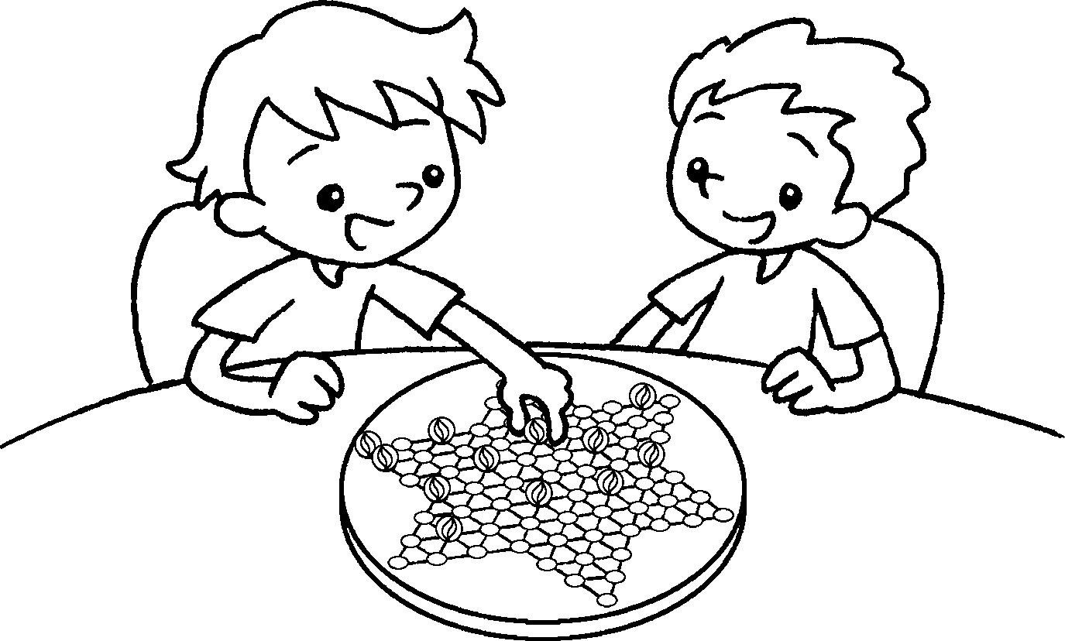  4  5 |  |   6 |  |  | 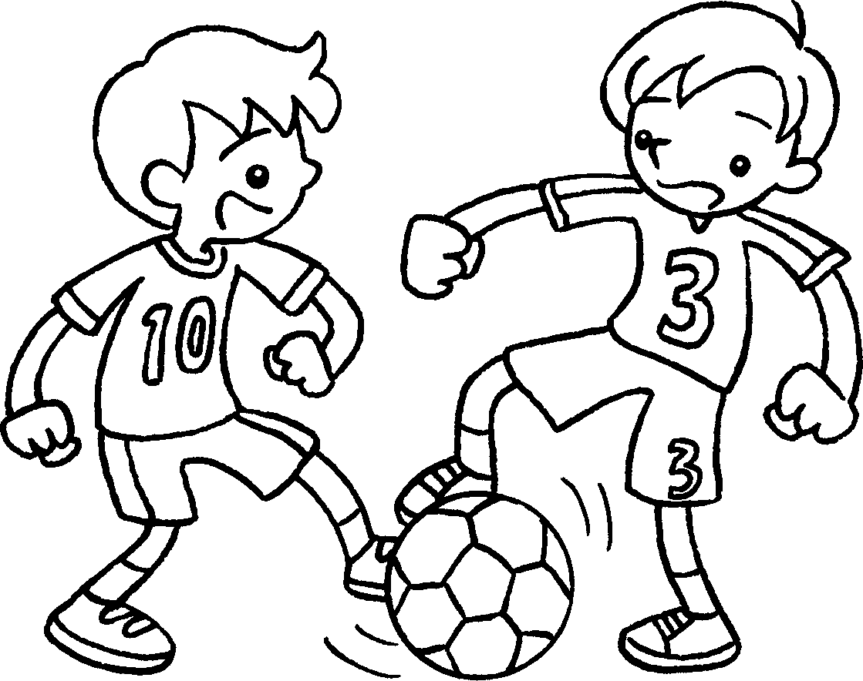
  7  8 |  |   9 |  |  |  | 7 go ____________________________  8 go ______________________  9 go _______________________
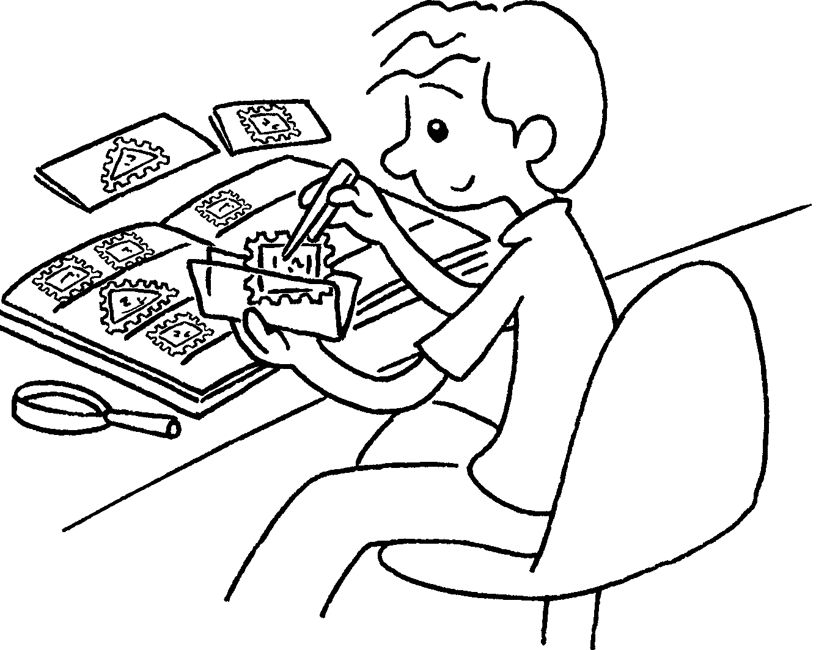  10  11  12 |  |  |  |  | 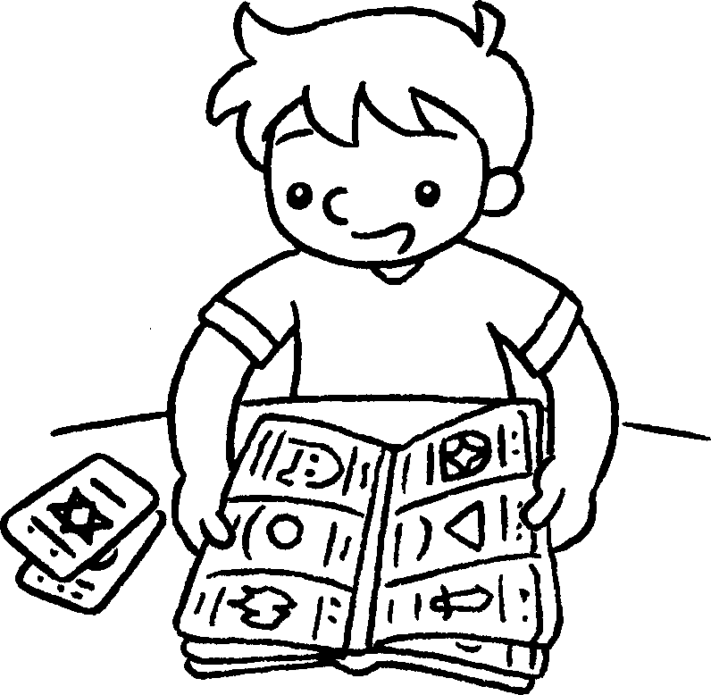 | 10 collect __________________  11 collect __________________  12 collect __________________
133
14
15
 |  |  |  |  | 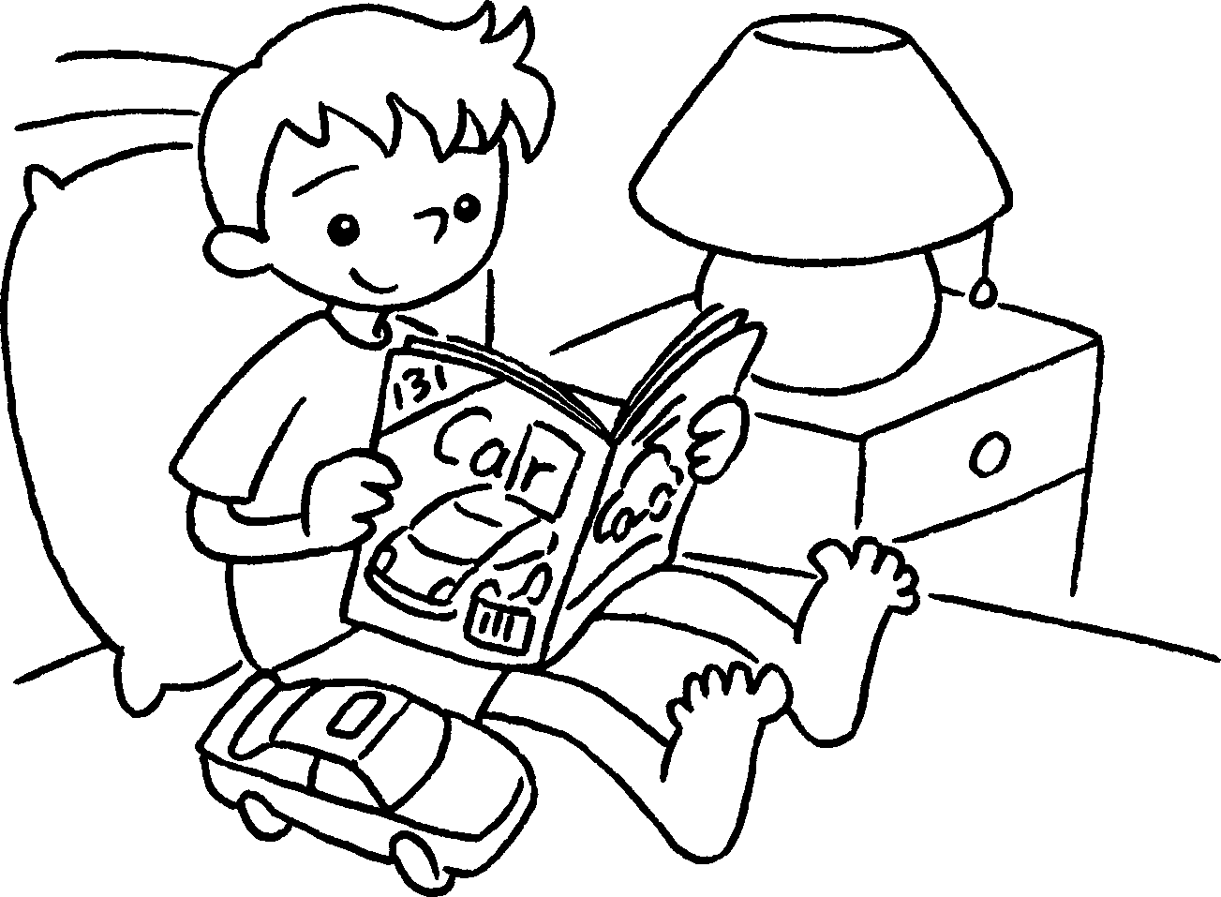 | - read __________________________  - read ___________________________  15 read __________________________


Book 4A Chapter 1 Graded Worksheets
Worksheet 1⬇⬇⬇

1 games
2 violin
3 the piano
4 Chinese checkers
5 basketball
6 football
7 ice-skating
8 cycling
9 swimming
10 stamps
11 stickers
12 cards
13 the newspaper
14 comics
15 magazines

