Circle the correct answers.

1 | 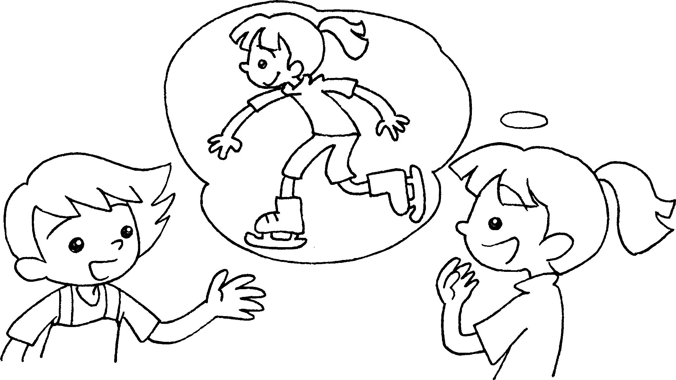  A  B | A : What do you like ( do / doing )  in your spare time?  B : I like ( go / going ) ice-skating.
2 | 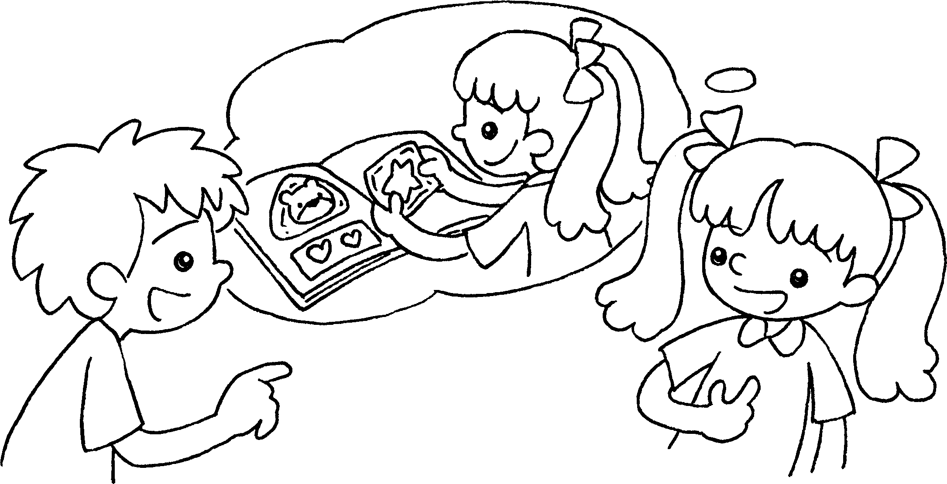  A  B | A : What do you like ( do / doing ) in your spare time?  B : I like ( collect / collecting ) stickers.
3 | 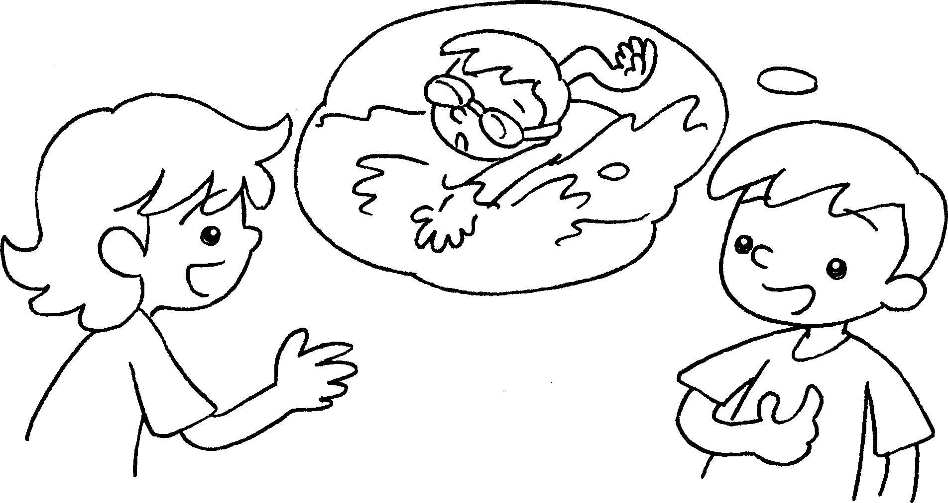  B  A | A : What do you ( like / likes )  ( do / doing ) in your spare time?  B : I like ( go / going ) swimming.
4 | 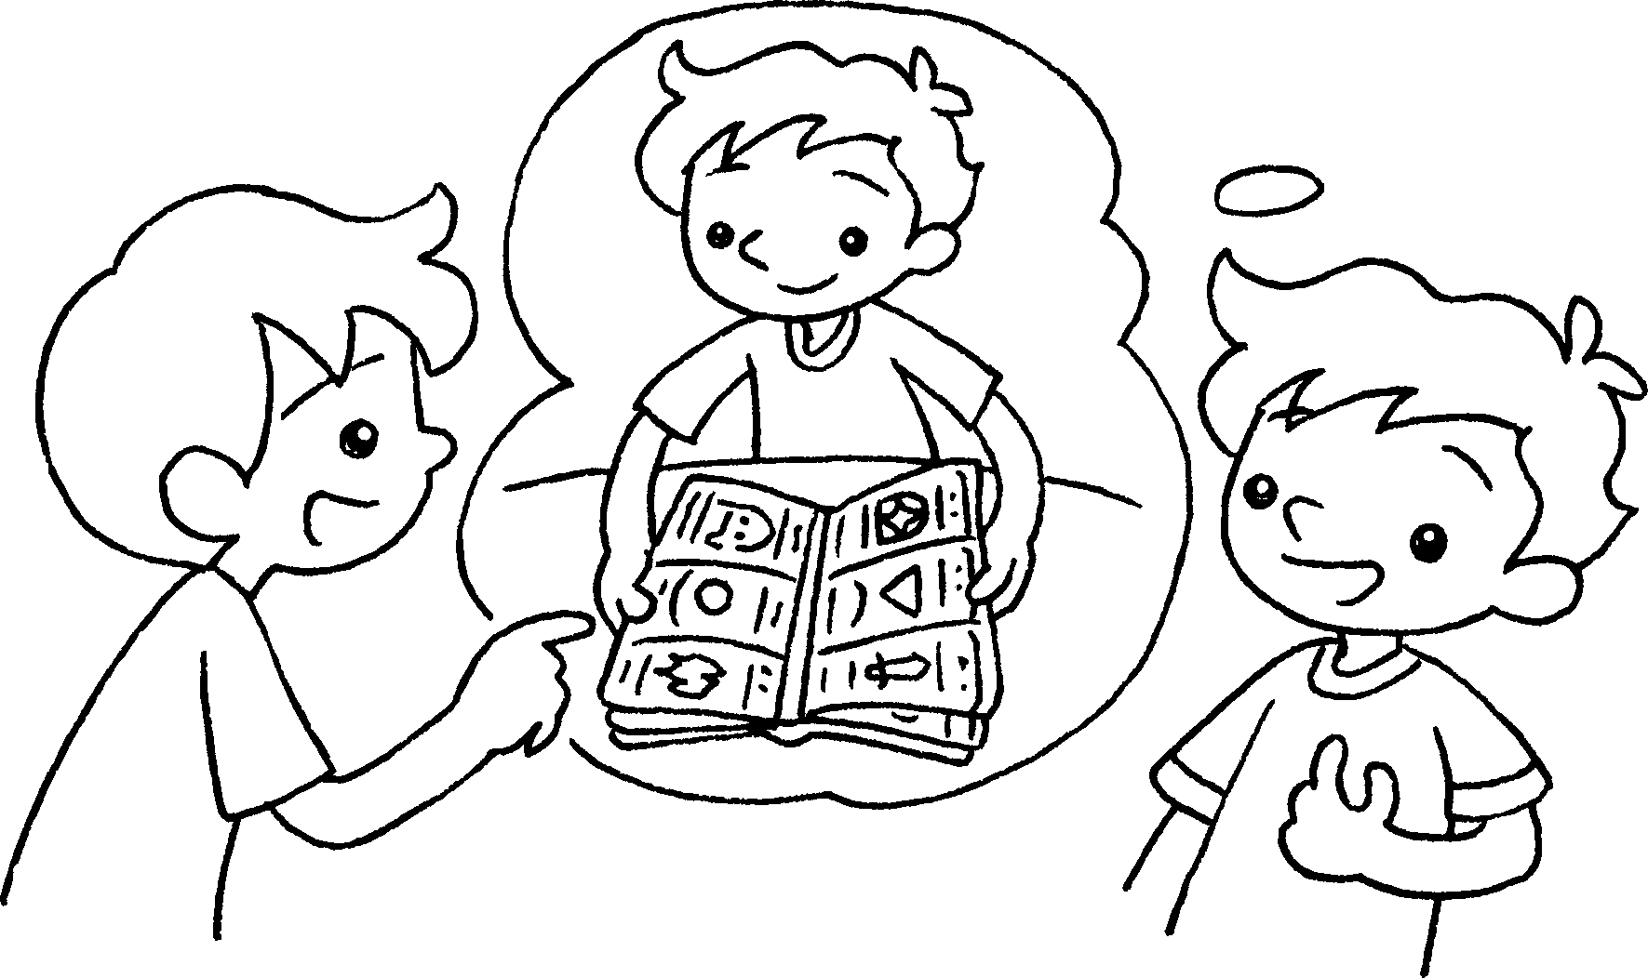  A  B | A : What do you ( like / likes )  ( do / doing ) in your spare time?  B : I ( like / likes )( collect / collecting ) cards.


Book 4A Chapter 1 Graded Worksheets
Worksheet 2⬇
- ( do / doing )
( go / going )
- ( do / doing )
( collect / collecting )
3 ( like / likes ) ( do / doing )
( go / going )
4 ( like / likes ) ( do / doing )
( collect / collecting )

