Finish the questions and answers.

do collect go swimming cards ice-skating stickers

1 | 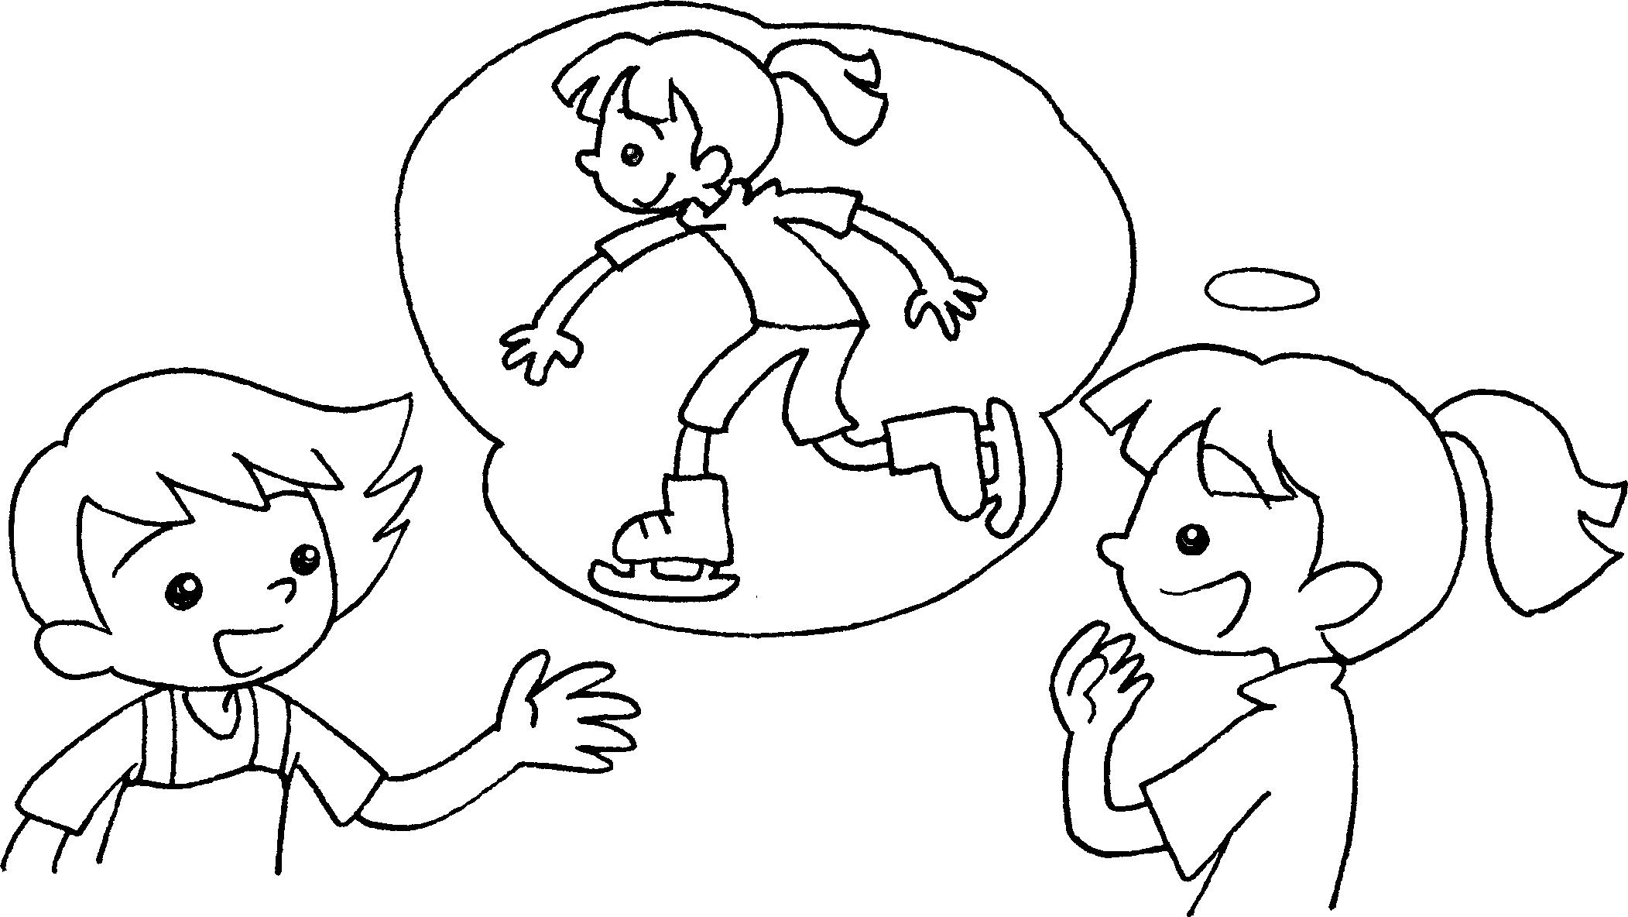  A  B | A : What do you like doing in your spare time?  B : I like going ___________________ .
2 | 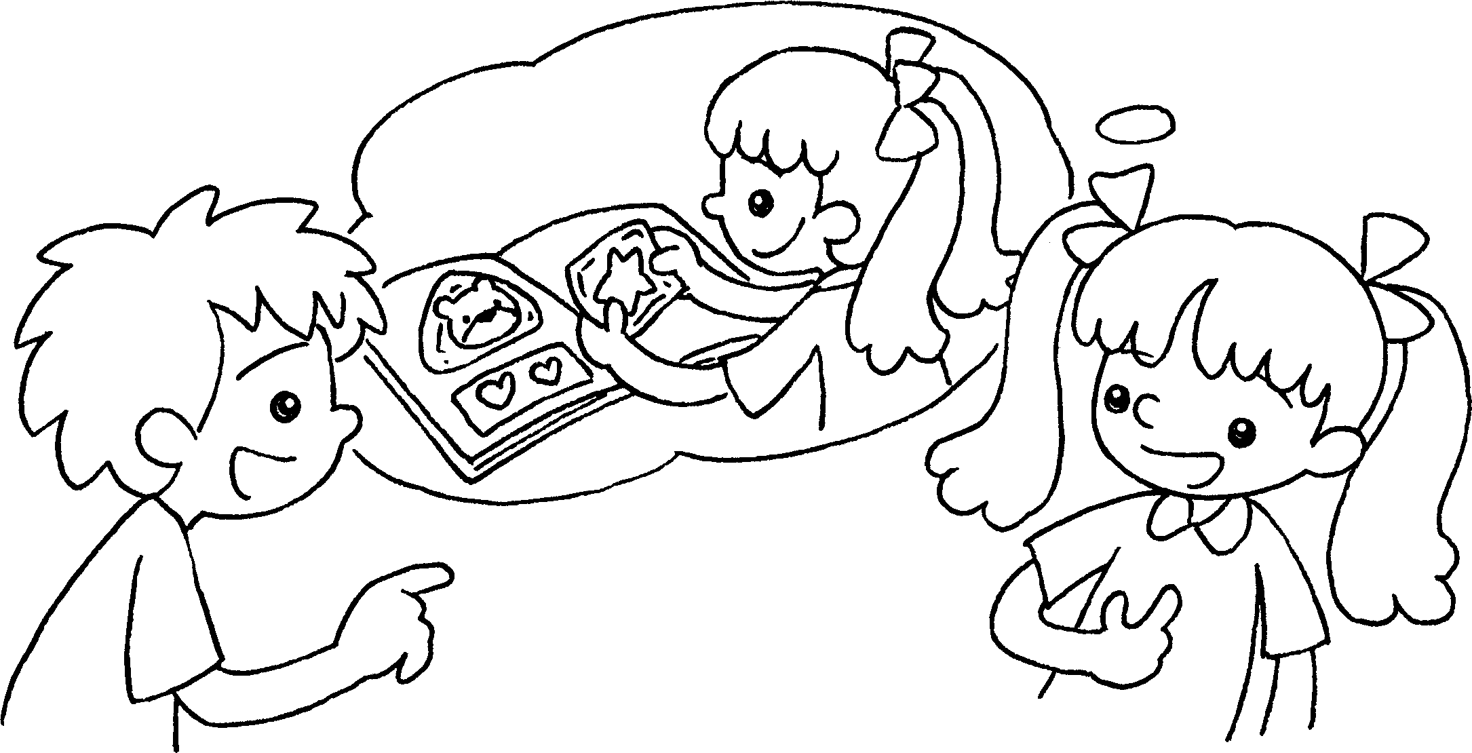  A  B | A : What do you like _______________ in your spare time?  B : I like ________________ ____________ .
3 | 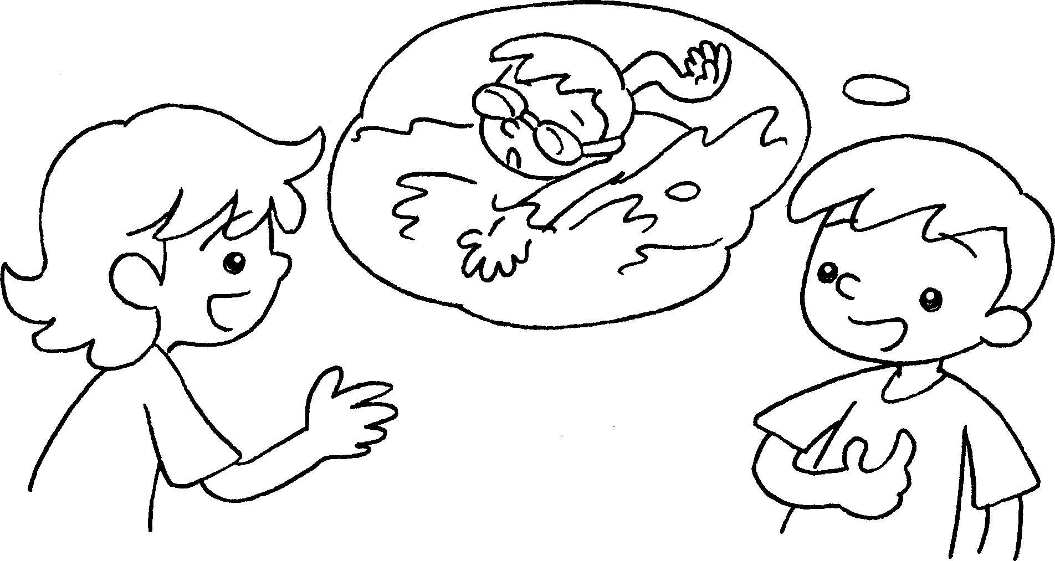  B  A | A : What do you ______________________ in your spare time?  B : I like _____________________________ .
4 | 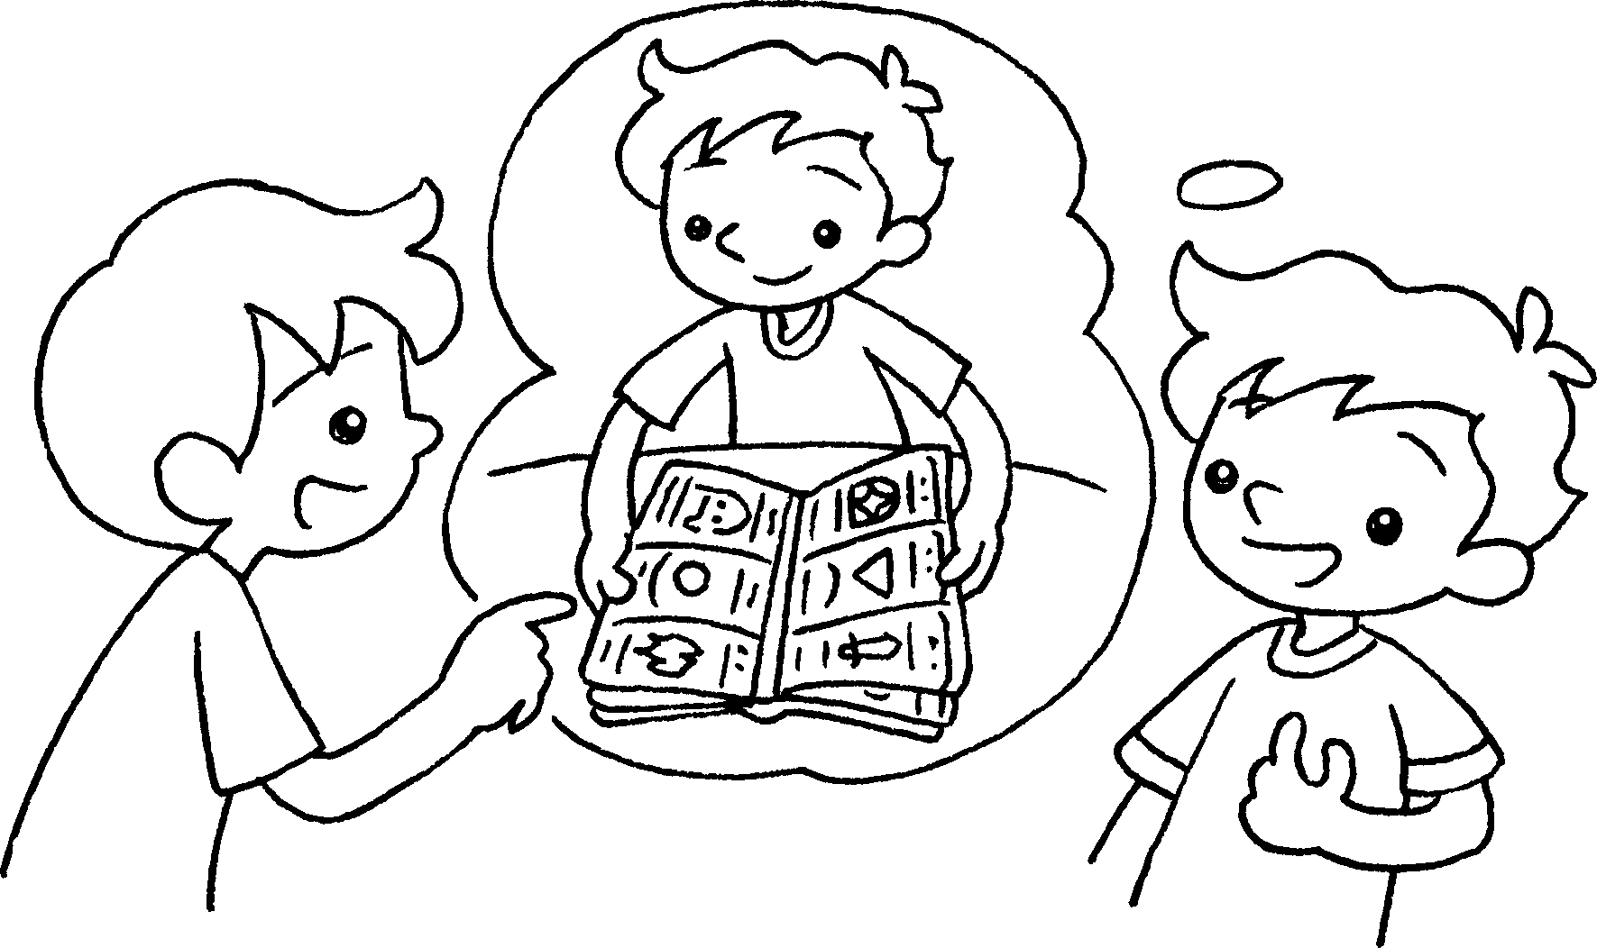  A  B | A : What do you ______________________  in your spare time?  B : I ________________________________ .


Book 4A Chapter 1 Graded Worksheets
Worksheet 2⬇⬇
- ice-skating
- doing
collecting stickers
- like doing
going swimming
- like doing
like collecting cards

