Finish the questions and answers.

swimming cards ice-skating stickers

1 | 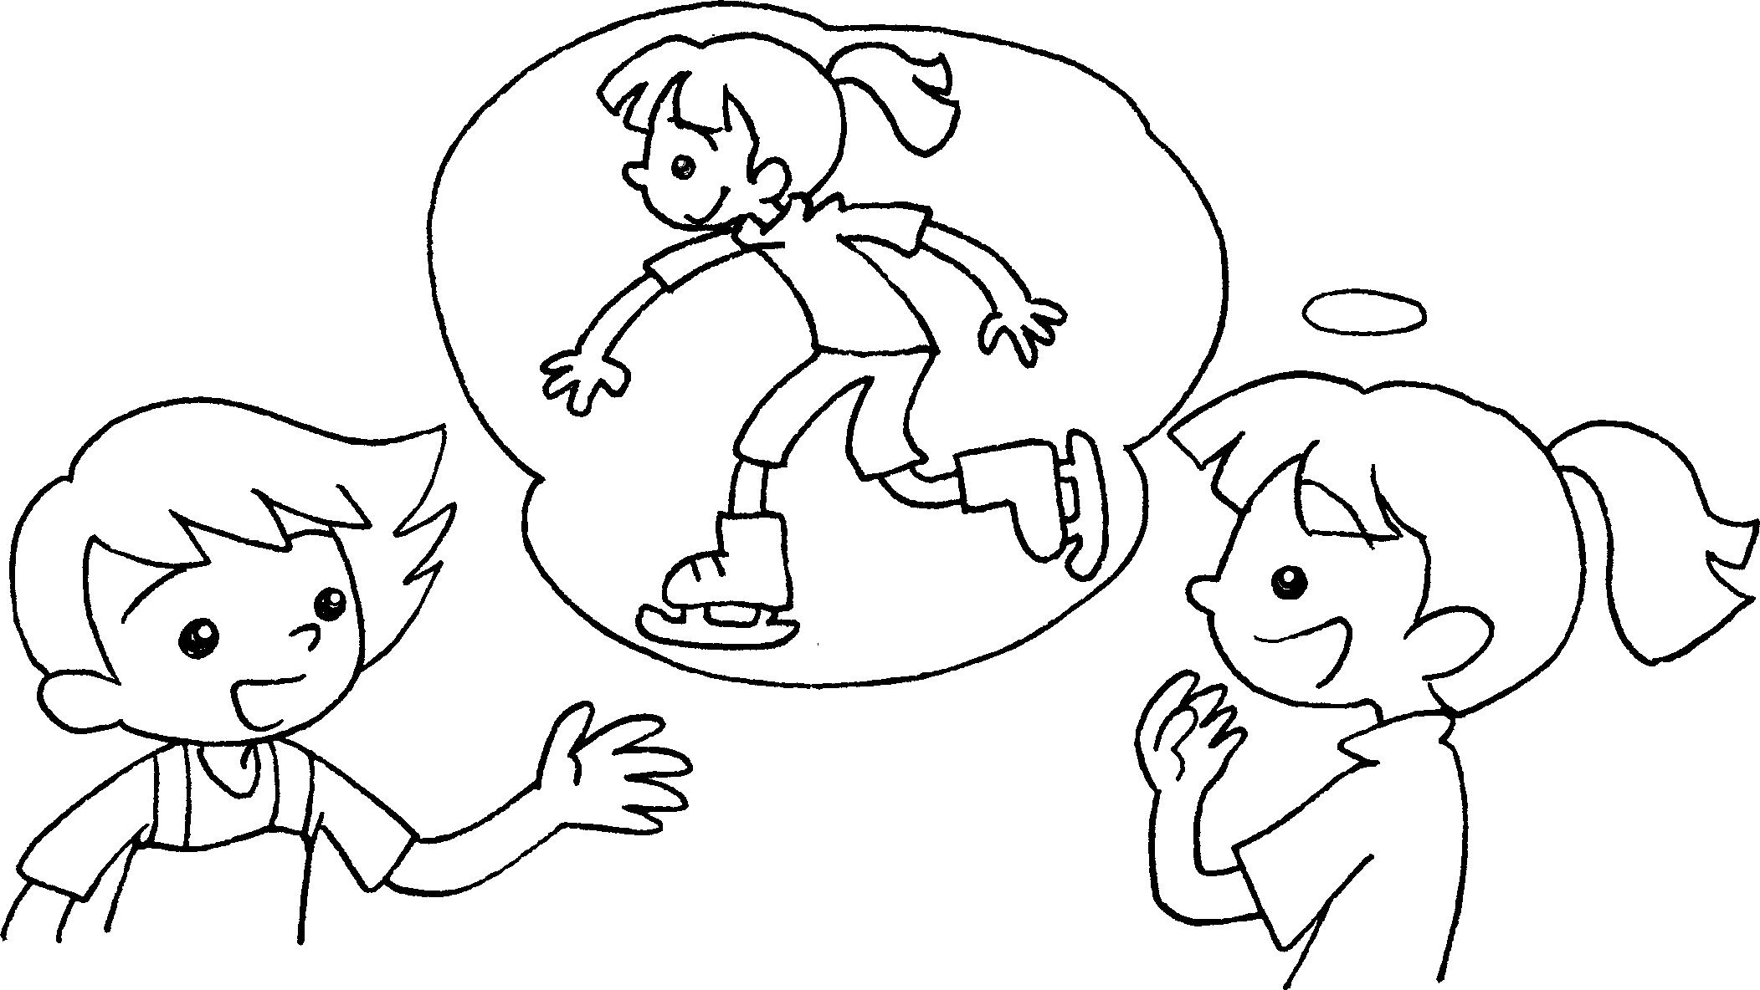  A  B | A : What do you like doing in your spare time?  B : I like going ___________________ .
2 | 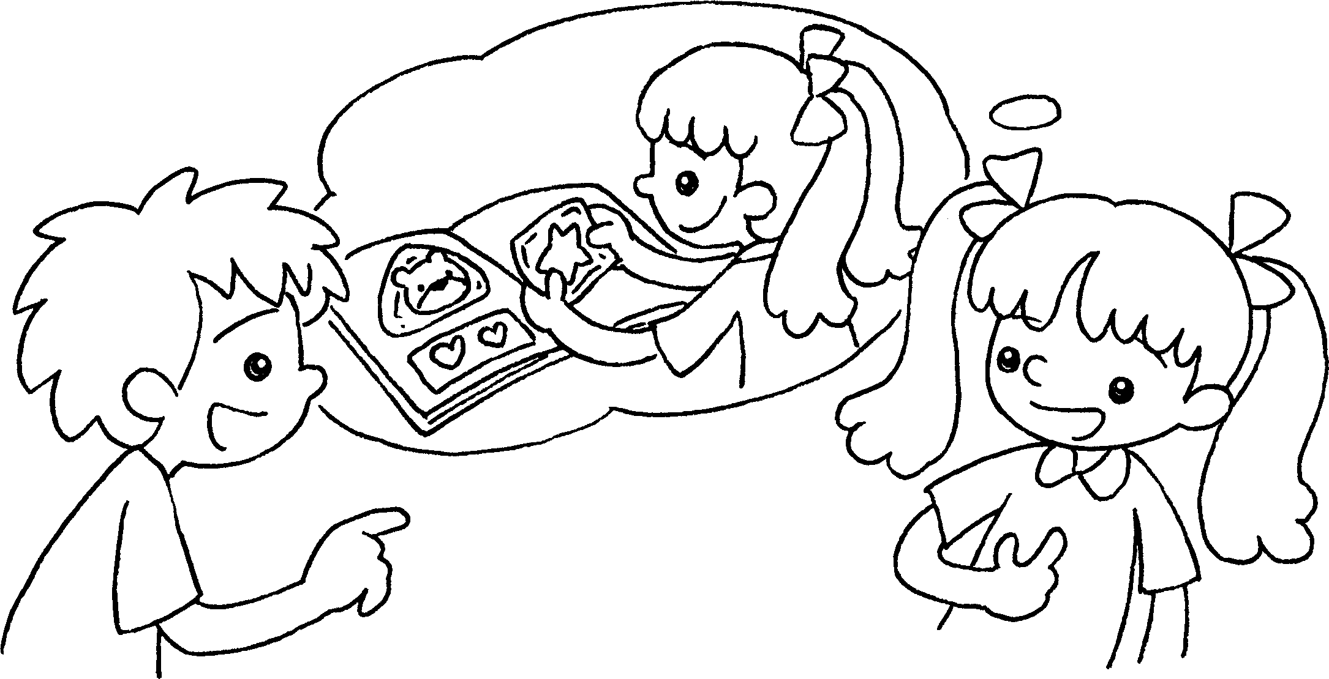  A  B | A : What do you like _______________ in your spare time?  B : I like ____________________________ .
3 | 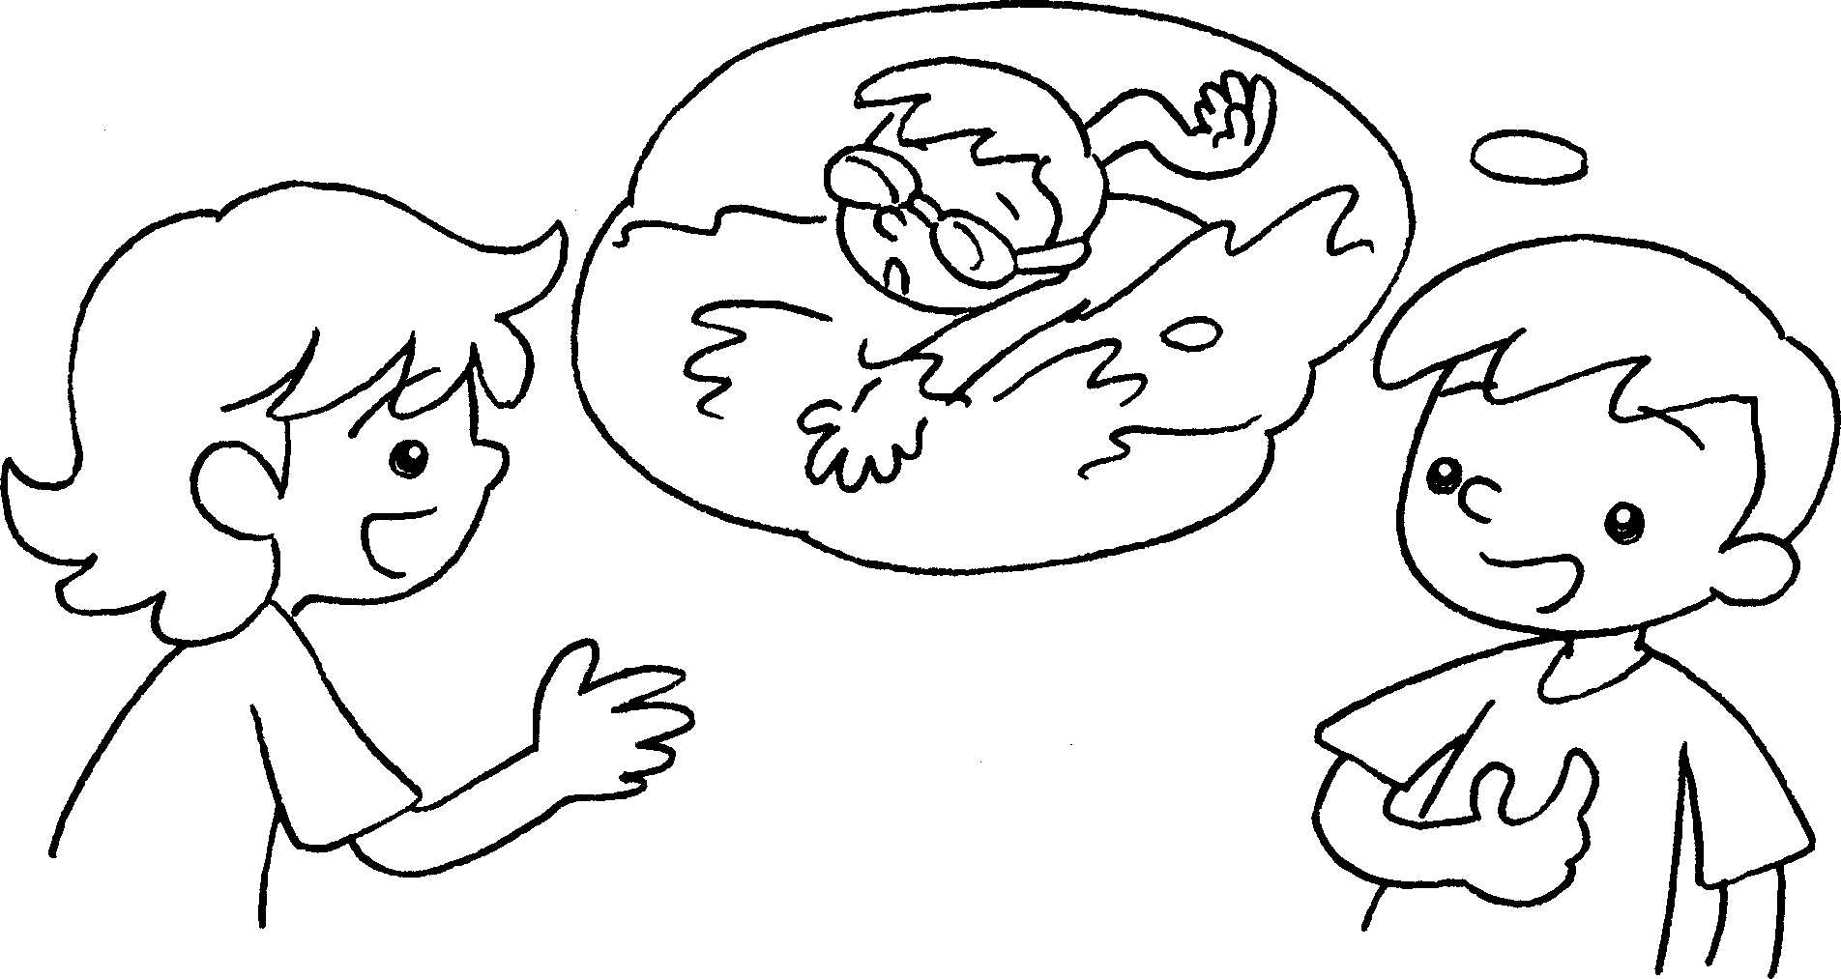  B  A | A : ___________________________________ in your spare time?  B : I ________________________________ .
4 | 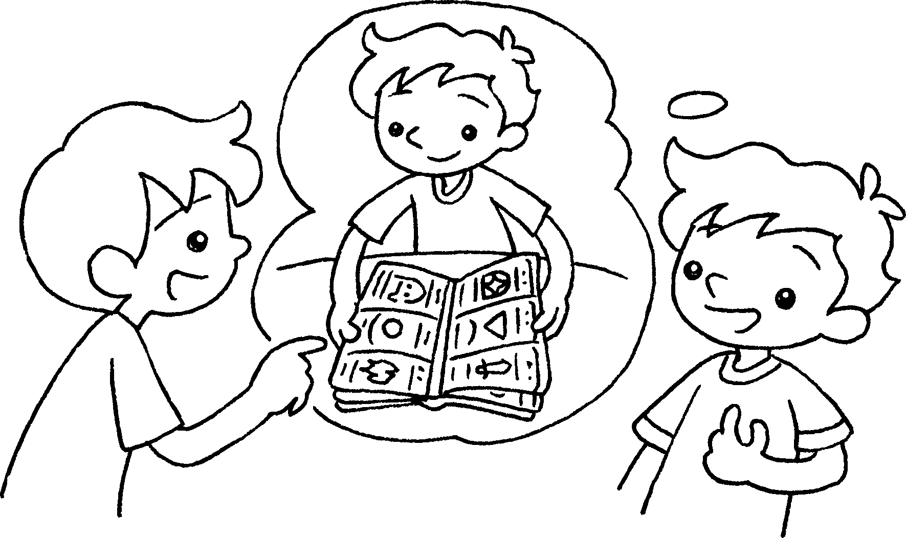  A  B | A : ___________________________________  ___________________________________  B : ___________________________________


Book 4A Chapter 1 Graded Worksheets
Worksheet 2⬇⬇⬇
- ice-skating
- doing
collecting stickers
- What do you like doing
like going swimming
- What do you like doing in your spare time?
I like collecting cards.

