How often does Sam do these activities? Finish what he says.
go

s

play
read

August
SunMonTueWedThuFriSat1
2
3
45
6
7
8
9
10
11
12
13
14
15
16
17
18
19
20
21
22
23
24
2526
27
282930
31

1 | always  I __________________ _______________ the newspaper on Sundays.
2 | I __________________ _______________ cycling on Mondays.
3 | I __________________ _______________ the piano on Tuesdays.
4 | I __________________ _______________ the violin on Wednesdays.
5 | 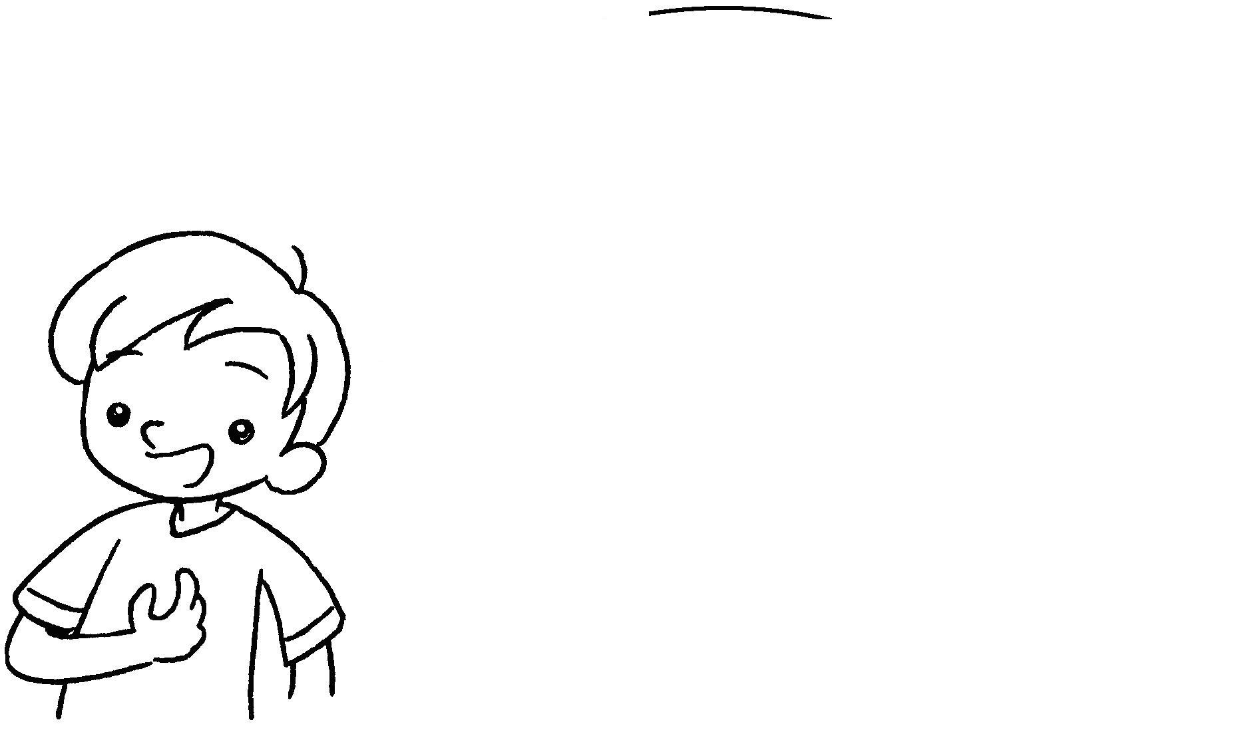  I __________________ _______________ basketball on Thursdays.
6 | I __________________ _______________ swimming on Fridays.
7 | I __________________ _______________ ice-skating on Saturdays.


Book 4A Chapter 1 Graded Worksheets
Worksheet 3⬇⬇
- read
- often go
- sometimes play
- always play
- never play
- sometimes go
- never go

