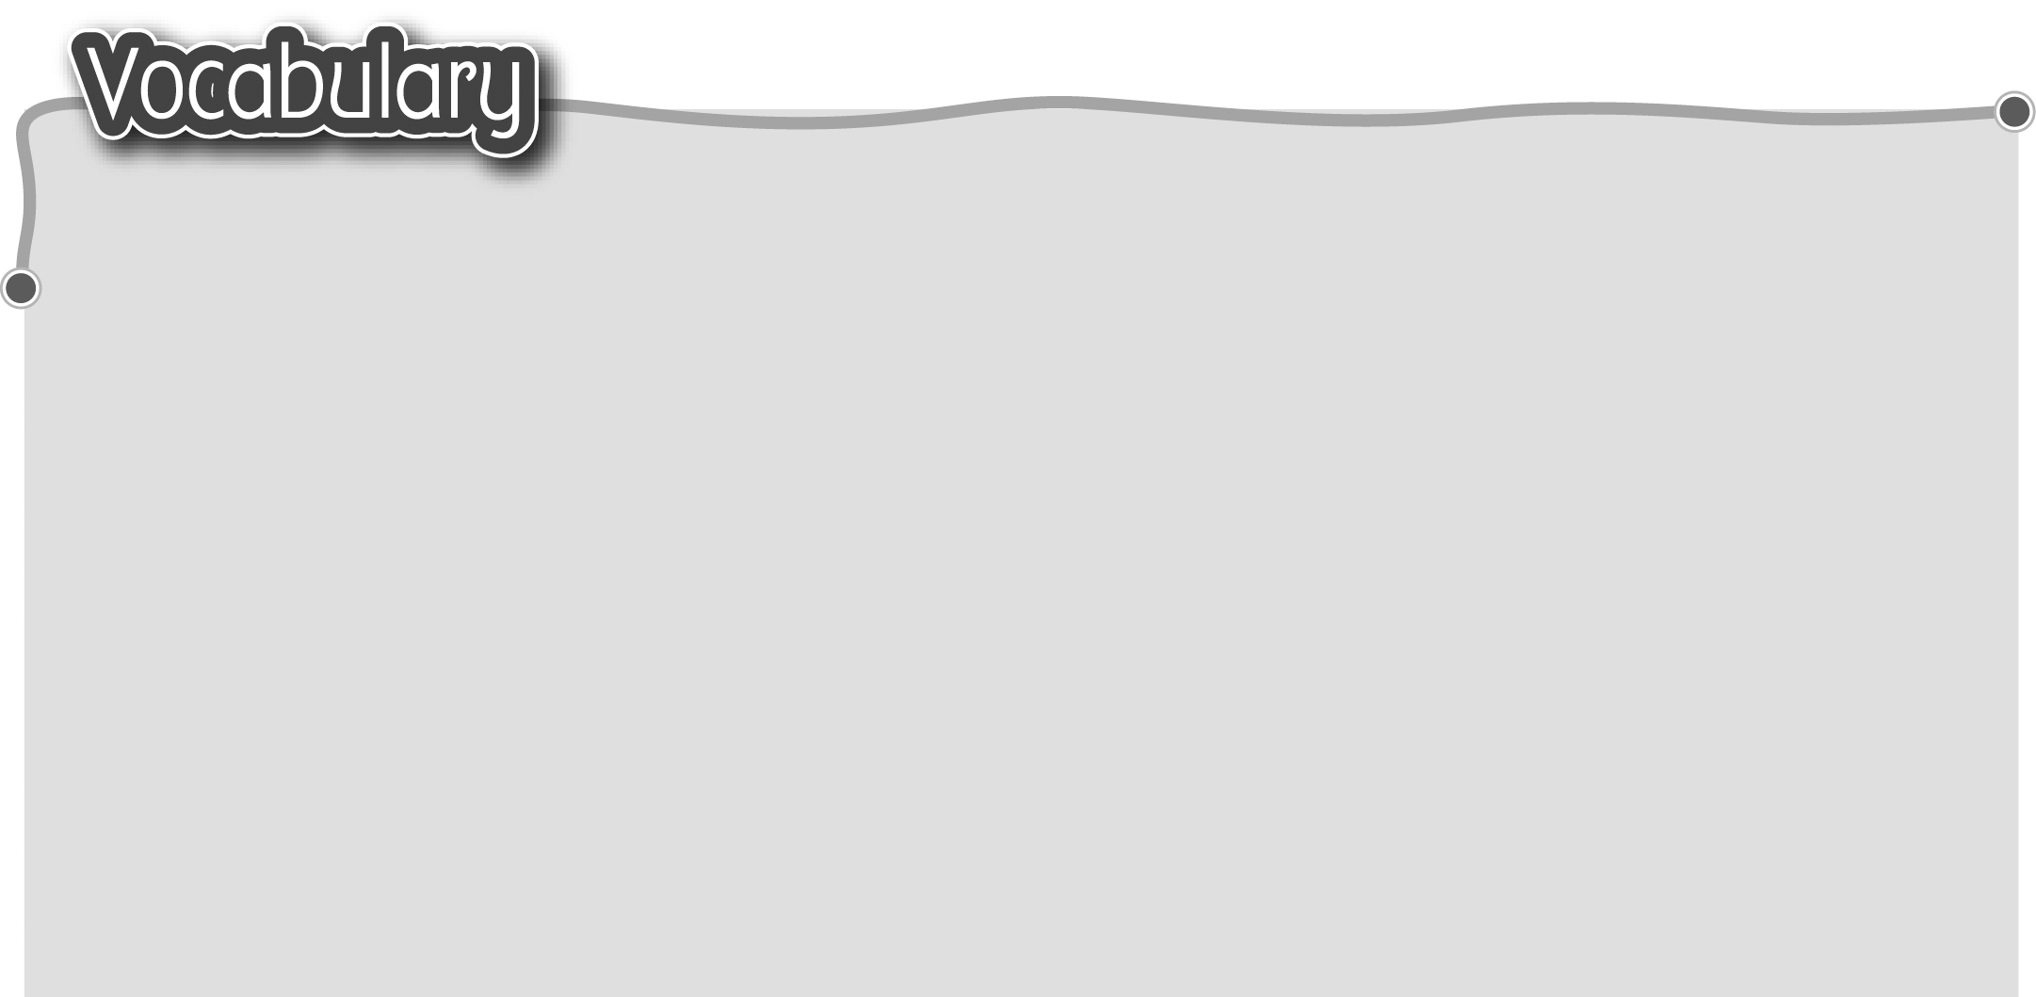
1 hobby (hobbies) 嗜好 10 going cycling 騎單車
2 collecting cards 收集卡片 11 playing computer games
3 collecting stickers 收集貼紙 玩電腦遊戲
4 collecting stamps 收集郵票 12 playing Chinese checkers
5 reading the newspaper 閱讀報紙 下波子棋
6 reading magazines 閱讀雜誌 13 playing the piano 彈鋼琴
7 reading comics閱讀漫畫書 14 playing the violin 拉小提琴
8 going ice-skating 溜冰 15 playing football 踢足球
9 going swimming 游泳 16 playing basketball 打籃球
The words marked with * have different meanings in other
contexts. You can look up those meanings in a dictionary.
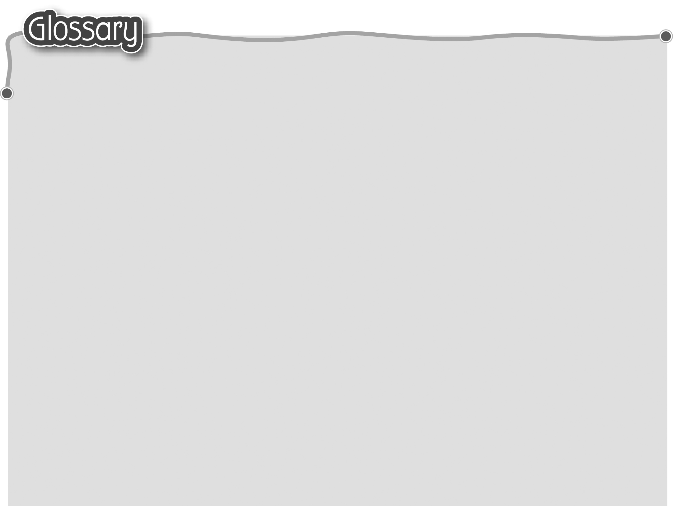
1 always (p.3) 經常 15 spare time (p.3) 空餘時間
2 often (p.2) 時常 16 look for (p.3) 找尋
3 sometimes (p.3) 有時 17 same (p.3) 相同
4 seldom (p.3) 很少 18 even* (p.3) 甚至
5 never (p.3) 從不 19 chat* (p.6) 聊天（動詞）
6 world (p.2) 世界 20 address* (p.8) 地址（名詞）
7 website (p.2) 網站 21 phone number (p.8) 電話號碼
8 rhyme* (p.2) 押韻詩（名詞） 22 how long* (p.9) 多久
9 surf the Net (p.2) 上網 23 interest class (p.9) 興趣班
10 weekend (p.3) 週末 24 native speaker (p.9) 以……為母語的人
11 when* (p.3) 當 25 course fee (p.9) 課程學費
12 jogging (jog) (p.3) 緩步跑（動詞） 26 venue (p.9) 地點
13 prefer (p.3) 寧願 27 enrol (p.9) 報名
14 boring (p.3) 沉悶

