Choose and write.
small | tall | light | fat | young | short
big | short | heavy | thin | old | long

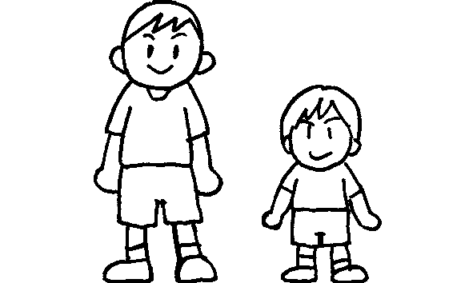
Peter
Simon
1 | Simon is ____________ .  Peter is ____________ .
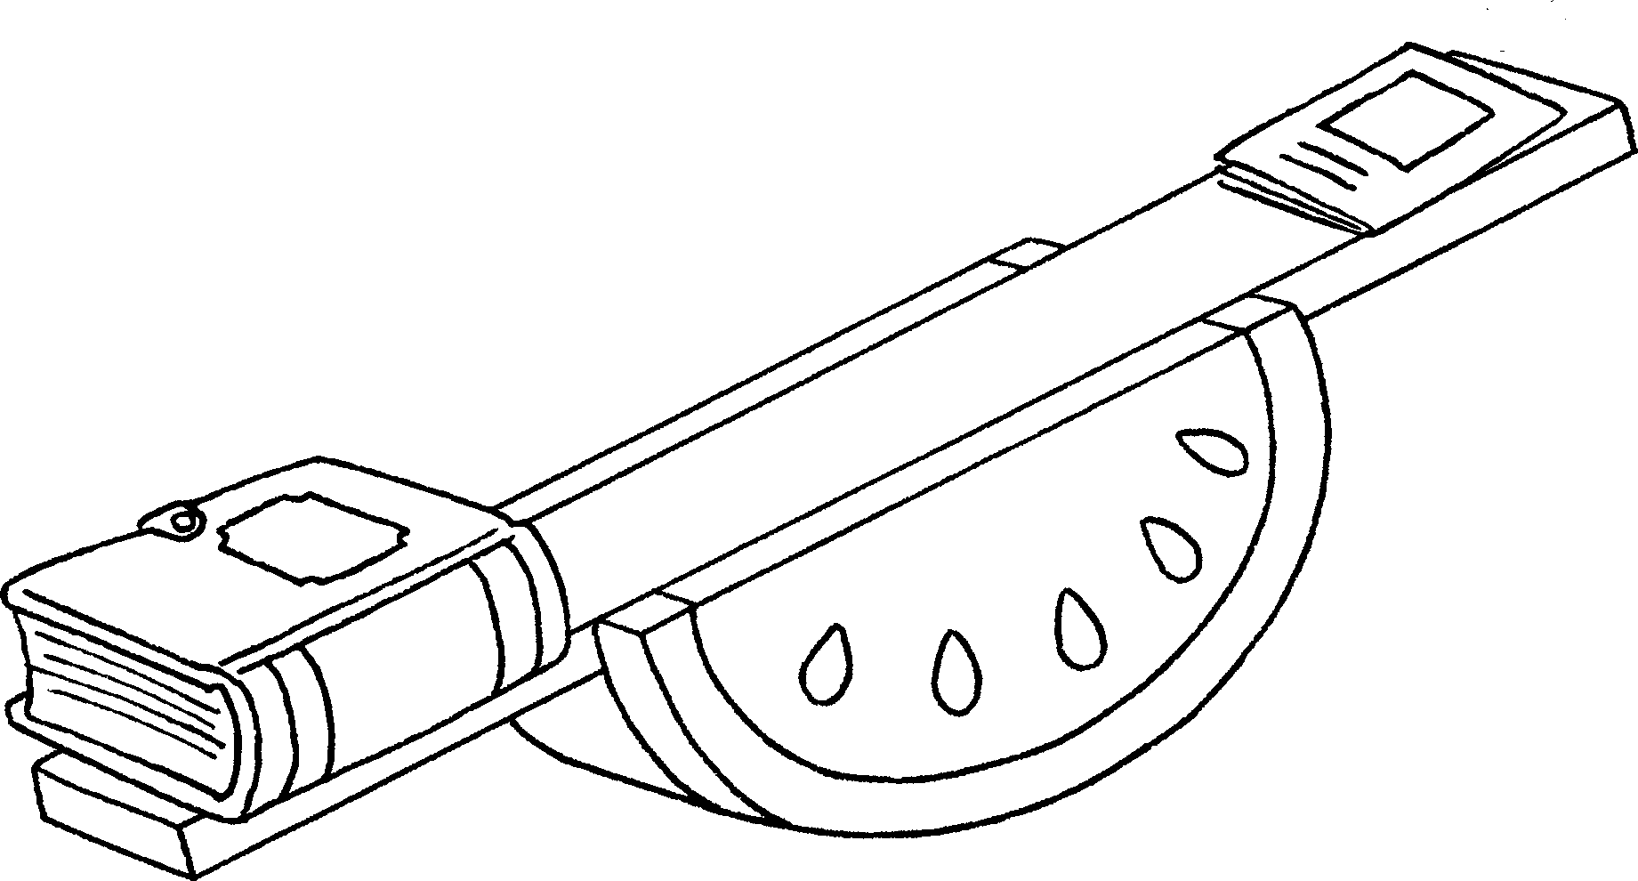  2  Mary’s book  Tim’s book | Mary’s book is ____________ .  Tim’s book is ____________ .
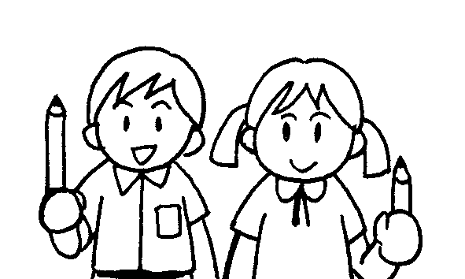  3  Betty  John | John’s pencil is ____________ .  Betty’s pencil is ____________ .
4 | The elephant is ____________ .  The mouse is ____________ .
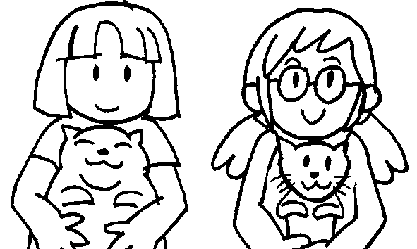  5  Sue  Kitty | Kitty’s cat is ____________ .  Sue’s cat is ____________ .
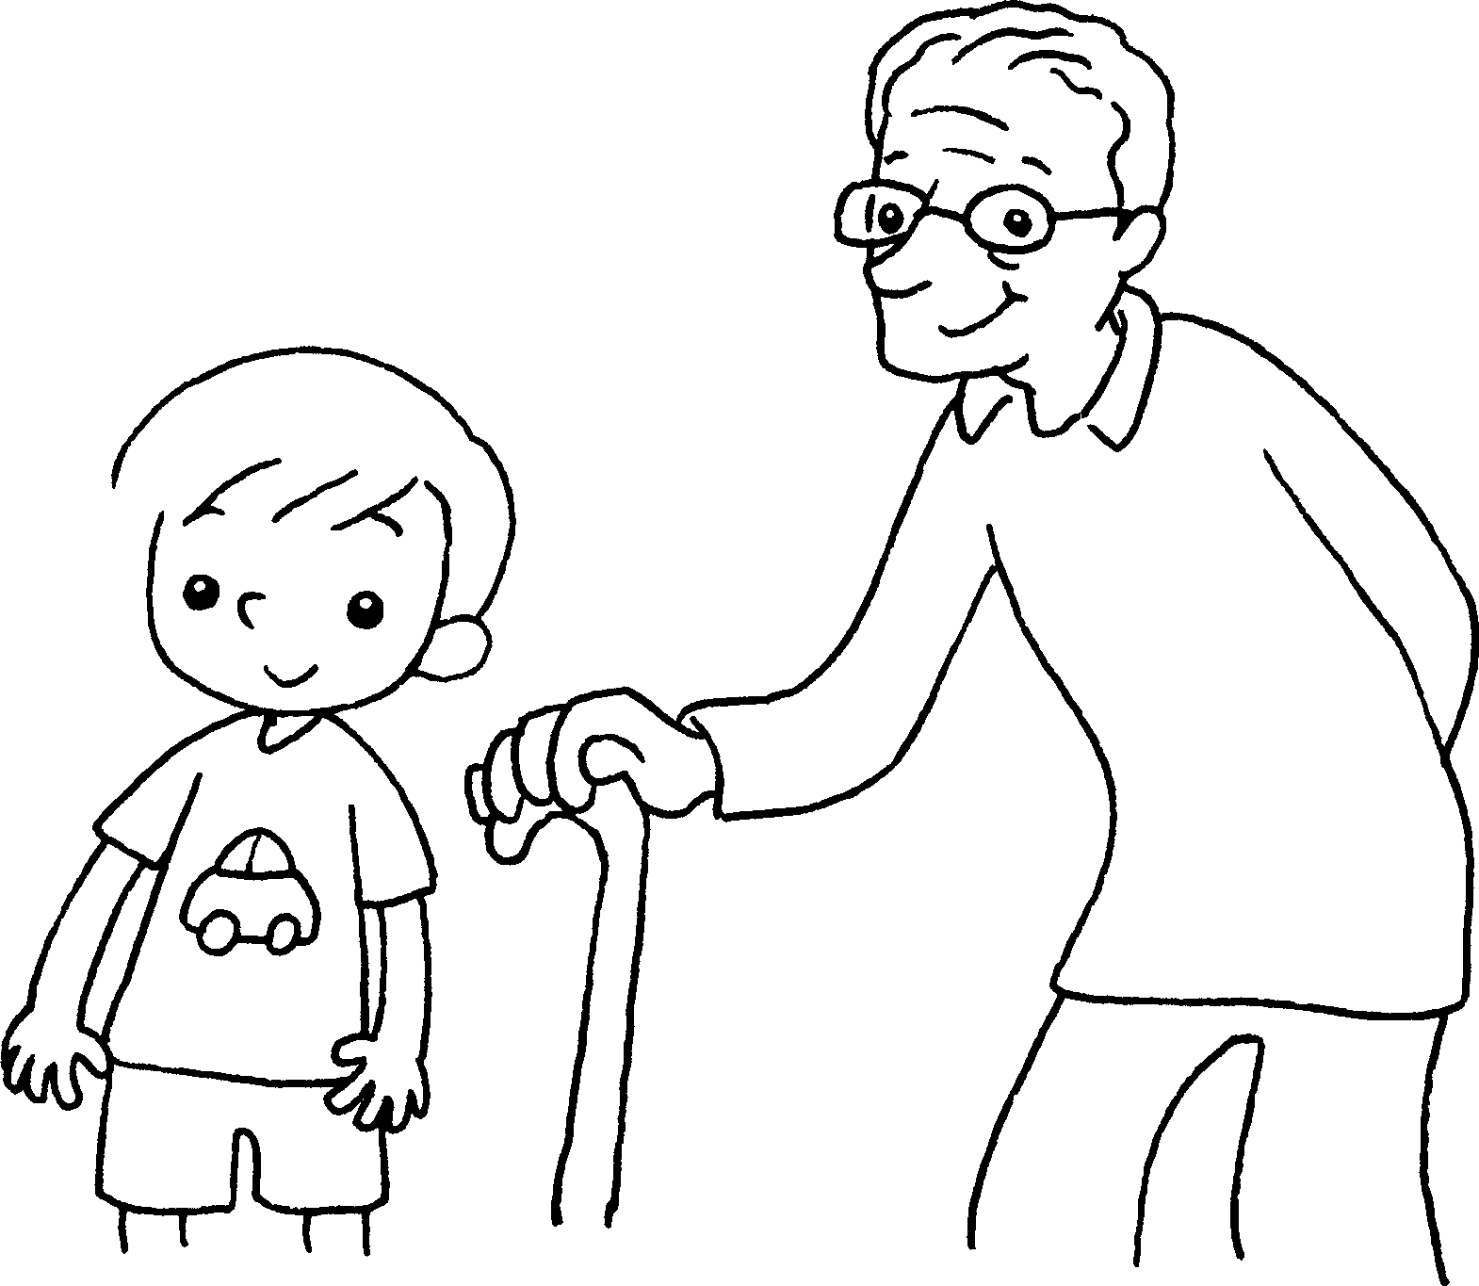  6  Sam  Mr Chow | Sam is _____________ .  Mr Chow is ____________ .


Book 4A Chapter 2 Graded Worksheets
Worksheet 1⬇
- tall
short
- heavy
light
- long
short
- big
small
- fat
thin
- young
old

