Describe the people and things. Write the opposite adjectives.

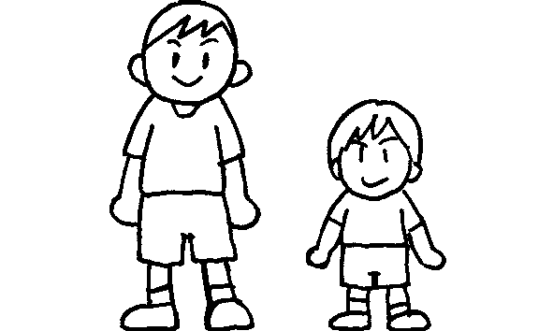  1  Peter  Simon | Simon is tall.  Peter is s .
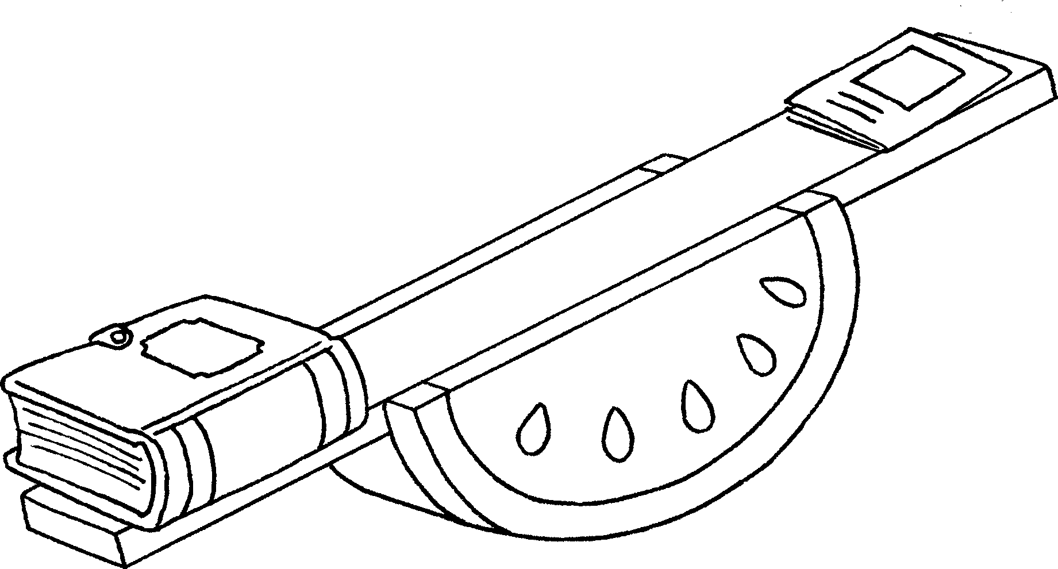  2  Mary’s book  Tim’s book | Mary’s book is h .  Tim’s book is light.
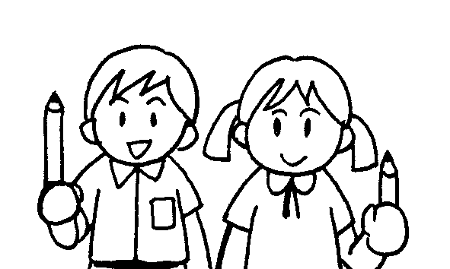  3  Betty  John | John’s pencil is l .  Betty’s pencil is short.
4 | The elephant is b .  The mouse is s .
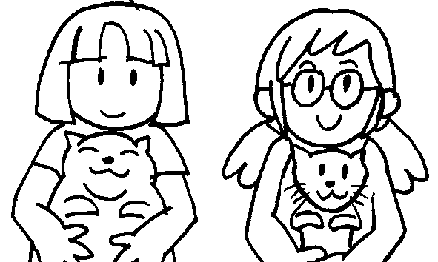  5  Sue  Kitty | Kitty’s cat is f .  Sue’s cat is t .
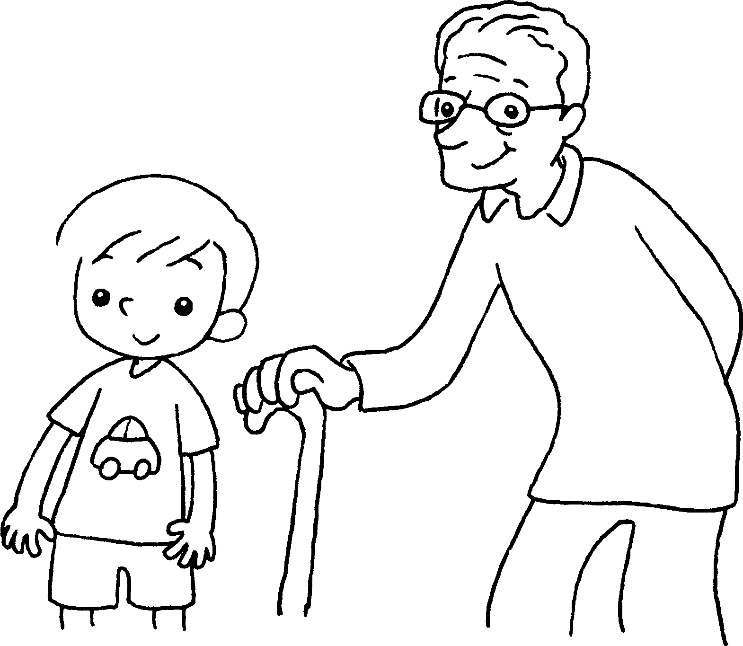  6  Sam  Mr Chow | Sam is y .  Mr Chow is o .


Book 4A Chapter 2 Graded Worksheets
Worksheet 1⬇⬇
- short
- heavy
- long
- big
small
- fat
thin
- young
old

