Describe the people and things. Write the opposite adjectives.

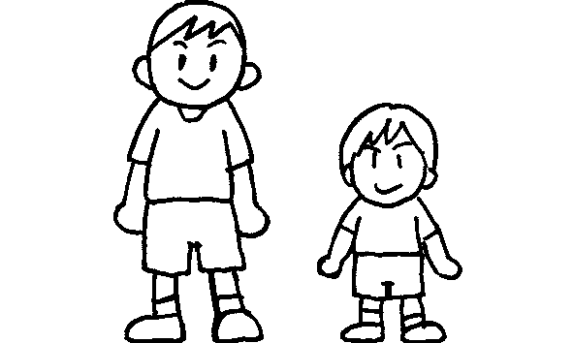  1  Peter  Simon | Simon is .  Peter is short.
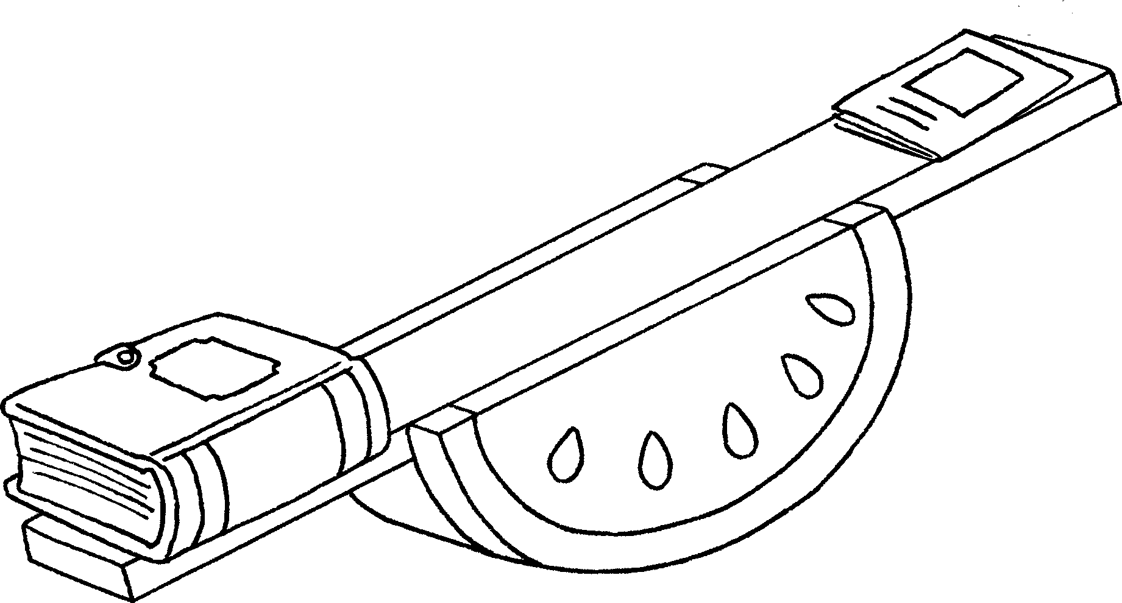  2  Mary’s book  Tim’s book | Mary’s book is .  Tim’s book is light.
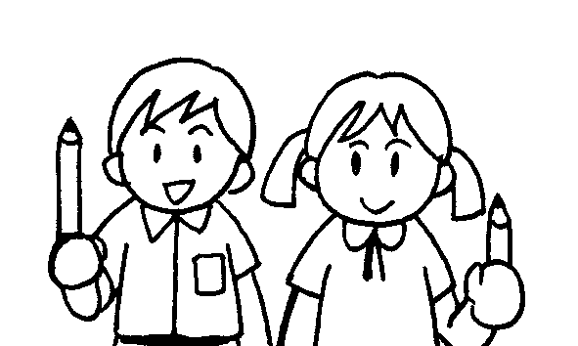  3  Betty  John | John’s pencil is l .  Betty’s pencil is s .
4 | The elephant is b .  The mouse is .
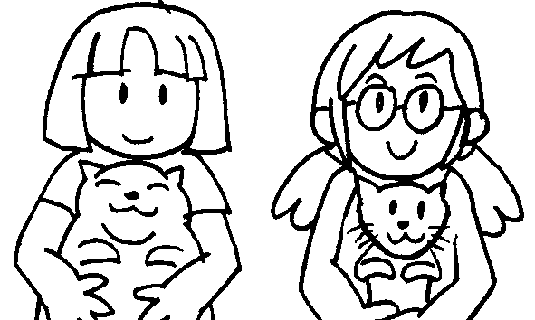  5  Sue  Kitty | Kitty’s cat is .  Sue’s cat is t .
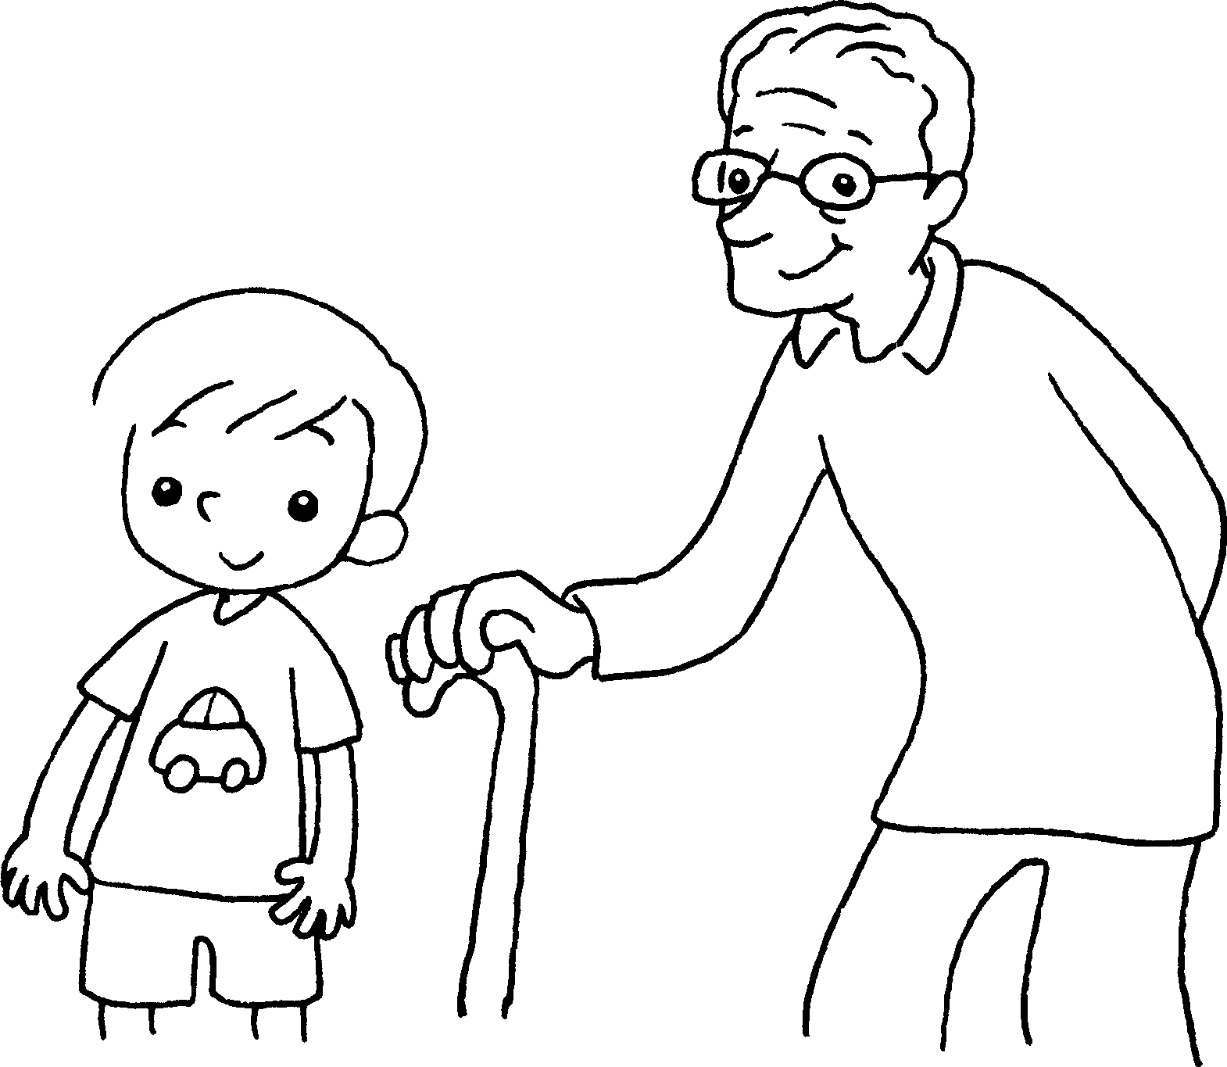  6  Sam  Mr Chow | Sam is .  Mr Chow is o .


Book 4A Chapter 2 Graded Worksheets
Worksheet 1⬇⬇⬇
- tall
- heavy
- long
short
- big
small
- fat
thin
- young

old

