Betty
Emma
May
Lucy
Fill in the blanks with the correct form of the words.
1  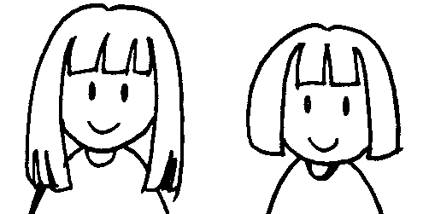 | 2  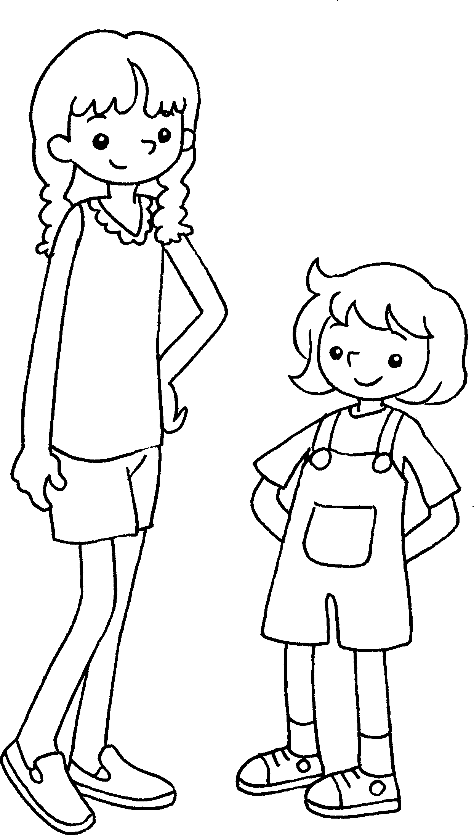
May’s hair is _______________  ( long ) than Lucy’s. | Betty is _______________  ( tall ) than Emma.
3  Kate’s bag  Dora’s bag  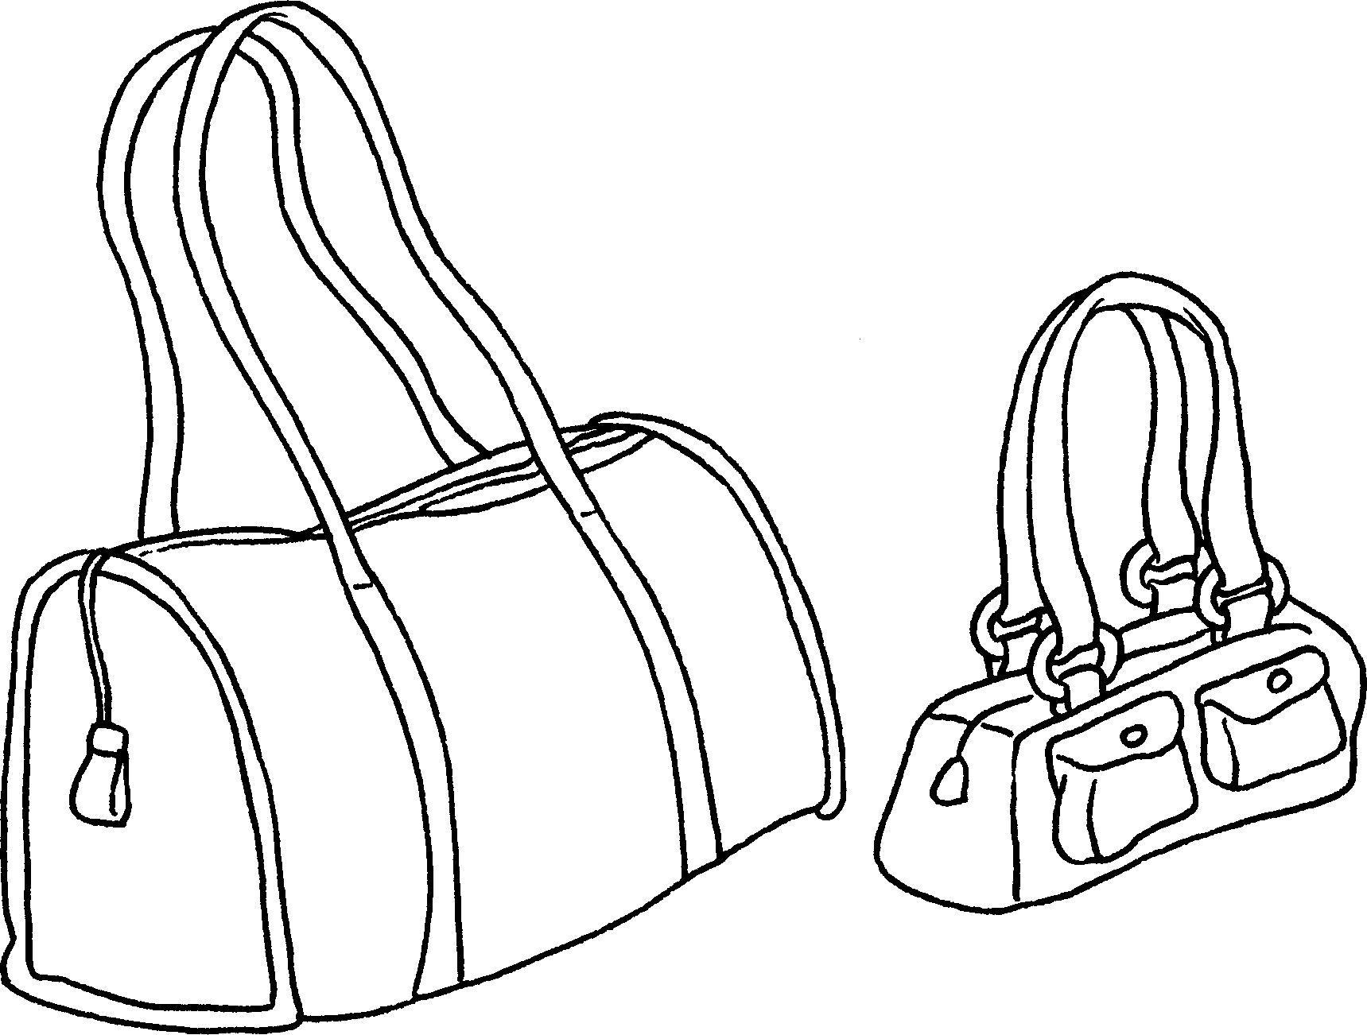 | 4  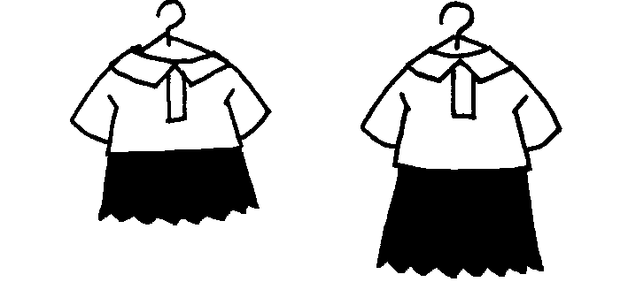  Sandy’s dress  Polly’s dress
Kate’s bag is _______________  ( big ) than Dora’s. | Sandy’s dress is ______________  ( short ) than Polly’s.
5  Andy  Mark  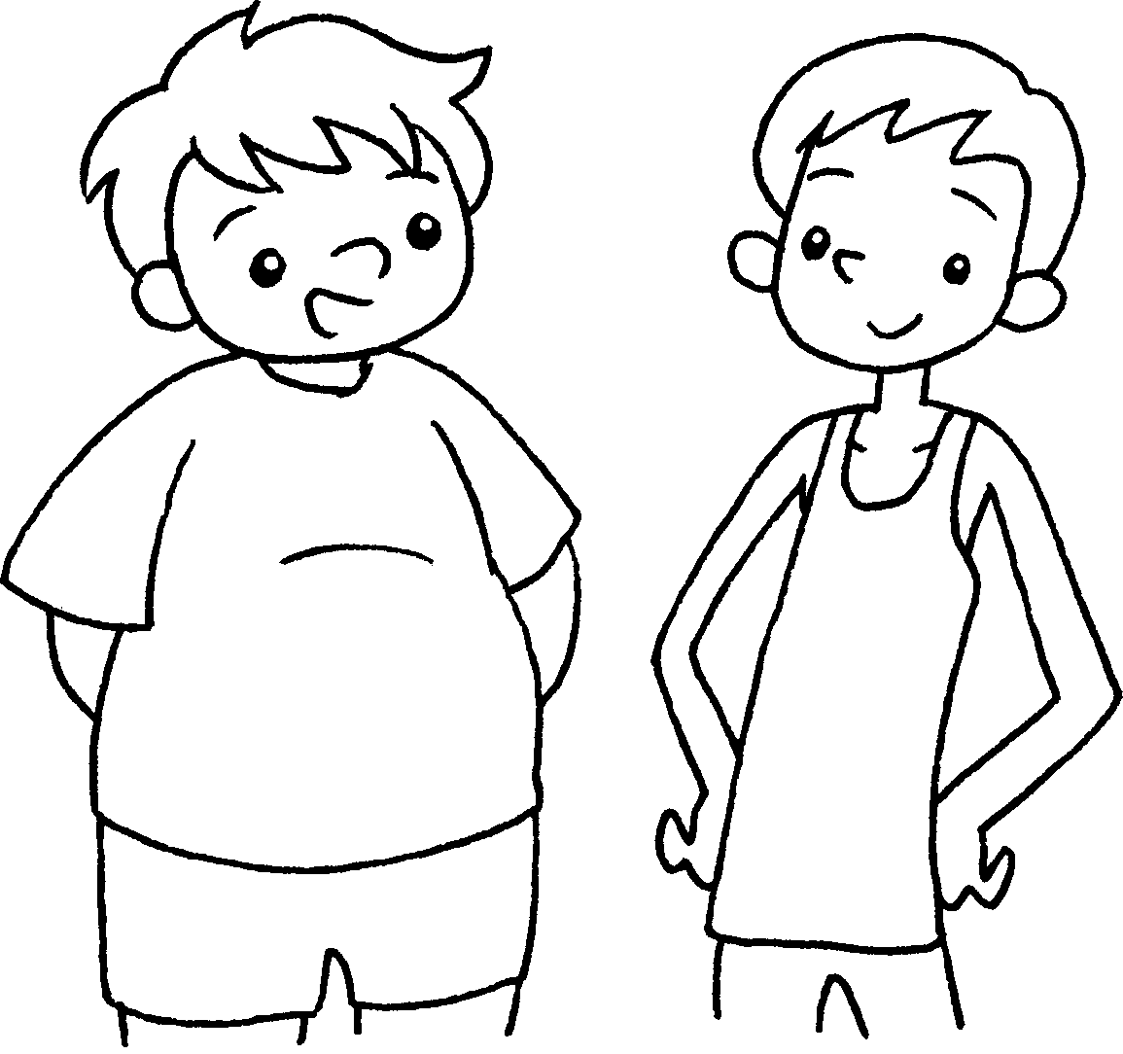 | 6  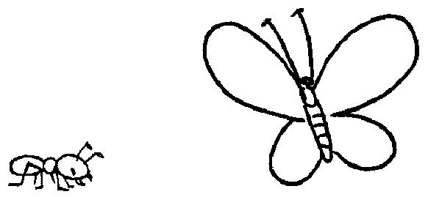
Andy is _______________ ( fat ) than Mark. | An ant is _______________ ( small ) than a butterfly.



Book 4A Chapter 2 Graded Worksheets
Worksheet 2⬇
- longer
- taller
- bigger
- shorter
- fatter
- smaller

