Betty
Emma
May
Lucy
Fill in the blanks with the correct form of the words.
long short big small tall fat

1  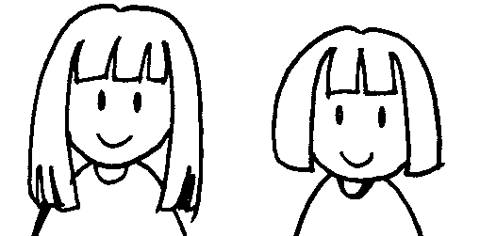 | 2  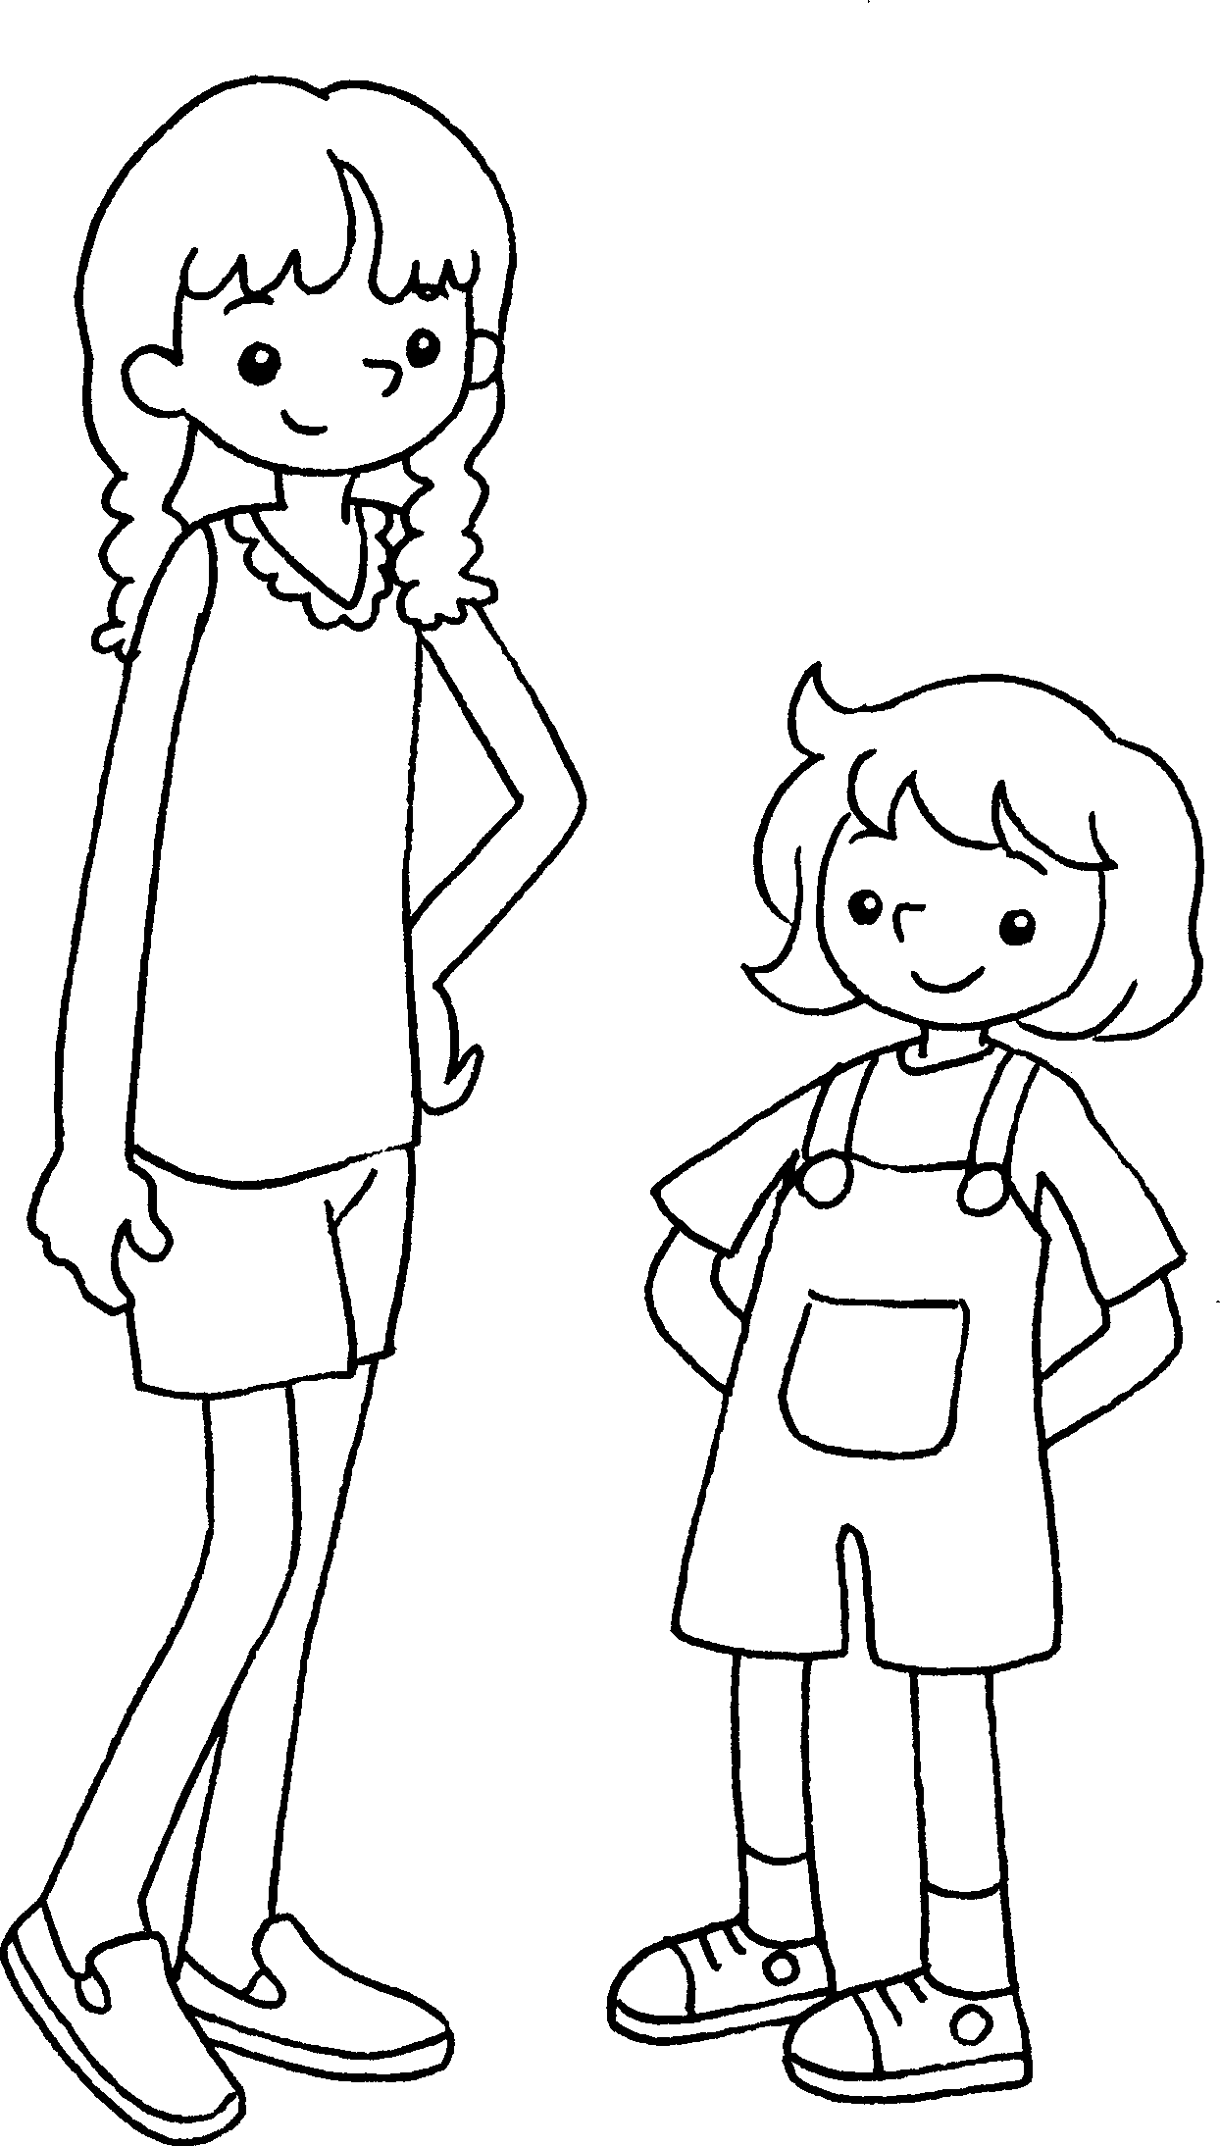
May’s hair is _______________  than Lucy’s. | Betty is _______________  than Emma.
3  Kate’s bag  Dora’s bag  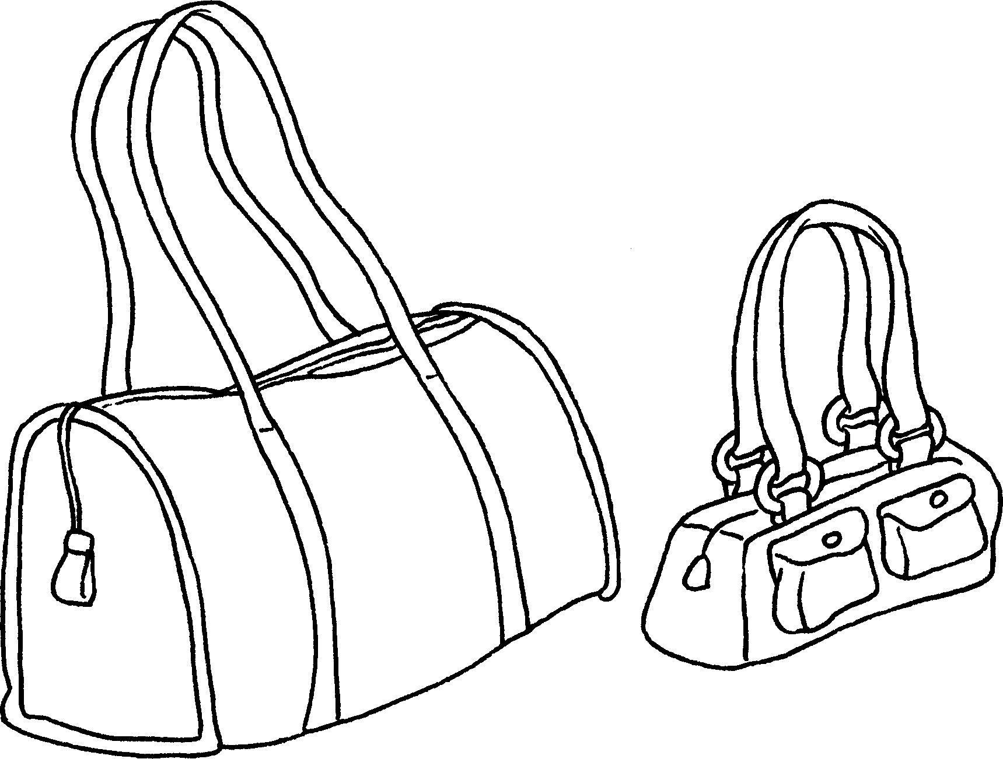 | 4  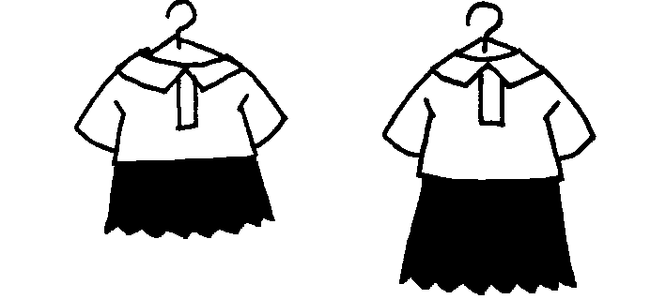  Sandy’s dress  Polly’s dress
Kate’s bag is _______________  than Dora’s. | Sandy’s dress is ______________  than Polly’s.
5  Andy  Mark  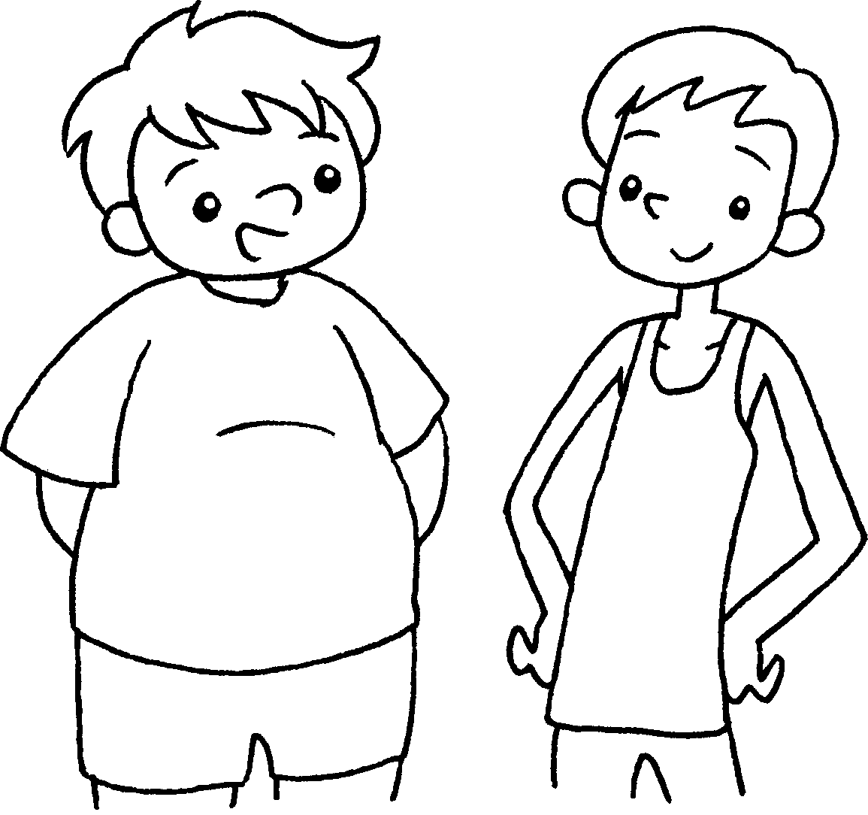 | 6  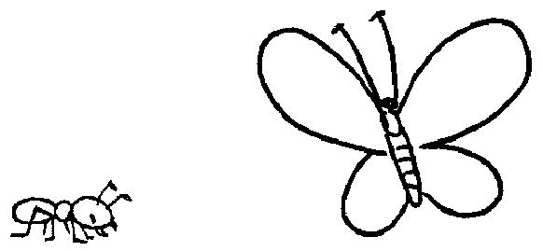
Andy is _____________________ Mark. | An ant is _____________________  a butterfly.



Book 4A Chapter 2 Graded Worksheets
Worksheet 2⬇⬇
- longer
- taller
- bigger
- shorter
- fatter than
- smaller than

