Betty
Emma
May
Lucy
Fill in the blanks with the correct form of the words.
1  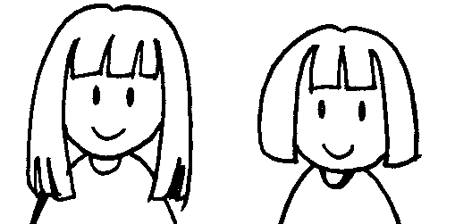 | 2  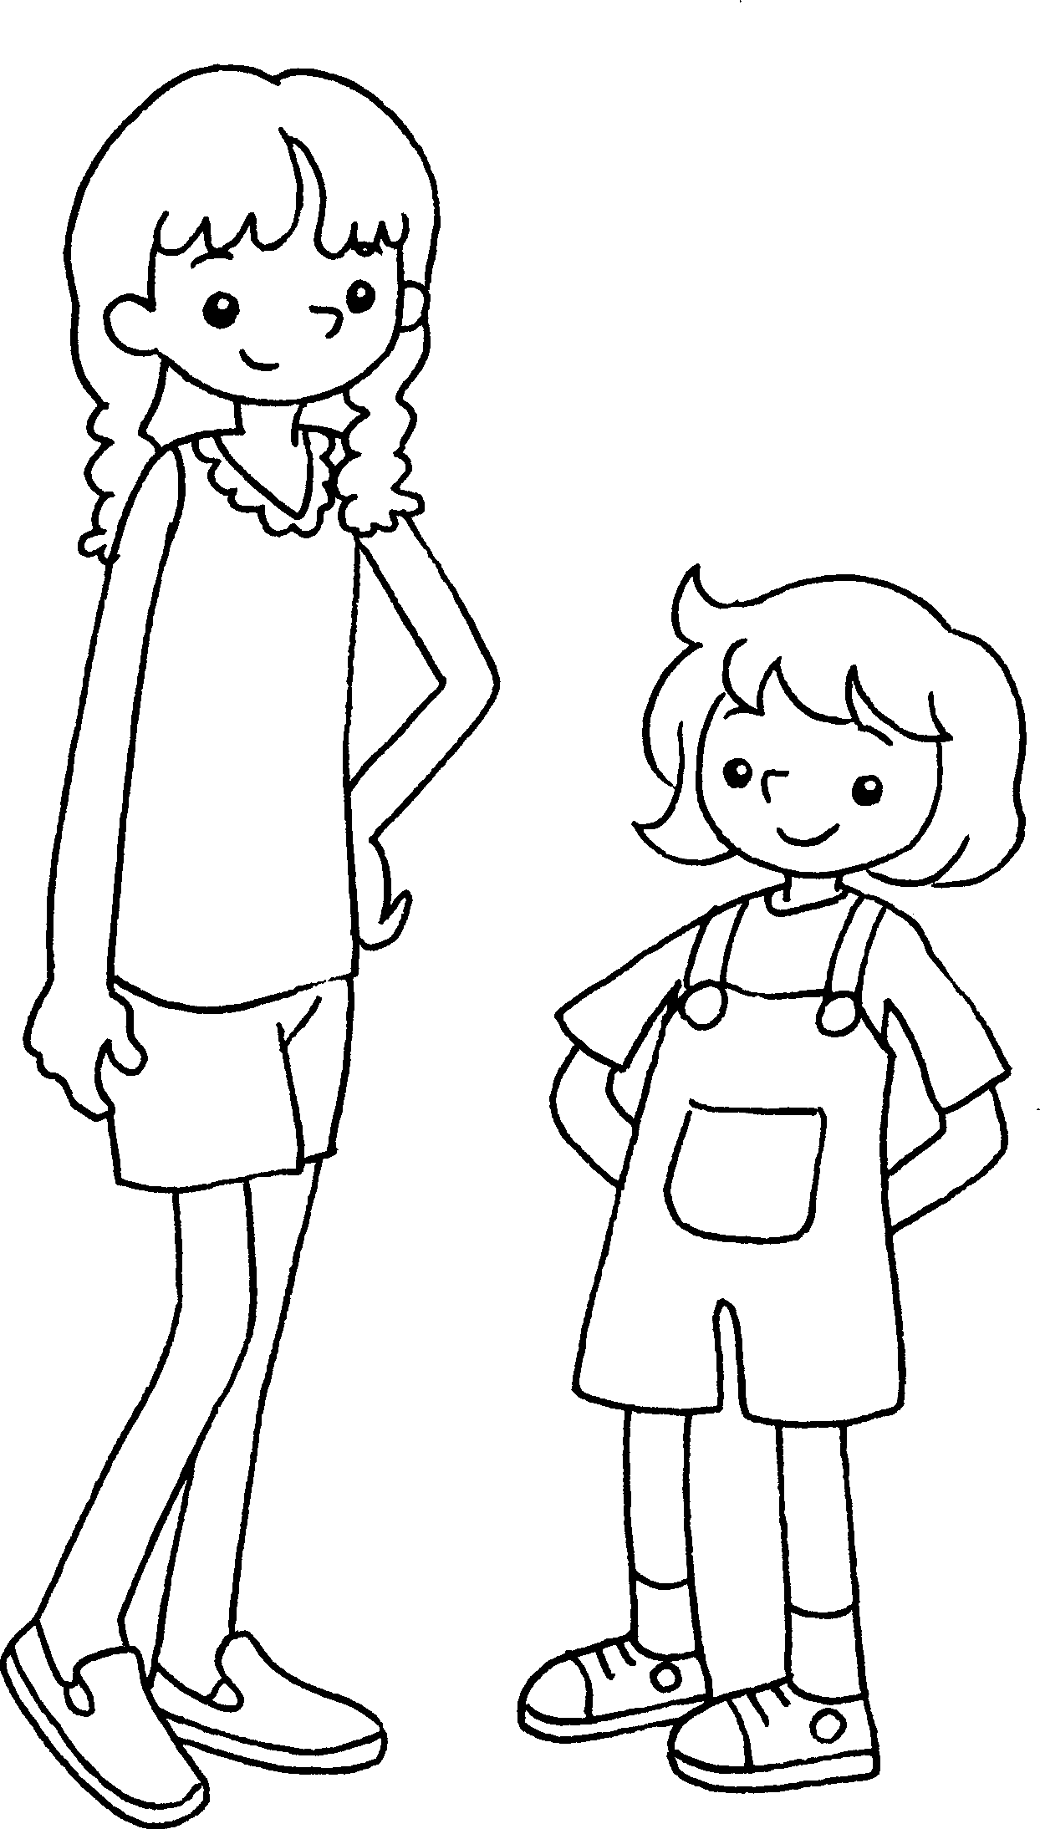
May’s hair is l  than Lucy’s. | Betty is t  than Emma.
3  Kate’s bag  Dora’s bag  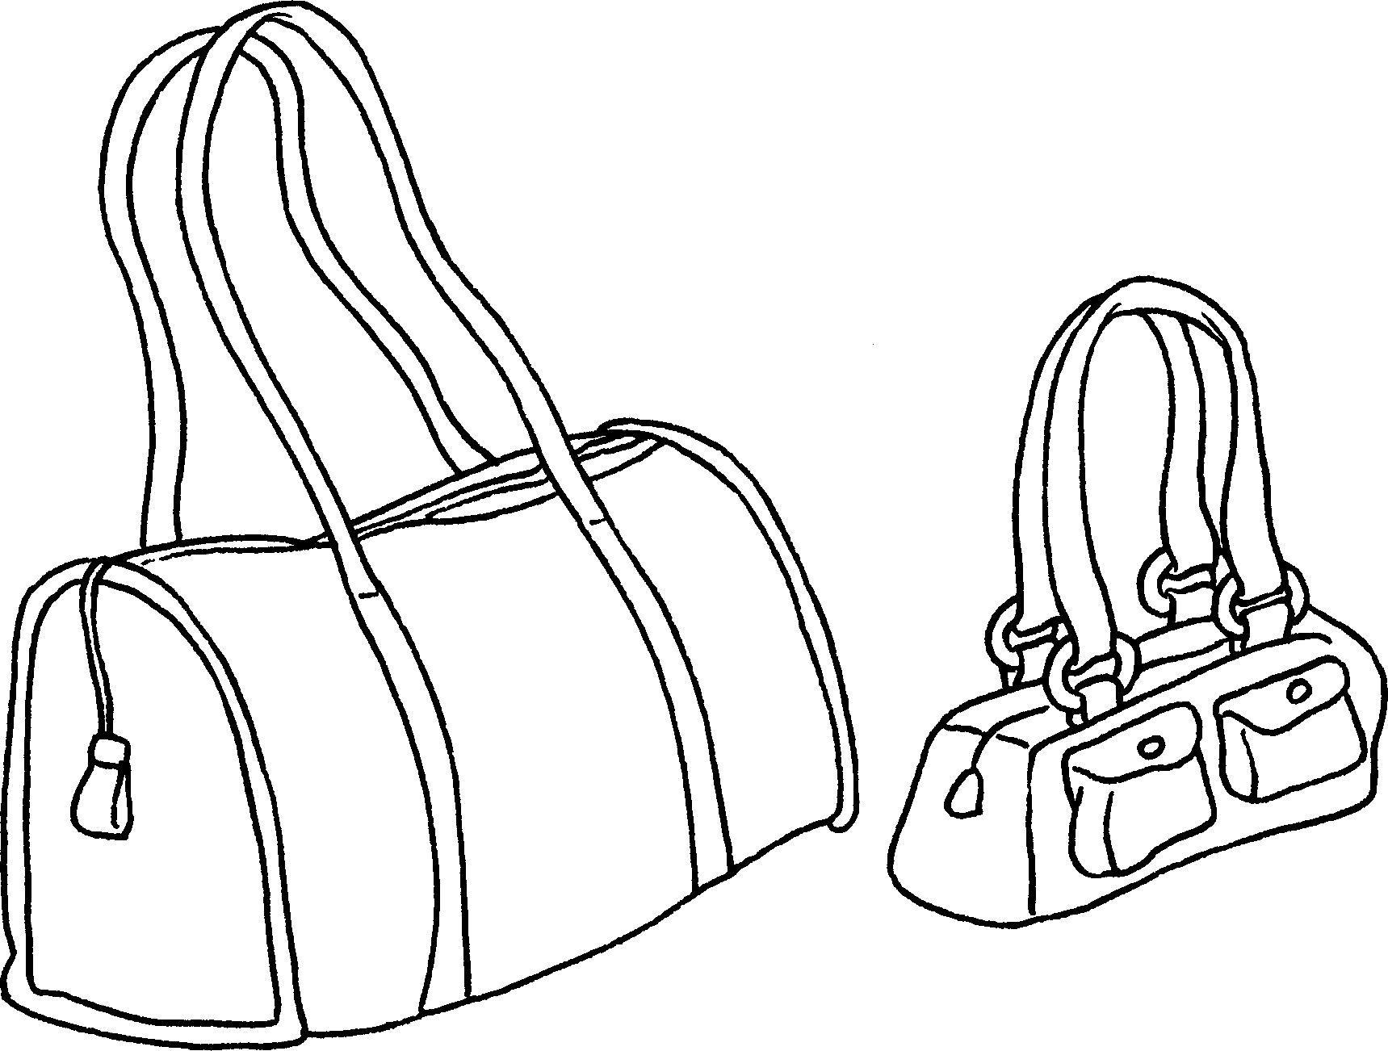 | 4  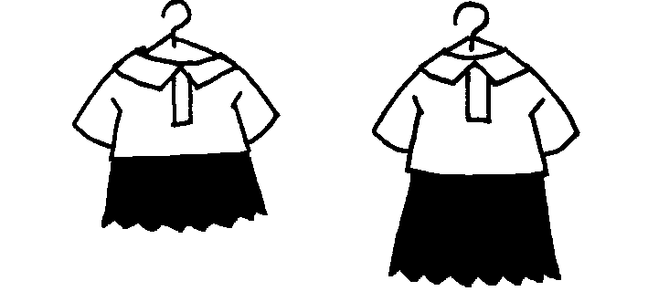  Sandy’s dress  Polly’s dress
Kate’s bag is b  than Dora’s. | Sandy’s dress is s  Polly’s.
5  Andy  Mark  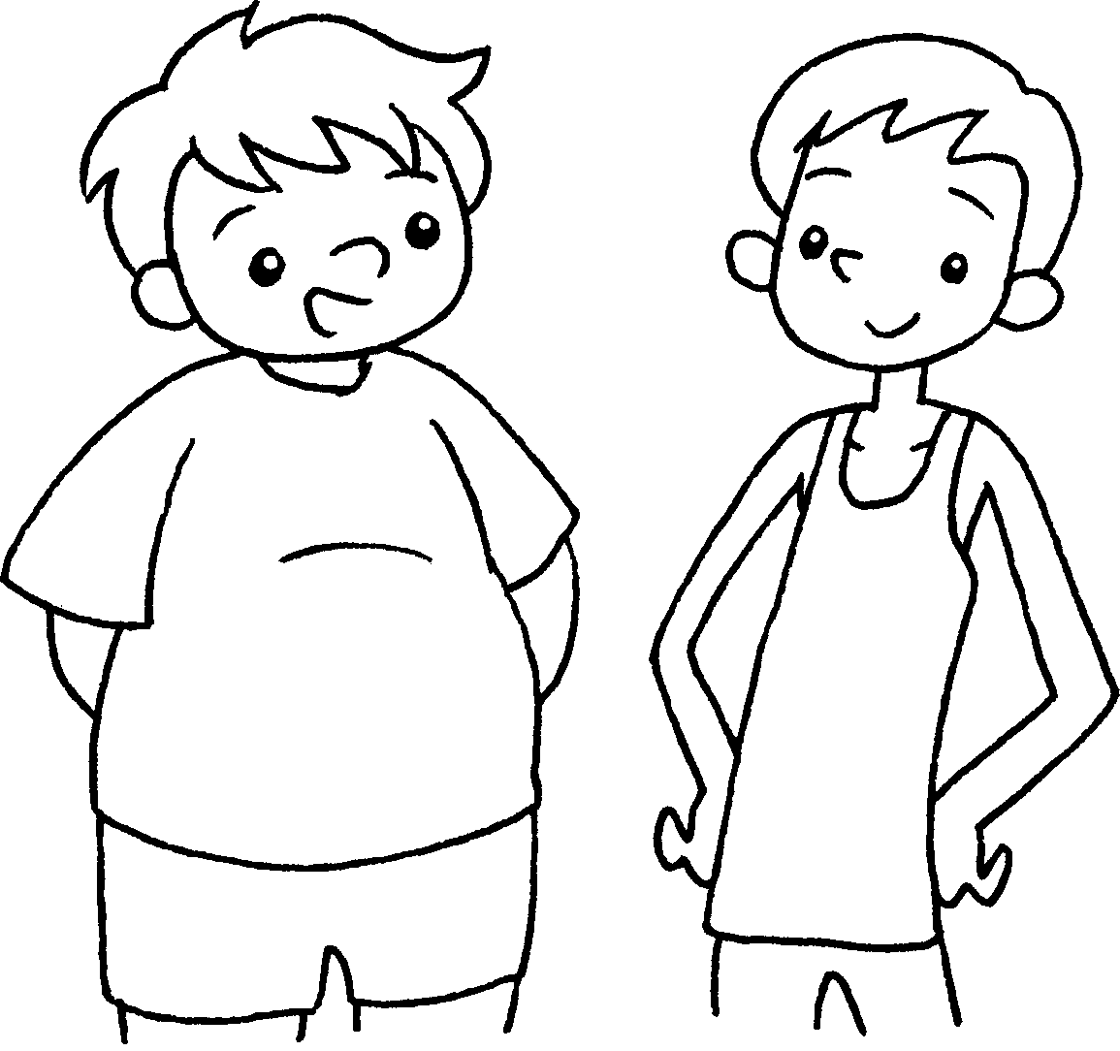 | 6  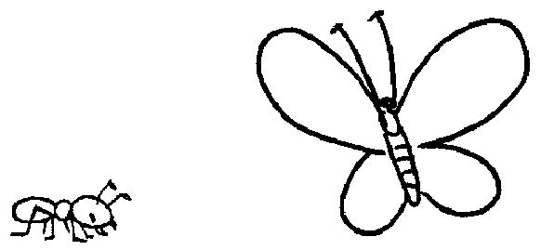
Andy is f  . | An ant is s  .


Book 4A Chapter 2 Graded Worksheets
Worksheet 2⬇⬇⬇
- longer
- taller
- bigger
- shorter than
- fatter than Mark
- smaller than a butterfly

