Circle the correct answers.
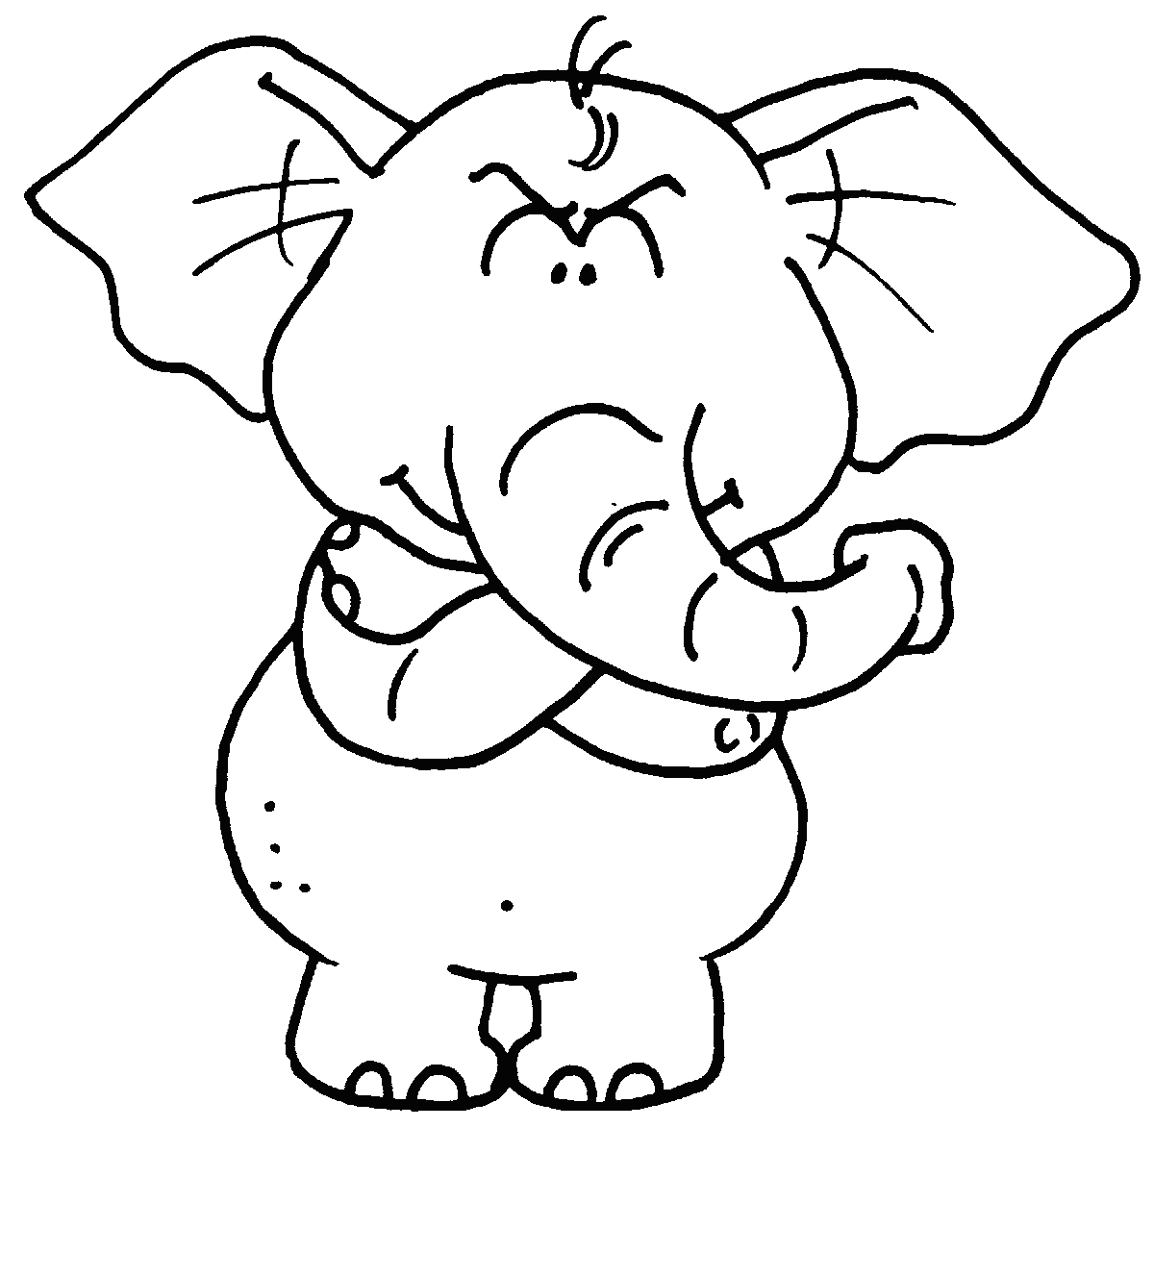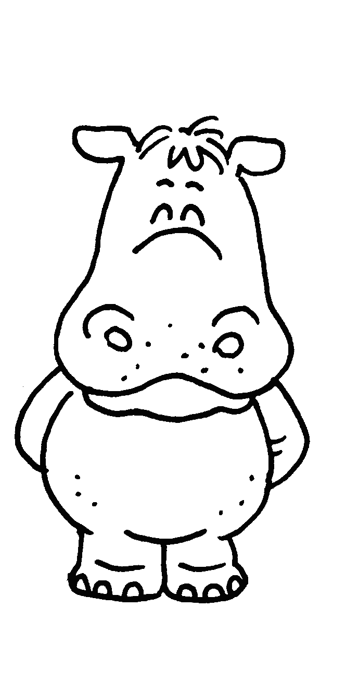
Elly
Hippy
Pandy

Weight1200 kg900 kg125 kgAge8124

1 Hippy is ( lighter than / the lightest ) Elly.
Pandy is ( lighter than / the lightest ).
2 Elly is ( younger than / the youngest ) Hippy.
Pandy is ( younger than / the youngest ).
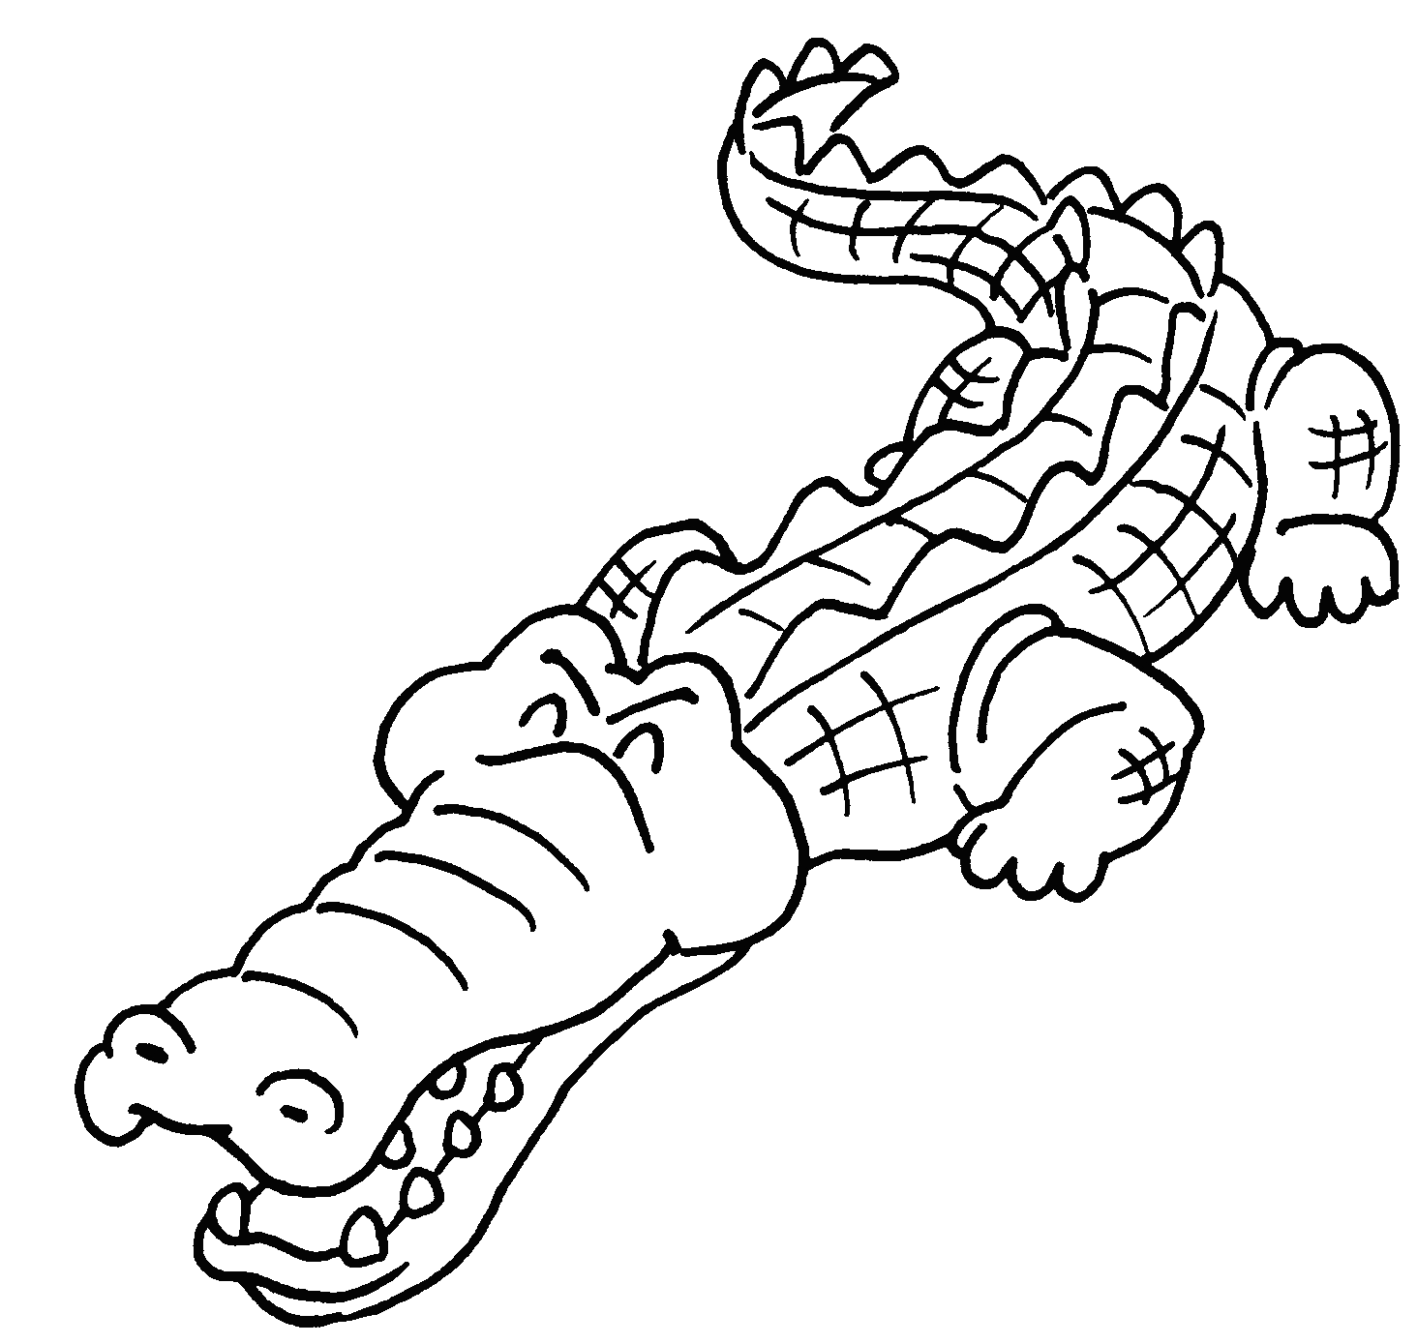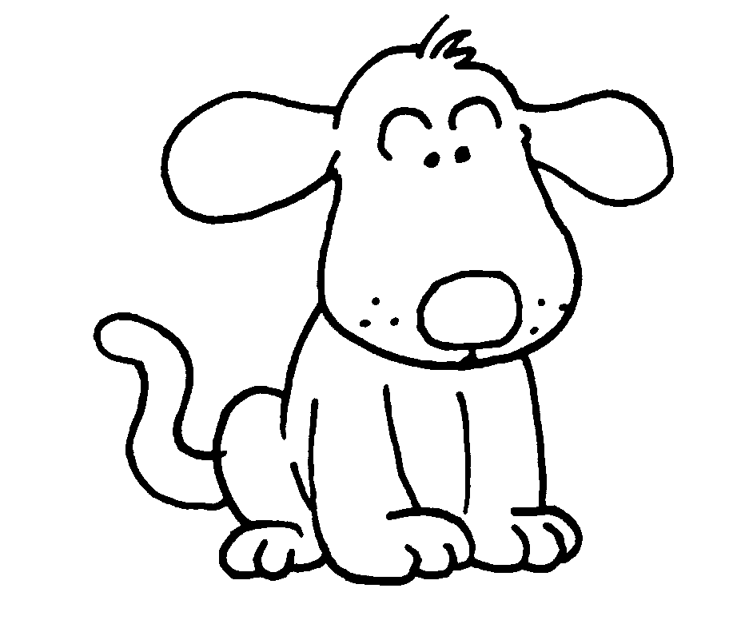
Coco
Doggie
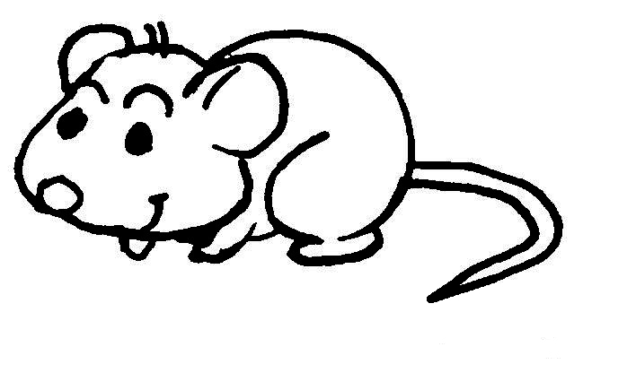
Mickey

Weight225 kg2 kg0.5 kgTail length110 cm20 cm10 cm

3 Doggie is ( heavier than / the heaviest ) Mickey.
Coco is ( heavier than / the heaviest ).
4 Doggie’s tail is ( shorter than / the shortest ) Coco’s.
Mickey’s tail is ( shorter than / the shortest ).



Book 4A Chapter 2 Graded Worksheets
Worksheet 3⬇
- ( lighter than / the lightest )
( lighter than / the lightest )
- ( younger than / the youngest )
( younger than / the youngest )
- ( heavier than / the heaviest )
( heavier than / the heaviest )
- ( shorter than / the shortest )
( shorter than / the shortest )

