Fill in the blanks with the correct form of words.
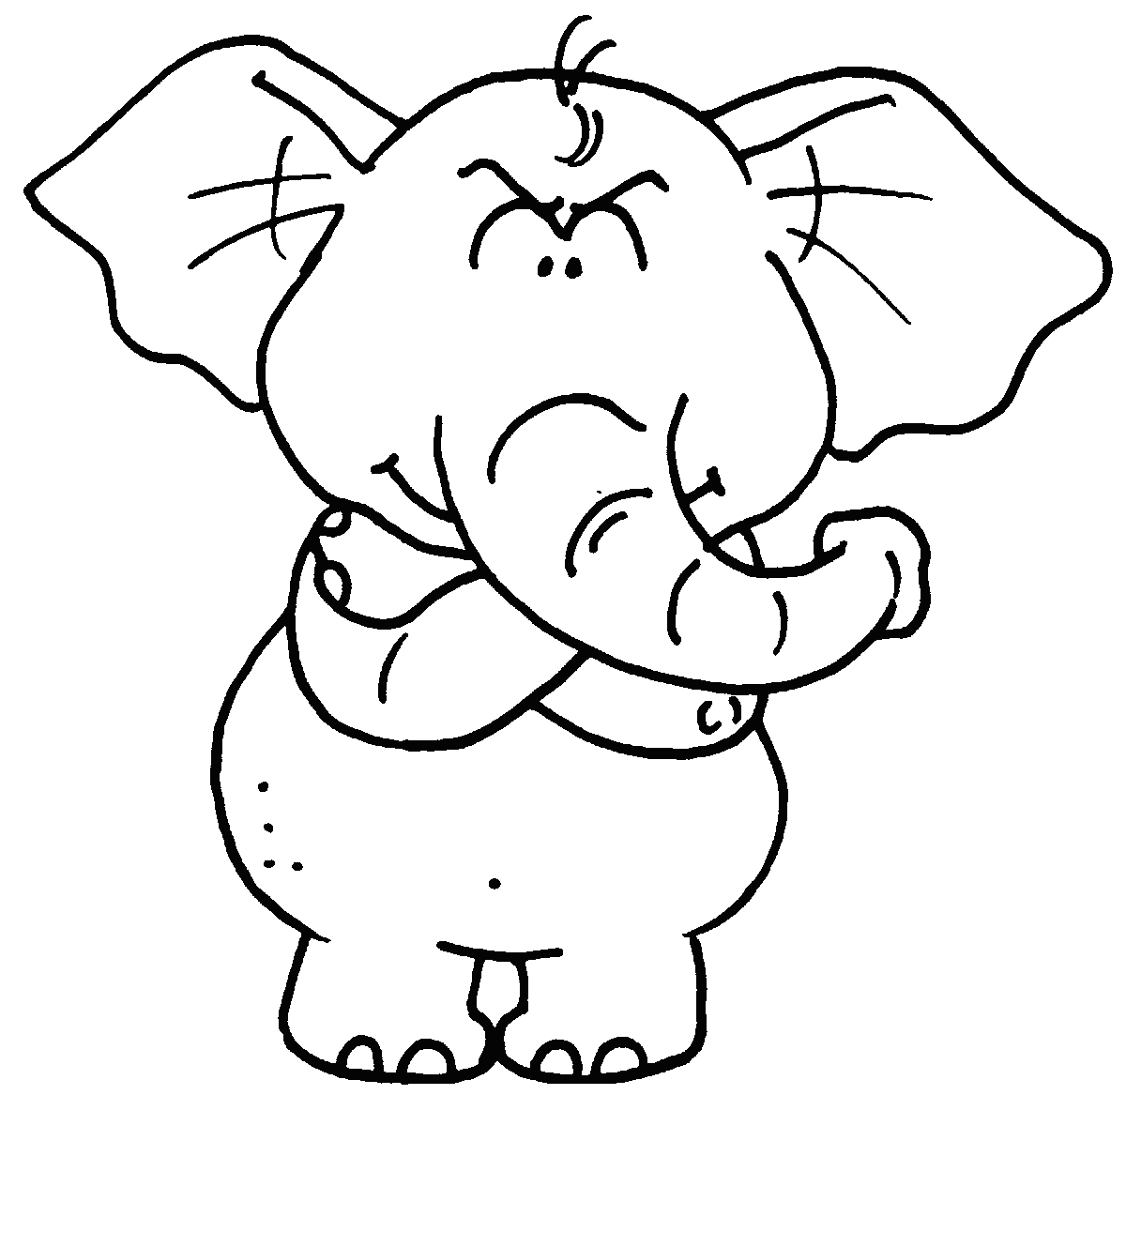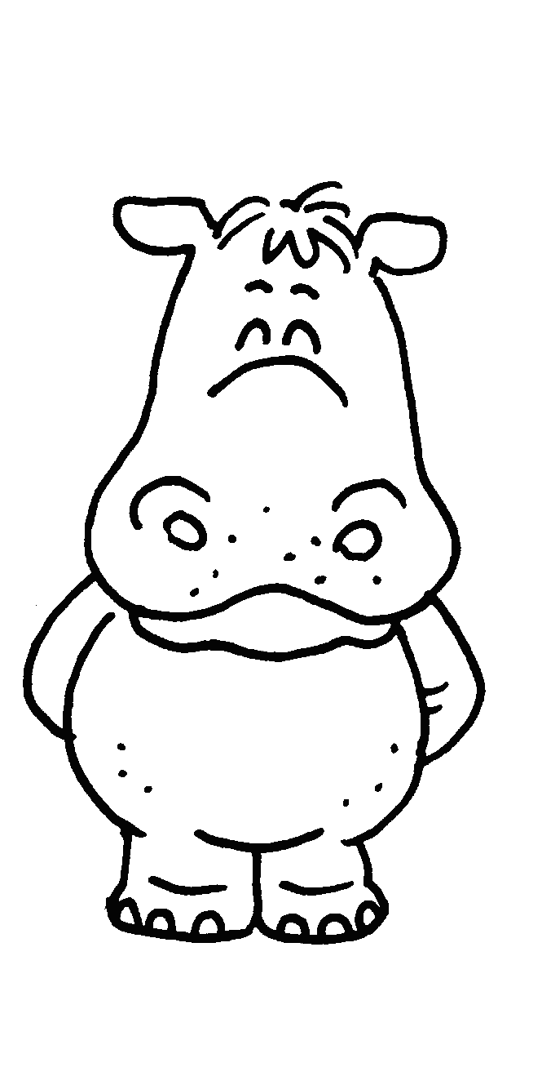
Elly
Hippy
Pandy

Weight1200 kg900 kg125 kgAge8124

1 Hippy is ______________________ ( light ) than Elly.
Pandy is the ______________________ ( light ).
2 Elly is _______________________ ( young ) than Hippy.
Pandy is the _______________________ ( young ).
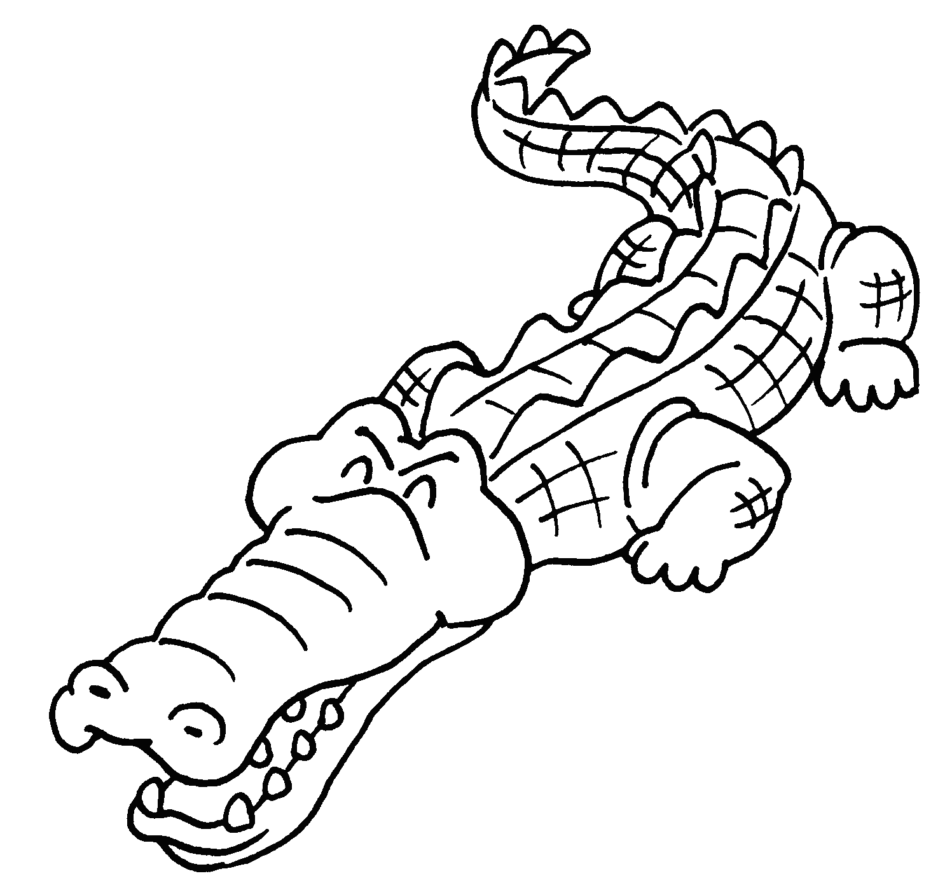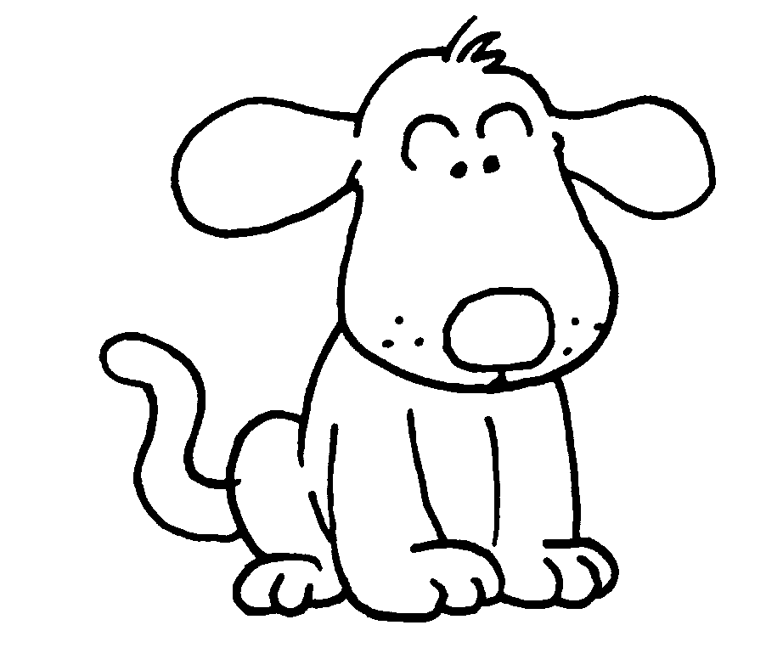
Coco
Doggie
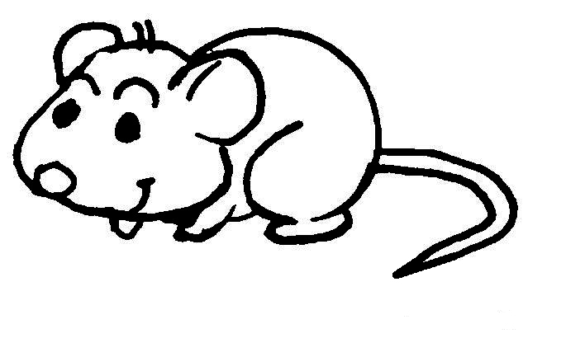
Mickey

Weight225 kg2 kg0.5 kgTail length110 cm20 cm10 cm

3 Doggie is _____________________ ____________ ( heavy ) Mickey.
Coco is ___________ ______________________ ( heavy ).
4 Doggie’s tail is _____________________ ____________ ( short ) Coco’s.
Mickey’s tail is _________ ______________________ ( short ).


Book 4A Chapter 2 Graded Worksheets
Worksheet 3⬇⬇
- lighter
lightest
- younger
youngest
- heavier than
the heaviest
- shorter than
the shortest

