Fill in the blanks with the correct form of words.
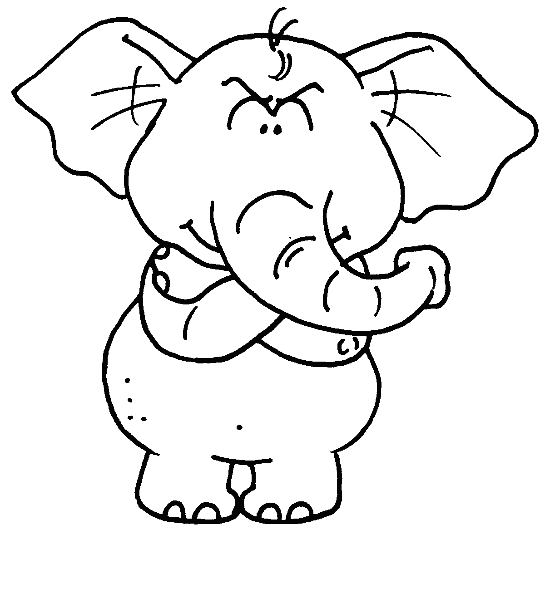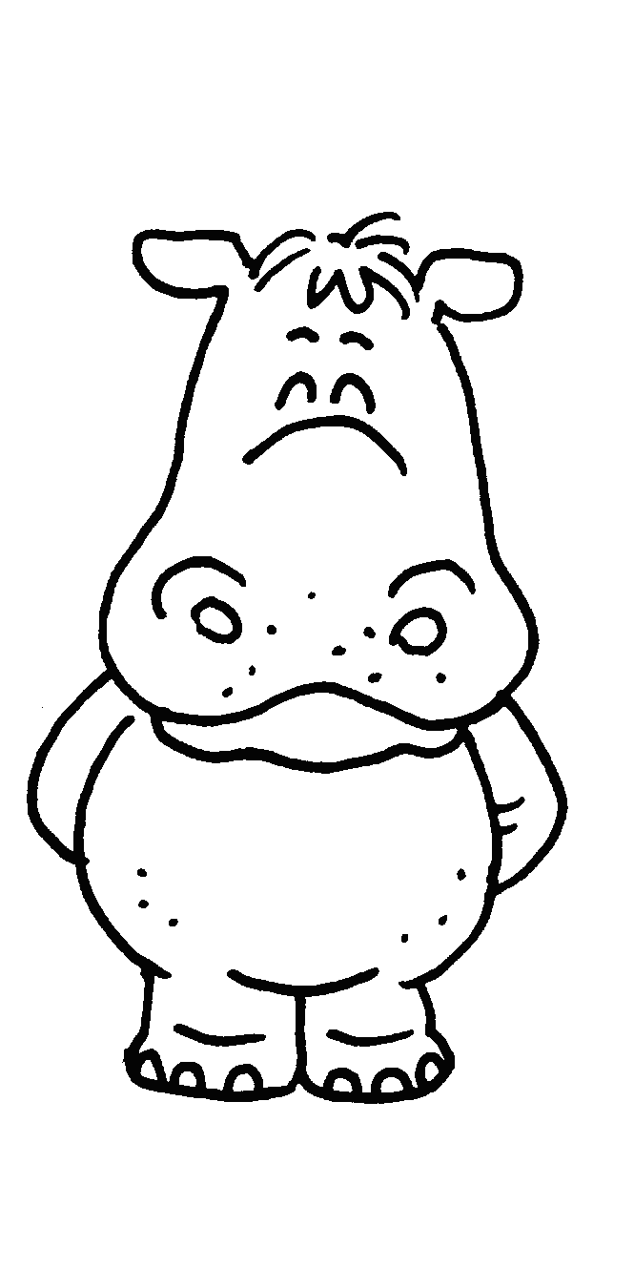
Elly
Hippy
Pandy

Weight1200 kg900 kg125 kgAge8124

1 Hippy is l than Elly.
Pandy is the l .
2 Elly is y than Hippy.
Pandy is the _______________________ .
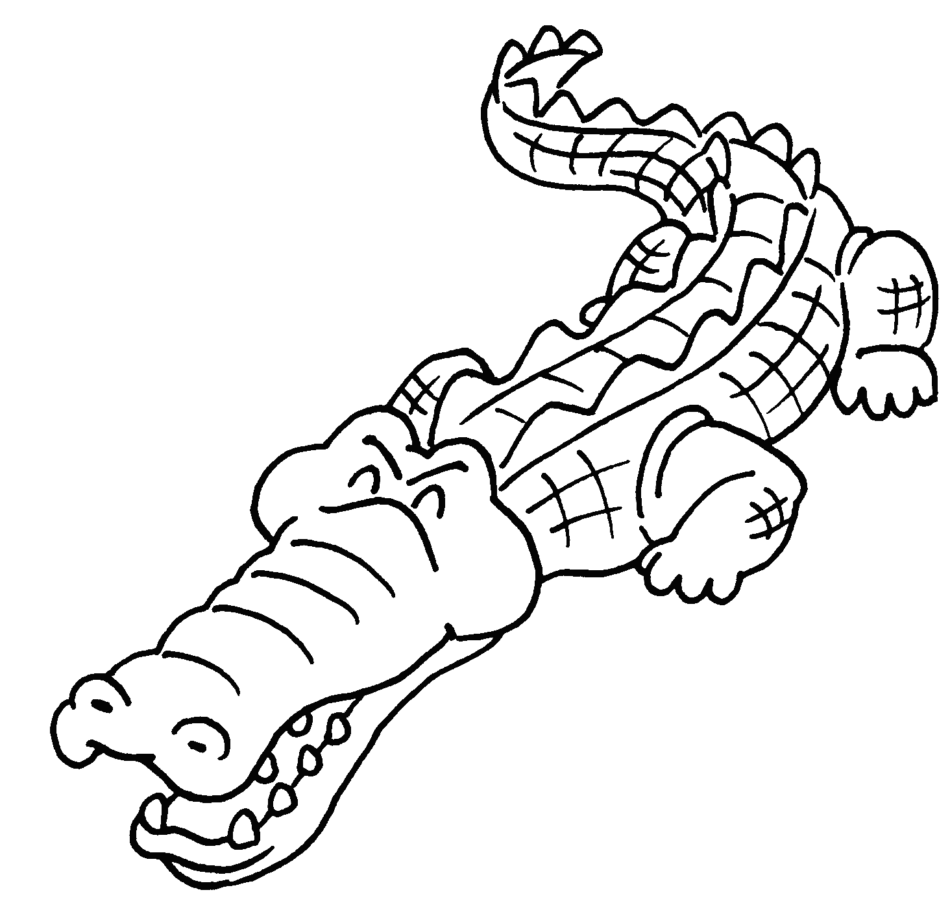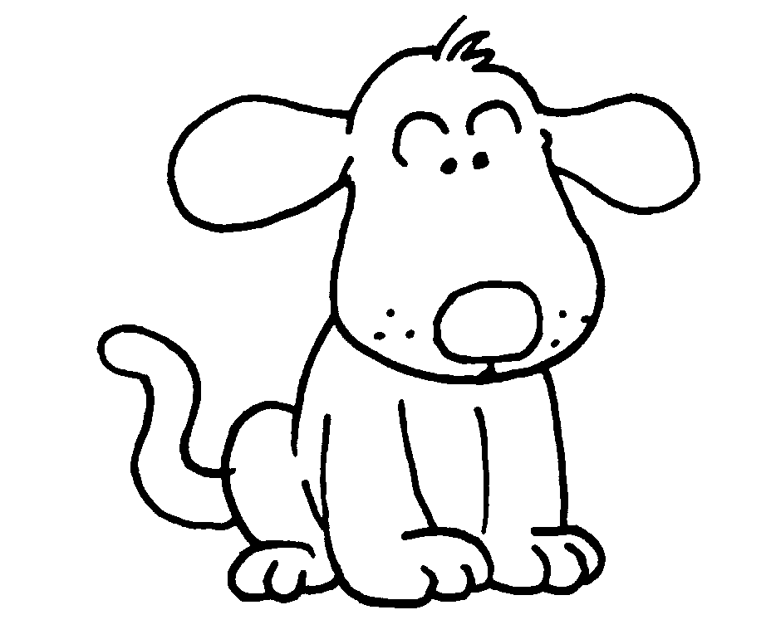
Coco
Doggie
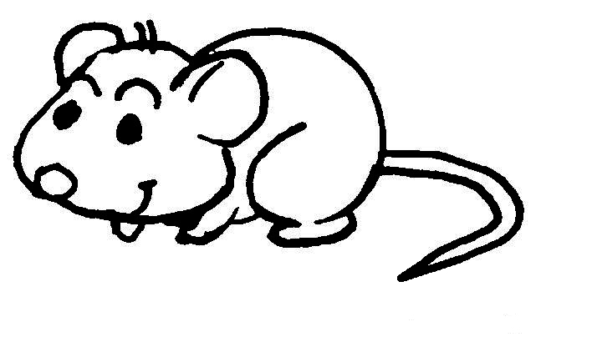
Mickey

Weight225 kg2 kg0.5 kgTail length110 cm20 cm10 cm

3 Doggie is h Mickey.
Coco is _____________________________________ .
4 Doggie’s tail is s Coco’s.
Mickey’s tail is .


Book 4A Chapter 2 Graded Worksheets
Worksheet 3⬇⬇⬇
- lighter
lightest
- younger
youngest
- heavier than
the heaviest
- shorter than
the shortest

