RP no: Century Gothic 15pt
(所有圈號用15pt)
Choose and write.

bunch | carton | jar
loaf | packet | tin
1

2
4
3
5
6
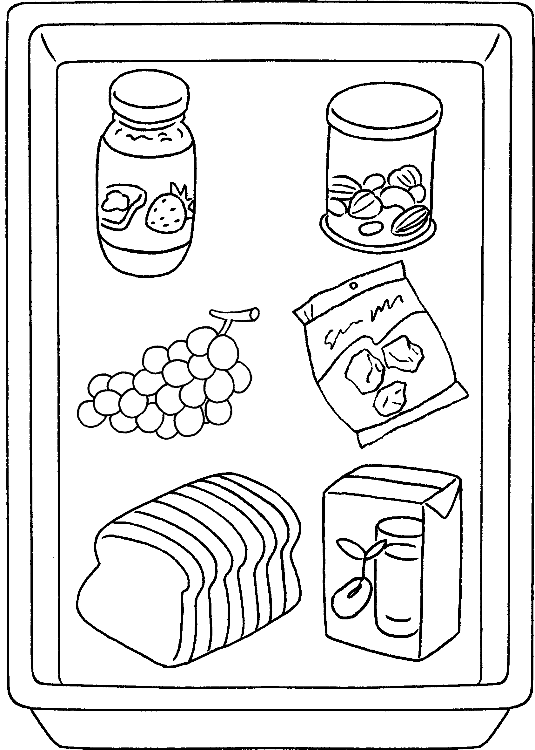 |  | 1 | a of jam
 |  | 2 | a of nuts
 |  | 3 | a of grapes
 |  | 4 | a of sour plums
 |  | 5 | a of bread
 |  | 6 | a of soya milk

a bar of | a bunch of | a carton of
a jar of | a packet of | a tin of
7
8
9
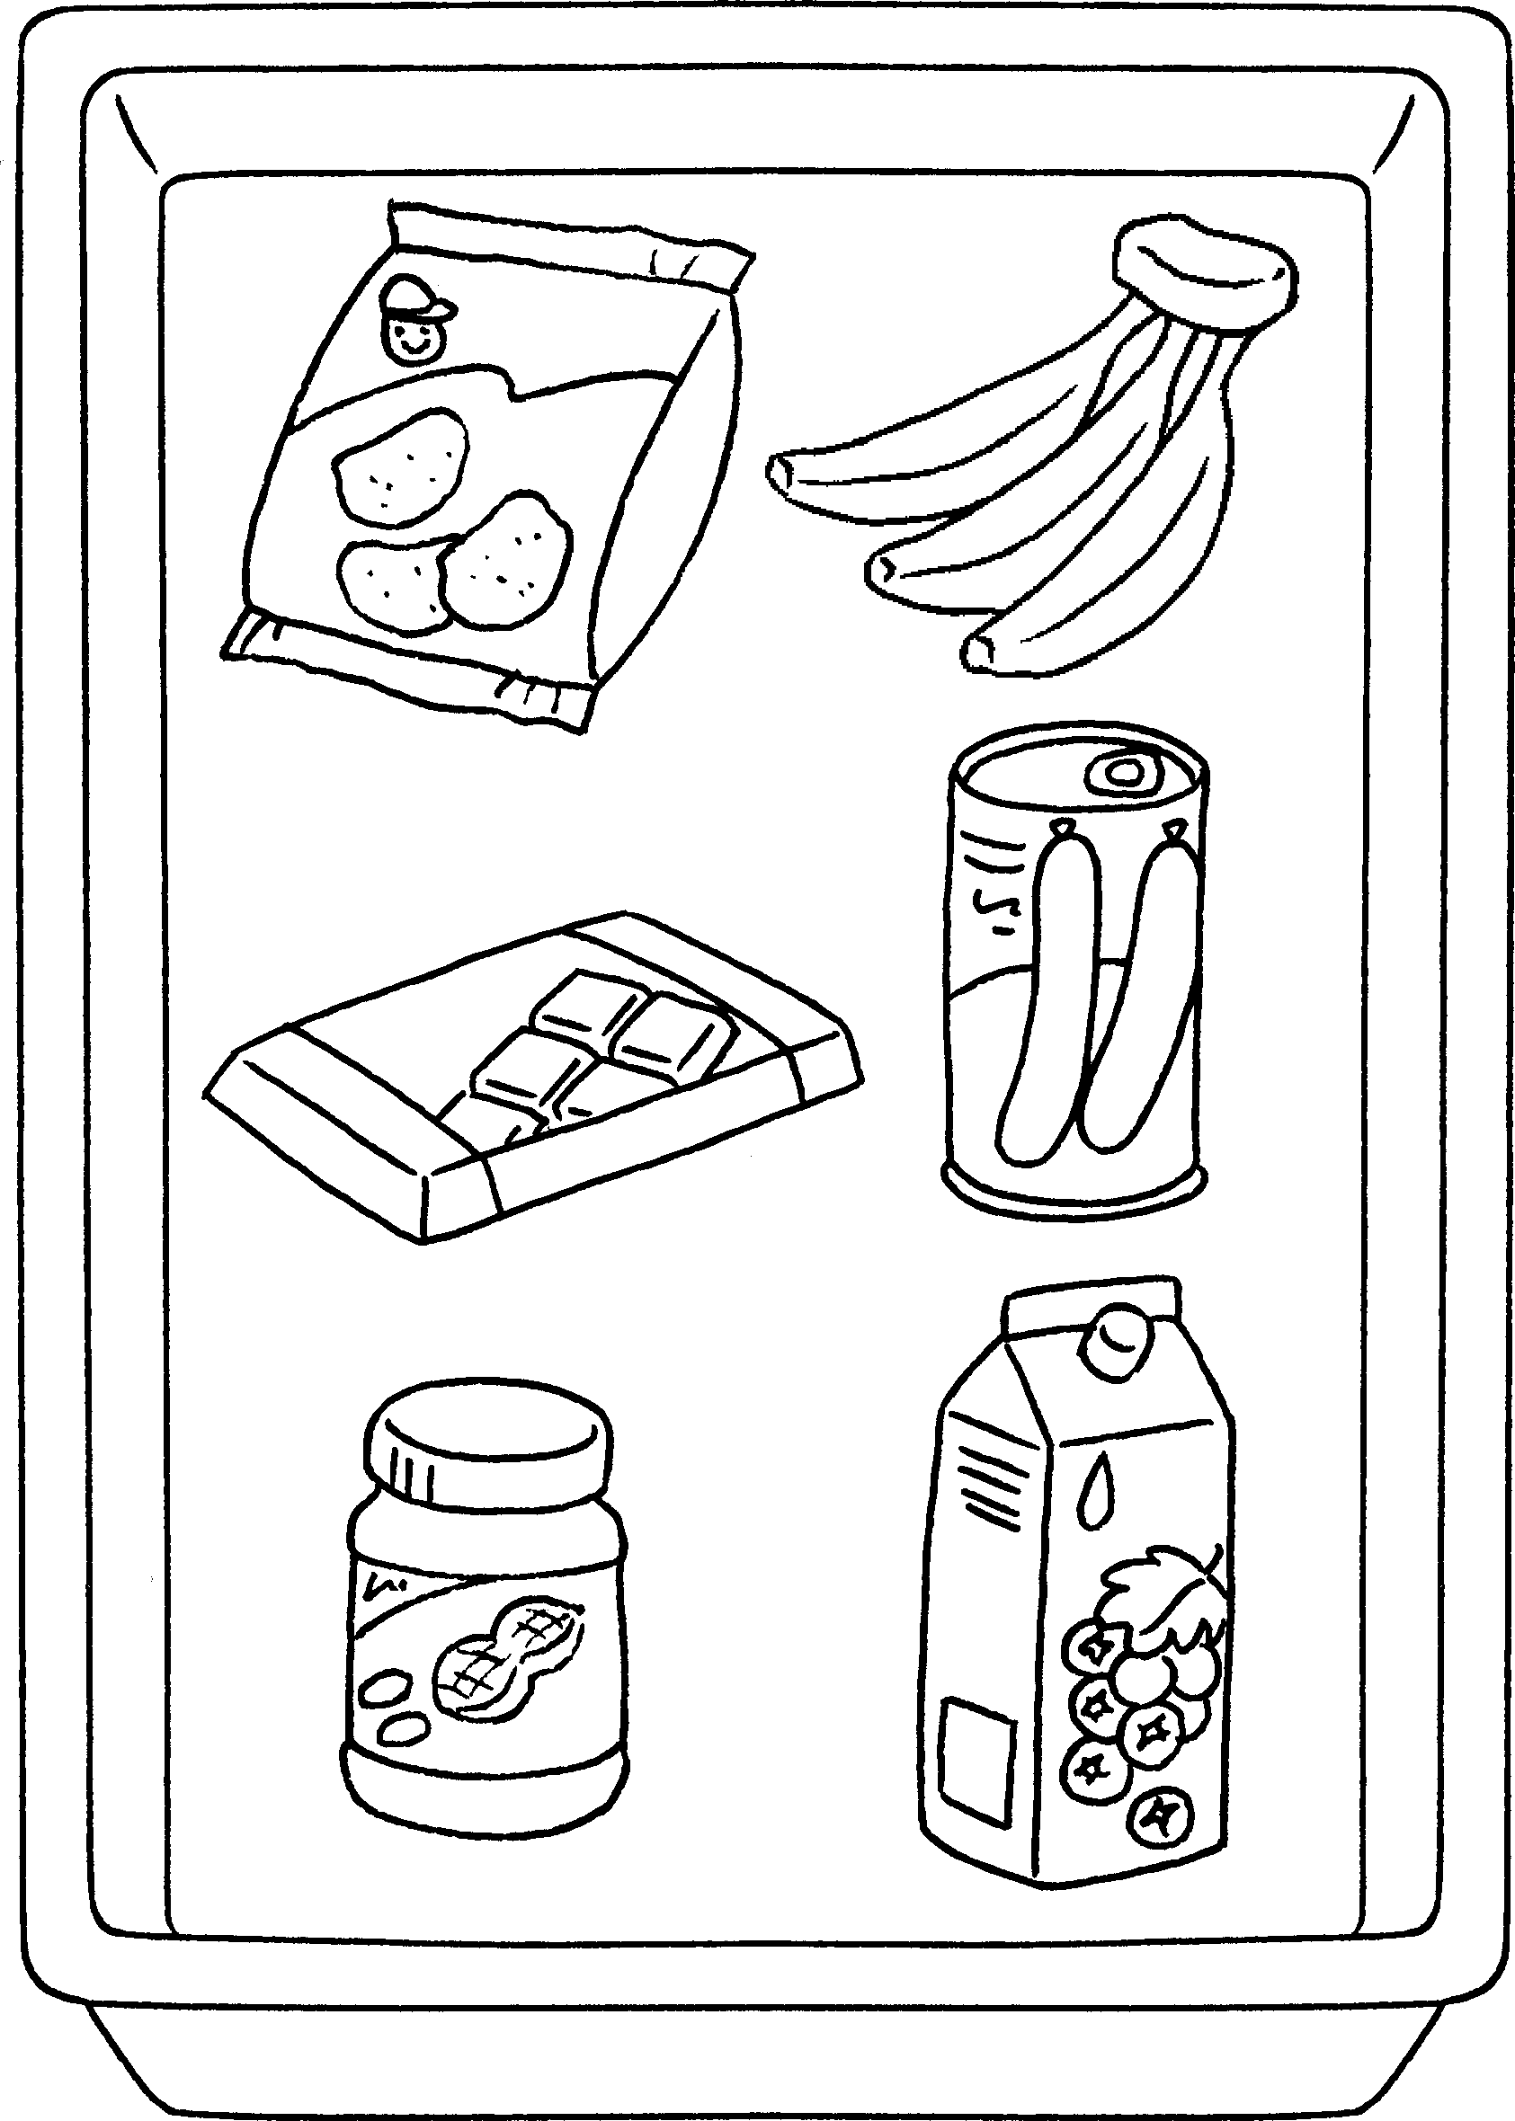  10  11  12 |  | 7 | potato chips
 |  | 8 | bananas
 |  | 9 | chocolate
 |  | 10 | sausages
 |  | 11 | peanut butter
 |  | 12 | blackcurrant juice


Book 4A Chapter 3 Graded Worksheets
Worksheet 1⬇
- jar
- tin
- bunch
- packet
- loaf
- carton
- a packet of
- a bunch of
- a bar of
- a tin of
- a jar of
- a carton of

