RP no: Century Gothic 15pt
(所有圈號用15pt)
What are they? Write.
1

2
4
3
5
6
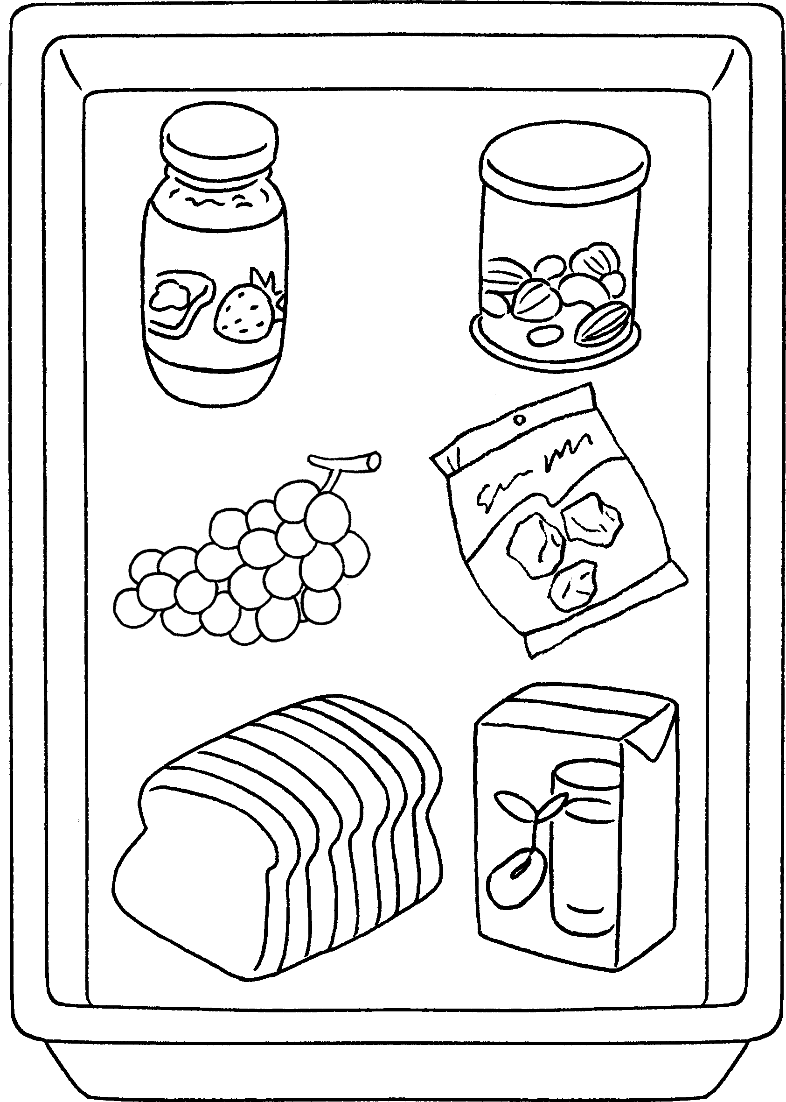 |  | 1 | a of jam
 |  | 2 | a tin of
 |  | 3 | a of
 |  | 4 | a of
 |  | 5 | a of
 |  | 6 | a of

7
8
9
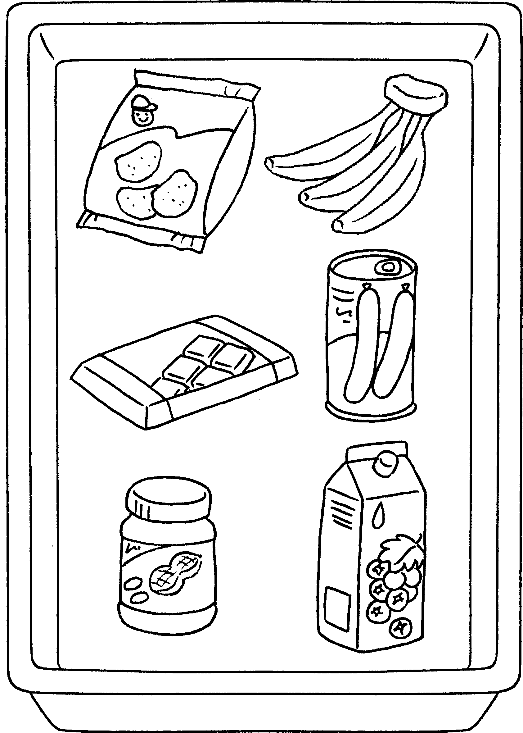  10  11  12 |  | 7 | a
 |  | 8 | a
 |  | 9
 |  | 10
 |  | 11
 |  | 12


Book 4A Chapter 3 Graded Worksheets
Worksheet 1⬇⬇⬇
- jar
- nuts
- bunch grapes
- packet sour plums
- loaf bread
- carton soya milk
- packet of potato chips
- bunch of bananas
- a bar of chocolate
- a tin of sausages
- a jar of peanut butter
- a carton of blackcurrant juice

