Finish the questions and answers.

How much | dollars

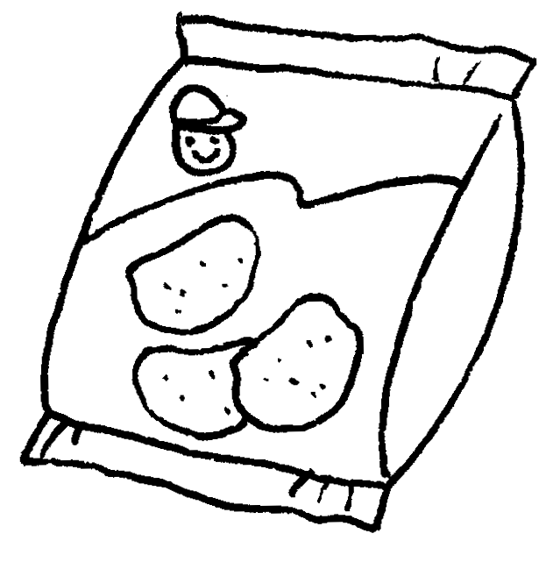
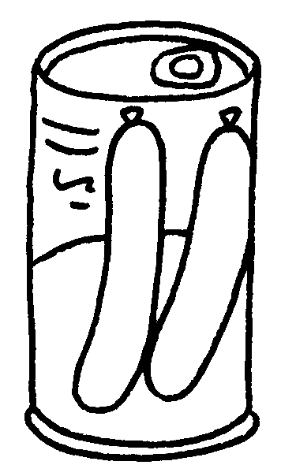
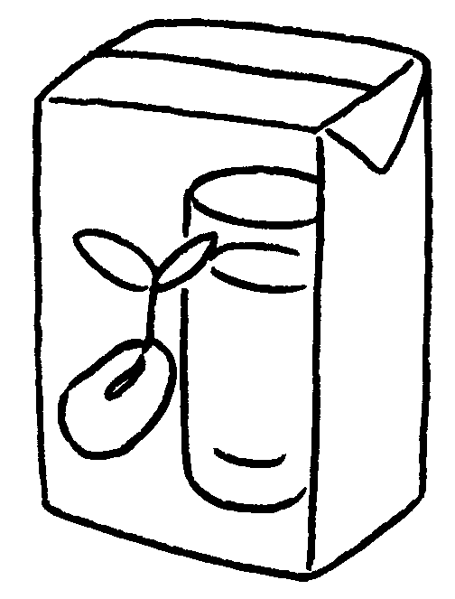

Yum Yum Supermarket
a packet of potato chips
$8.50
a carton of soya milk
$10.20
a jar of jam
$21.80
a tin of sausages
1
2
3
4
$13.40

1 A : is a packet of potato chips?
B : It’s eight fifty.
2 A : is a jar of jam?
B : It’s thirteen forty.
3 A : is a carton of soya milk?
B : It’s .
4 A : is a tin of sausages?
B : It’s .


Book 4A Chapter 3 Graded Worksheets
Worksheet 2⬇
- How much
dollars
- How much
dollars
- How much
ten dollars twenty
- How much
twenty-one dollars eighty

