Finish the questions and answers.

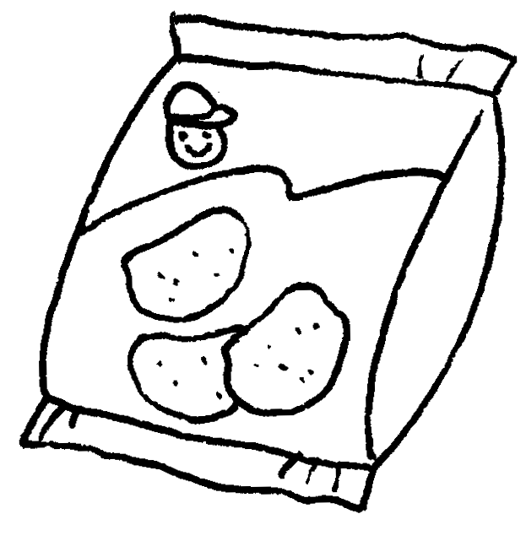
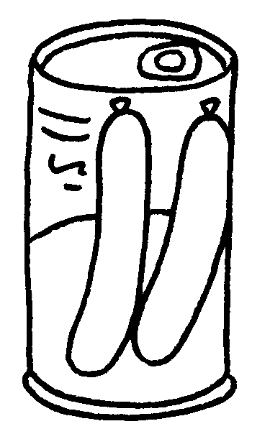
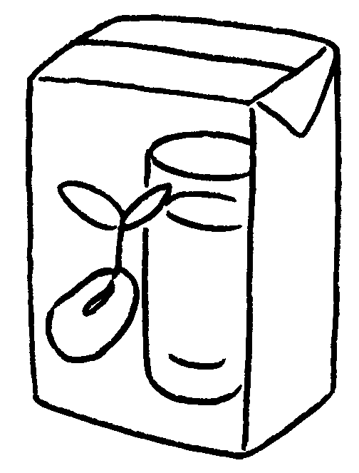

Yum Yum Supermarket
a packet of potato chips
$8.50
a carton of soya milk
$10.20
a jar of jam
$21.80
a tin of sausages
1
2
3
4
$13.40

1 A : How much is a packet of ?
B : It’s eight fifty.
2 A : How much is ?
B : It’s thirteen .
3 A :
B : It’s .
4 A :
B :


Book 4A Chapter 3 Graded Worksheets
Worksheet 2⬇⬇
- potato chips
dollars
- a jar of jam
dollars forty
- How much is a carton of soya milk?
ten dollars twenty
- How much is a tin of sausages?
It’s twenty-one dollars eighty.

