Finish the questions and answers.

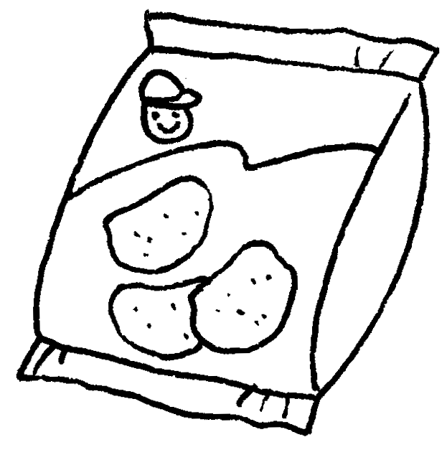
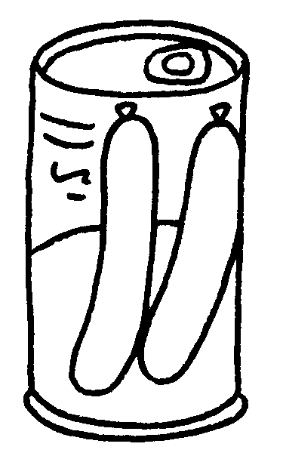
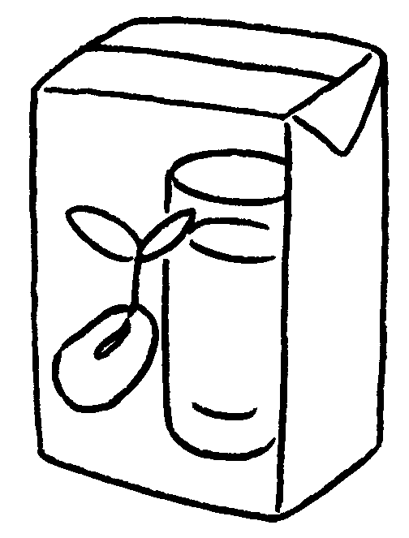

Yum Yum Supermarket
$8.50
$10.20
$21.80
1
2
3
4
$13.40

1 A : How much is a packet of ?
B : It’s eight fifty.
2 A : How much is jam?
B : It’s .
3 A :
B :
4 A :
B :


Book 4A Chapter 3 Graded Worksheets
Worksheet 2⬇⬇⬇
- potato chips
dollars
- a jar of
thirteen dollars forty
- How much is a carton of soya milk?
It’s ten dollars twenty.
- How much is a tin of sausages?
It’s twenty-one dollars eighty.

