Circle the correct answers.

 | 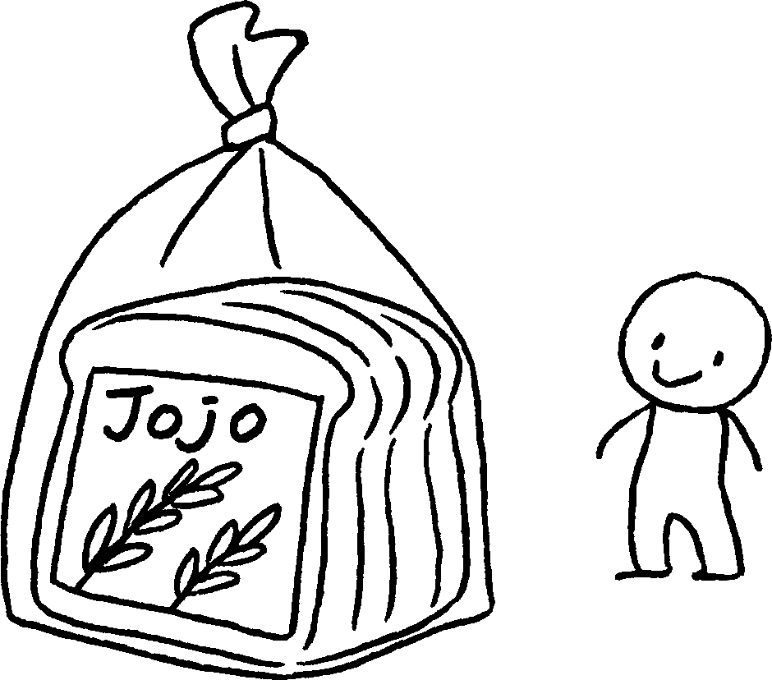
1 | Yoyo Bread is ( more popular than / the most popular ) Jojo Bread.  Momo Bread is ( more popular than / the most popular ).
 | 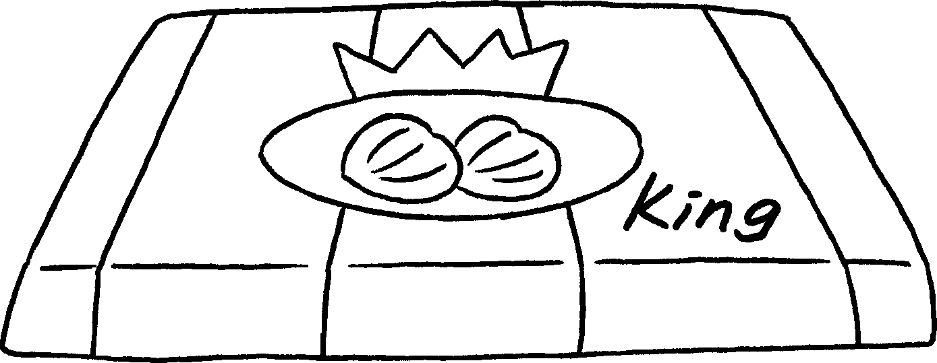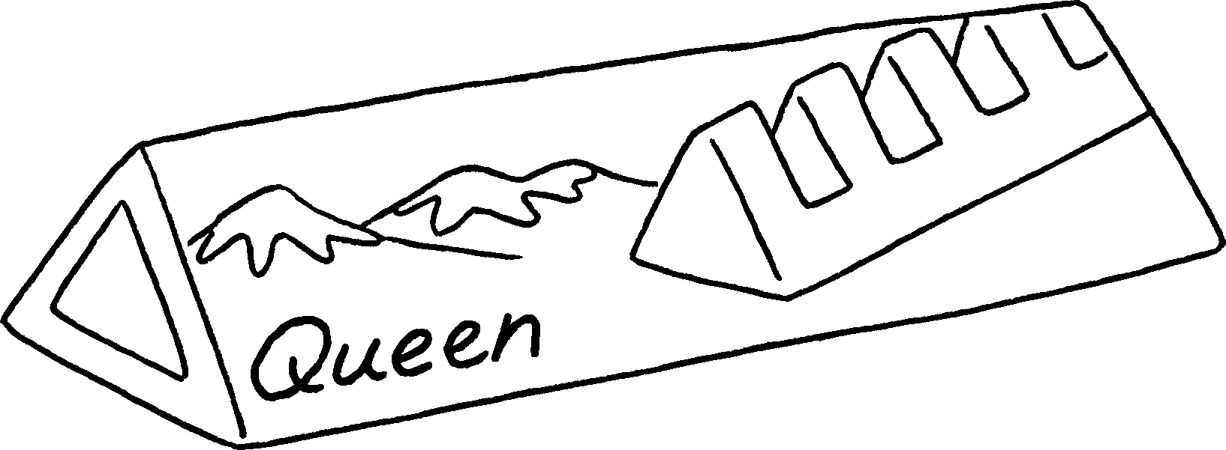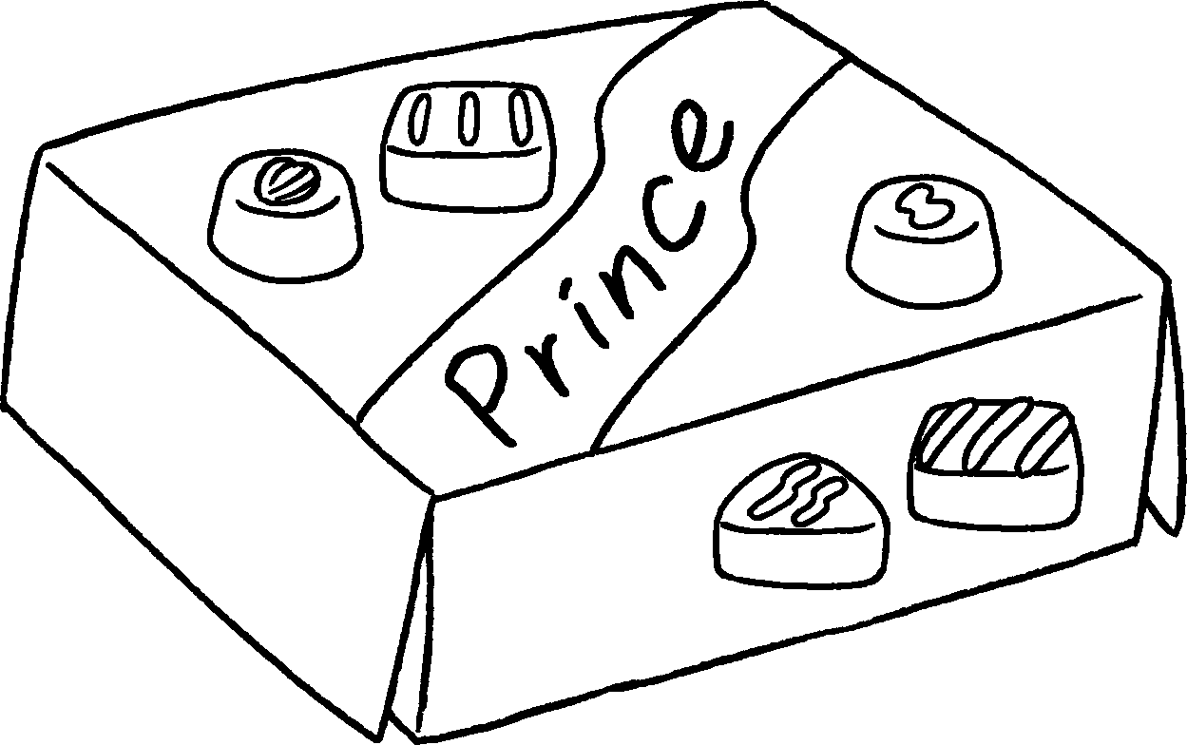
2 | Queen Chocolate is ( more delicious than / the most delicious ) Prince Chocolate.  King Chocolate is ( more delicious than / the most delicious ).

$27.30
$21.60
$32.50
3 | Every Day Milk is ( more expensive than / the most expensive )  Daily Milk.    Healthy Milk is ( more expensive than / the most expensive ).  Book 4A Chapter 3  Remedial Worksheets  Worksheet 3  1 more popular than  the most popular  2 more delicious than  the most delicious  3 more expensive than  the most expensive


Book 4A Chapter 3 Graded Worksheets
Worksheet 3⬇
- ( more popular than / the most popular )
( more popular than / the most popular )
2 ( more delicious than / the most delicious )
( more delicious than / the most delicious )
- ( more expensive than / the most expensive )
( more expensive than / the most expensive )

