Fill in the blanks.

more … than | the most …

 | 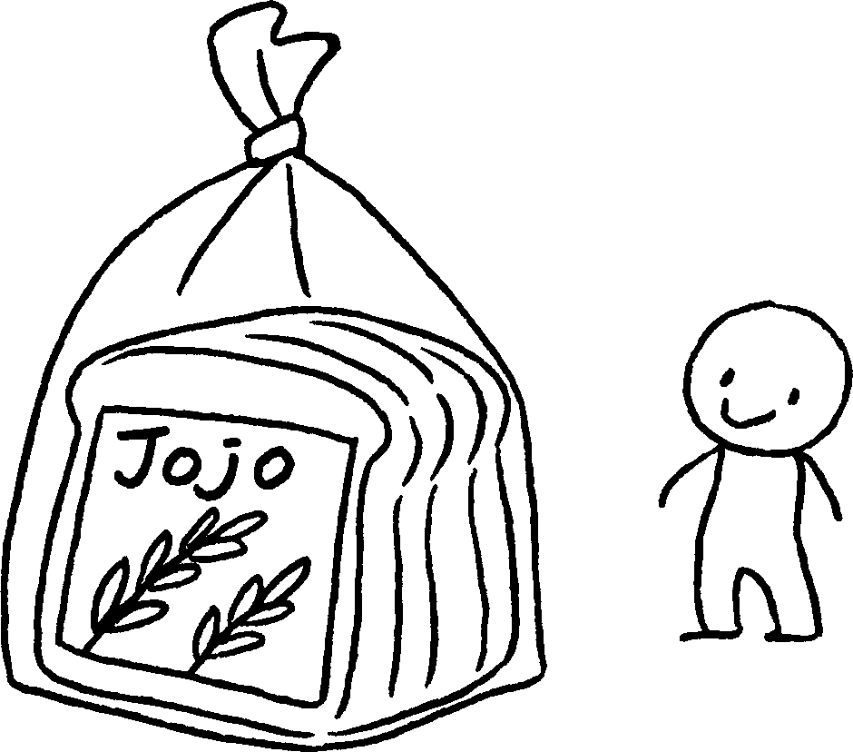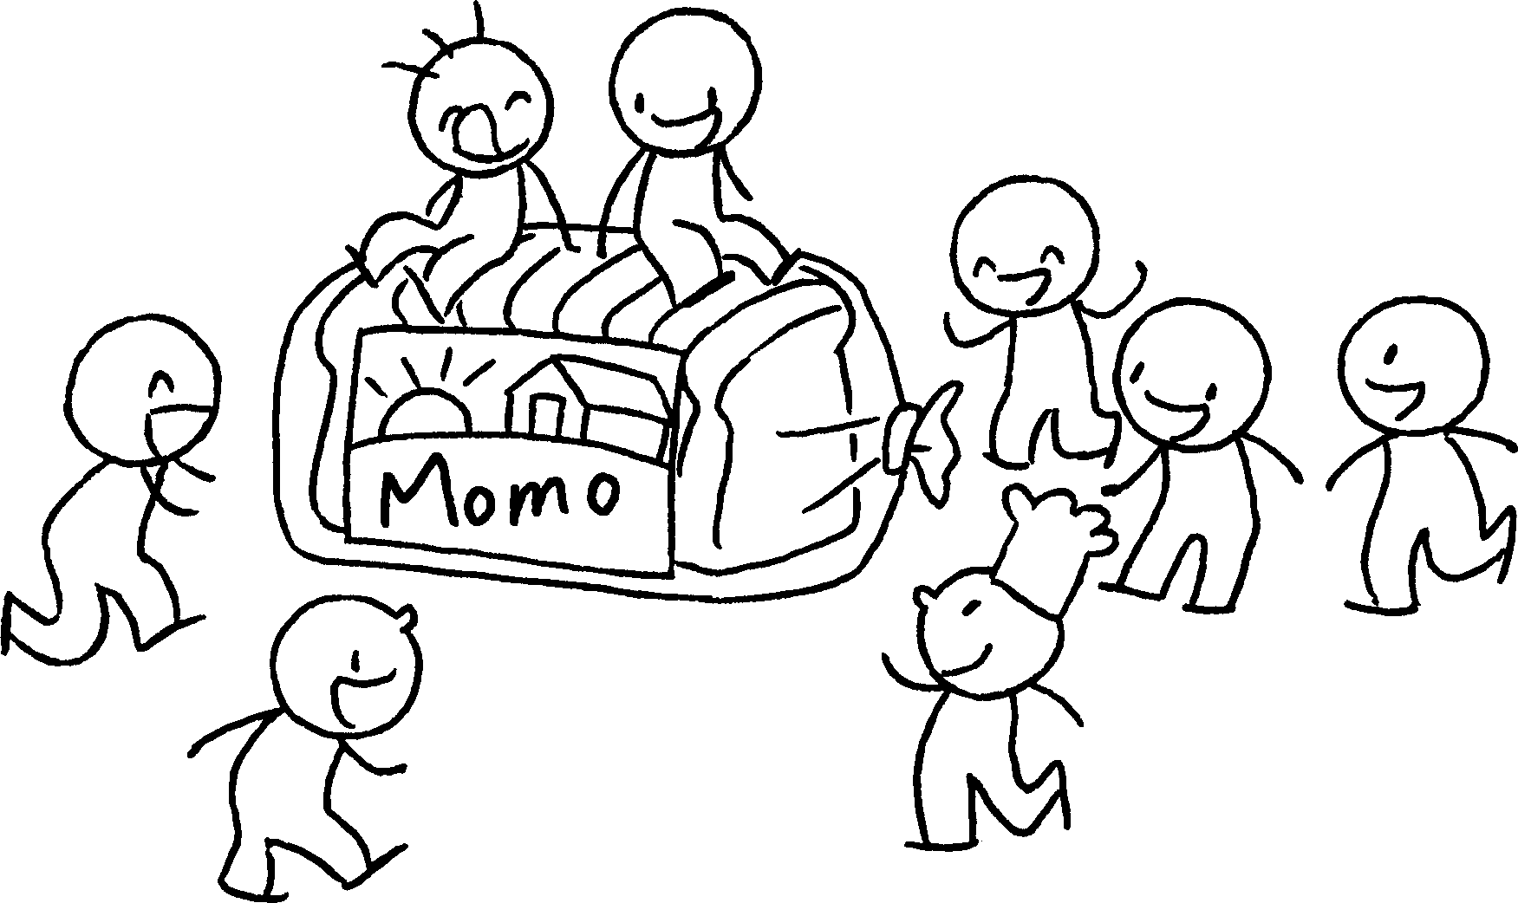
1 | Yoyo Bread is ( popular ) Jojo Bread.  Momo Bread is ( popular ).
 | 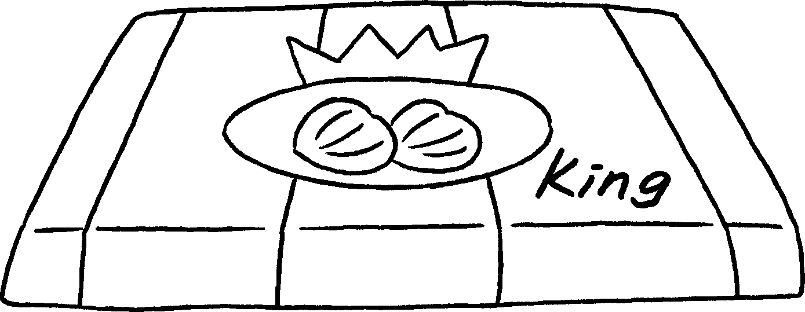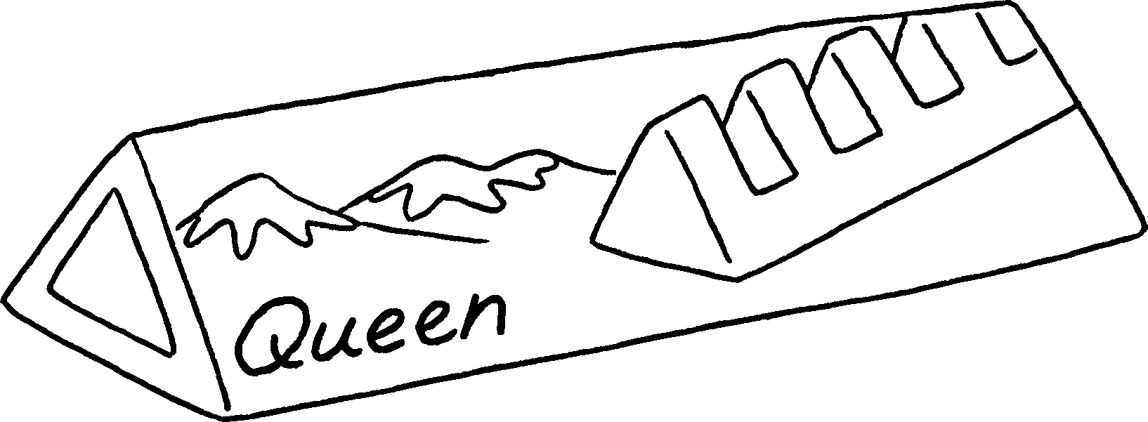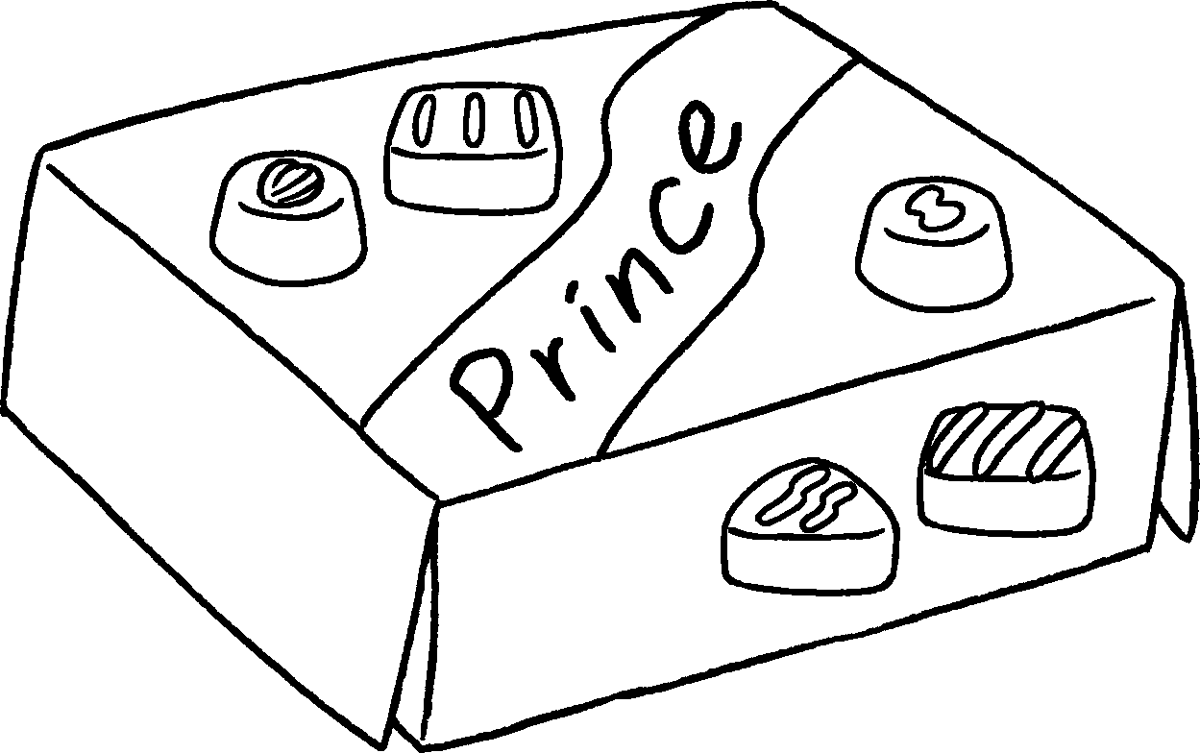
2 | Queen Chocolate is ( delicious ) Prince Chocolate.  King Chocolate is ( delicious ).
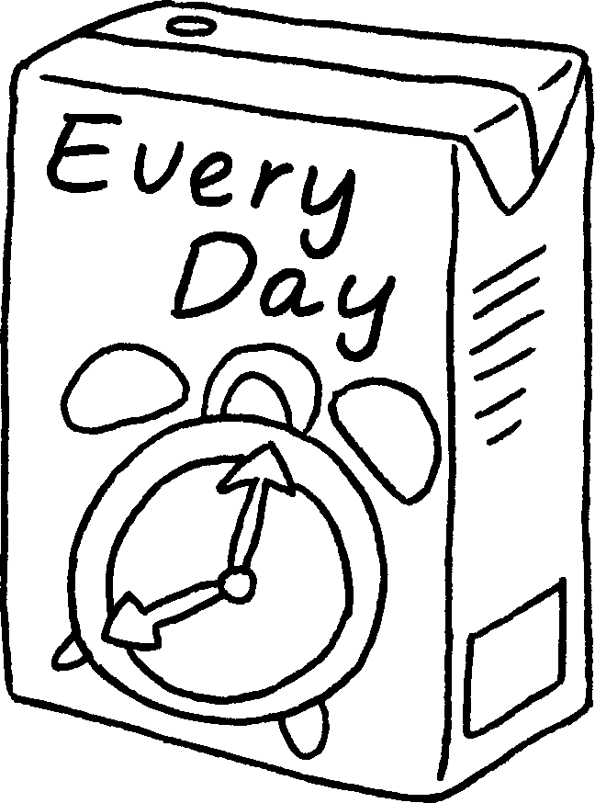
$27.30
$21.60
$32.50
3 | Every Day Milk is ( expensive )  Daily Milk.    Healthy Milk is ( expensive ).  Book 4A Chapter 3  Remedial Worksheets  Worksheet 2  1 How much  dollars  2 How much  dollars  3 How much  ten dollars twenty  4 How much  twenty-one dollars eighty  Book 4A Chapter 3  Remedial Worksheets  Worksheet 3  1 more popular than  the most popular  2 more delicious than  the most delicious  3 more expensive than  the most expensive


Book 4A Chapter 3 Graded Worksheets
Worksheet 3⬇⬇
1 more popular than
the most popular
2 more delicious than
the most delicious
3 more expensive than
the most expensive

