Compare the products. Fill in the blanks.

 | 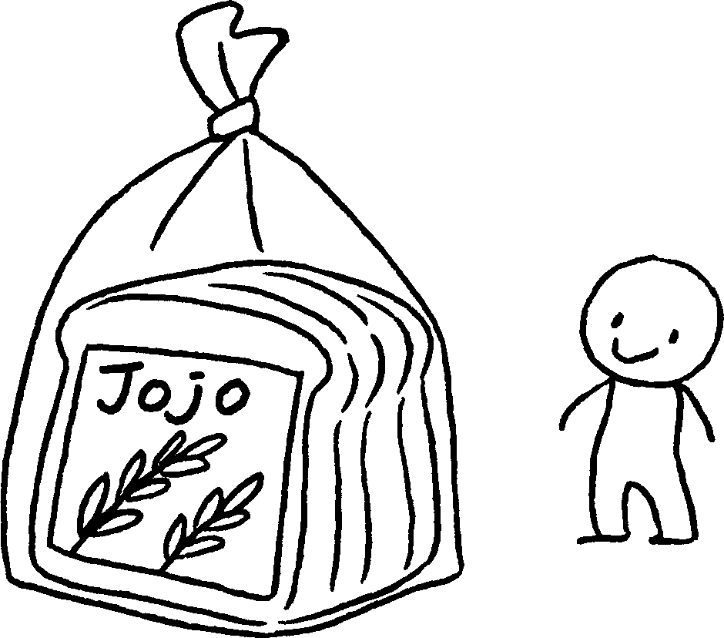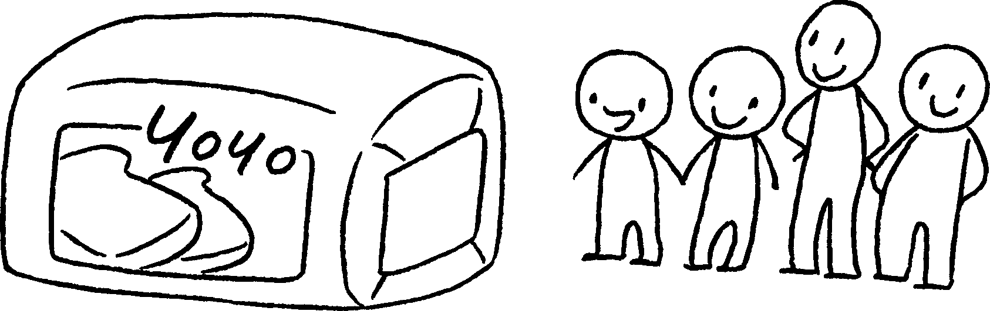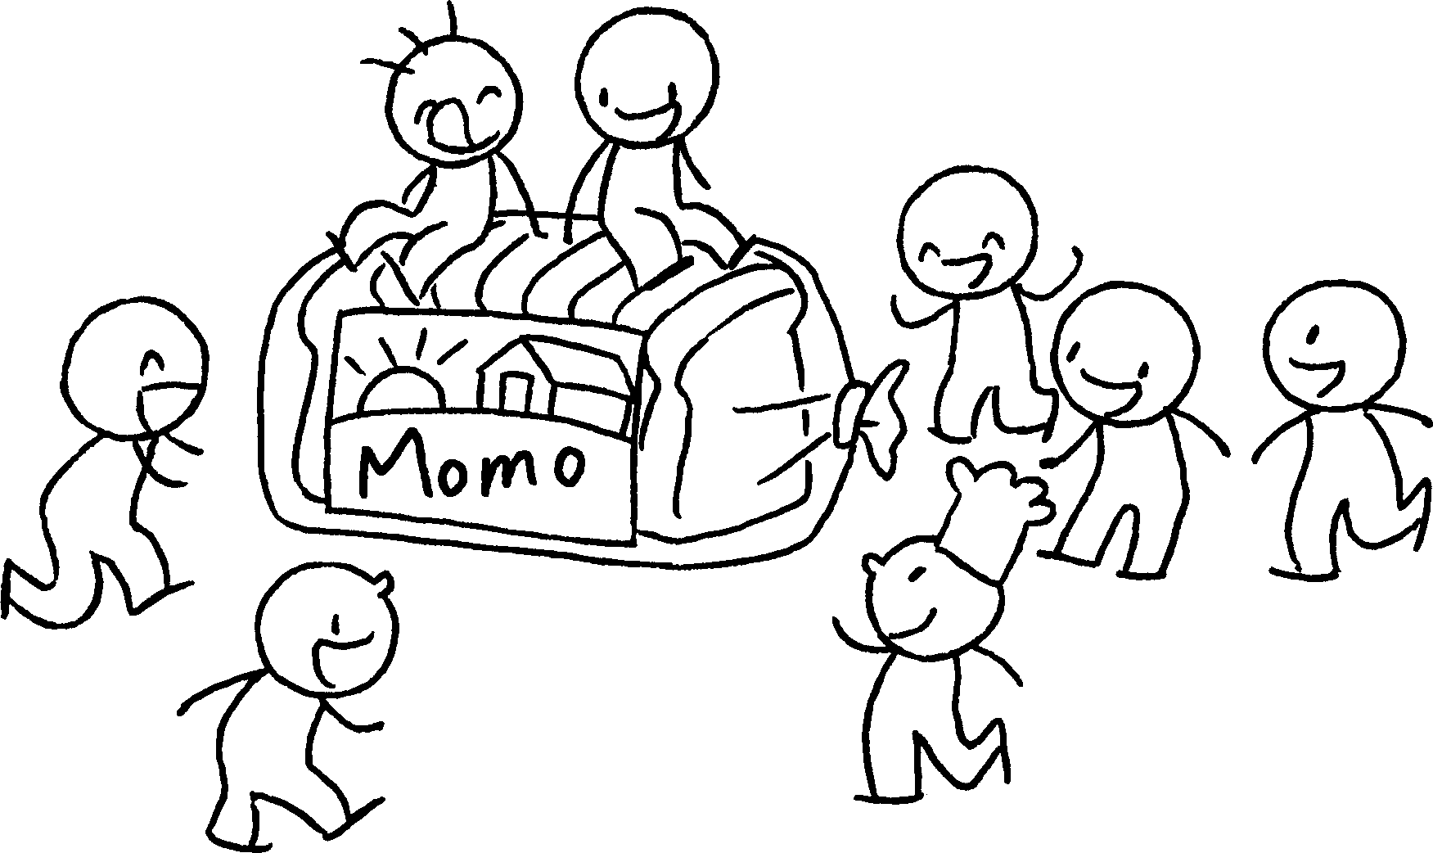
1 | Yoyo Bread is popular Jojo Bread.  Momo Bread is most .
 | 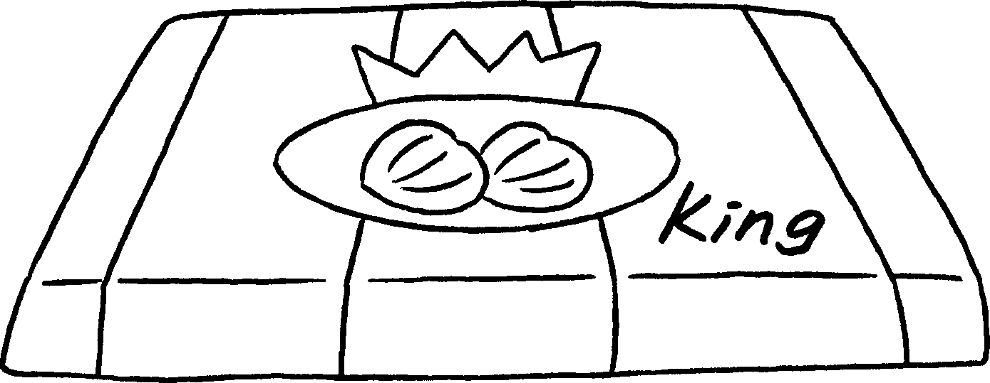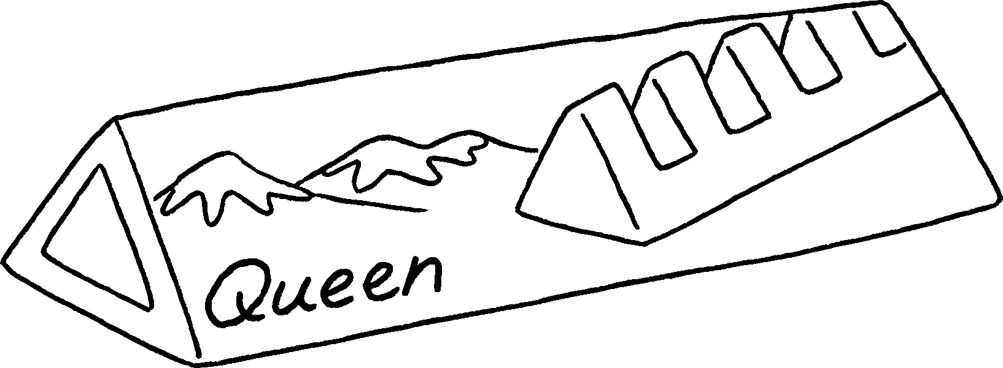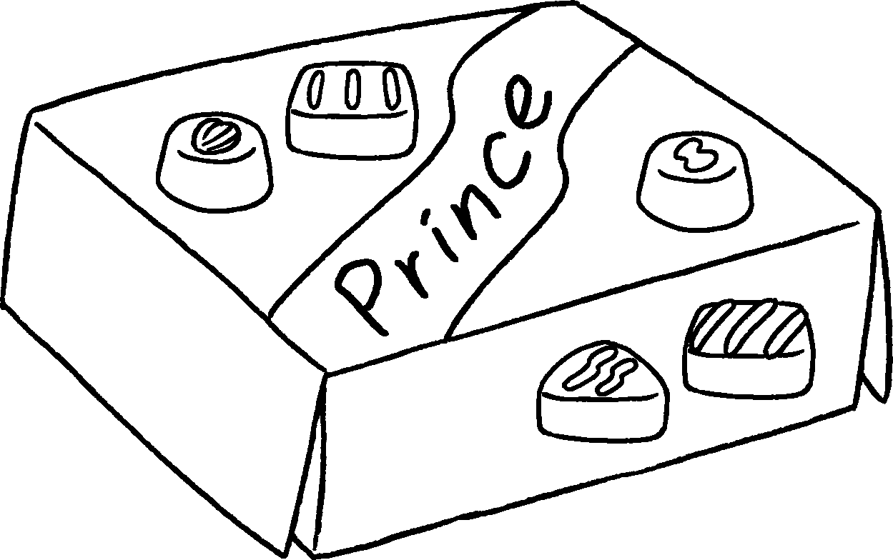
2 | Queen Chocolate is d Prince Chocolate.  King Chocolate is .
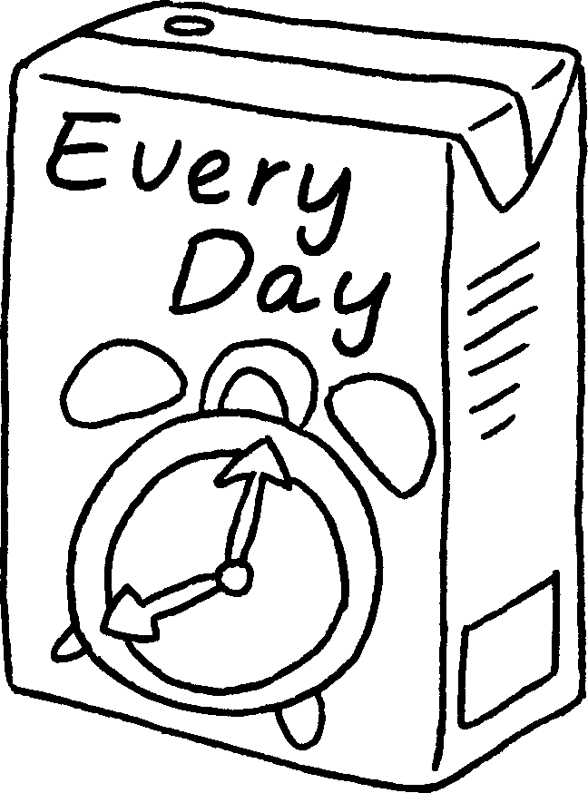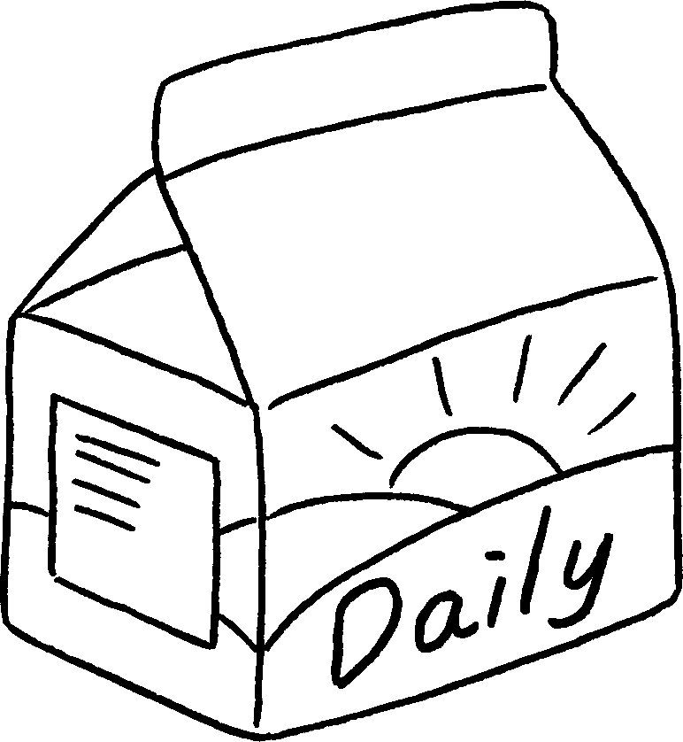
$27.30
$21.60
$32.50
3 | Every Day Milk is e  Daily Milk.    Healthy Milk is .  Book 4A Chapter 3  Remedial Worksheets  Worksheet 3  1 more popular than  the most popular  2 more delicious than  the most delicious  3 more expensive than  the most expensive


Book 4A Chapter 3 Graded Worksheets
Worksheet 3⬇⬇⬇
1 more than
the popular
2 more delicious than
the most delicious
3 more expensive than
the most expensive

