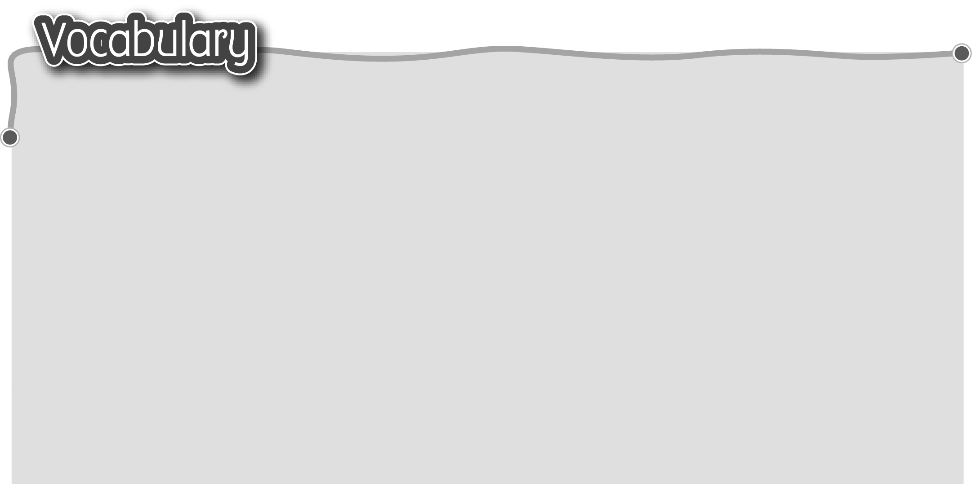
1 a bunch of grapes 一串葡萄 7 a tin of nuts 一罐果仁
2 a bunch of bananas 一把香蕉 8 a tin of sausages 一罐香腸
3 a packet of sour plums 9 a jar of peanut butter一瓶花生醬
一包話梅 10 a jar of jam 一瓶果醬
4 a packet of potato chips 11 a bar of chocolate 一排朱古力
一包薯片 12 a loaf of bread 一條麵包
5 a carton of soya milk 一盒豆奶
6 a carton of blackcurrant juice
一盒黑加侖子汁
The words marked with * have different meanings in other
contexts. You can look up those meanings in a dictionary.
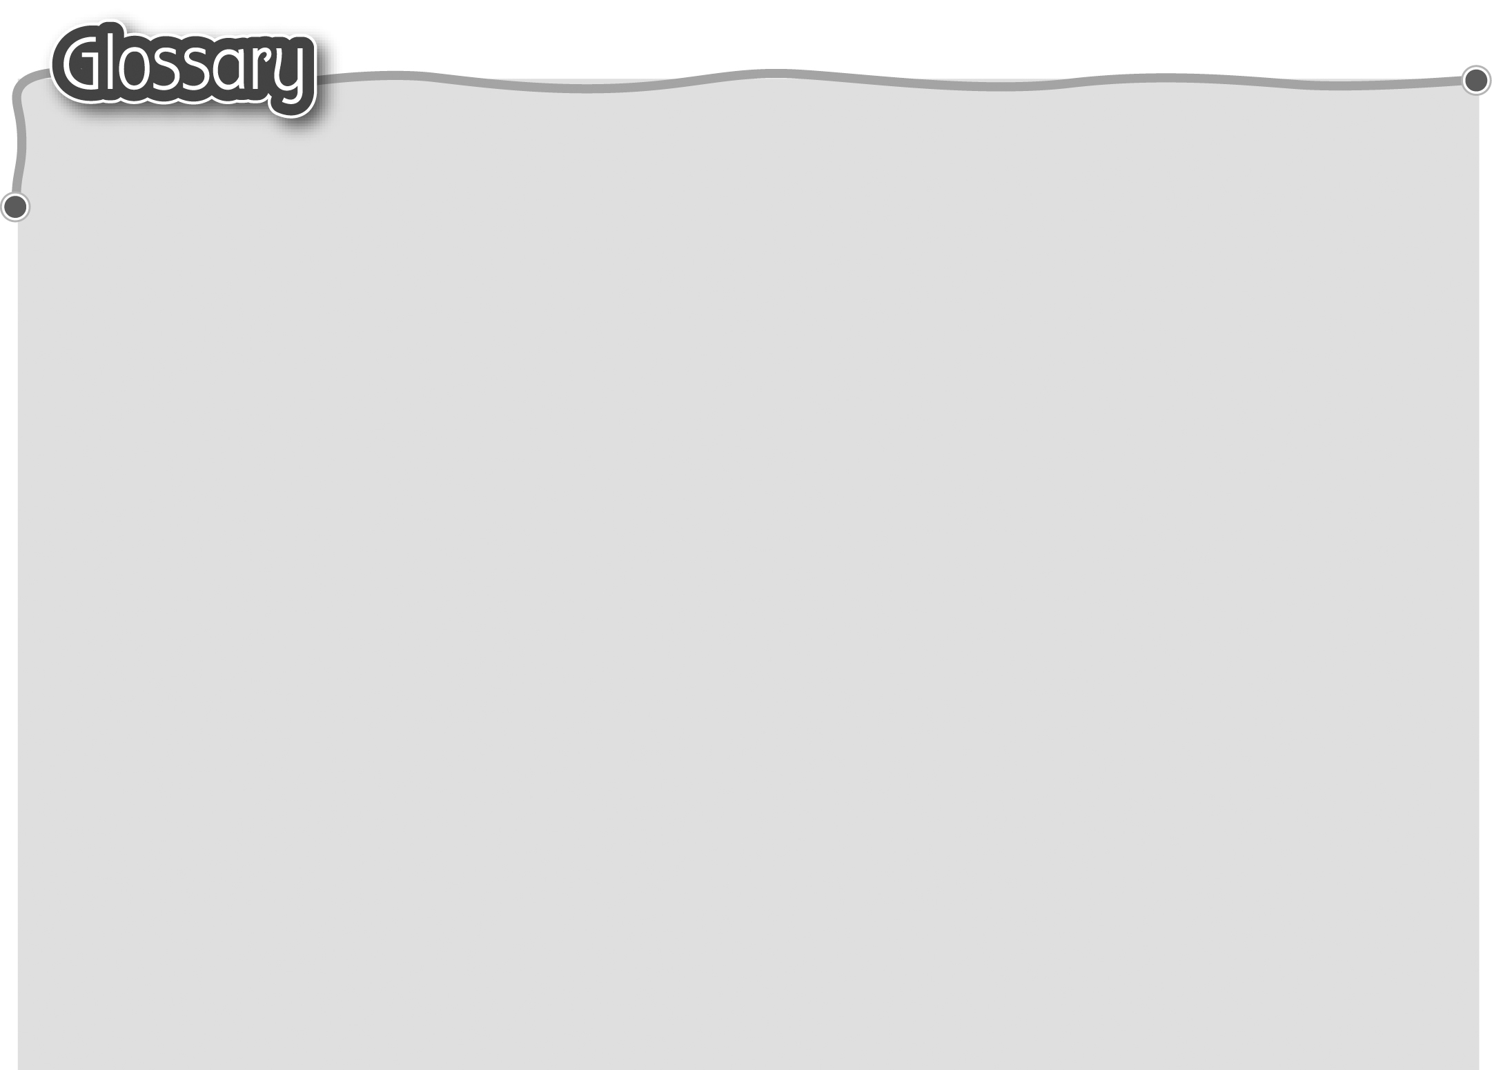
1 choose (p.20) 選擇 15 delicious (p.21) 美味
2 dinosaur (p.20) 恐龍 16 popular (p.21) 受歡迎
3 expensive (p.20) 昂貴 17 checkout* (p.21) 收銀處
4 instead (p.20) 代替 18 left* (leave) (p.21) 遺留（動詞）
5 upset* (p.20) 不開心（形容詞） 19 Octopus card (p.21) 八達通卡
6 trolley (p.20) 購物車 20 reward point (p.21) 積分（名詞）
7 fair* (p.20) 公平 21 cashier* (p.21) 收銀員
8 point at (p.20) 指向 22 shopping bag (p.21) 購物袋
9 jingle (p.20) 廣告歌 23 in the end (p.21) 最後
10 cheapest (cheap) (p.20) 最便宜 24 survey* (p.25) 調查（名詞）
11 pick up* (p.21) 拿起 25 change* (p.26) 找回的零錢（名詞）
12 disgusting (p.21) 令人嘔心 26 receipt (p.27) 收據
13 threw (throw) away (p.21) 27 item (p.27) 物件
扔掉 28 how many (p.27) 幾多/多少
14 win* (p.21) 贏取（動詞） 29 price* (p.27) 價錢（名詞）

