- Favourite food and drinks
Do you go to the supermarket with your parents? What snacks do you usually buy? What do Kelly and Tony buy? Read the story and find out.
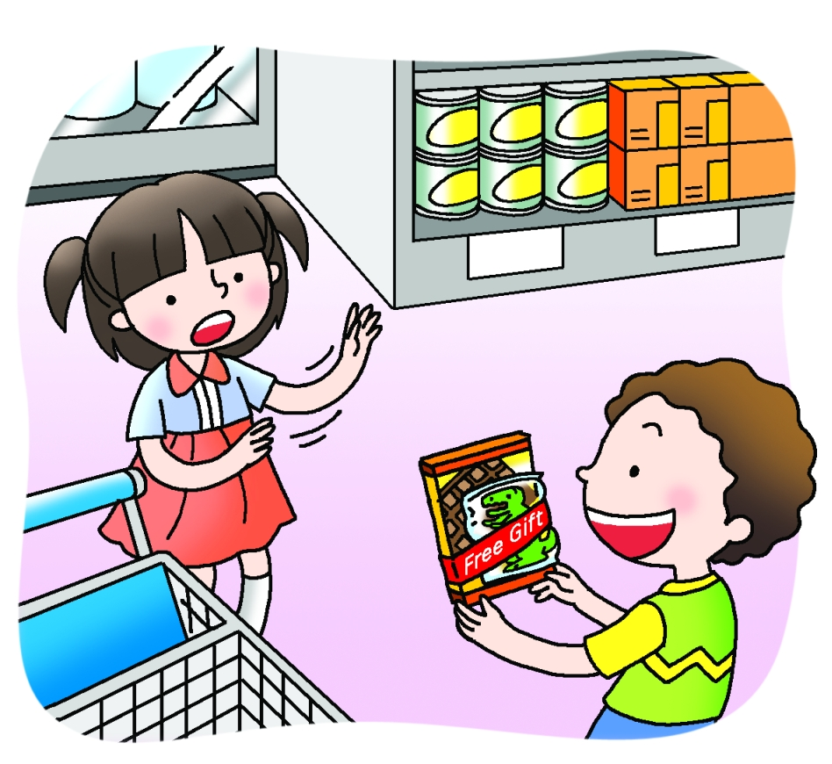

$7.40
$5.20
Kelly and Tony were at the supermarket with their mother.
Kelly said, ‘Let’s choose a bar of chocolate.’
‘How about Yummy Chocolate?’ asked Tony.
‘How much is it?’ asked Kelly.
‘It’s $12.50,’ Tony said.
‘$12.50!’ said Kelly. ‘It’s more expensive than Crunchy Chocolate. Let’s buy Crunchy Chocolate instead. It’s just $4.80.’
Next Kelly put two packets of Juicy Sour Plums in the trolley.
‘That’s not fair!’ said Tony. ‘Why did you choose the most expensive sour plums?’
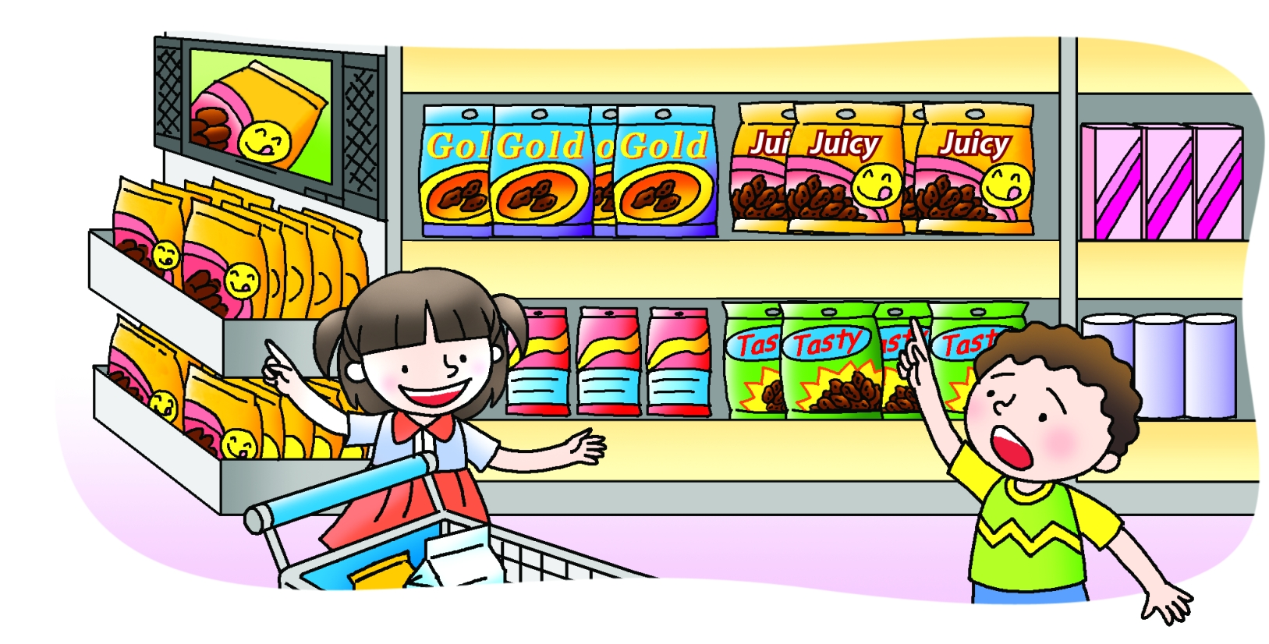
‘Listen to the jingle!’ Kelly said. ‘If we buy two packets, Juicy Sour Plums are the cheapest.’
$9.20
$6.90
$7.50
All over the world, from East to West,
Juicy Sour Plums are the best!
Buy one packet and get one free.
One packet for you and one for me.

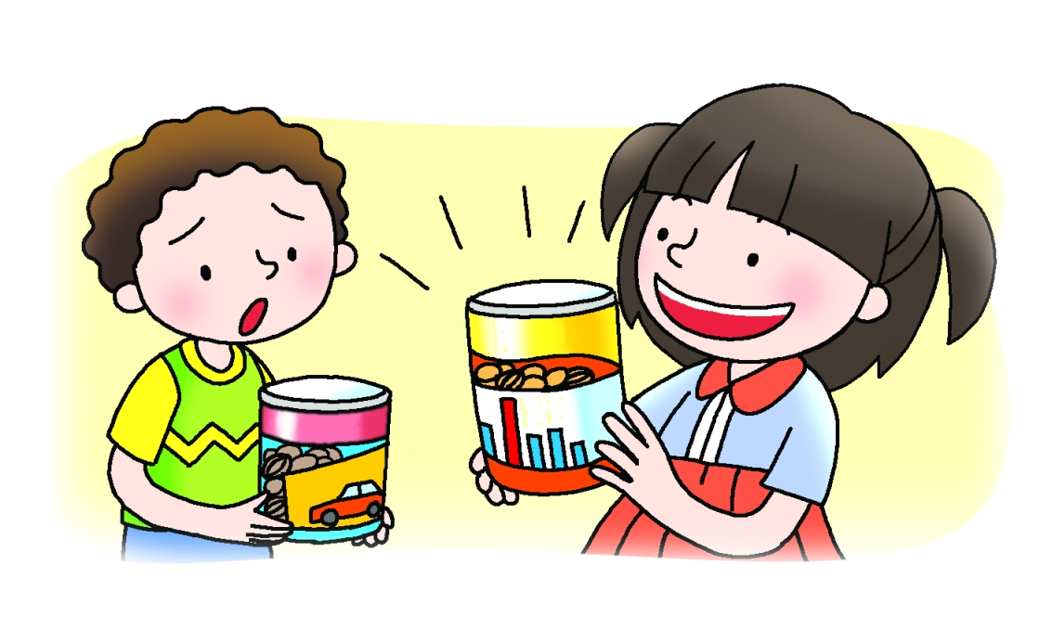
Tony picked up a tin of Nutty Nuts.
Nice Nuts
Nutty Nuts
‘Yuck!’ said Kelly. ‘Nutty Nuts were the most disgusting nuts ever. We threw them away last time.’

Kelly chose a tin of Nice Nuts instead. ‘These are more delicious than Nutty Nuts,’ she said. ‘They’re the most popular nuts in Hong Kong.’
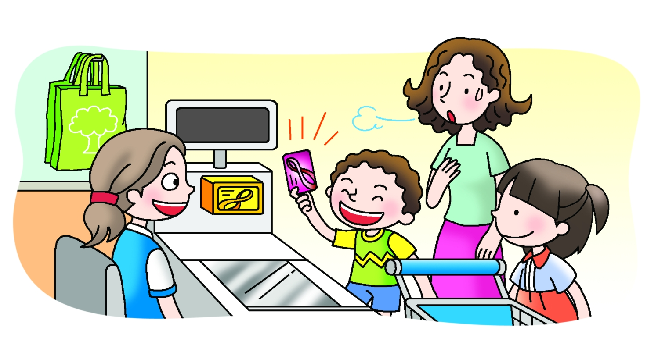
$256.00
$256.00
‘Oh no!’ said Mum. ‘I left my purse at home.’
‘It’s OK,’ said Tony. ‘I’ve got my Octopus card.’
‘You have a lot of reward points,’ said the cashier. ‘You can get a shopping bag with 15 points.’
In the end, everyone was happy!

