Choose and write.

beef curry | chicken curry
prawn salad | tuna salad

1   | 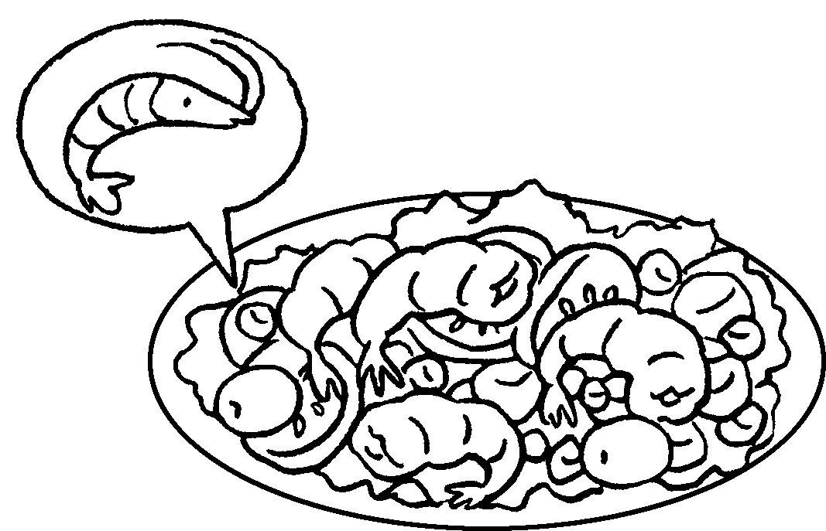 |  |  |  | 2 | 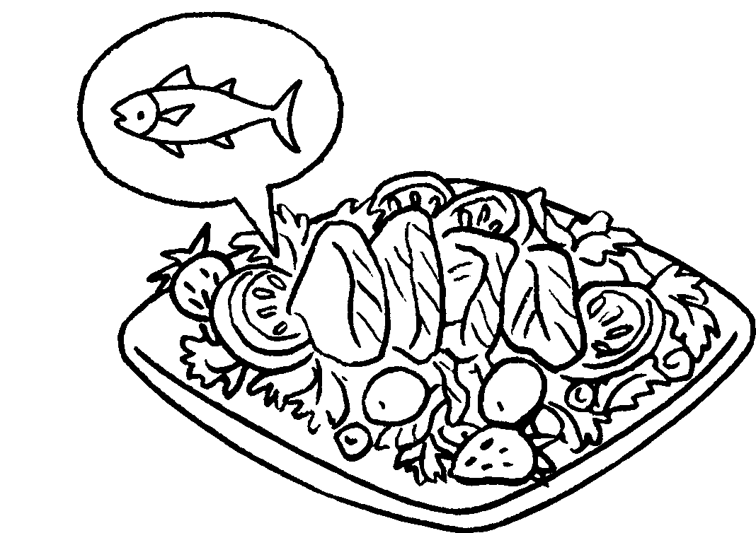
3 | 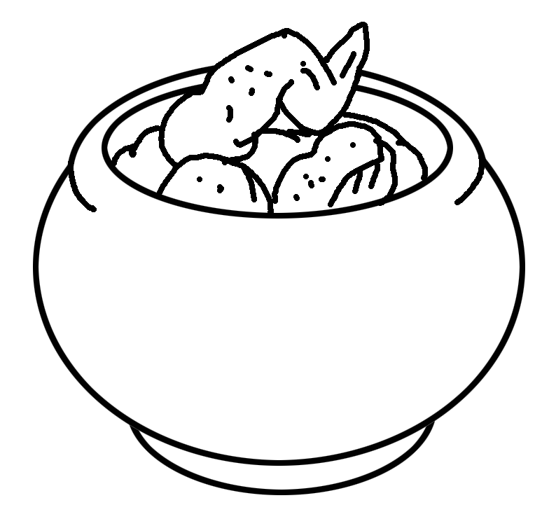 |  |  |  | 4 | 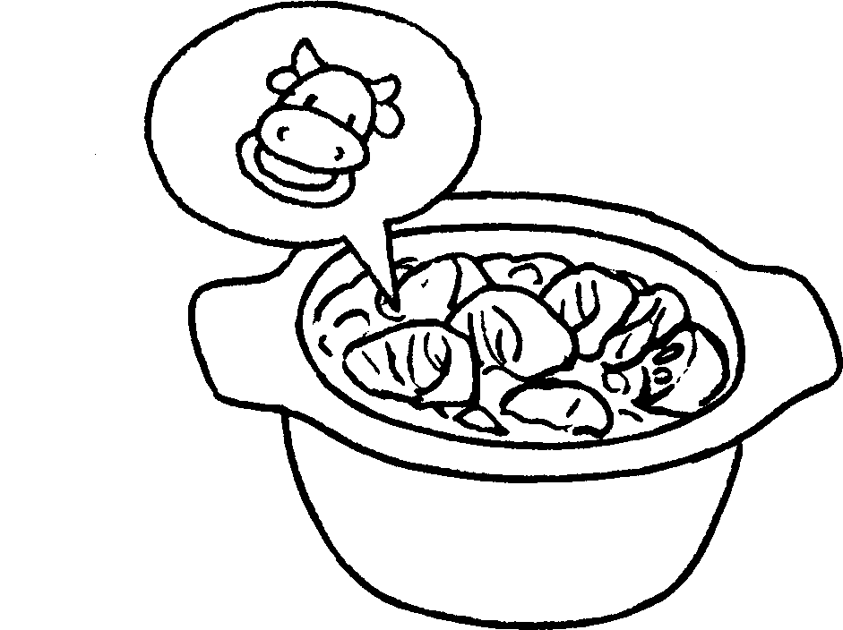

macaroni with mushrooms | soup noodles with dumplings
soup noodles with pork chop | spaghetti with meat sauce

5 | 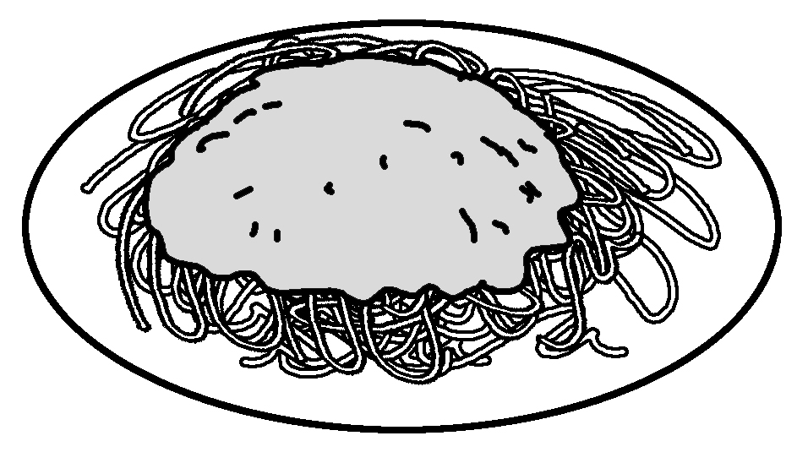
6 | 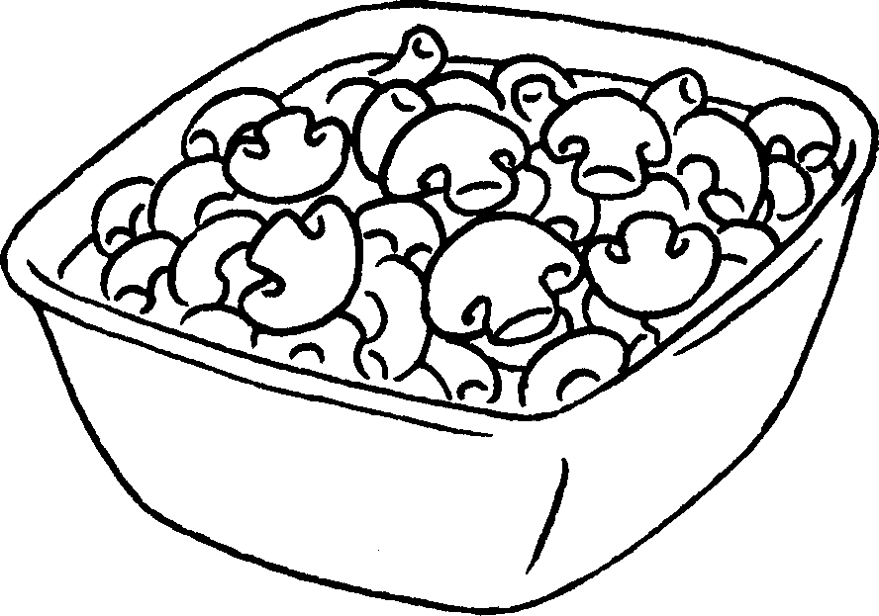
7 | 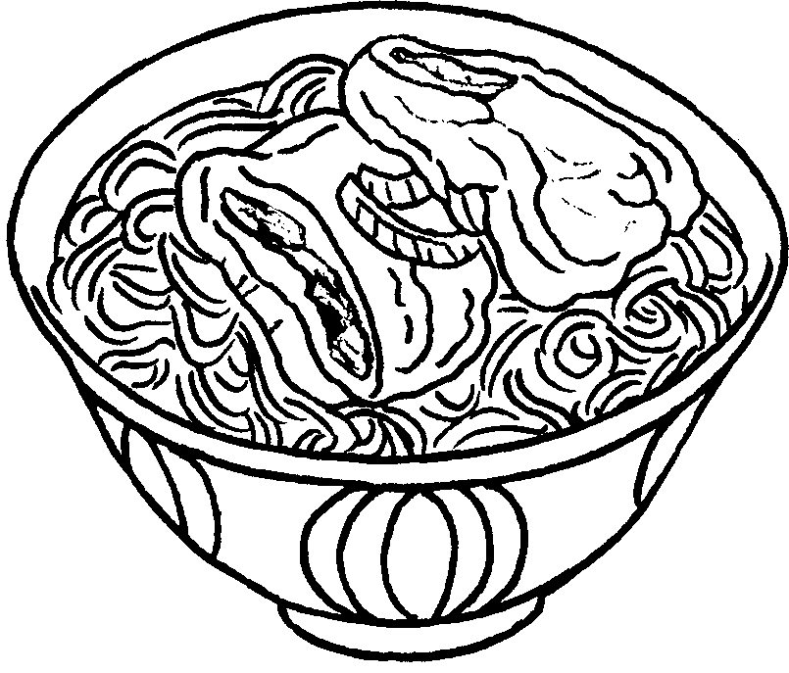
8 | 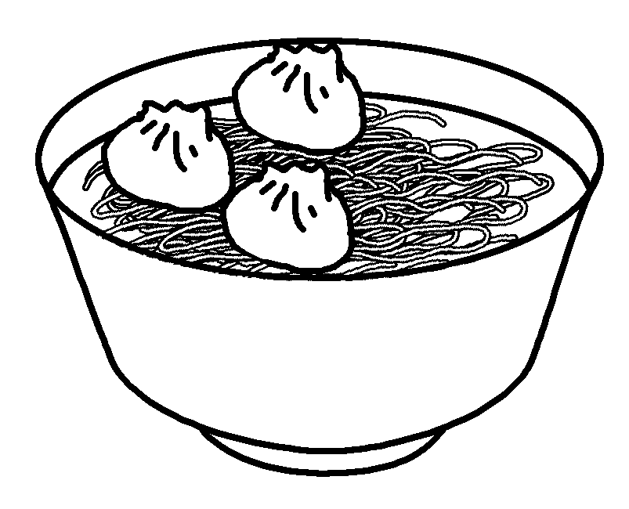



Book 4A Chapter 4 Graded Worksheets
Worksheet 1⬇
- prawn salad
- tuna salad
- chicken curry
- beef curry
- spaghetti with meat sauce
- macaroni with mushrooms
- soup noodles with pork chop
- soup noodles with dumplings

