What are they? Write.

1 | 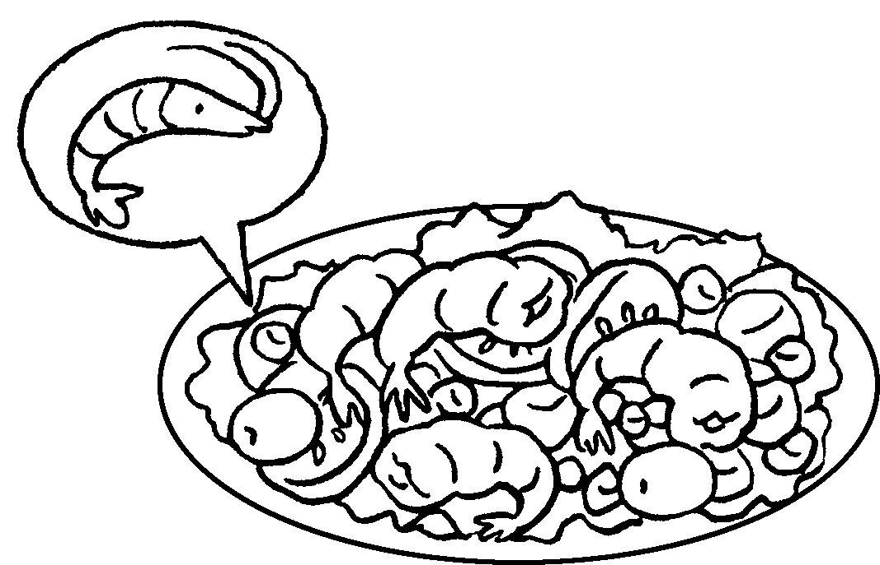 | p s
2 | 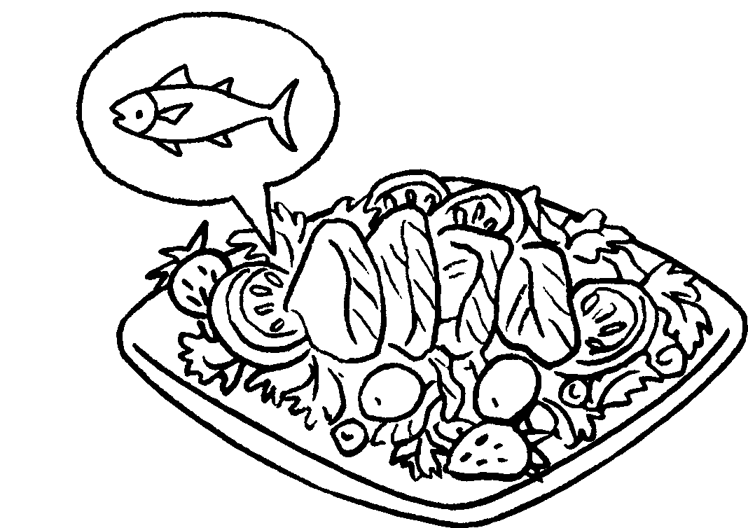 | t s
3 |   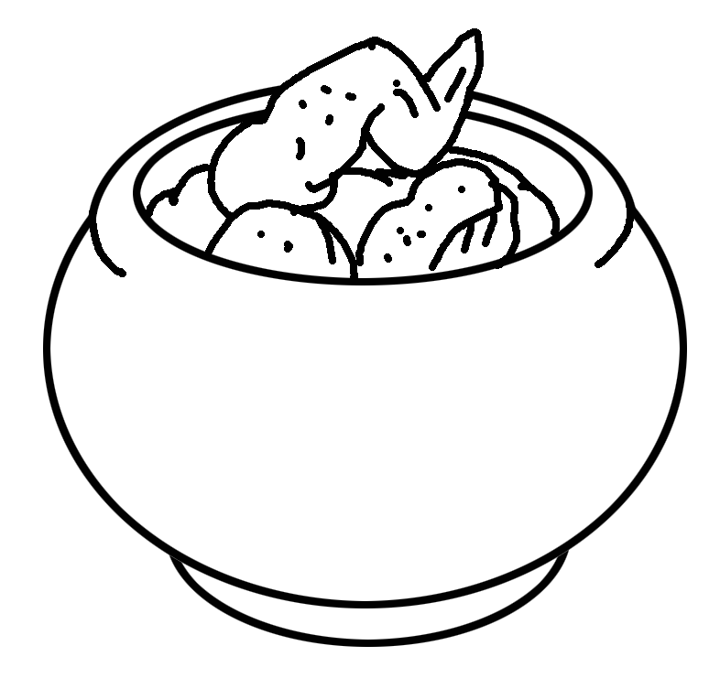 | c c
4 | 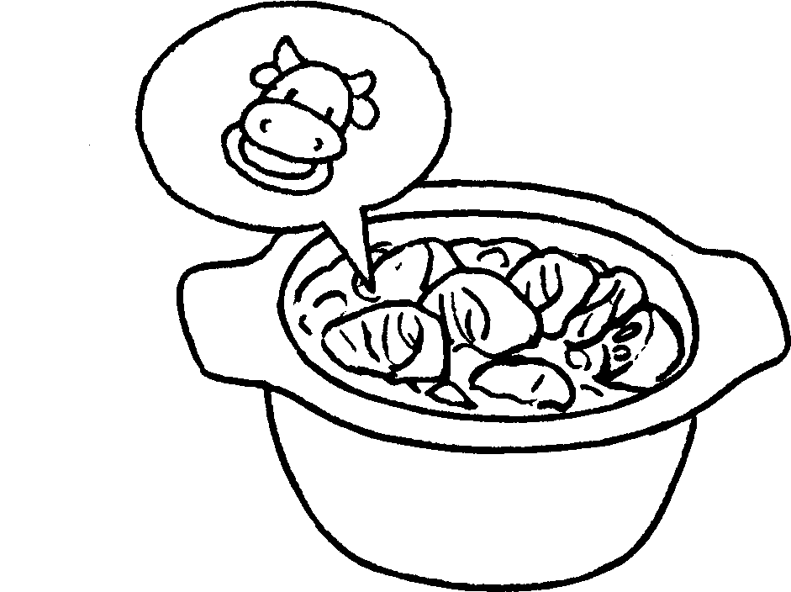 | b c
5 | 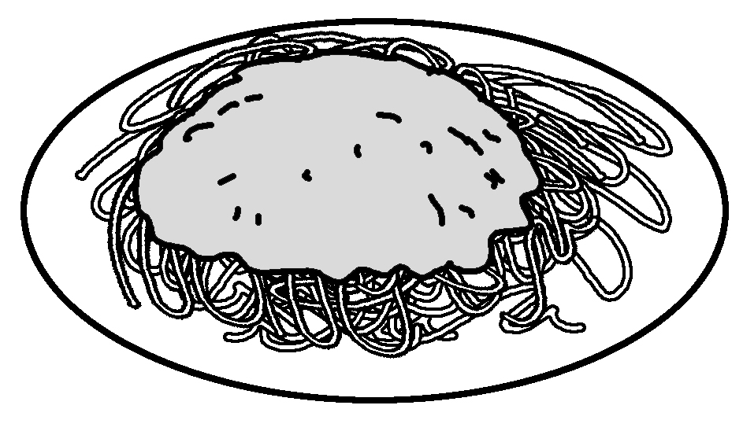 | s with m sauce
6 | 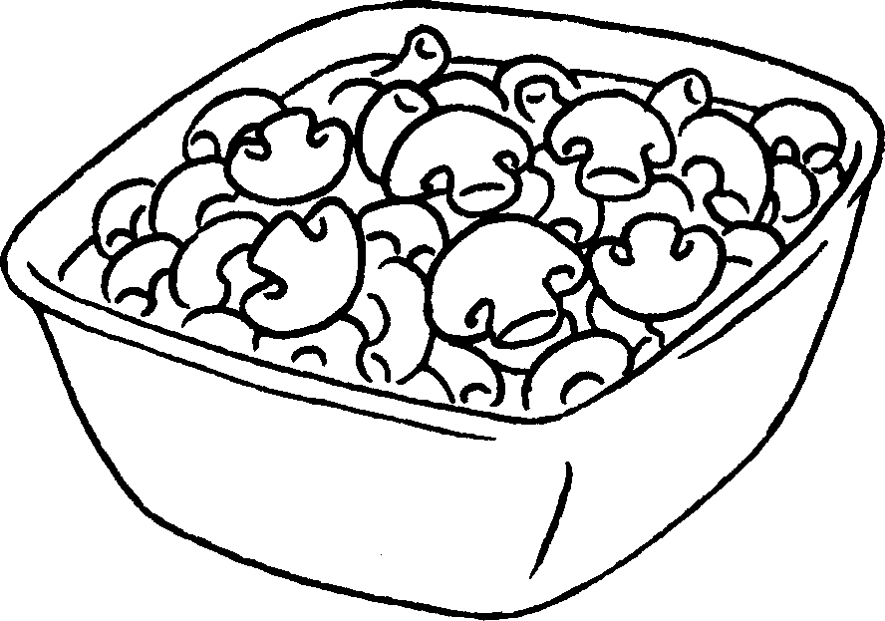 | m with mushrooms
7 | 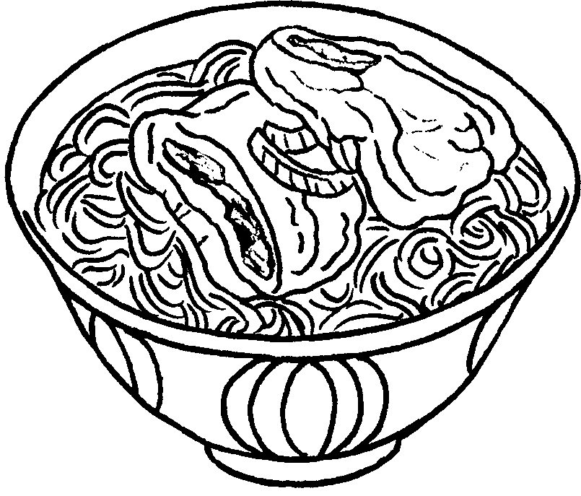 | s n with pork chop
8 | 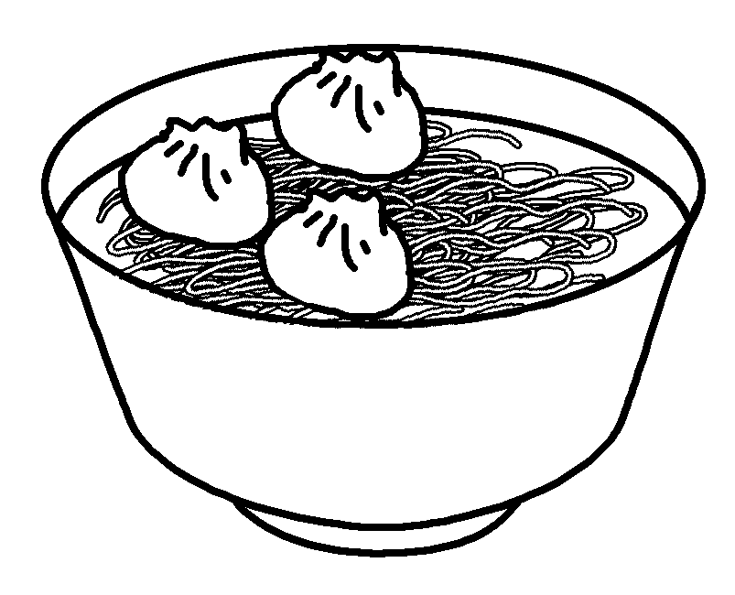 | s n with d



Book 4A Chapter 4 Graded Worksheets
Worksheet 1⬇⬇
- prawn salad
- tuna salad
- chicken curry
- beef curry
- spaghetti meat
- macaroni
- soup noodles
- soup noodles dumplings

