What are they? Write.

1 | 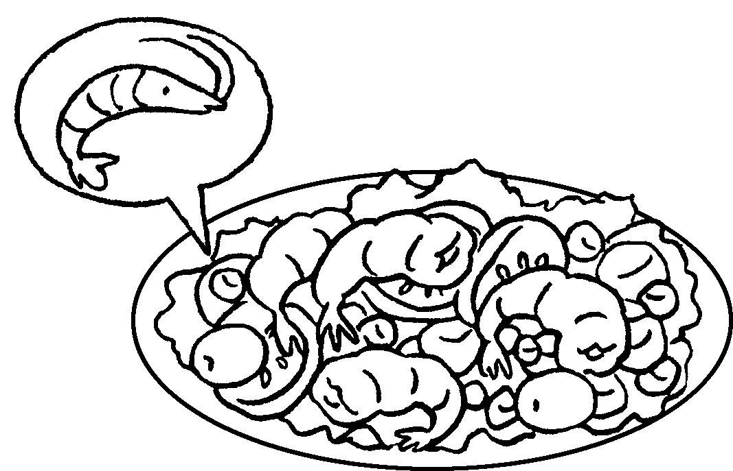 | salad
2 | 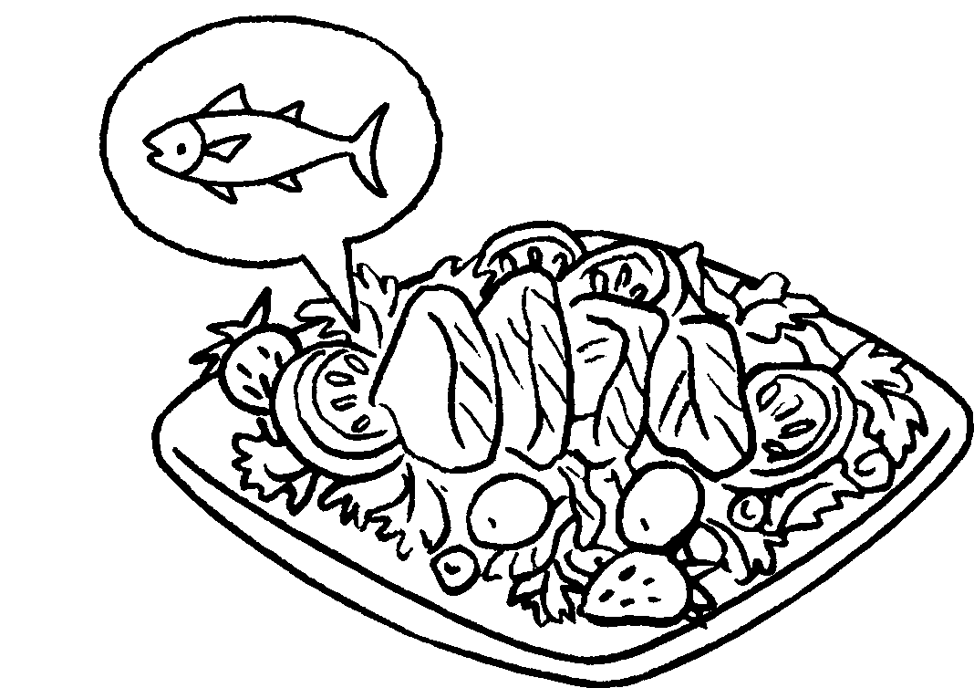 | tuna
3 |   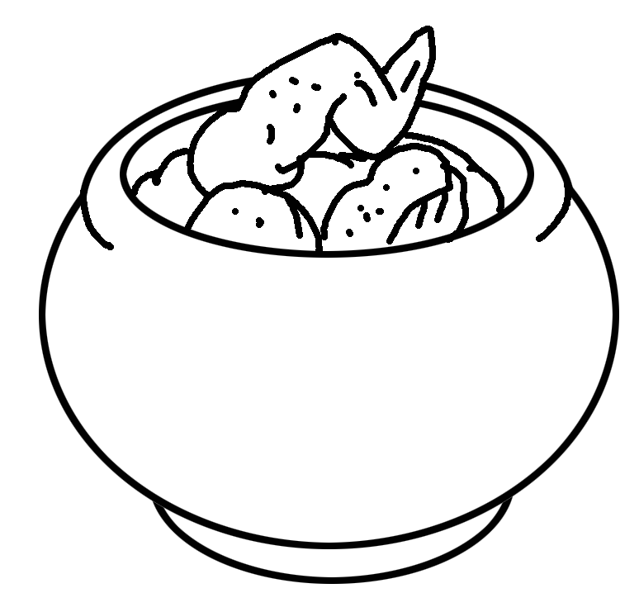
4 | 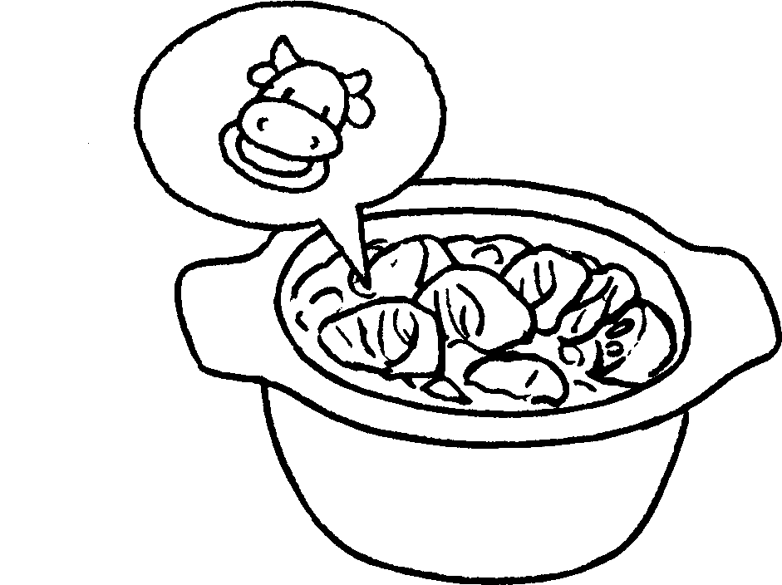
5 | 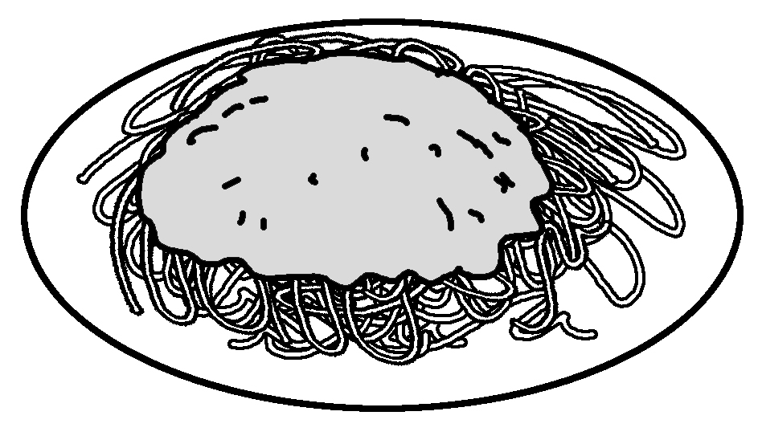 | sauce
6 | 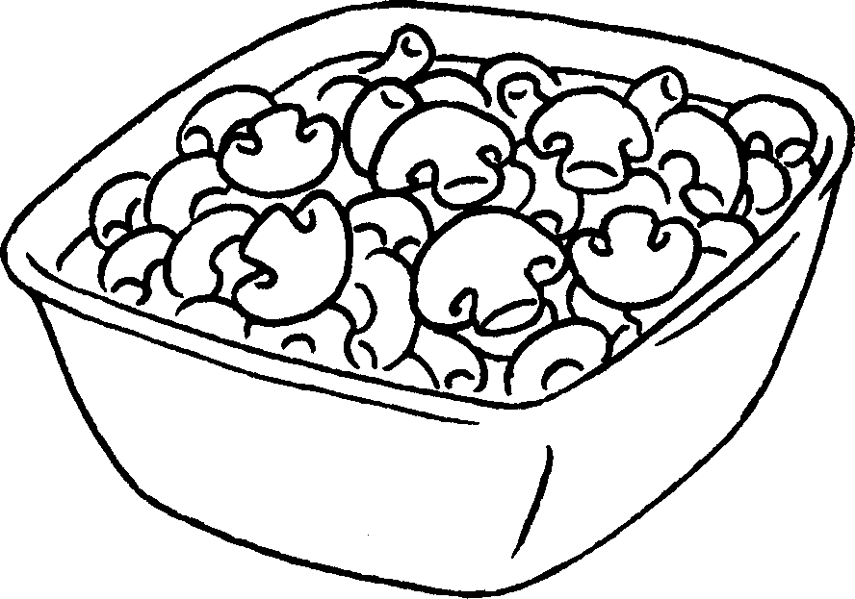 | mushrooms
7 | 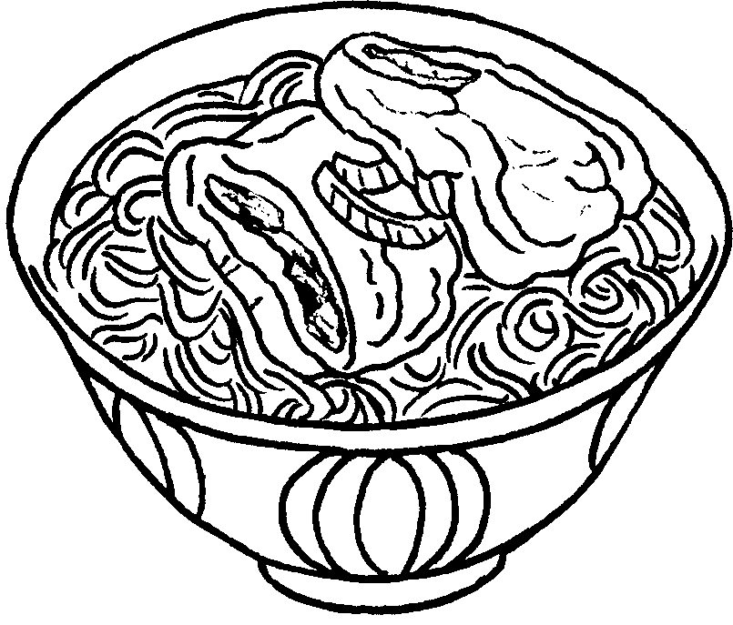 | with pork chop
8 | 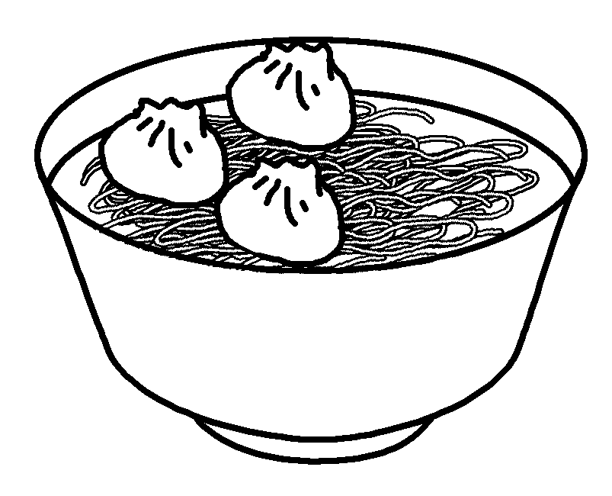 | with



Book 4A Chapter 4 Graded Worksheets
Worksheet 1⬇⬇⬇
- prawn
- salad
- chicken curry
- beef curry
- spaghetti with meat
- macaroni with
- soup noodles
- soup noodles dumplings

