Choose and write.

What | Which |  | would | or | I’d
A
B
B
A
B
A
1 | 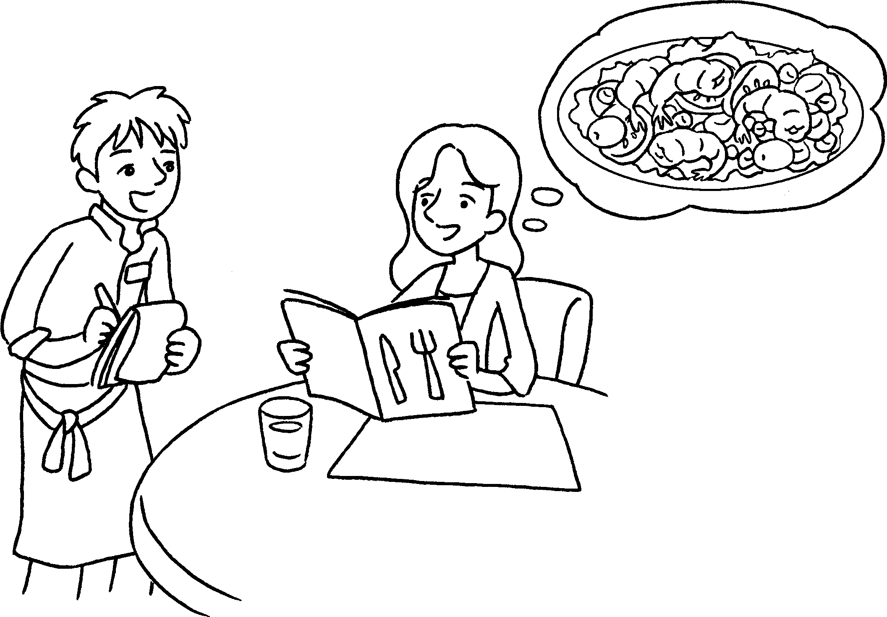 |  | A : What you like?  B : I’d like some salad.  A : Which you like,  tuna salad or prawn salad?  B : like prawn salad.
2 | 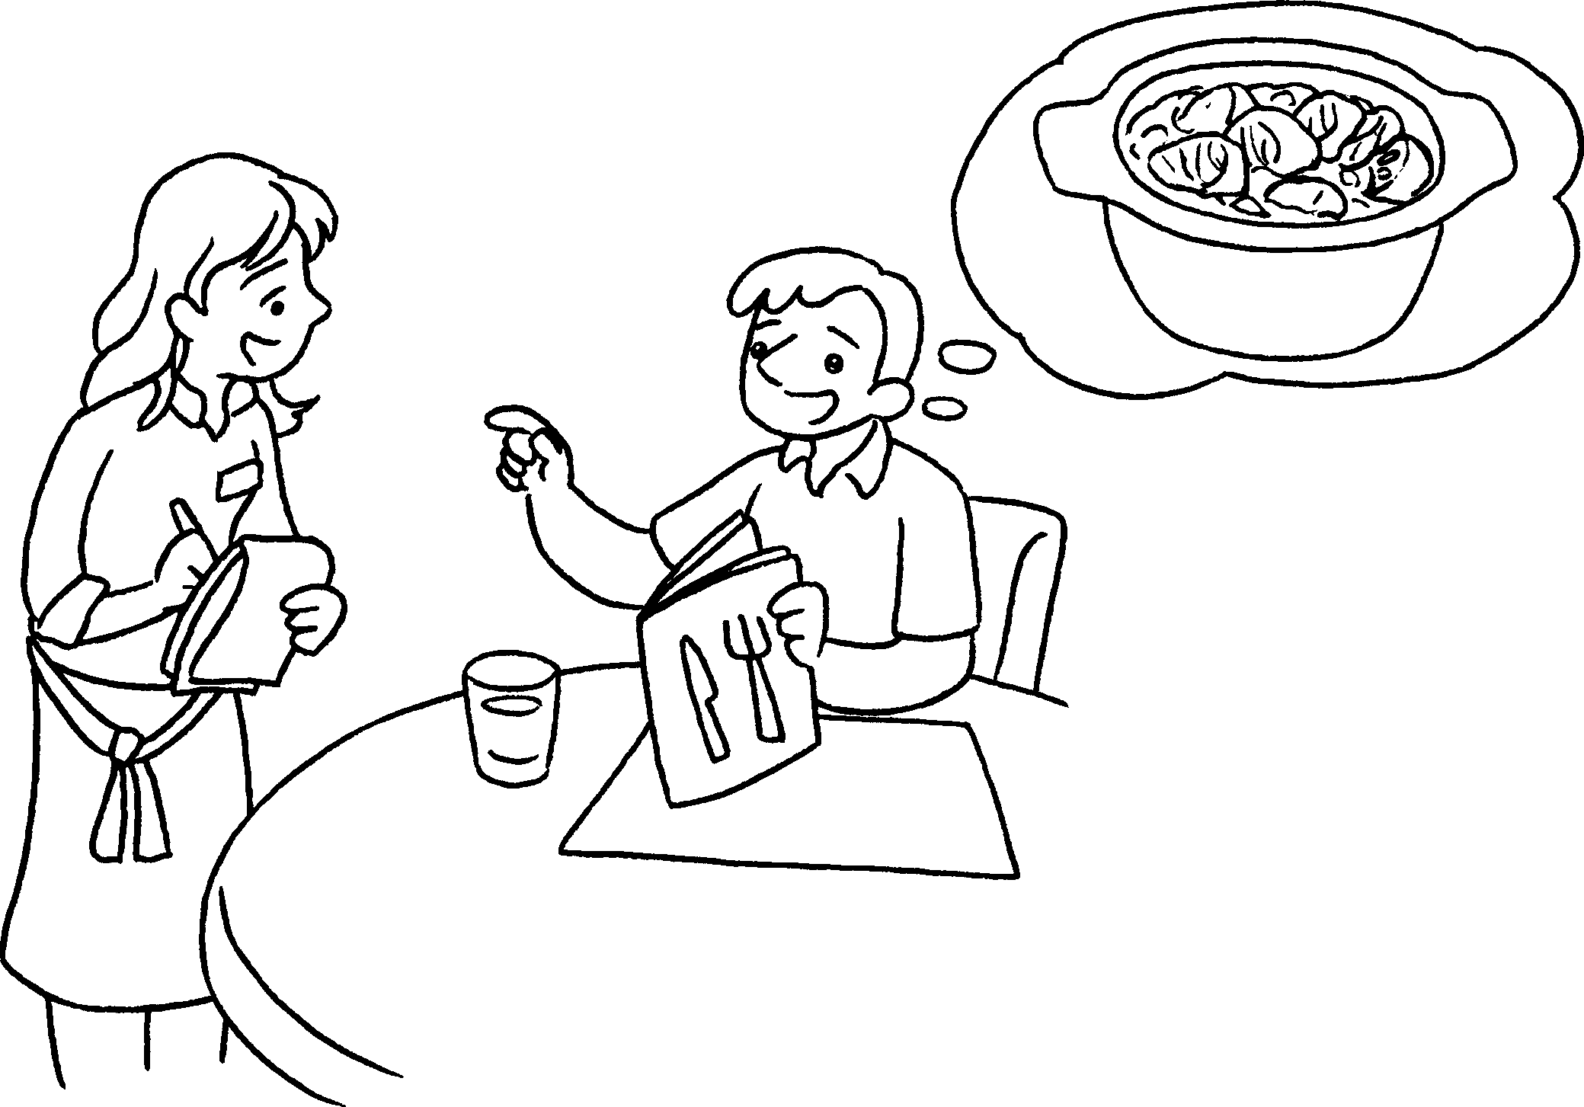 |  | A : would you like?  B : I’d like some curry.  A : would you like,  chicken curry  beef curry?  B : like beef curry.
3 | 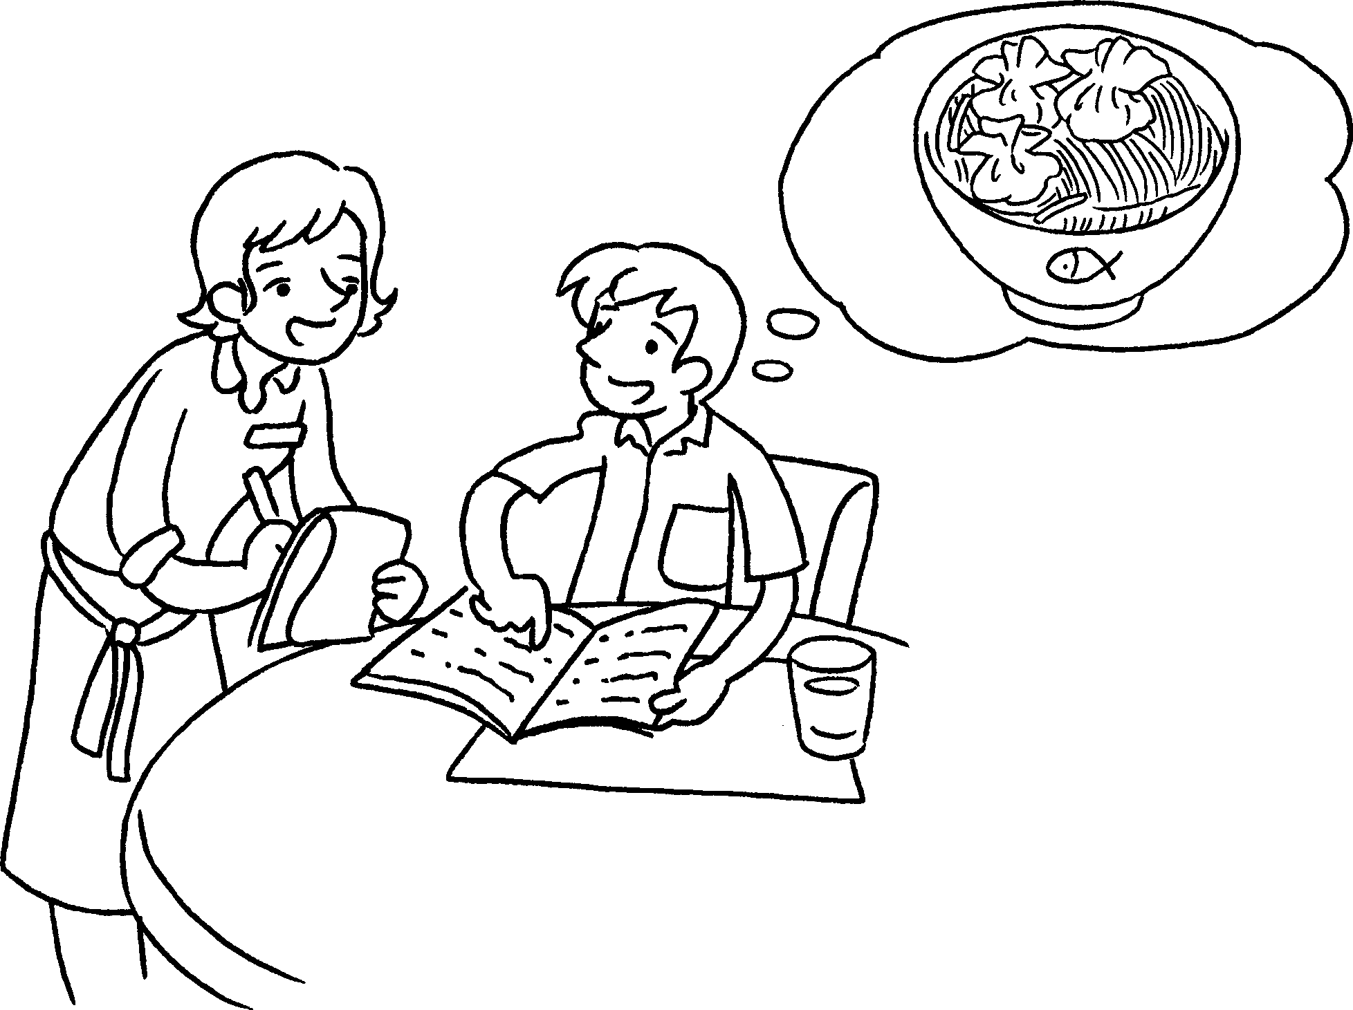 |  | A :  you like?  B : like some soup noodles.  A :  you like, soup noodles with  dumplings soup  noodles with pork chop?  B : like soup  noodles with dumplings.


Book 4A Chapter 3 Graded Worksheets
Worksheet 3⬇
- would
would
I’d
- What
Which or
I’d
- What would
I’d
Which would or
I’d

