Finish what the people say.

What | Which
A
B
B
A
B
A
1 | 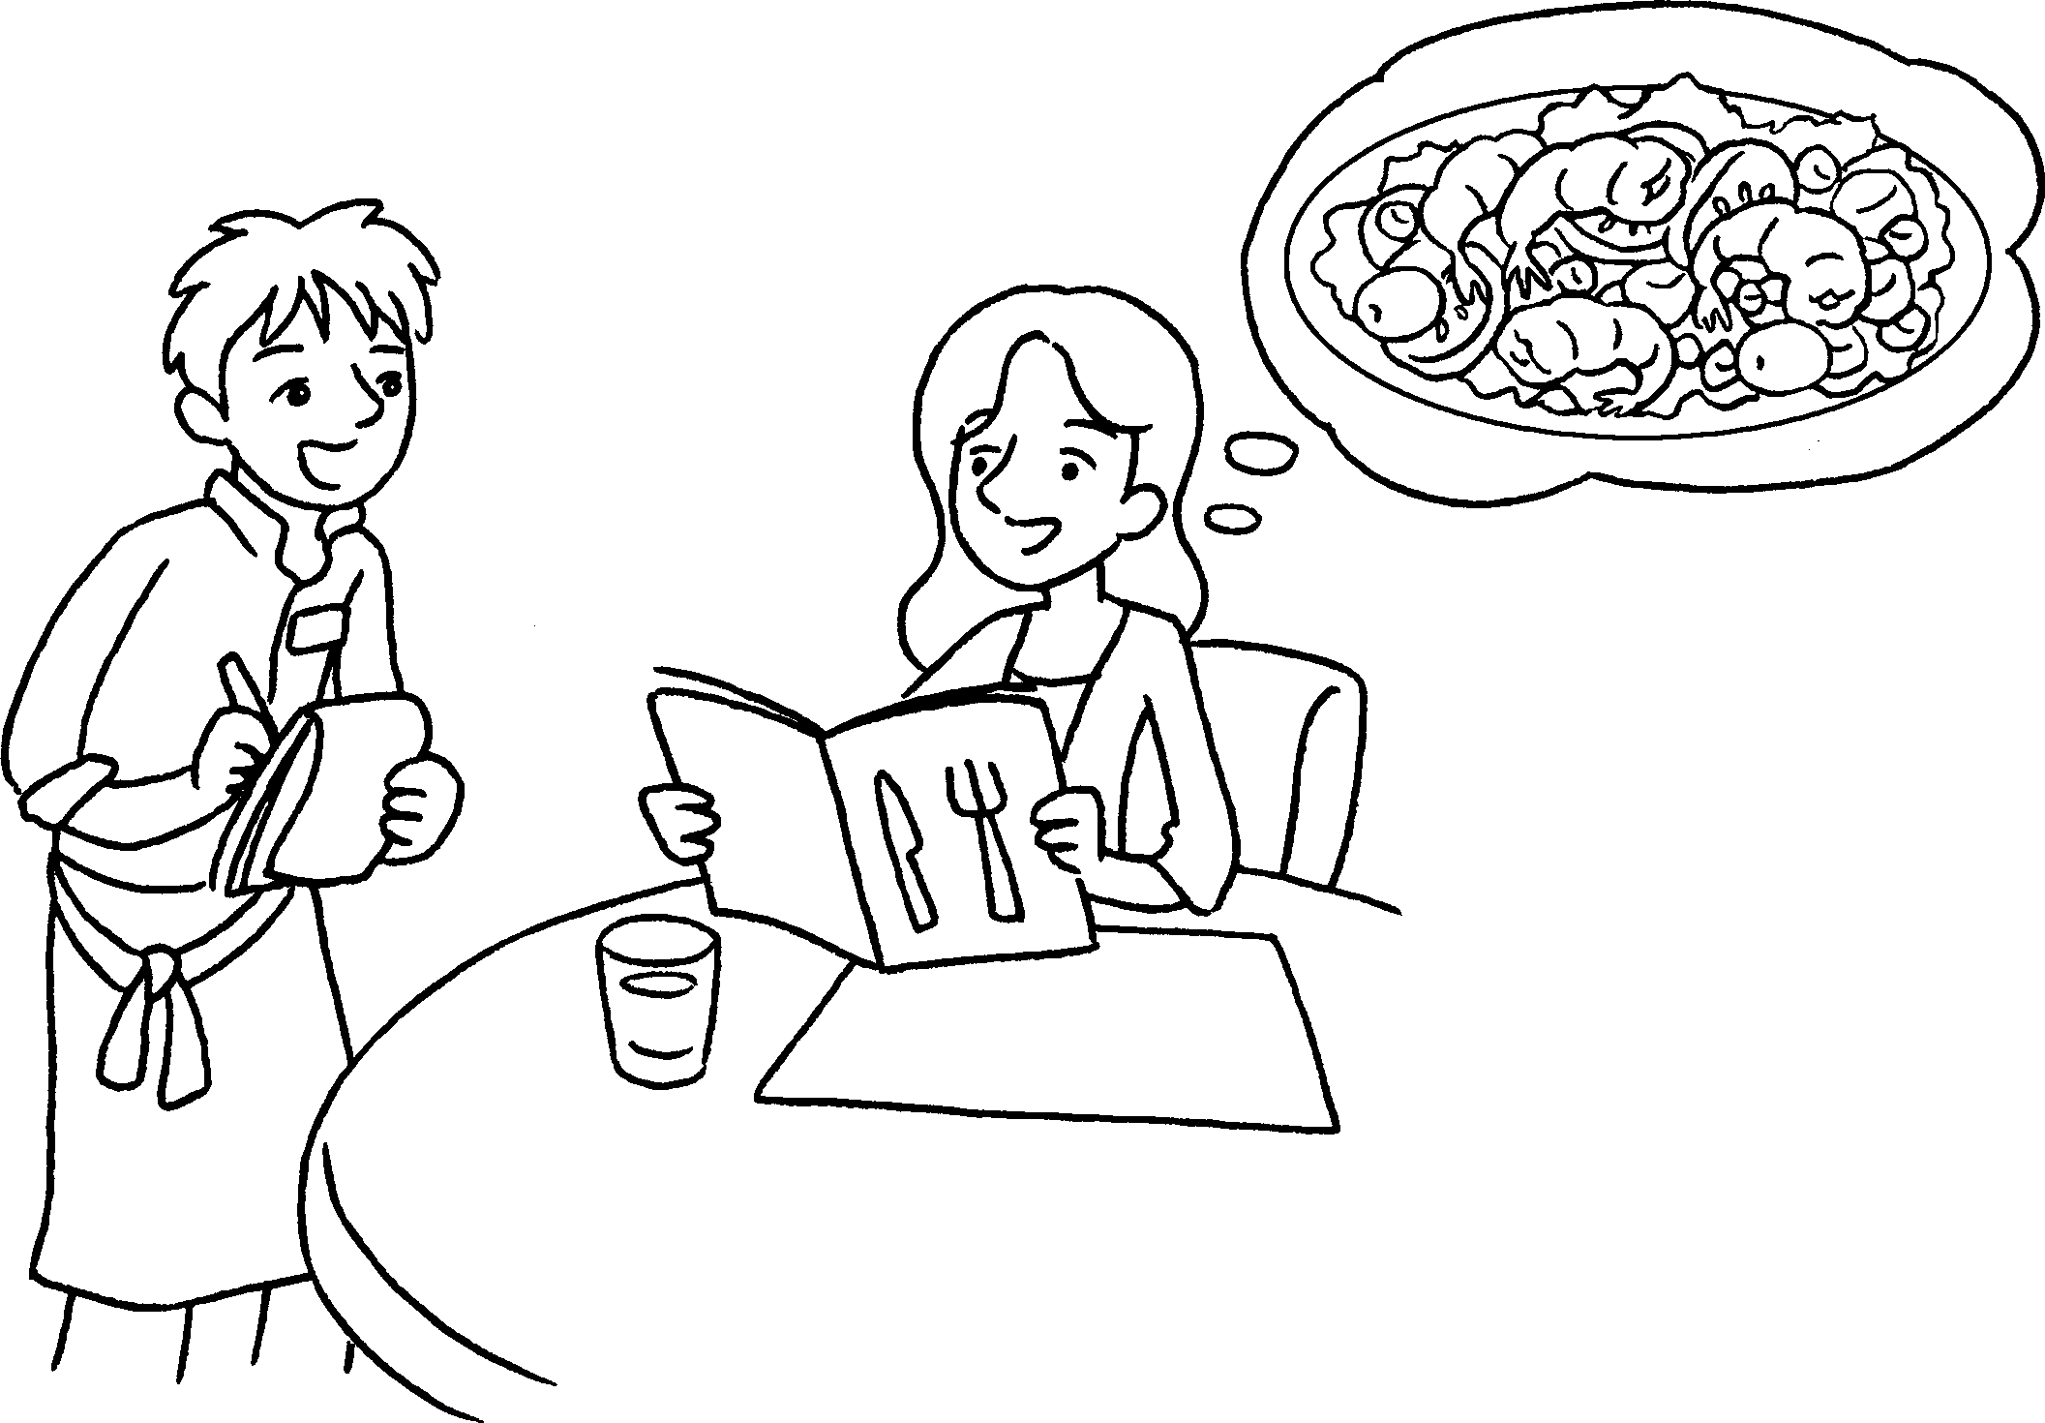 |  | A : would you like?  B : I’d like some salad.  A : would you like,  tuna salad or prawn salad?  B : like prawn salad.
2 | 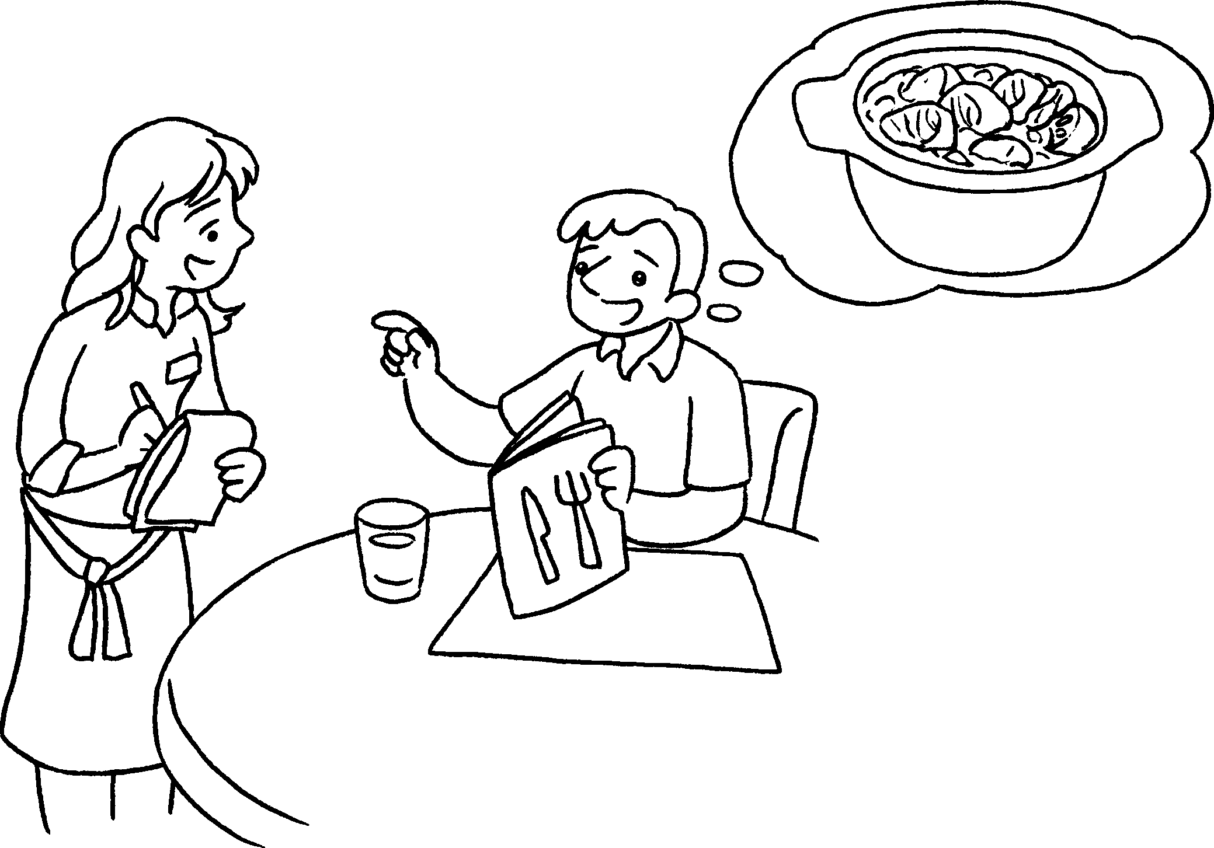 |  | A : would you like?  B : some curry.  A : would you like,  chicken curry  beef curry?  B : beef curry.
3 | 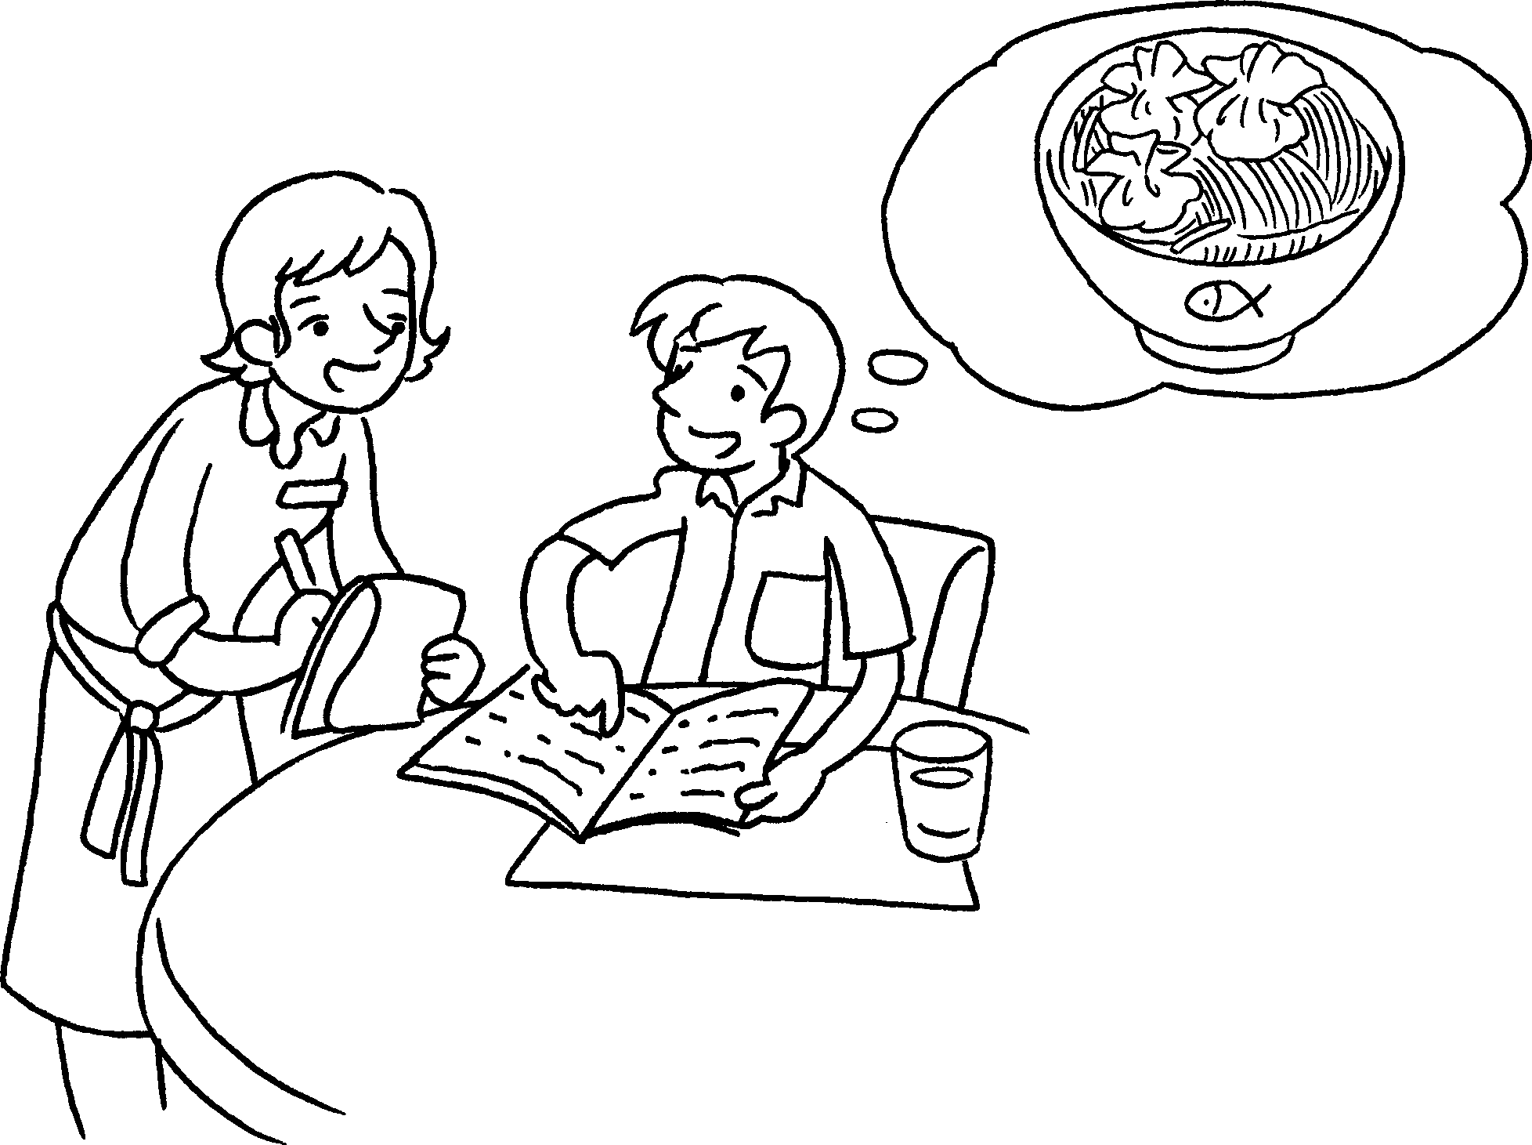 |  | A :  you like?  B : some soup noodles.  A :  you like, soup noodles with  dumplings soup  noodles with pork chop?  B :



Book 4A Chapter 3 Graded Worksheets
Worksheet 3⬇⬇
- What
Which
I’d
- What
I’d like
Which or
I’d like
- What would
I’d like
Which would or
I’d like soup noodles with dumplings.

