Finish what they people say.
A
B
B
A
B
A
1 | 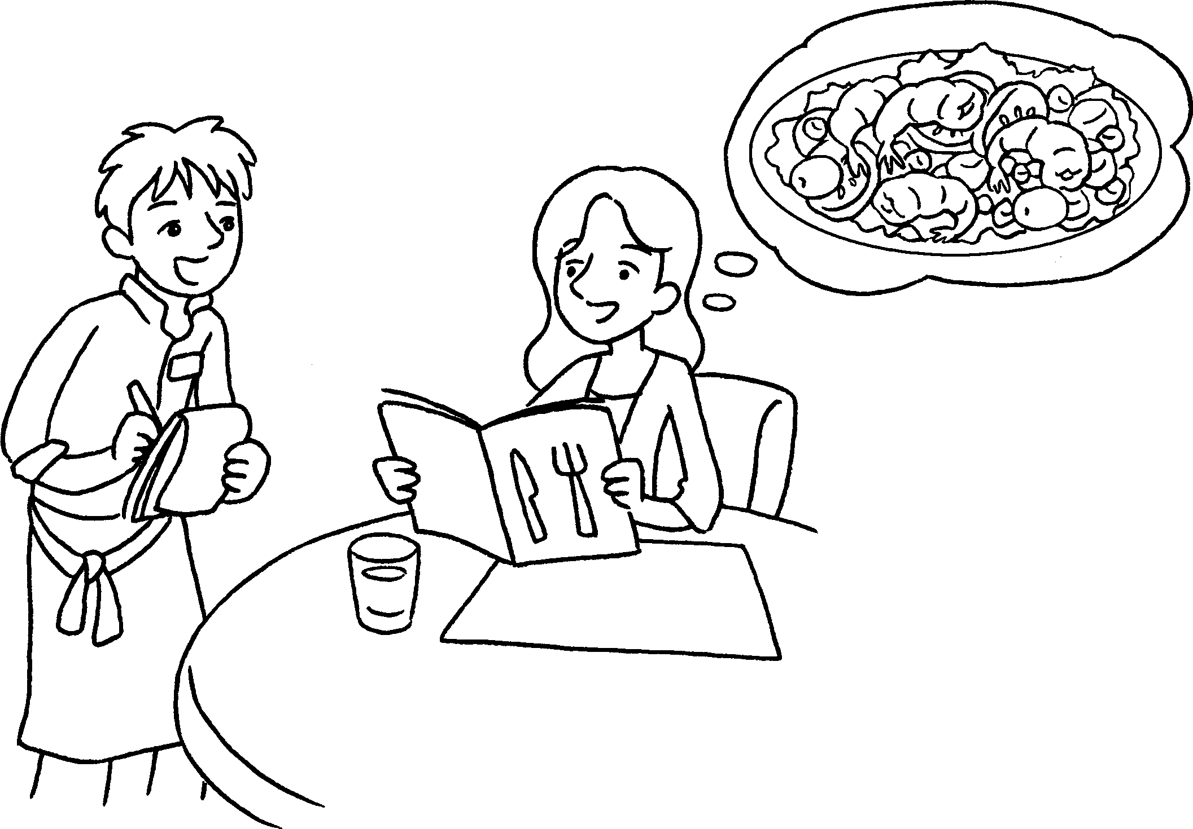 |  | What  A : would you like?  B : I’d some salad.  A : would you like,  tuna salad or prawn salad?  Which  B : like prawn salad.
2 | 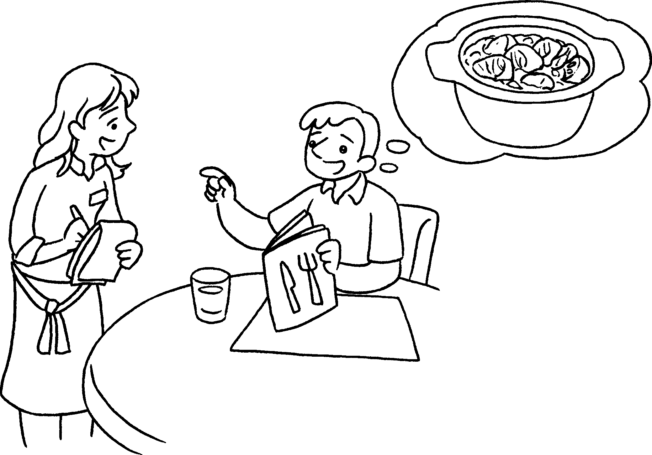 |  | A : would you like?  B : some curry.  A :  , chicken curry  beef curry?  B : beef curry.
3 | 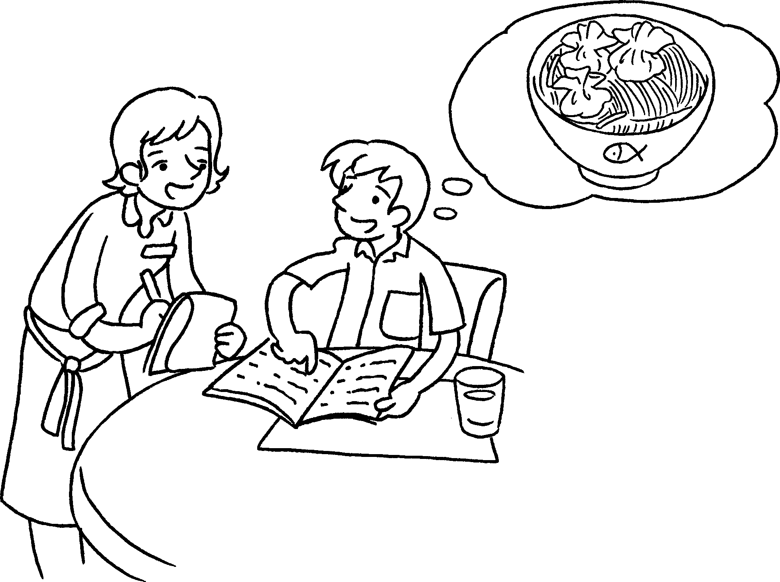 |  | A :  B : some soup noodles.  A :  , soup noodles with dumplings soup noodles with pork chop?  B :


Book 4A Chapter 3 Graded Worksheets
Worksheet 3⬇⬇⬇
1 like
I’d
2 What
I’d like
Which would you like or
I’d like
3 What would you like?
I’d like
Which would you like or
I’d like soup noodles with dumplings.

