- Eating out
Do you like eating out? What kind of restaurant do you like best? Did Mark and his family like the restaurant they went to? Read the play and find out.

The Best Restaurant in the World – A Play
This tells us where the scene takes place.
This tells us what the characters do.
This tells us how the characters feel and speak.
Characters
Mr Tong Mrs Tong Mark Tong

Scene 1 At the Tongs’ home
Enter Mark.
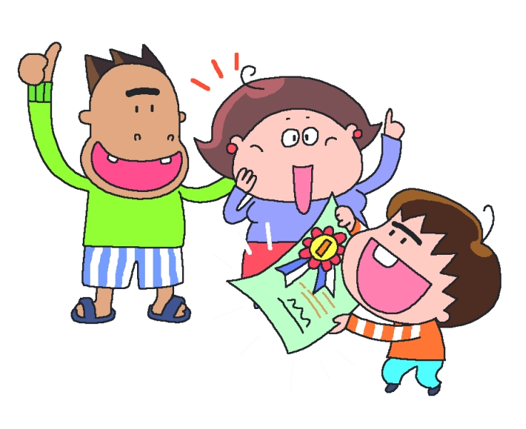
Mark : (excitedly) I won in the Speech Festival!
Mrs Tong : Well done! Let’s go out for dinner!
Mark : Can we go to ‘The Best Restaurant in the World’?
Mr Tong : Let’s go!
All exit.
Scene 2 In the restaurant
The Best Restaurant in the World ― Menu
Indian food  Beef curry $48  Chicken curry $46 | Chinese food  Soup noodles with dumplings $26  Soup noodles with pork chop $23
Japanese food  Sushi $24 − $150  Crab stick salad $36 | Italian food  Macaroni with mushrooms $45  Spaghetti with meat sauce $38  Spaghetti with ham and cheese $30

Mrs Tong : What would you like, Mark?
Mark : I’d like some spaghetti, please.
Mrs Tong : Which would you like, spaghetti with meat sauce or ham and cheese?
Mark : I’d like spaghetti with ham and cheese.
Mr Tong : I’d like beef curry, please.
Mrs Tong : Erm … um … Should I have noodles with pork chop or dumplings?
Mr Tong : Please choose quickly. I’m very hungry.
Mark : Me too. I could eat a horse!
Mrs Tong : OK! Noodles with dumplings.

Scene 3 In the restaurant

The waiter brings the food.
Mr Tong : Aargh! I need water! This curry is too spicy!
(shouting) Waiter!
Mark : (angrily) Yuck! There’s a cockroach in my spaghetti.
(shouting) Waiter!
Mrs Tong : (angrily) Urgh! My noodles are cold and there’s a hair in this dumpling.
(shouting) Waiter!
Mark : This is the worst restaurant in the world!
Mrs Tong : Let’s go. I know a better place to eat …
All : Home!

― The end ―

