RP no: Century Gothic 15pt
(所有圈號用15pt)
Choose and write.

 | DVD player |  | digital camera
electronic games |  | mobile phone |  | MP3 player

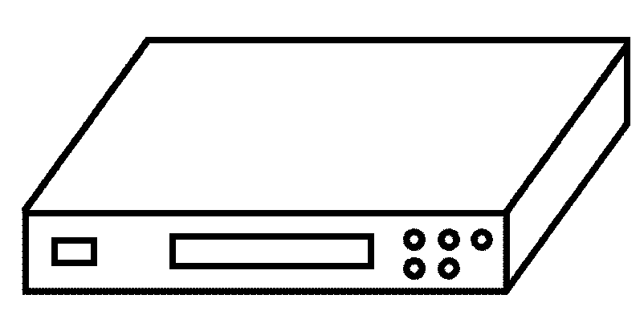  1  2  4  3  5  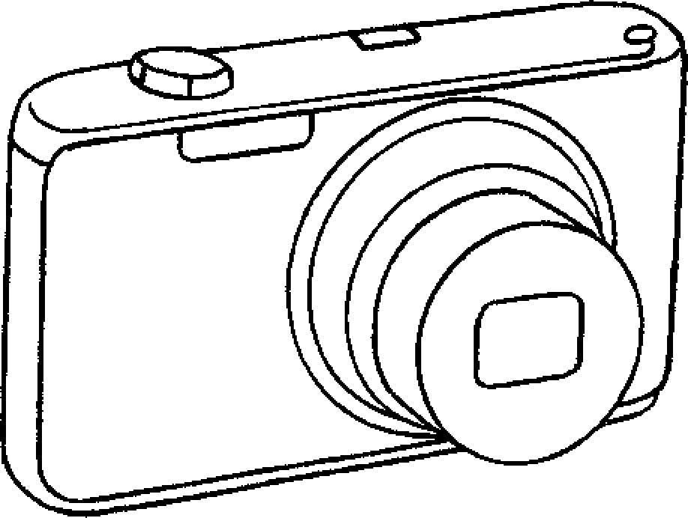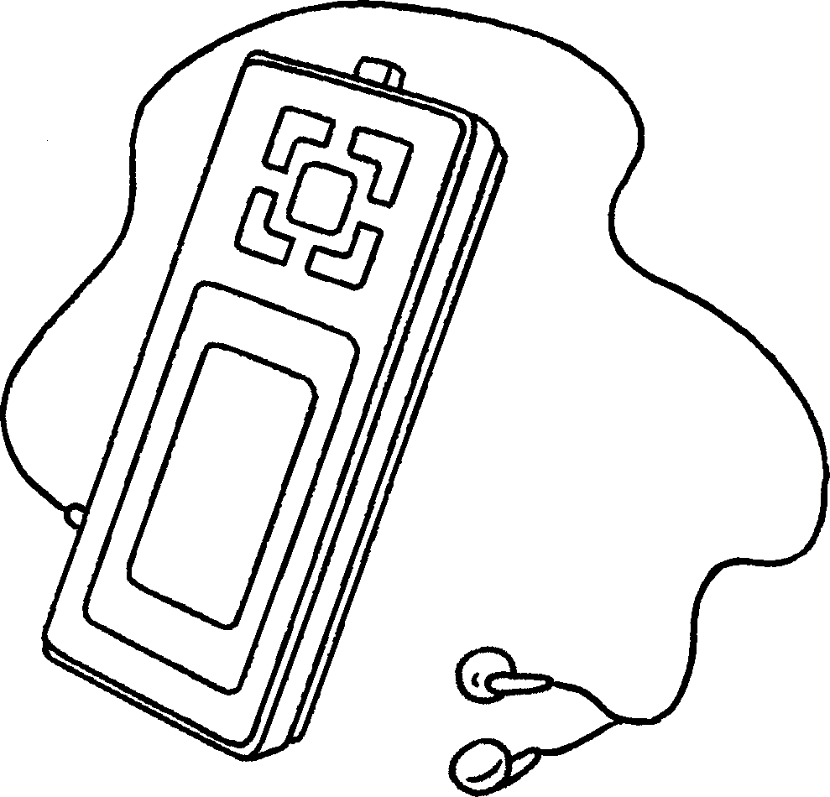  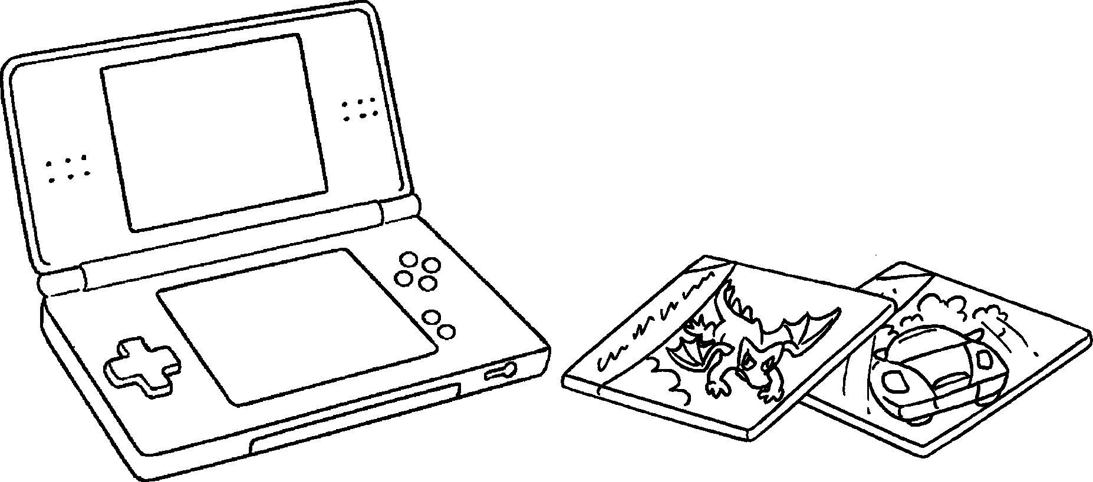 |  | 1 | a
 |  | 2 | a
 |  | 3 | a
 |  | 4 | an
 |  | 5

airport | theme park
shopping centre | supermarket
6
7
9
8
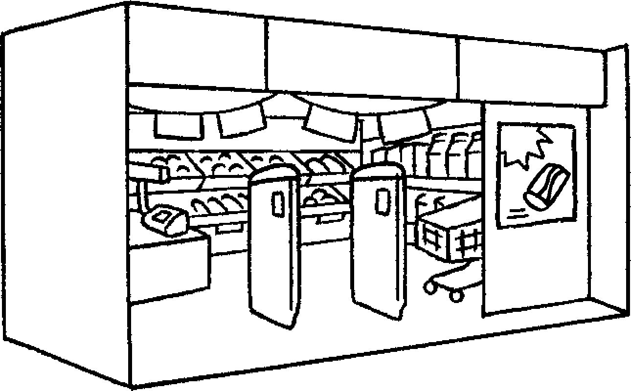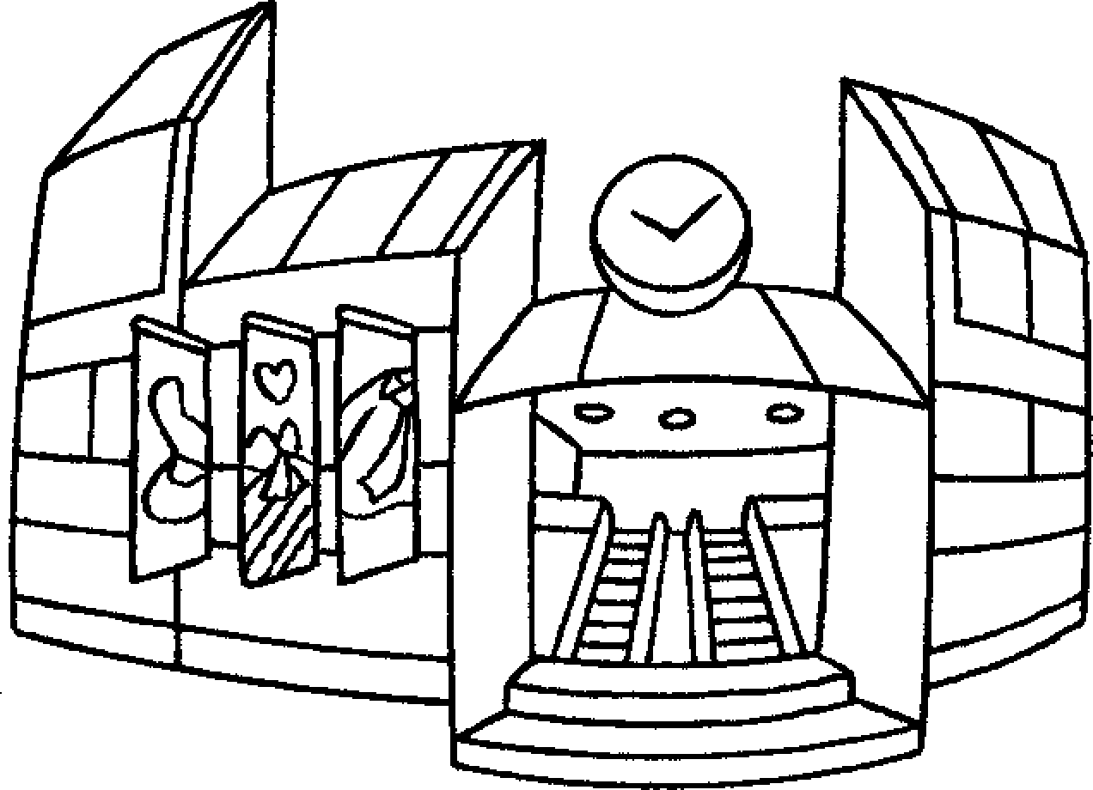  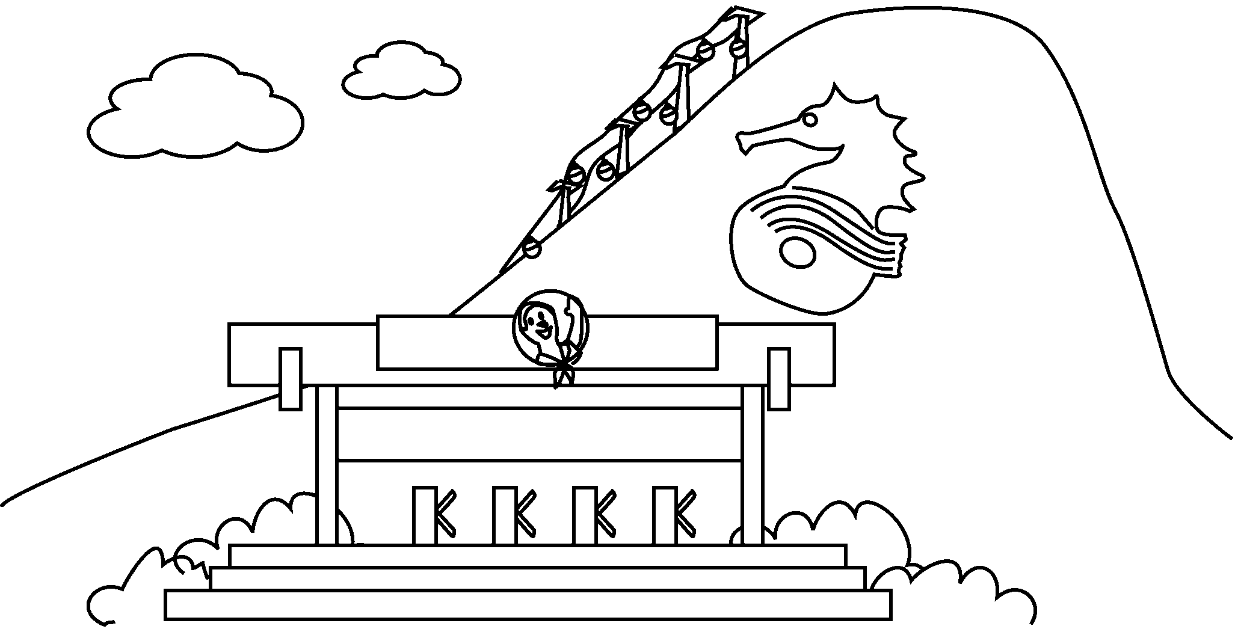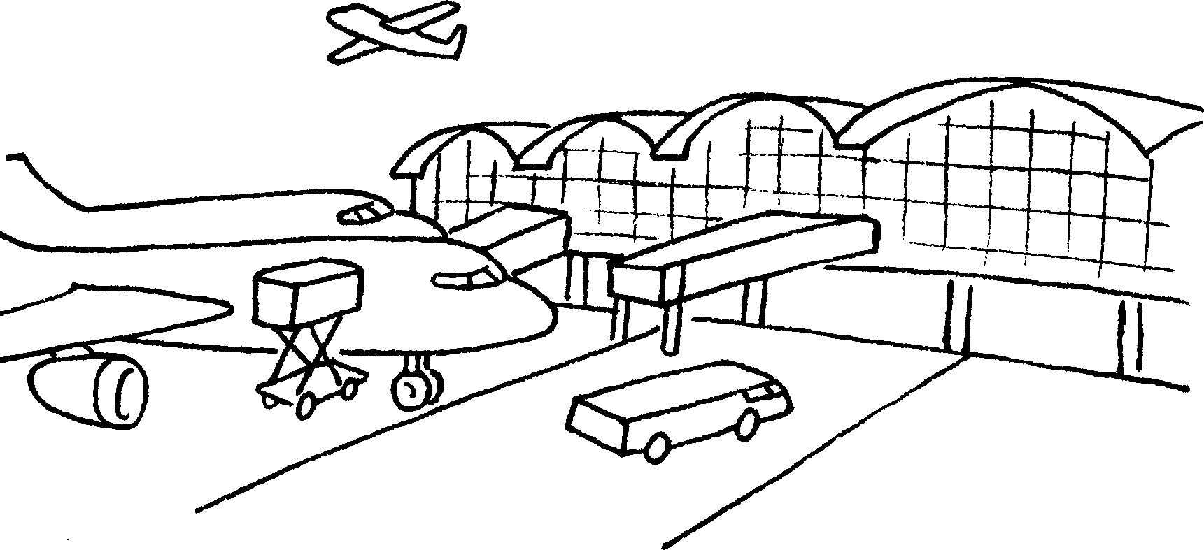 |  | 6 | a
 |  | 7 | a
 |  | 8 | a
 |  | 9 | an


Book 4A Chapter 5 Graded Worksheets
Worksheet 1⬇
- mobile phone
- DVD player
- digital camera
- MP3 player
- electronic games
- supermarket
- shopping centre
- theme park
- airport

RP no: Century Gothic 15pt
(所有圈號用15pt)

